Mathematics Instructional Plan – Grade 8

Relations and Functions; Domain and Range
Strand: Patterns, Functions, and Algebra
Topic: Determine whether a given relation is a function. Determine the domain and range of a function.
Primary SOL: 8.15 The student will
- determine whether a given relation is a function;
- determine the domain and range of a function.
Related SOL: 6.8, 6.12, 8.13

Materials
- Four generic locations in the classroom (e.g., corners, using colors, letters, etc.)
- Is the Relation a Function? activity sheet (attached)
- To Be a Function or Not activity sheet (attached)

Vocabulary
graph, input, ordered pair, output, table, vertical line, x-value, y-value (earlier grades)
function, dependent, domain, independent, range, relation (8.15)

Student/Teacher Actions: What should students be doing? What should teachers be doing?
- Direct students to move to the locations as indicated. In the first three scenarios, every student should have one place to go, so adjust the criteria, if needed.
Attribute | Location 1 | Location 2 | Location 3 | Location 4
Number of Letters in Your Last Name | 0-4 | 5-9 | 10-14 | 15-19
Height | 4 feet or less | Greater than 4 feet and less than or equal to 5 feet | Greater than 5 feet and less than or equal to 6 feet | Greater than 6 feet
Birth Month | Jan, Feb, Mar | Apr, May, June | July, Aug, Sept | Oct, Nov, Dec
Type of Clothing | Jeans | Sweatshirt | Tennis Shoes | T-shirt
The intention of the fourth attribute is to cause questions about the correct location as they are wearing more than one of the items of clothing listed. Explain to students that they have just experienced the difference between a function (knowing where to go) and a relation (could go more than one place). Have students return to their seats.
- Distribute the Is the Relation a Function? activity sheet, and discuss the various representations as well as how to determine whether the relation is a function. Connect the thinking process to the opening activity. Does each number in the domain (student) have only one number in the range (location)? If so, the relation is a function.
- Again, connecting to the opening activity, discuss domain and range. The domain was the set of students and the range was the locations. Connect the terms to the various representations on the Is the Relation a Function? activity sheet. Have students list the domain and range of each of the relations.
- Provide students with the To Be a Function or Not activity sheet, and have them add two points, table entries, and ordered pairs to each function. The information needs to be added so that the functions on the left are to remain functions and the functions on the right are to no longer be functions.
- Students can use the Desmos graphing calculator to create their own relations and then quiz other students regarding whether or not it is a function. Teachers and students can learn more about graphing ordered pairs in tables using Desmos at http://learn.desmos.com/tables

Assessment

Questions
  - Ask student to explain the statement, “Some relations are functions; all functions are relations.” and provide an example of each.
  - Provide students with additional examples of relations to identify which are functions. With those that are functions, give the domain and range.

Journal/writing prompts
  - In which of the representations of a relation, table, graph, or set of ordered pairs, is it easiest for you to determine whether the relation is a function? Explain.
  - How would you explain the difference between the domain and range to a classmate who was absent?

Other Assessments
  - Provide students a function in one form and have them add two additional points, table entries, or ordered pairs so that it remains a function.
  - Provide students a function in one form and have them add one additional point, table entry, or ordered pair so that it is no longer a function.

Extensions and Connections (for all students)
- Students can be provided with a graph, table, or set of ordered pairs and asked to represent the information in the other two formats. Once this is done, the student can determine whether the relation is a function. Also, the student can determine the domain and range.
- Have students research to find graphs (scatterplots) of interest to them. Students should print the graph and then determine whether the graph is a function and determine the domain and range of the relation.

Strategies for Differentiation
- One representation (table, graph, set of ordered pairs) can be focused on at a time.
- Use various vocabulary development strategies to reinforce the mathematical meaning of words which have different everyday uses (i.e., range, independent, dependent).

Note: The following pages are intended for classroom use for students as a visual aid to learning.

Virginia Department of Education © 2018
Is the Relation a Function?
x y  –2 3  1 4  2 2  4 –1  5 3 | {(2, 4), (–1, 3), (3, 4),  (2, 2), (0, 5)}
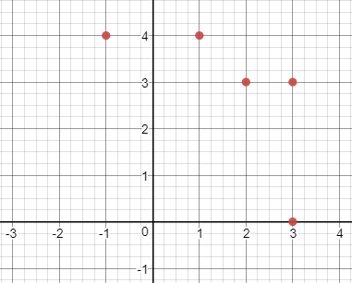 | 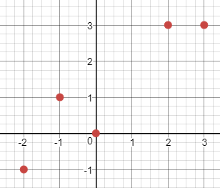

To Be a Function or Not
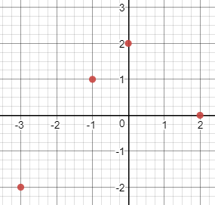
Function Not

x | y |  | x | y
–6 | 3 |  | –6 | 3
–4 | 5 |  | –4 | 5
0 | 2 |  | 0 | 2

{(3, 5), (2, 9), (–2, 4),
(–1, 6), (___, ___),
(___, ___)}
{(3, 5), (2, 9), (–2, 4),
(–1, 6), (___, ___),
(___, ___)}

