Mathematics Instructional Plan – Grade 8

Scatterplots: Estimating the Line of Best Fit
Strand: Probability and Statistics
Topic: Estimate the line of best fit with a drawing for data represented in a scatterplot.
Primary SOL: 8.13 The student will
- use a drawing to estimate the line of best fit for data represented in a scatterplot.
Related SOL: 6.8, 6.12, 7.10, 8.13a, 8.13b, 8.15

Materials
- What Do You Notice? activity sheet (attached)
- Straightedge (e.g., ruler, raw spaghetti noodle)
- Line of Best Fit – Scatterplots activity sheet (attached)
- Test Scores, Football, Flowers, and Accidents activity sheet (attached)

Vocabulary
line of best fit, prediction, negative correlation, no correlation, positive correlation, relationship, scatterplot

Student/Teacher Actions: What should students be doing? What should teachers be doing?
- Distribute the What Do You Notice? activity sheet. Have each student record observations about the scatterplots. After it appears most students have at least one observation for each graph, have students discuss in pairs. Finally, have students share their observations. While this discussion is occurring, if needed, rephrase student responses to include the appropriate vocabulary. Make sure that, in this discussion, the relationship shown in the data of each scatterplot is understood.
- If it does not come out in the discussion, have students compare the three graphs to decide which of the three is not like the others. Allow students to pair up and discuss which one and why before having a class discussion. Validate contributions that are true observations, and if needed, focus the discussion on being able to draw a straight line through all points in Graph 1 and Graph 2 but not for Graph 3.
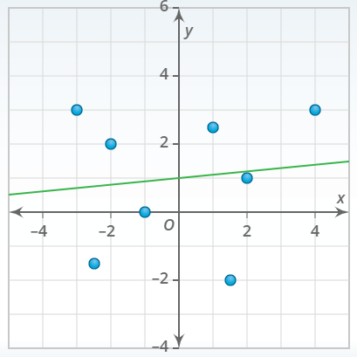
- Have students draw the line that connects the points on Graph 1 and Graph 2. Using Graph 2, have students work in pairs to determine the y-value for the x-value of 5. Repeat for the x-value of –3. Next, use Graph 1 and have the student pairs determine the y-value for the x-values of –4.5 and 4.5. Finally, using Graph 3, ask students whether they would be able to predict the y-value for the x-value of 3. Have students explain why, or why not, justifying their answer with example points.
Note: The calculated line of best fit is y = 0.1x + 1; correlation r = 0.12.
- Distribute the Line of Best Fit – Scatterplots activity sheet, and have each student place (do not draw yet) his/her straightedge on the scatterplot of the Video Game Market Value to estimate the line of best fit. Show the students how you placed your line of best fit and model your thinking of how you determined the placement of the line. Have students use the straightedge to add the line of best fit to their scatterplots. Ask students to make predictions using the line of best fit.
- Repeat Step 4 with the Ice Cream Sales scatterplot.
- Distribute the Test Scores, Football, Flowers, and Accidents activity sheet and have students draw the line of best fit for each of the four scatterplots. As students are working, circulate to provide feedback as well as ask prediction questions.

Assessment

Questions
  - Provide students with an additional scatterplot, have them draw a line of best fit, describe the relationship in the data, and make predictions for two values.
  - Provide students with a scatterplot with the line of best fit drawn inaccurately. Have students decide whether the line of best fit is the best fit and, if not, draw a line where it should be.

Journal/writing prompts
  - Describe how you determine the line of best fit for a scatterplot.
  - Explain how you would decide whether a scatterplot has a positive, negative, or no correlation.
  - Explain how a line can be a line of best fit for a scatterplot even if it does not go through any of the points in the scatterplot.

Other Assessments
  - Have students search information sources for scatterplots on which they can draw a line of best fit, describe the relationship in the data, and predict values.
  - Provide students with a set of scatterplots to sort in categories of positive, negative, no correlation.

Extensions and Connections (for all students)
- Discuss the difference between extrapolating and interpolating.
- Have students order a set of scatterplots based on the strength of the correlation (approximate, not exact).
- Have students predict x-values for given y-values.

Strategies for Differentiation
- Have students collect data of interest to them, create a scatterplot of the data, and estimate the line of best fit.
- Allow students to explore spreadsheets as a tool to generate scatterplots.
- Provide repeated practice with smaller data sets and low correlations.

Note: The following pages are intended for classroom use for students as a visual aid to learning.

Virginia Department of Education © 2018

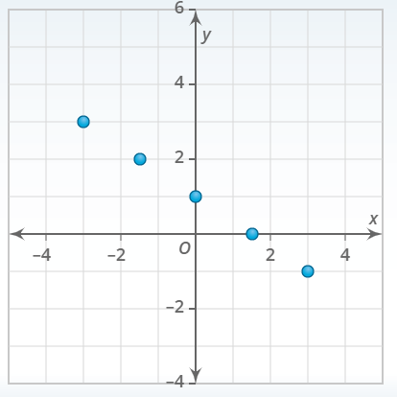
What Do You Notice?
Graph 1 Observations
_______________________________
_______________________________
_______________________________
_______________________________
_______________________________
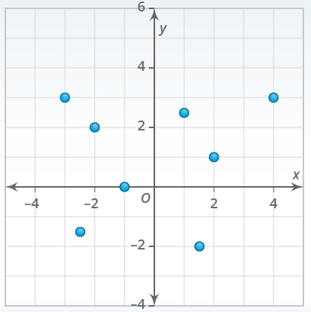
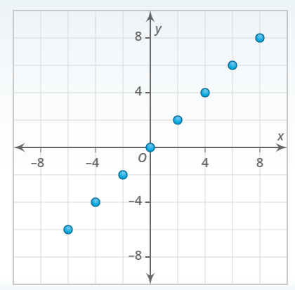
Graph 3 Observations
_______________________________
_______________________________
_______________________________
_______________________________
_______________________________
Graph 2 Observations
_______________________________
_______________________________
_______________________________
_______________________________
_______________________________
Line of Best Fit – Scatterplots

Test Scores, Football, Flowers, and Accidents
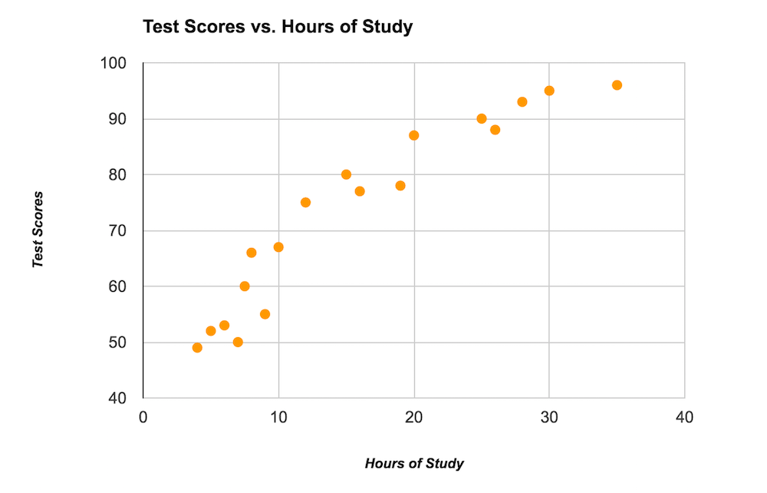
From: http://www.fulcrumapp.com/blog/a-primer-on-spreadsheets-and-visualization/

From: https://cobbk12.blackboard.com/bbcswebdav/institution/eHigh%20School/Courses/CCVA%20CCGPS%20Coordinate%20Algebra/Curriculum/Unit%204/U4_FittingDataToModelAndCorrelation/U4_FittingDataToModelAndCorrelation_print.html
From: https://www.khanacademy.org/math/probability/scatterplots-a1/creating-interpreting-scatterplots/v/constructing-scatter-plot
From: https://www.khanacademy.org/math/probability/scatterplots-a1/creating-interpreting-scatterplots/v/constructing-scatter-plot

