*Mathematics Instructional Plan – Grade 8*

# 3-D Figures

**Strand:** Measurement and Geometry

**Topic:** Solving problems involving three-dimensional figures

**Primary SOL:** 8.8 The student will construct a three-dimensional model, given the top, or bottom, side, and front views.

## Materials

* Legos or the Marwick’s website <https://www.mecabricks.com/en/workshop>
* 3-D Figures activity sheet (attached)
* 3-D Figures Patterns activity sheet (attached)
* 3-D Matching Cards (attached; one set for each student pair)
* Isometric dot paper

## Vocabulary

*bottom view, front view, mirror image, perspective, side view, three-dimensional figures, top view*

## Student/Teacher Actions: What should students be doing? What should teachers be doing?

1. Group students in pairs, and give each pair a set of Legos and a copy of the 3-D Figures activity sheet. Have partners use the Legos to build three-dimensional models of the figures shown on the activity sheet. After students have built each model, instruct them to draw the top, side, and front views of each figure. Have partners compare their drawings with those of another pair of students and discuss any differences.
2. Next, give each pair a copy of the 3-D Figure Patterns activity sheet, and have them build three-dimensional models of the figure whose top, side, and front views are shown. Have partners compare their models with those of another student pair and discuss any differences.
3. Finally, give each student pair a set of the Matching Cards, and have them match the top, side, and front views to each figure. Then, have them build three-dimensional models of the figures.

## Assessment

### Questions

* + What characteristics do you identify first when constructing a three-dimensional figure?
  + If you were given only the top and bottom views, would you be able to build the model accurately?

### Journal/writing prompts

* + Identify some careers that involve working with different views of three-dimensional figures.
  + Explain the difference between two-dimensional and three-dimensional and provide examples of each.

### Other Assessments

* + Have students build new figures and quiz each other on sketching the front, top, and side views.

## Extensions and Connections

* Have students build original three-dimensional models and then draw the figures on isometric dot paper.
* Have each student build the first letter of his/her first name, using linking cubes, and then draw the three different views of it.
* Use computer software programs and internet sites to demonstrate the different views and rotate three-dimensional figures.

## Strategies for Differentiation

* Color-code the front, top, and side views. Use the same shading for every figure so students can more readily distinguish the three different views.
* Model one of the figures at the front of the classroom, and have students come to the front to examine the figure in each view and explain how many cubes they can see in each.
* Start with figures that use fewer cubes to model, and then progress to examples that use more cubes.
* Build the three-dimensional models of the figures whose top, side, and front views are shown on the 3-D Figures Patterns activity sheet, and then have students match the models to the views.

**Note: The following pages are intended for classroom use for students as a visual aid to learning.**

Virginia Department of Education © 2018

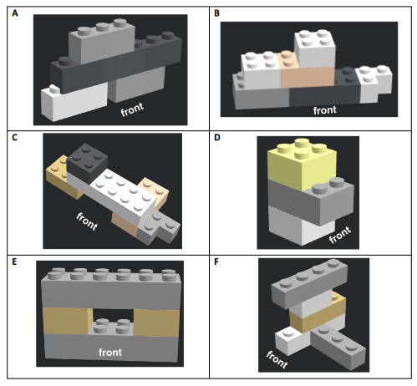**3-D Figures**

<https://www.mecabricks.com/en/workshop>

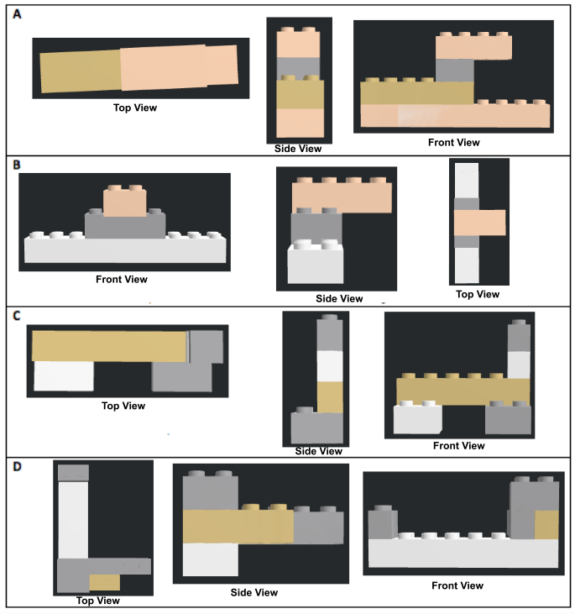**3D Figure Patterns**

**3-D Matching Cards**

Print on card stock and cut out.

|  |  |  |  |
| --- | --- | --- | --- |
| **Top View A** | **Side View E** | **Front View D** | **Figure 1** |
| **Top View C** | **Side View D** | **Front View A** | **Figure 2** |
| **Top View D** | **Side View A** | **Front View C** | **Figure 3** |
| **Top View B** | **Side View C** | **Front View E** | **Figure 4** |
| **Top View E** | **Side View B** | **Front View B** | **Figure 5** |