*Mathematics Instructional Plan – Grade 8*

# Transformations

**Strand:** Measurement & Geometry

**Topic:** Applying Transformations

**Primary SOL:** 8.7 The student will

1. given a polygon, apply transformations, to include translations, reflections, and dilations, in the coordinate plane figures; and
2. identify practical applications of transformations.

## Materials

* Table-Top Transformations Recording Sheet (attached)
* Chart-paper-size graph paper
* Markers
* Shapes for Table-Top Transformations activity sheet (attached)
* Scissors
* Describing Translations activity sheet (attached)

## Vocabulary

*congruent, horizontal translation,* *image, preimage, reflection, scale factor, similar figures, transformation, translation, vertical translations* *(earlier grades)*

*dilation* (8.7)

## Student/Teacher Actions: What should students be doing? What should teachers be doing?

1. Distribute the Table-Top Transformations Recording Sheet. Display a large coordinate plane with cutouts of a rectangle, parallelogram, and right triangle placed on it. Have students record on their recording sheets the original position of each shape by listing the ordered pair for each vertex. *(Note: Ensure the shape needs to remain on the coordinate plane).*
2. Distribute the Shapes for Table-Top Transformations activity sheet and scissors. Have students cut out each shape and label each vertex of each shape with the ordered pair for its original position.
3. Divide the class into small groups, and give each group a chart-paper-size sheet of graph paper and a marker. Have students in each group work together to create a coordinate plane on the graph paper and then lay each shape in its original position on the coordinate plane. Then, direct groups to complete each transformation described on their recording sheets and record the new position of each shape. Provide assistance while students work, as needed.
4. When students are finished, discuss the different types of transformations. Have selected students present the transformations they completed.
5. At the end of class, have a student come up and complete a “secret” transformation on large graph paper. Have the other students identify the secret transformation.
6. Review how we can describe the way a figure is translated (horizontal, vertical, or a combination of both). Discuss how the description can include translations shown on a coordinate plane, or the application of translations (not in the coordinate plane as shown below).

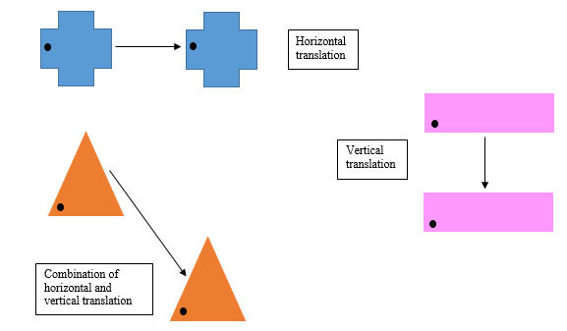

Review the example problem included on the Describing Translations activity sheet. Have students describe the translations for the problems provided (in words and using coordinate mappings).

## Assessment

### Questions

* + What is the difference between a scale factor less than 1 and greater than 1? How do you know, and what happens to the image?
  + What is different about describing locations and transformations on a two-dimensional surface and in space?

### Journal/Writing Prompts

* + Describe examples of transformations encountered in real life.
  + In animation and graphic design, think about how transformations might be used and make production easier and faster.

## Extensions and Connections (for all students)

* Have each student draw a figure on graph paper and complete five different transformations of the figure. Then, have students write out the directions for these five transformations and exchange them with other students, who will follow the directions in order to create the same transformations.
* Have students create tessellations.
* Label each corner of the room with a different type of transformation. Give students sample transformation cards, and have them go to the transformation corners that their samples represent.
* Create a dance routine in which students perform movements based on reflections and translations, and label the movements as such.
* Use online resources to model transformations.

## Strategies for Differentiation

* Start with all figures in quadrant 1 for the first few examples.
* Have students complete more than one transformation of the same figure.
* Have students use patty paper or tracing paper to complete transformations.
* Have students find examples of transformations within the classroom or on their clothing.
* Provide original figures already drawn so that students only have to draw the transformed figure.
* Use color-coding.
* Provide a numbered coordinate plane.

**Note: The following pages are intended for classroom use for students as a visual aid to learning.**

Virginia Department of Education © 2018

**Table-Top Transformations Recording Sheet**

**Name Date**

|  |  |  |  |
| --- | --- | --- | --- |
| **Shape** | **Preimage** | **Transformation** | **Image** |
| **Rectangle** | A ( )  B ( )  C ( )  D ( ) | Translate 5 units to the left and 3 units up. | A ( )  B ( )  C ( )  D ( ) |
| **Parallelogram** | W ( )  X ( )  Y ( )  Z ( ) | Reflect across the *x*-axis and translate 2 units to the left. | W ( )  X ( )  Y ( )  Z ( ) |
| **Right Triangle** | R ( )  S ( )  T ( ) | Dilate by scale factor of ½ | R ( )  S ( )  T ( ) |
| **Rectangle** | A ( )  B ( )  C ( )  D ( ) | Dilate by scale factor of 3 | A ( )  B ( )  C ( )  D ( ) |
| **Parallelogram** | W ( )  X ( )  Y ( )  Z ( ) | Reflect across the *y*-axis. | W ( )  X ( )  Y ( )  Z ( ) |
| **Right Triangle** | R ( )  S ( )  T ( ) | Translate 2 units to the right and 2 units up. | R ( )  S ( )  T ( ) |

**Shapes for Table-Top Transformations**

**Directions:** Cut out each shape, and label each vertex with the ordered pair for the original position.

**A**

**B**

**D**

**C**

**R**

**S**

**T**

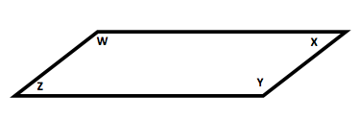

**Describing Translations**

A translation can be described as horizontal (right or left), vertical (up or down) or a combination of horizontal (right or left) and vertical (up or down). A translation can also be described by how the coordinates of each point (x, y) on the preimage have been translated to create the image.

Example: Verbal description - Horizontal translation of 5 units to the right.

The points (x, y) in the preimage are translated to the points (x + 9, y) in the image.

This can be described using a coordinate mapping of (x, y) →(x + 9, y).

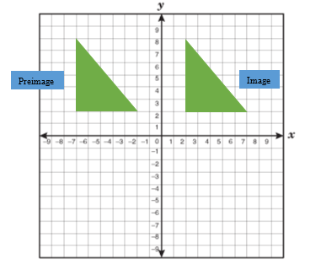

Describe the translations shown below verbally and using a coordinate mapping:

1. 2.

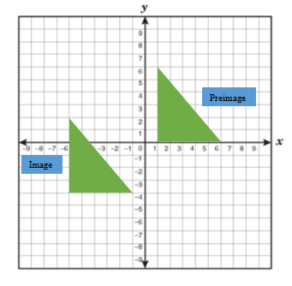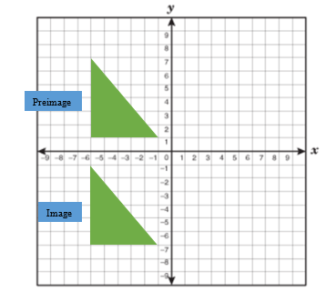

Describe each translation using a coordinate mapping.

|  |  |  |  |
| --- | --- | --- | --- |
| 1.    (x, y) →_______________ | 2.    (x, y) →_______________ | 3.    (x, y) →_______________ | 4.    (x, y) →_______________ |