*Mathematics Instructional Plan – Grade 8*

# Volume and Surface Area of Cones and Pyramids

**Strand:** Measurement and Geometry

**Topic:** Solve problems involvingvolume and surface area of cones and pyramids.

**Primary SOL:** 8.6 The student will

1. solve problems, including practical problems, involving volume and surface area of cones and square-based pyramids

**Related SOL:** 8.14, 8.17

## Materials

* SurfaceArea of Pyramids, Cones activity sheet (attached)
* Volume of Pyramids and Cones activity sheet (attached)
* Set of 3-D shapes
* Rulers
* Graph paper
* Demonstration tool (e.g., document camera, digital display)

## Vocabulary

*Expressions, equations, perimeter, base area, radius, diameter, pi, variable, height, width, substitution, surface area, volume (earlier grades)*

*slant height, lateral area, apex (8.6a)*

## Student/Teacher Actions: What should students be doing? What should teachers be doing?

1. Use models to demonstrate that a cone with an equal height and base area is one-third the volume of a cylinder.
2. Display the notes for Surface Area of Pyramids, Cones activity sheet. Have students record in their notes sections of the activity sheet what you fill in on the displayed sheet. To encourage engagement, ask for volunteers to answer what goes in each blank. Students are going to need lots of practice as to what “p”, “l” and “B” stand for. As you answer practice questions from notes, ask a different student what each letter stands for first, then what its value is. It is vital that students understand these variables and what they mean. Also, take the time to explain that if a cone question gives the diameter, students need to divide by 2 to find the radius.
3. Display the notes for Volume of Cones and Pyramids activity sheet. Have students record in their notes sections of the activity sheet what you fill in on the displayed sheet. To encourage engagement, ask for volunteers from class to answer what goes in each blank. Make sure that, when teaching volume of cones, students multiply pi (π) times r(radius)2 times h(height), *then* divide by 3. Emphasize how a cone is exactly one-third the volume of a cylinder of the same measurements.
4. Using the set of 3-D shapes, have students measure each shape and find the surface area and volume.

## Assessment

### Questions

* A construction cone has a volume of 157 cubic inches. If its height is 6, what is its radius? Students will use 3.14 for pi.
  + Students will set up the formula with the variable “r” remaining. First, they will multiply both sides by three, then multiply 6 and 3.14 giving them 18.84, then divide both sides by 18.84, then find the square root of both sides, giving them 5 as the radius.
* A construction cone has a surface area of 94.2 square mm. If its diameter is 6, what is its slant height? Students will use 3.14 for pi.
  + Students will set up the formula with the variable “l” remaining. First, they will divide the diameter of 6 by 2 to get a radius of 3. Then they multiply 3.14 by 32 to get 28.26. Then they will subtract 28.26 from each side of the equation. Next, students will multiply 3.14 by 3 to get 9.42. Then they will divide both sides by 9.42 to get the slant height of 7.
* A square-based pyramid has a volume of 30 cubic meters. If its height is 10, what are its base side lengths?
  + Students will set up the formula with the variable B replaced by s2 (s for side length). They will first multiply both sides of the equation by 3, then divide both sides by 10, then find the square root of both sides to give them a side length of 9.
* A square-based pyramid has a surface area of 80 square feet. If its base has side lengths of 4, what is its slant height?
  + First, students need to discover what “p” and “B” are. P would be 16 because 4 + 4 + 4 + 4 = 16. B would also be 16, because 4(4) is 16. Next students would subtract 16 from both sides of the equation. Then they would multiply 16 by .5, giving them 8. Then they divide both sides by 8, giving them a slant height of 8.

### Journal/writing prompts

* There are a fair number of actual square-based pyramids in the world, some large and some small. Talk about a couple of scenarios where it would be important to know the surface area and volume of an actual pyramid. Example: Surface Area = painting the outside surface. Volume = filling a pyramid-shaped pool.
* There are a fair number of actual cones in the world, some large and some small. Talk about a couple of scenarios where it would be important to know the surface area and volume of an actual cone. Example: Surface Area = painting the outside surface. Volume = filling an ice cream cone.

### Other Assessments

* + Create an online learning/quiz game for each shape.
  + Have students draw their own shapes with measurements to give to other students to calculate surface area and volume.

## Extensions and Connections (for all students)

* Give students practice with variable substitution equations, and remind them that 3-D formulas are equations that require substitution.
* Briefly talk about the evolution of the pyramid, from different cultures and types (i.e., Aztecs, Egyptians, Mayans, etc.).

## Strategies for Differentiation

* Have a completed copy of notes for students with that accommodation.
* For the station activity as well as the physical measuring of objects, either the teacher, a special education teacher, or para-educator should work with a small group(s).
* For the independent practice sheets, either the teacher, a special education teacher, or a para-educator should work with a small group(s).
* Students who are tactile learners will appreciate the 3-D shapes to measure, if possible.

**Note: The following pages are intended for classroom use for students as a visual aid to learning.**

Virginia Department of Education © 2018

**Surface Area of Pyramids, Cones**

**Objective: To calculate the surface area of pyramids, cones.**

|  |  |
| --- | --- |
| Questions/ Main Ideas | Notes: |
|  | |  |  |  |  |  |  |  |  | | --- | --- | --- | --- | --- | --- | --- | --- | | **http://upload.wikimedia.org/wikipedia/commons/thumb/9/94/Square_pyramid_net.svg/240px-Square_pyramid_net.svg.pngPyramid**    ***SA = 1/2lp + B***  ***SA***: _______________________  ***l***: ________________________  ***p***: _______________________  ***B***: _______________________ | *Finding the surface area of a pyramid*     |  |  | | --- | --- | |  | a*.* Write the **formula** | |  | b. **Substitute** for each known variable. | |  | c. **Solve** the equation for the unknown variable. | | |
|  | |  |  |  |  |  |  |  |  | | --- | --- | --- | --- | --- | --- | --- | --- | | **Cone**  http://4.bp.blogspot.com/_vHzN1_rjjgo/TUyyeJRWkBI/AAAAAAAAACY/_uKikcQQ31w/s1600/cone+net.gif  ***S.A.= πrl + πr2 or S.A.= πr2 + πrl***  ***SA***: _______________________  ***l***: ________________________  ***h***: _______________________  ***r***: _______________________ | *Finding the surface area of a cone*     |  |  | | --- | --- | |  | a*.* Write the **formula** | |  | b. **Substitute** for each known variable. | |  | c. **Solve** the equation for the unknown variable. | | |

**Directions:** Find the surface area of each 3-D shape to the nearest square unit if necessary.

|  |  |
| --- | --- |
|  |  |
| 3. | 4. |

**Volume of Pyramids, Cones**

**Objective: To calculate the VOLUME of pyramids, cones.**

|  |  |
| --- | --- |
| Questions/ Main Ideas | Notes: |
|  | |  |  |  | | --- | --- | --- | | **Volume of a**  **Pyramid** | **Volume of a**  **Cone** |  | |
| Remember:  a. Formula  b. Substitute  c. Solve | **Directions:** Find the volume of each figure. Round your answer to the nearest tenth if necessary.   |  |  |  | | --- | --- | --- | |  |  |  | |

**Volume of Pyramids and Cones**

**Objective: To calculate the volume of pyramids and cones.**

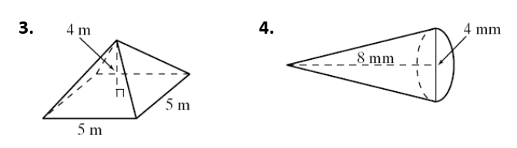**Directions:** Find the volume of each figure to the nearest cubic unit. 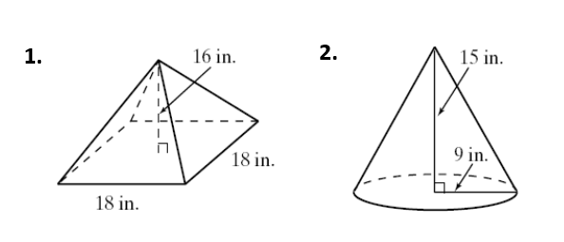

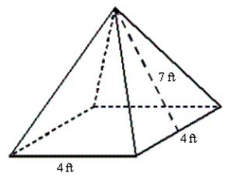

**5.**