Mathematics Instructional Plan – Grade 8

Do You Like to Spend Money?
Strand: Computation and Estimation
Topic: Solving problems involving percents and reconciling an account balance
Primary SOL: 8.4 The student will solve practical problems involving consumer applications
Related SOL: 7.3

Materials
- Do You Like to Spend Money? activity sheet (attached)

Vocabulary
discount, percent, sales tax, tip (earlier grades)
balance, credit, interest, transaction, reconcile an account (8.4)

Student/Teacher Actions: What should students be doing? What should teachers be doing?
- This lesson should be taught after teaching and reviewing sales tax, discount, tip, and interest. Review the process in calculating the sales tax, discount, tip, and interest.
- Distribute the Do You Like to Spend Money? activity sheet, and have students work with partners to complete it. As students work, circulate around the classroom to provide assistance, as needed.
- When students are finished, have them share their results.

Assessment

Questions
  - Why is it important to be able to calculate discount, sales tax, tip, and interest?
  - Why is it important to reconcile your credit and debit card accounts?

Journal/writing prompts
  - Explain practical situations in which you would have to determine discounts.
  - Discuss why some businesses make markups before they advertise discounts.

Other Assessments
  - Provide students with receipts and have them create a credit card statement.
  - Have students create an inaccurate credit card statement based on a list of purchases. Then, have students trade the statements to find the wrong charges.

Extensions and Connections
- Have students create their own shopping trip where students will track their spending. Then have students create their own credit card statements to match their charges.

Strategies for Differentiation
- Adjust the sales tax to another percentage, such as 5.5 percent.
- Discuss reconciling an account.
- Provide previously completed class notes on discount, sales tax, and tip.
- Provide students with one or more completed examples of calculating discount, sales tax, tip, and interest for reference.

Note: The following pages are intended for classroom use for students as a visual aid to learning.

Virginia Department of Education © 2018

Do You Like to Spend Money?
Name Date
Scenario
You have a busy day of errands ahead of you. Your favorite store is having a super sale. You go into the store and decide to buy from the following items.
SALE!!! SALE!!! SALE!!! SALE!!! SALE!!!
 |  | Original Price | Discount
 | T-shirts | $12.00 | 25% off
 | Shorts | $15.00 | 20% off
 | Jeans | $35.00 | 40% off
 | Sweatshirts | $20.00 | 30% off
You purchase two T-shirts, one pair of shorts, two pairs of jeans, and one sweatshirt. Use the table below to calculate the cost of each item.
Discount Table
Item | Original Price | Discount Amount | Sale Price | Sales Tax (5%) | Final Price
2 T-shirts
Pair of shorts
2 pairs of jeans
Sweatshirt
What is the total cost for all of the discounted items, including sales tax? __________________
You leave your favorite store excited about your savings. Your next stop is a local salon and barbershop. The services they provide are listed below.
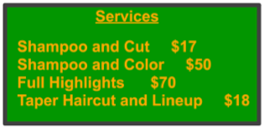

You decide to get a shampoo and cut. You leave your hairstylist a 20 percent tip. What is the total amount of money you spent at the salon and barbershop?

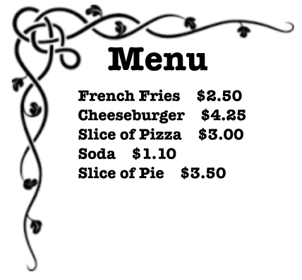
Your last stop is a local restaurant. You order a cheeseburger, a slice of pie, and a soda from the menu below. The service was excellent, so you decide to leave a 40 percent tip. What was the total cost of your meal, including tip? _____________________________________

Task
Your credit card statement has just arrived. It is important that you check the statement to determine whether the money you spent on errands matches the money charged to your account. Review the credit card statement below. Fill in all of the missing information.
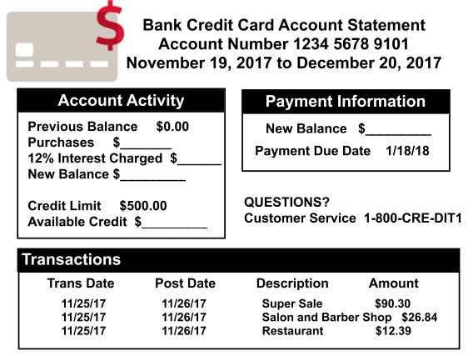

Check your transactions to ensure that the charges for your shopping spree, haircut, and meal match the amounts charged. Which transaction was charged wrong? _____________________

