Mathematics Instructional Plan – Grade 8

Where Do They Lie?
Strand: Number and Number Sense
Topic: Estimating and determining where a square root lies on a number line
Primary SOL: 8.3 The student will
- estimate and determine the two consecutive integers between which a square root lies;
- determine both the positive and the negative square roots of a given perfect square.
Related SOL: 7.1d

Materials
- Where Do They Lie? activity sheet (attached)
- Pictorial Perfect Squares Memory Match activity sheet (attached)
- I Have … Who Has? Cards (attached)
- Glue
- Scissors

Vocabulary
integer, perfect square, square root (earlier grades)
consecutive numbers, irrational number, radical number (8.3)

Student/Teacher Actions: What should students be doing? What should teachers be doing?
- Ask students to discuss and define a perfect square. Have students provide examples of perfect squares.
- Write $\sqrt{49}$ on the board. Ask students to identify the square root. Students should respond with 7. Then, write $-\sqrt{64}$ on the board. Ask students to identify the square root. Students should respond with –8. Drill students on a few more known perfect squares, alternating between negative square roots and positive square roots.
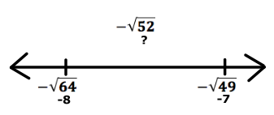
- Now, write $-\sqrt{52}$ on the board. Discuss with students how we can use our knowledge of perfect squares to estimate where this square root would fall on a number line. Guide the discussion to help students to understand that the negative square root of 52 falls between –7 and –8.
- Help students to understand that –52 falls between –49 and –64. Therefore, the square root of –52 must fall between the square roots of –49 and –64.
- Distribute the “Where Do They Lie?” number line template and square roots.
- Have students work in pairs or small groups to create a number line ranging from –20 to 20.
- Students will need scissors and glue. Have students cut out all of the square roots provided. Have students sort the square roots by creating a pile of perfect squares.
- Next, have students place the perfect squares in their correct locations on the number line.
- Have students glue all of their perfect squares above the number line.
- Now, using their knowledge of perfect squares, have students estimate the locations of the remaining square roots.
- Have students glue all of the nonperfect squares below the number line between the two consecutive integers in which they fall.

Assessment

Questions
  - When given a radical, how can you determine whether the square roots will be greater than or less than zero? When could the radical equal zero?
  - What is the difference between $\sqrt{100}$ and $-\sqrt{100}$?
  - Nonperfect squares are included in which categories of the real number system?
  - Which perfect square results in only one integer?

Journal/writing prompts
  - Write to a younger student to explain what a square root is.
  - Explain in your own words how your knowledge of perfect squares can help to determine the two consecutive integers in which a nonperfect square would lie on a number line.

Other Assessments
  - Copy and distribute the I Have. Who Has? Cards and complete a round or two with your class.
  - Copy and distribute the Perfect Squares Memory Match activity sheet. Have students pair up and play memory match.
  - Use the square roots provided in the Where Do They Lie? activity to conduct a “speed” sort for perfect and nonperfect squares.

Extensions and Connections (for all students)
- Use the square roots provided in the Where Do They Lie? activity to conduct a speed sort for rational or irrational.

Strategies for Differentiation
- Provide students with a numbered number line.
- Have students give examples of consecutive numbers before working on square roots to ensure they understand the vocabulary.
- Have students practice with Perfect Squares Memory Match before this lesson to practice identifying perfect squares.
- Have students draw the perfect squares on graph paper.
- Display a multiplication table, and indicate by circling or shading the perfect squares.
- Ensure that each small group is comprised of students with varying abilities and that each student has a meaningful role within the group.
- Allow students to work in pairs during steps 1-5.
- Pre-teach essential vocabulary to certain students prior to the lesson introduction.

Note: The following pages are intended for classroom use for students as a visual aid to learning.

Virginia Department of Education © 2018

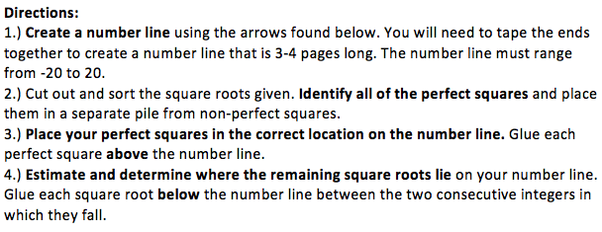

Where Do They Lie? Square Roots
$$\sqrt{196}$$ | $$-\sqrt{196}$$ | $$\sqrt{50}$$ | $$-\sqrt{50}$$ | $$\sqrt{250}$$
$$\sqrt{361}$$ | $$-\sqrt{361}$$ | $$\sqrt{49}$$ | $$-\sqrt{49}$$ | $$-\sqrt{250}$$
$$\sqrt{36}$$ | $$-\sqrt{36}$$ | $$\sqrt{72}$$ | $$-\sqrt{72}$$ | $$\sqrt{122}$$
$$\sqrt{300}$$ | $$-\sqrt{300}$$ | $$\sqrt{144}$$ | $$-\sqrt{144}$$ | $$-\sqrt{122}$$
$$\sqrt{2}$$ | $$-\sqrt{2}$$ | $$\sqrt{1}$$ | $$-\sqrt{1}$$ | $$\sqrt{9}$$
$$\sqrt{80}$$ | $$-\sqrt{80}$$ | $$\sqrt{12}$$ | $$-\sqrt{12}$$ | $$-\sqrt{9}$$
$$\sqrt{169}$$ | $$-\sqrt{169}$$ | $$\sqrt{100}$$ | $$-\sqrt{100}$$ | $$\sqrt{0}$$

Pictorial Perfect Squares Memory Match
 | $$\sqrt{400}$$
 | $$\sqrt{361}$$
 | $$\sqrt{324}$$
 | $$\sqrt{289}$$
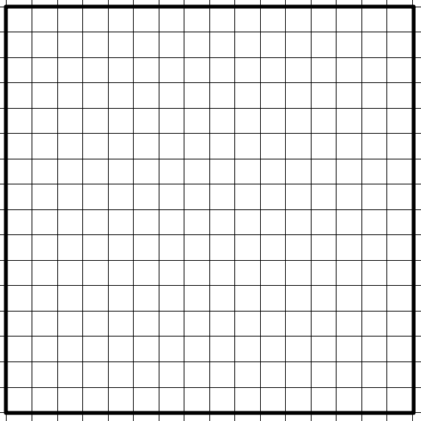 | $$\sqrt{256}$$
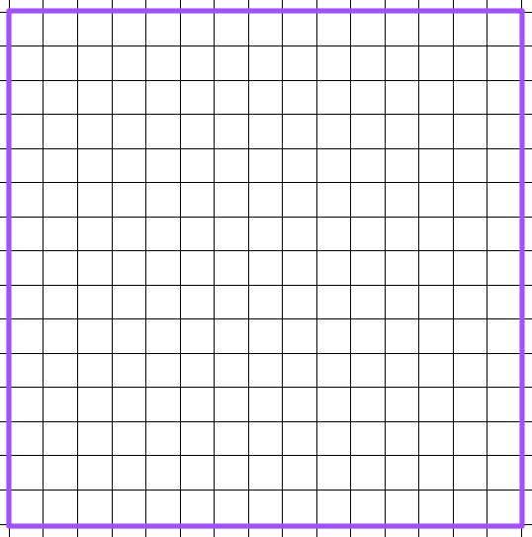 | $$\sqrt{225}$$
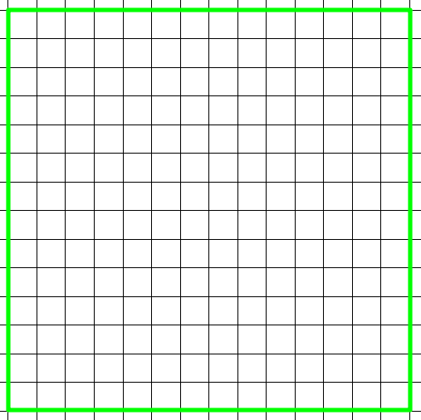 | $$\sqrt{196}$$
 | $$\sqrt{169}$$
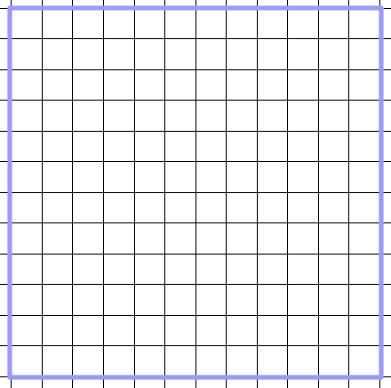 | $$\sqrt{144}$$
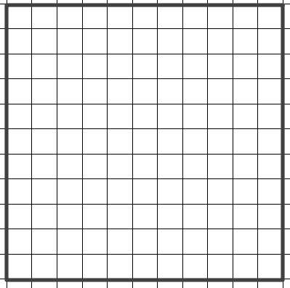 | $$\sqrt{121}$$
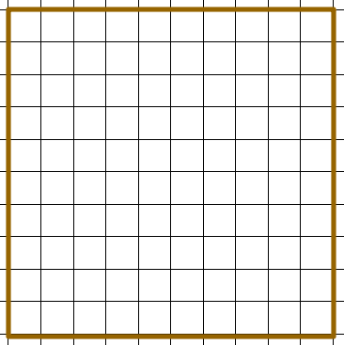 | $$\sqrt{100}$$
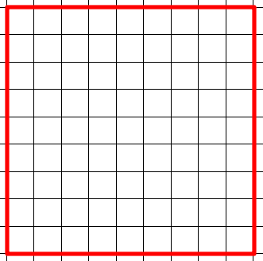 | $$\sqrt{81}$$
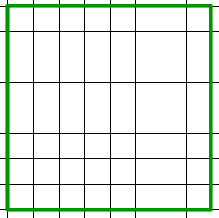 | $$\sqrt{64}$$
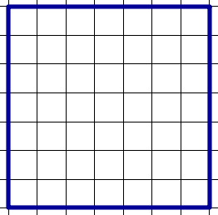 | $$\sqrt{49}$$
 | $$\sqrt{36}$$
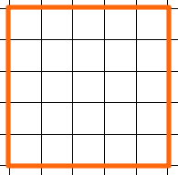 | $$\sqrt{25}$$
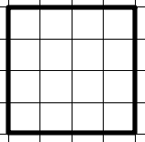 | $$\sqrt{16}$$
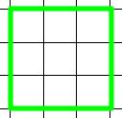 | $$\sqrt{9}$$
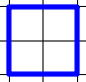 | $$\sqrt{4}$$
 | $$\sqrt{1}$$
 | $$\sqrt{0}$$

I Have … Who Has? Cards
Copy cards on card stock and cut out.
I have 18.
Who has 4²?
I have 16.
Who has my square root?
I have 4.
Who has the two consecutive numbers
between which the $\sqrt{29}$ lies?
I have 5 and 6.
Who has 5²?
I have 25.
Who has the two consecutive numbers
between which the $\sqrt{45}$ lies?
I have 6 and 7.
Who has the square root of 169?
I have 13.
Who has the square root of 400?
I have 20.
Who has the area of a square with a side length of 7?
I have 49.
Who has the length of a side of a square with an area of 81?
I have 9.
Who has the two consecutive numbers between which
the length of a side of a square with an area of 122 lies?
I have 10 and 11.
Who has 12²?
I have 144.
Who has 10²?
I have 100.
Who has the two consecutive numbers between which
the square root of 74 lies?
I have 8 and 9.
Who has the area of a square with a side length of 15?
I have 225.
Who has the square root of 289?
I have 17.
Who has the two consecutive numbers between which
the square root of 5 lies?
I have 2 and 3.
Who has the $-\sqrt{36}$?
I have –6.
Who has the two consecutive numbers
between which the $-\sqrt{111}$ lies?
I have –10 and –11.
Who has the $-\sqrt{256}$?
I have –16.
Who has the two consecutive numbers
between which $-\sqrt{300}$ lies?
I have –17 and -18.
Who has the square root of 324?

