Mathematics Instructional Plan – Grade 7

All Graphs are Not the Same
Strand: Probability and Statistics
Topic: Compare Histograms to stem-and-leaf, line plots and circle graphs
Primary SOL: 7.9 The student, given data in a practical situation, will
- compare histograms with the same data represented in stem-and-leaf plots, line plots, and circle graphs.
Related SOL: 7.9a, 7.9b

Materials
- Graphs (attached)
- Graph paper
- Technology (if available)
- Sticky notes

Vocabulary
circle graph, frequency table, line plot, measures of central tendency, range, stem-and-leaf plot (earlier grades)
comparison, frequency distribution, histogram, inference, prediction (7.9)

Student/Teacher Actions: What should students be doing? What should teachers be doing?
- Review circle graphs, line plots, and stem-and-leaf plots with students.
- Given the attached graphs, create small student groups and have each group match the appropriate histogram, circle graph, line plot, and stem-and-leaf plot with each graph that shows the same data. Students should then give each graph an appropriate title and label the graphs as needed.
- Have student groups do a gallery walk, in which they write comments on a sticky note stating they agree or disagree with the other groups matching and attaching the note to the group’s answers.
- Student groups should correct their matches based on gallery walk feedback and their observations.
- Given a set of data (whether students collect it or it’s given) have student groups create a line plot, stem-and-leaf plot, circle graph, and histogram. Technology can be used to create most items, if needed.
- Student groups should share their information with the class in order to receive appropriate feedback.

Assessment

Questions
- How is a histogram different from a line plot? A circle graph? A stem-and-leaf plot?
- When is it more appropriate to use a histogram? A line plot? A circle graph? A stem-and-leaf plot?

Journal/Writing Prompts
- If you were given data on the different heights of students in the classroom, which graph would you use and why?
- Explain what information a histogram can show and what it cannot show.

Other
- Find a histogram online. Create a similar graph based on the data given.
- Find a circle graph online. Create a similar graph based on the data given.
- Find a line plot online. Create a similar graph based on the data given.
- Find a stem-and-leaf plot online. Create a similar graph based on the data given.
- Students should make discoveries on the similarities and differences of the different graphs.

Extensions and Connections (for all students)
- In groups of four, use two calendars from Weather Underground that show the weather in Blacksburg (or change to a city of your choice) in January and February, and graph the two months using circle graphs, line plots, histograms, and stem-and leaf graphs. Based on your group’s graphs, come up with some conclusions.
Virginia Tech January 2017 Daily Weather Calendar – Weather Underground
Virginia Tech February 2017 Daily Weather Calendar – Weather Underground
*Note – webpages are best viewed in Google Chrome

Strategies for Differentiation
- Assign students of varying abilities to each group in steps 2–6.
- Ensure each student within the groups has a meaningful role in each activity.
- Provide larger depictions of the attached graphs as needed.

Note: The following pages are intended for classroom use for students as a visual aid to learning.

Virginia Department of Education © 2018

Graphs
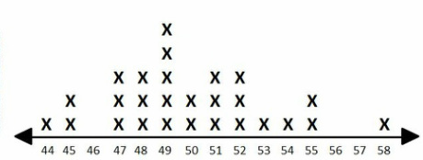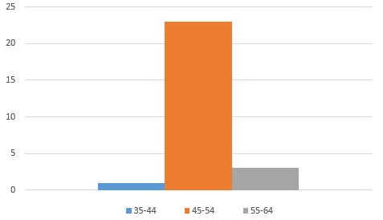

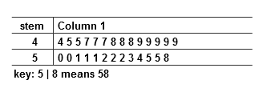

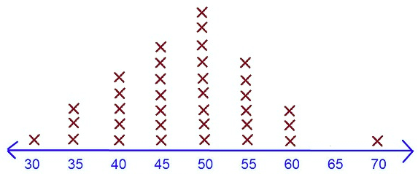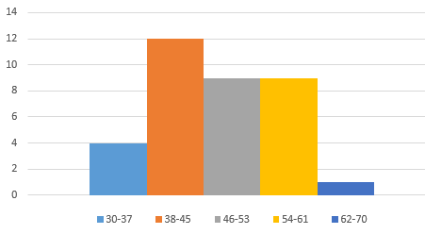

Graphs
