Mathematics Instructional Plan – Grade 7

Numbers in a Name
Strand: Probability and Statistics
Topic: Constructing, analyzing, comparing, and contrasting histograms
Primary SOL: 7.9 The student, given data in a practical situation, will
- represent data in histogram;
- make observations and inferences about data represented in a histogram; and
- compare histograms with the same data represented in stem-and-leaf plots, line plots, and circle graphs.

Materials
- Sticky notes
- Chart paper
- Markers
- Calculators
- Venn Diagram Templates 1 and 2 (optional; attached)
- Scientific calculators

Vocabulary
circle graph, frequency table, line plot, measures of central tendency, range, stem-and-leaf plot (earlier grades)
comparison, frequency distribution, histogram, inference, prediction (7.9)

Student/Teacher Actions: What should students be doing? What should teachers be doing?
- Give each student a sticky note, and ask them to write the total number of letters in their first and last names. Ask students to think about how this data could be organized once it is collected from each student. Discuss ideas as a class.
- Try to organize the data based on the suggestions that have been given. Discuss the pros and cons of each suggestion. Ask students whether grouping the data would be helpful. Introduce students to the grouped frequency table, and be sure to discuss the importance of consecutive equal intervals.
Sample grouped frequency table
Number of Letters in First and Last Name | Tally | Frequency | Cumulative Frequency
5–10
11–16
17–22
- Ask students to make observations from the grouped frequency table, including what information is displayed and what is not.
- Ask students to determine what type of graph they can make from a grouped frequency table. Introduce students to a histogram – a form of bar graph in which the categories are consecutive and at equal intervals and the height of each bar is determined by the frequency of each interval. Make a histogram from the numbers in first/last name data. Be sure to point out the axes, the intervals, and the frequencies of the data.
- Ask students to analyze the information in the histogram and make observations, inferences, and predictions. Sample questions:
- If another student gets added to our class, where do you predict their name would fall in our histogram?
- What could happen to our histogram if we asked this same question in another country? In a different era in history? In another culture?
- Place students in small groups, and distribute chart paper and markers. Have some groups display the first/last name data in a line plot; some groups, a circle graph; and some, a stem-and-leaf plot. Have calculators or computers available for the circle graph group(s). Be prepared to review how to construct these graphs as needed.
- Have each small group analyze their graph by making three observation statements on the same piece of paper as the graph. Each observation should be specific. The first observation should be a comparison, in which the students describe differences in characteristics. The second observation should include a prediction that the students make based on a trend in the data. The third observation should be an inference made the students. The inference should describe what could happen if something else occurs.
- Have each group present their graph and observation statements to the class. Compare and contrast each graph to the original histogram. You may want to use a Venn diagram for this.

Assessment

Questions
  - Using the Venn Diagram Templates, compare the various types of graphs. How is histogram different from a line plot? Circle graph? Stem-and-leaf plot?
  - What types of data are most appropriate to display in a histogram? Give specific examples.
  - How can a histogram help a student find central tendency (mean, median, and mode)?
  - What can you infer from a histogram?

Journal/writing prompts
  - Describe how to create a grouped frequency table and a histogram from a set of data.
  - Explain what information a histogram can show and what it cannot show.
  - Explain how a histogram differs from other bar graphs.

Other Assessments
  - Have students create a survey question, collect data, and display the data in a histogram, line plot, circle graph, and stem-and-leaf plot. Students should analyze and interpret the data.
  - Give students the following scenario and ask them to create a histogram that could represent:
Jack’s repair shop opens at 9:00 a.m. and closes at 5:00 p.m. One day, Jack kept track of the number of customers in his shop each hour and recorded the information in a histogram. He noticed the range of customers was 30, and the average number of customers in the store each hour was 10.

Extensions and Connections (for all students)
- Graph data using a graphing calculator.

Strategies for Differentiation
- Use the jigsaw strategy to have students compare and contrast histograms with line plots, circle graphs, and stem-and-leaf plots.
- Before the lesson, review how to make frequency tables and bar graphs.
- Before the lesson, set up circle graphs that have been designed based on your class data for students to complete.
- Teacher could model step 2 for the class on the board or using a demonstration tool (e.g., document camera, digital display).
- Assign each student a partner to work with during steps 1–5, before small-group assignments in step 6.

Note: The following pages are intended for classroom use for students as a visual aid to learning.

Virginia Department of Education © 2018

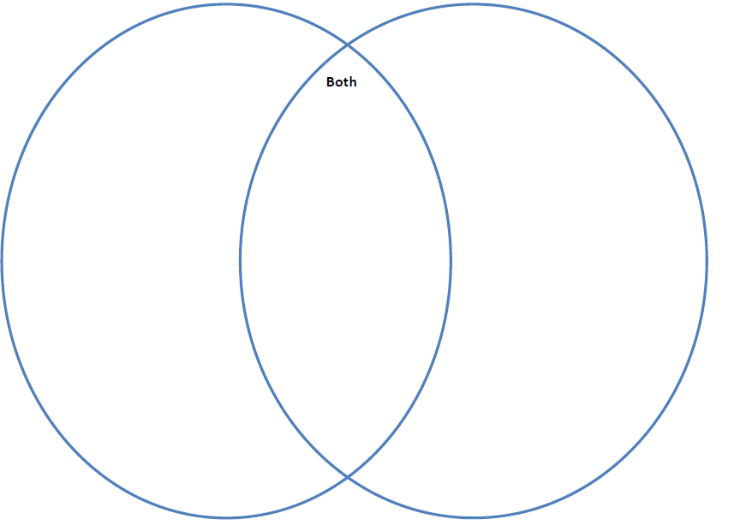
Venn Diagram Template 1

Venn Diagram Template 2
