Mathematics Instructional Plan – Grade 7

Making Connections
Strand: Patterns, Functions, and Algebra
Topic: Determine Slope
Primary SOL: 7.10 The student will
- make connections between and among representations of a proportional or additive relationship between two quantities using verbal descriptions, tables, equations, and graphs.
Related SOL: 7.10 a–d

Materials
- Activity Sort: Proportional Relationship 1 (attached)
- Activity Sort: Proportional Relationship 2 (attached)
- Activity Sort: Proportional Relationship 3 (attached)
- Activity Sort: Additive Relationship 1 (attached)
- Activity Sort: Additive Relationship 2 (attached)
- Activity Sort: Additive Relationship 3 (attached)
- Scientific calculator (optional)

Vocabulary
additive relationship, constant of proportionality, multiplicative relationship, proportional, relationship, unit rate (earlier grades)
constant ratio, rate of change, slope, slope triangle, y-intercept (7.10)

Student/Teacher Actions: What should students be doing? What should teachers be doing?
- Review with students information on ratio tables, multiplicative relationships, equivalent ratios, proportional relationships, slope (m), additive relationships, and y-intercept (b).
- Distribute the cut-out graphs, tables, equations, and verbal situations from the Activity Sort. The students will work in pairs or groups to match each verbal situation with the correct graph, table, and equation.
Teachers may wish to use the Desmos Making Connections 7.10e Student Activity created for this card sort for students to complete the activity using a laptop or tablet.
- From the page, create a class code to distribute to students (visit the Desmos tutorial Class Activities to learn more about managing class activities)
- Students should go to https://student.desmos.com/ and type in the class code that the teacher creates to access the assignment.
- Students should correctly match the representations, then create two separate piles. One pile should represent those that are additive, while the other represents those that are proportional.
- Students should then discuss the similarities and differences between the two piles that were created.
- Students should notice that some of the graphs only include the points, but others connect the points with a line. Ask students why this might be the case. Students should note that the graphs connected with lines represent situations in which there are an infinite number of points that could be graphed (e.g., comparing time and distance), whereas others only have specific points that could represent the situation (e.g., weeks taking lessons and the number of songs that can be played). Also note with students that all of the graphs are represented by points in the first quadrant only (x ≥ 0). Because the graphs represent practical situations, there is a limitation on the values that should be included in the graph. Whereas, if we were just graphing an equation, such as $y =3x$, without having a context for the relationship, we would connect the points with a straight line and there would be no limitation on the values of the variables.

Assessment

Questions
- How can you use a table of values to determine the graph of a line?
- How can you use the graph of a line to determine an equation of a line?
- What are key words in the real-world examples that help you determine whether the situation is additive or multiplicative?

Journal/Writing Prompts
- What is the difference between an additive and a multiplicative relationship in a table of values?
- What is the difference between an additive and a multiplicative relationship in the graphs of the lines?

Other
- Students can create their own situation and share it with another student to graph, put in a table, and make an equation that matches the practical situation.

Extensions and Connections (for all students)
- Students can enter in several $y =x +b$ and $y =mx$ equations on a graphing calculator or online graphing calculator in order to make connections to the y-intercept of a line and the value of b.

Strategies for Differentiation
- Students can use the sort as a jigsaw activity – distributing/grouping the cards based on student ability.
- Review prior vocabulary and preteach new essential vocabulary to certain students as necessary before introducing the lesson.
- Ensure that students of varying abilities are represented in each small group, and that all students have a meaningful role.

Note: The following pages are intended for classroom use for students as a visual aid to learning.
Virginia Department of Education © 2018

Activity Sort
Print on card stock and cut out.
Desmos Digital Version: https://teacher.desmos.com/activitybuilder/custom/5a9363f490db701bb48ad9ee

Proportional Relationship 1:
Mary and her friends set out to sea on their annual fishing trip. Their distance from the shore in miles, y, increases by 3 miles each hour, x. Write an equation to model this relationship.

x y  0 0  1 3  2 6  3 9 | 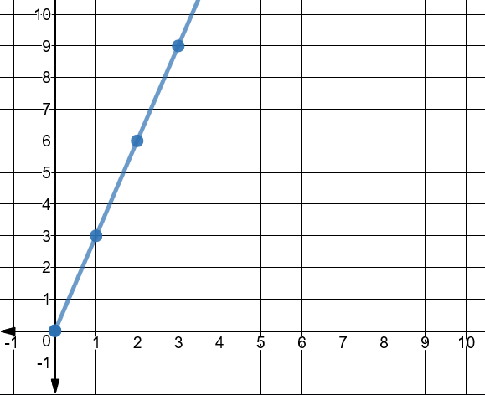

Proportional Relationship 2
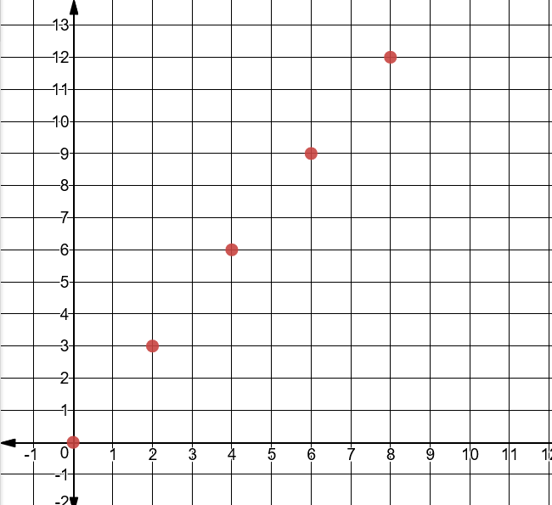 | x y  2 3  4 6  6 9  8 12
Shawn has started a small business selling bat houses. He can build 6 houses in 4 hours. Write an equation to model the relationship between the number of hours Shawn has worked, x, and the number of houses, y, he has built. | $$y = \frac{3}{2}x$$

Proportional Relationship 3
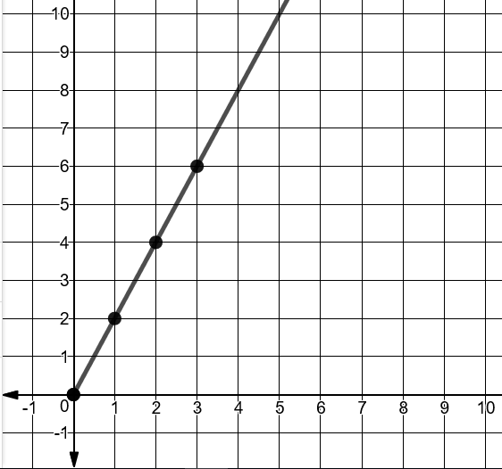 | x y  0 0  1 2  2 4  3 6
$$y =2x$$ | Martha can swim 12 yards in 6 seconds. Write an equation to represent the number of yards, y, Martha can swim in x seconds.

Additive Relationship 1
$$y =x +3$$ | 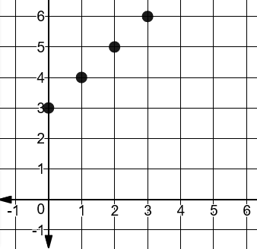
Sam is taking guitar lessons and will learn one new song per week. When he started, he already knew how to play 3 songs. Write an equation to model the relationship between the number of songs Sam knows how to play, y, and the number of weeks, x, he has been taking lessons. | x y  0 3  1 4  2 5  3 6

Additive Relationship 2
x y  4 0  5 1  6 2  7 3 | 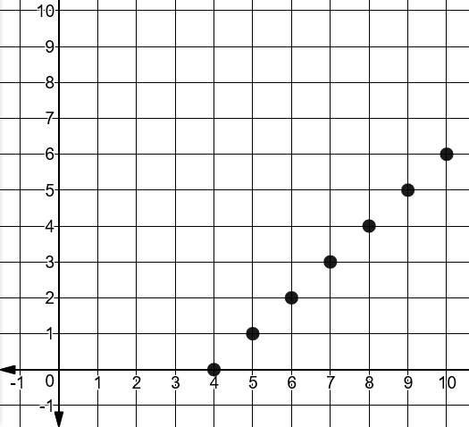
 | Every issue of Billy’s favorite comic book has 4 pages of ads. The remaining pages contain the story. Write an equation that relates the total number of pages in a comic book, x, and the number of story pages, y.
Additive Relationship 3
On each necklace Sarah makes, there are 5 more purple beads than silver beads. Write an equation to represent the relationship between the number of silver beads, x, and the number of purple beads, y. | 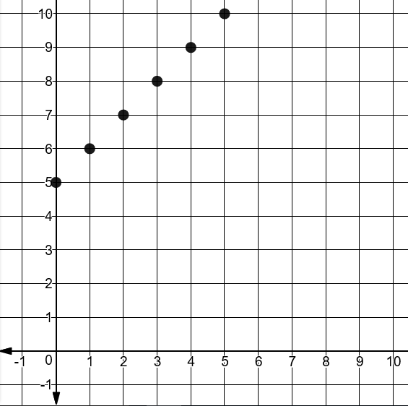
x | y
0 | 5
1 | 6
2 | 7

