Mathematics Instructional Plan – Grade 7

Discover y-intercept (b)
Strand: Patterns, Functions, and Algebra
Topic: Determine Slope
Primary SOL: 7.10 The student will
        - determine the y-intercept, b, in an additive relationship between two quantities and write an equation in the form$y =x+b$ to represent the relationship;
        - graph a line representing an additive relationship between two quantities given the y-intercept and an ordered pair, or given the equation in the form $y =x+b$, where b represents the y-intercept
Related SOL: 7.3; 7.10a, b

Materials
- Activity Work Pages 1–3 (attached)
- Computers
- Handheld graphing utilities or an online graphing calculator (optional)

Vocabulary
additive relationship, constant of proportionality, multiplicative relationship, proportional, relationship, unit rate (earlier grades)
constant ratio, rate of change, slope, slope triangle, y-intercept (7.10)

Student/Teacher Actions: What should students be doing? What should teachers be doing?
- Review with students information learned in SOL 6.12, SOL 7.10a, and 7.10b, with special attention to ratio tables, multiplicative relationships, equivalent ratios, and proportional relationships.
- Students will create tables using the situations that are given on the Activity Work 1 page and make graphs to represent the information. Discuss with students about how the information is additive in order to connect to SOL 6.12.
- Students should create an equation in the form $y =x+b$ that represents the information from the table and the graph. Students should understand that b represents the y-intercept. Reinforce with students that the coordinate point for the y-intercept should have an x-value of zero. For example, a y-intercept of 3 would be
(0, 3).
- The ratio of y to x should be defined as 1 in the given situations in order to connect to the previously taught SOL 7.10a and 7.10b.
- Students should continue with Activity Work Pages 2–3.
- Teachers should have students practice how to determine the y-intercept and how to graph a line between two quantities by assigning:
Desmos SOL 7.10cd – Y-Intercept Investigation Student Activity

From the page, create a class code to distribute to students (visit the Desmos tutorial Class Activities to learn more about managing class activities).
Students should go to https://student.desmos.com/ and type in the class code to access the assignment.

Assessment

Questions
- What makes a relationship between y and x additive?
- How can you use a table of values to determine the graph of a line?
- How can you use the graph of a line to determine an equation of a line?

Journal/Writing Prompts
- Kris and Kenzie were given a table of values. Kenzie said the y-intercept was –2, Kris said the y-intercept was zero. Who is correct and why?
x | y
1 | –1
3 | 1
5 | 3
7 | 5

- Create a table of values with an additive relationship. Write the equation that matches the table of values.

Other
- Students can create their own situation and share it with another student to graph, put in a table, and make an equation that matches the practical situation.

Extensions and Connections (for all students)
- Students can enter in several $y =x+b$ equations on a graphing calculator or online graphing calculator in order to make connections to the y-intercept of a line and the value of b.

Strategies for Differentiation
- Allow students to work in pairs for all learning activities.
- Provide completed examples with guiding notation for students to use as a reference.

Note: The following pages are intended for classroom use for students as a visual aid to learning.

Virginia Department of Education © 2018

Activity Work 1
Name Date
- Jordyn’s big sister gives her a 10-yard head start before they start racing. If Jordyn can run 1 yard per second, make a table of values, graph, and an equation that represents how far Jordyn can go.
Time | Distance

y = x + ____

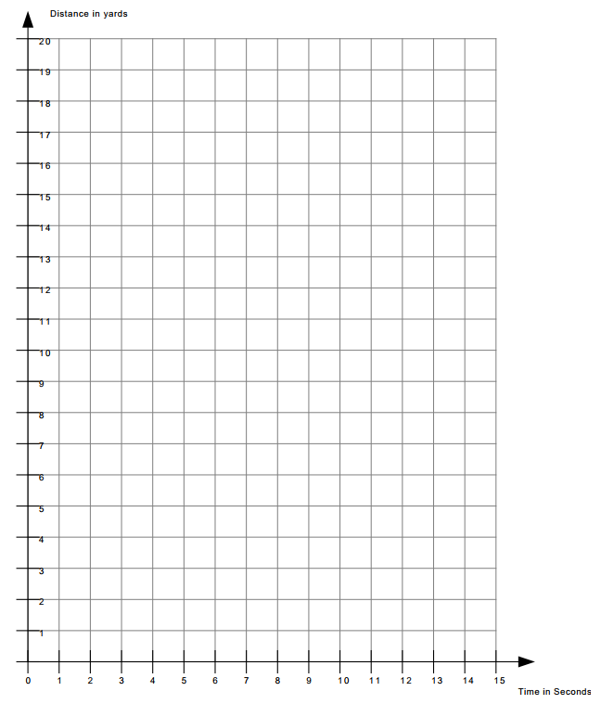

Activity Work 2
- A trampoline park charges Tyler $15.00 to enter the building and then $1.00 for each hour he plays. Make a table of values, graph, and an equation that represents how much it will cost Tyler over time.
y = x + ____
Hours | Cost
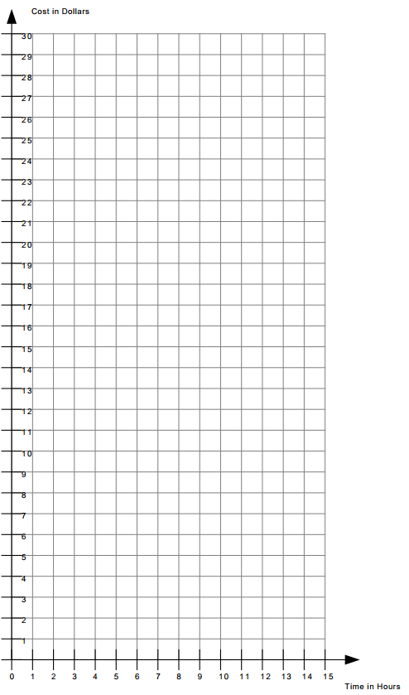

Activity Work 3
- A new ice cream shop only charges $3.00 for a cup of ice cream. They then charge you $1.00 for each topping you choose to add to the cup of ice cream. Make a table of values, graph, and an equation that represents how much it will cost for each additional topping.
y = x + ____
Topping | Cost
