Mathematics Instructional Plan – Grade 7

Discover Slope (m)

**Strand:** Patterns, Functions, and Algebra

**Topic:** Determine Slope

**Primary SOL:** 7.10 The student will

1. determine the slope, *m*, as rate of change in a proportional relationship between two quantities and write an equation in the form *y = mx* to represent the relationship;
2. graph a line representing a proportional relationship between two quantities given the slope and an ordered pair, or given the equation in y = mx form where m represents the slope as rate of change;

**Related SOL:** 7.3

# Materials

* Activity Work pages 1–3 (attached)
* Computers
* Handheld graphing utility or online graphing calculator (optional)

# Vocabulary

*additive relationship, constant of proportionality, multiplicative relationship, proportional, relationship, unit rate (earlier grades)*

*slope, rate of change, constant ratio, slope triangle, y-intercept (7.10)*

# Student/Teacher Actions: What should students be doing? What should teachers be doing?

1. Review with students information learned in SOL 6.12, with special attention to ratio tables, multiplicative relationships, equivalent ratios, and proportional relationships.
2. Students will create a ratio table that will connect to the given situation using the Activity Work Pages 1–3. Discuss with students about how the information is proportional in order to connect to SOL 7.3.
3. Students should graph the points on the graph provided to represent the points from the table.
4. Students should discuss the proportionality of the ratio tables. Discussions on the unit rate and the proportional relationship should be discussed in order to relate to prior knowledge from SOL 6.12. Students can use the double number line to further explore the slope.
5. The ratio of *y* to *x* should be defined as the slope. Students will need to understand the ratio of the vertical change to the horizontal change in the line is the same as the ratio found in the ratio table. That ratio should be defined as *m.*
6. Students should understand how the equation $y =mx$ can be used to describe the table and the line of the given values and create an equation that represents the given situation.
7. Students should continue with Activity Work Pages 2 and 3.
8. After completing the three activities, teachers and students should have a conversation of the different slopes of each of the graphs. A discussion on the steepness of the slopes and the value of *m* should be considered.
9. Have students practice how to determine slope and how to graph a line between two quantities by assigning:

[Desmos 7.10ab – Slope Investigation Student Activity](https://teacher.desmos.com/activitybuilder/custom/5943dc10f9604406139e429d)

From the page, create a class code to distribute to students (visit the Desmos [tutorial Class Activities](http://learn.desmos.com/activities) to learn more about managing class activities)

Students should go to <https://student.desmos.com/> and type in the class code that the teacher creates to access the assignment.

# Assessment

## Questions

* What makes ratios between *y* and *x* proportional?
* How can a proportional relationship be represented by a slope triangle?

## Journal/Writing Prompts

* Describe to a friend the different ways to represent $y =3x$ as a proportional relationship.
* Describe what $\frac{1}{2}$ means in $y = \frac{1}{2}x$.
* Why is the information in the given table proportional?

table - row 1 seconds; row 2 meters

## Other

* Students can create their own situation and share it with another student to graph, put in a table, and make an equation that matches the practical situation.

# Extensions and Connections (for all students)

* Students can enter in several $y =mx$ equations on a graphing calculator or an online graphing calculator in order to make connections to the slope of a line and the steepness of the line.

# Strategies for Differentiation

* Allow students to work with a partner or in small groups of 2–3 for all learning activities.
* Provide certain students with worked examples to use as a reference for independent practice activities.
* Preteach essential vocabulary to certain students before introducing the lesson.

**Note: The following pages are intended for classroom use for students as a visual aid to learning.**

Virginia Department of Education © 2018

**Activity Work 1**

**Name Date**

1. Taylor buys candy at the store that costs $1.50 per candy bar. Create a table that could represent Taylor’s cost per candy bar. Graph those points on the graph and create a rule that represents the relationship.

|  |  |
| --- | --- |
| Candy | Cost |
|  |  |
|  |  |
|  |  |
|  |  |

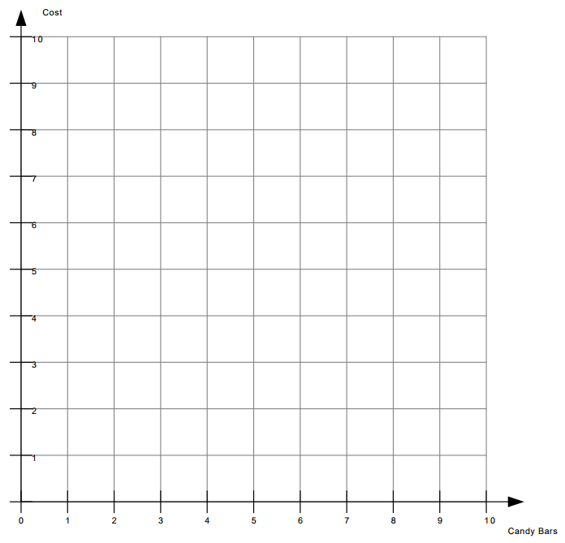

y = _____ x



Cost

0



Candy Bars

0

**Activity Work 2**

1. A maple tree seed is planted and the tree grows 2 feet per month. Create a table that could represent the tree’s height. Graph those points on the graph and create a rule that represents the relationship.

|  |  |
| --- | --- |
| Month | Height |
|  |  |
|  |  |
|  |  |
|  |  |

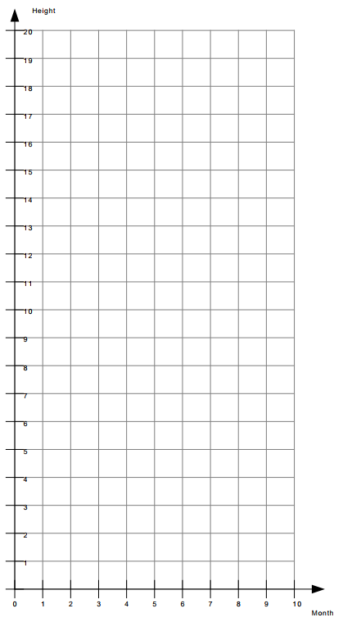

y = _____ x



Height

0



Month

0

**Activity Work 3**

1. A seahorse can move at a constant speed of 0.5 miles per hour. Create a table that could represent the distance a seahorse can travel over time. Graph those points on the graph and create a rule that represents the relationship.

|  |  |
| --- | --- |
| Time | Distance |
|  |  |
|  |  |
|  |  |
|  |  |

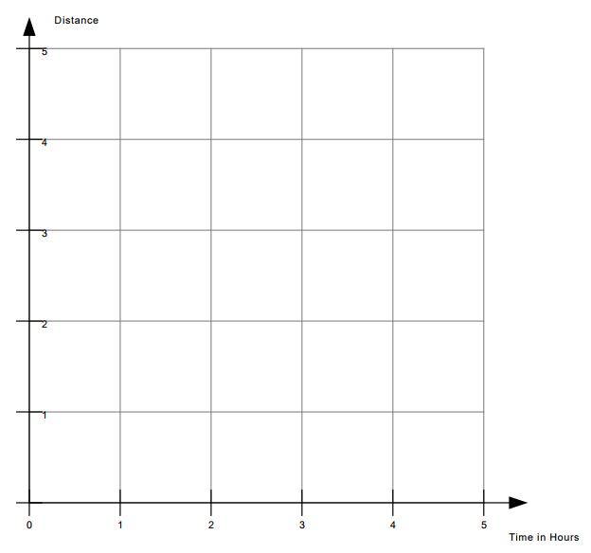

y = _____ x



Distance

0



Time in Hours

0