Mathematics Instructional Plan – Grade 7

Missing Measurements
Strand: Measurement and Geometry
Topic: Solve a proportion to determine the missing side length of similar quadrilaterals or triangles.
Primary SOL: 7.5 The student will solve problems, including practical problems, involving the relationship between corresponding sides and corresponding angles of similar quadrilaterals and triangles.
Related SOL: 7.3

Materials
- Trapezoid 1 Template (attached)
- Trapezoid 2 Template (attached)
- Missing Measurements: Part 1 activity sheet (attached)
- Missing Measurements: Part 2 activity sheet (attached)
- Missing Angle Measurements activity sheet (attached)
- Scissors
- Glue or tape

Vocabulary
congruence, congruent, polygon, proportion, quadrilateral, proportion, ratio, triangle (earlier grades)
corresponding, similar figures, similarity (7.5)

Student/Teacher Actions: What should students be doing? What should teachers be doing?
- Cut out and display the two similar trapezoids. The sides of the trapezoids are labeled with their measurements. Use this demonstration to introduce proportions and show how they relate to corresponding sides. Have students express the proportional relationships that exist for this set of trapezoids. Use this demonstration to introduce similar quadrilaterals.
- Distribute the Missing Measurements: Part 1 activity sheet, and have students identify the corresponding sides and corresponding angles. Using the corresponding sides, have students set up a proportion to solve for the unknown side length. Discuss with the students the various proportions that could be used for the example and the importance of corresponding sides.
- Distribute the Missing Measurements: Part 2 activity sheet. Have students identify the corresponding sides and set up a proportion to solve the real-world application problem.
- Distribute the Missing Angle Measurements activity sheet, and have students determine corresponding angles and corresponding sides. Allow the students to write the statement of similarity for the triangles. Review or introduce to students that the sum of the angles of a triangle are 180 degrees. Students should be able to use the information provided to find the unknown angle measures and the unknown side length.

Assessment

Questions
  - What makes two triangles/quadrilaterals similar?
  - When given two similar triangles/quadrilaterals with an unknown side length, is it important to determine the corresponding sides? Why, or why not?
  - How do the angles of similar triangles/quadrilaterals compare with the angles of congruent triangles/quadrilaterals?

Journal/writing prompts
  - Explain whether a figure can be similar with only one corresponding angle congruent.
  - Give a practical example of when you would use a proportion to find the unknown side length of a similar figure.

Other Assessments
  - Have students create two similar triangles or quadrilaterals and write a proportion for corresponding sides.
  - Have students create two similar triangles or quadrilaterals and determine corresponding angles.

Extensions and Connections (for all students)
- Have students find a practical application for finding the unknown side length or angle measures of similar quadrilaterals or triangles.

Strategies for Differentiation
- Color code corresponding sides and corresponding angles.
- Use a color-coded figure and shadow it with a similar figure of another color to assist in finding corresponding sides and angles.
- Have students work with a peer partner for at least steps 3–6.

Note: The following pages are intended for classroom use for students as a visual aid to learning.

Virginia Department of Education © 2018

Trapezoid 1 Template
10 m
4 m
2 m
6 m

Trapezoid 2 Template
5 m
2 m
1m
3 m

Missing Measurements: Part 1
Name Date
ABCD ~ HGFE. Create a proportion that could be used to determine the missing side length.
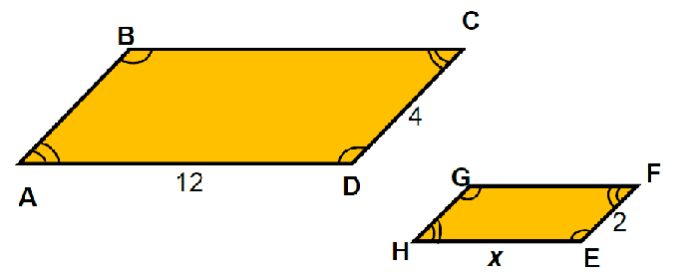
Directions:
- Identify the corresponding sides.
$\overline{AB}$ corresponds to _____; $\overline{BC}$corresponds to _____; $\overline{CD}$ corresponds to ____;
$\overline{DA }$ corresponds to _____
- Identify the corresponding angles.
∠A corresponds to ______; ∠B corresponds to ______; ∠C corresponds to ______;
∠D corresponds to _______.
- Select the values from the boxes below that could be used in the proportion to determine the value of x.
- Using scissors, cut out the values and paste them into the proportion.
- Show your work to solve the proportion.
- Find your solution from the values below, cut it out, and paste it in the solution box.

$$\frac{}{}=\frac{}{}$$
Solution:

2 | 12 | 24 | x | 6 | 4
Missing Measurements: Part 2
Name Date
A rehabilitation facility hired an architect to create a ramp for patients in wheelchairs. The facility requested that the ramp rise 10 centimeters for every 30 centimeters in horizontal length. The height of the platform is 180 centimeters. How much space will the architect need for the length of the ramp?
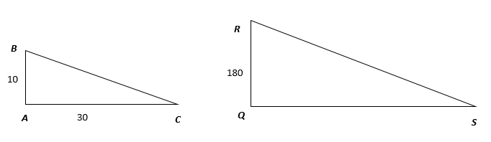

Directions:
- Select the values from the boxes below that could be used in the proportion to determine the length of the ramp.
- Using scissors, please cut out the values and paste them into the proportion.
- Show your work to solve the proportion.
- Find your solution from the values below, cut it out, and paste it in the solution box.

$$\frac{}{}=\frac{}{}$$

Solution:

540 | x | 30 | 60 | 180 | 10

Missing Angle Measures
Name Date
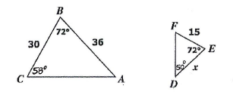

Given , answer the following questions:
- ∠A corresponds to _____

- ∠B corresponds to _____

- ∠C corresponds to _____

- $\overline{AB}$ corresponds to ______

- $\overline{BC}$ corresponds to ______

- $\overline{CA}$ corresponds to ______

- What is the measure of ∠A? ____

- What is the measure of ∠F? ____

- What is the value of x?

