Mathematics Instructional Plan – Grade 6

Solving One-Step Inequalities Involving Addition and Subtraction
Strand: Patterns, Functions, and Algebra
Topic: Solve a one-step linear inequality in one variable, involving addition or subtraction, and graph the solution on a number line.
Primary SOL: 6.14 The student will
- solve one-step linear inequalities in one variable, involving addition or subtraction, and graph the solution on a number line.
Related SOL: 6.13, 6.14a

Materials
- Solving Inequalities activity sheet (attached)
- Index cards (four for each student)

Vocabulary
associative properties, commutative properties, distributive property, identity properties (earlier grades)
inverse properties, linear equation, linear inequality, , multiplicative property of zero, substitution property, variable properties of equality (6.13, 6.14)
Student/Teacher Actions: What should students be doing? What should teachers be doing?
Before beginning this lesson, students should have had experience with solving one-step equations. They also should have used the properties (e.g., equality, substitution, inverse) to ensure that they have used the correct steps to solve the equations. Also, students should have experience with graphing inequalities and writing inequalities from practical situations.
- Give students the following equation: x + (-3) = 6. Ask students how they would solve it. Students should recognize that it can be solved by adding a 3 to both sides of the equation to keep it balanced. Students can use algebra tiles, counters, and balancing scales to help them remember. Ask, “What properties could be used when solving this equation?” They should be able to apply the additive inverse property and the addition property of equality. Have students graph their answer on a number line. It should look like this:
- After graphing the solution, ask students what the dot represents. They should recognize that the dot represents that 9 is the solution to the problem. After they have explained this, ask them to try solving the following problem: x + (-3) < 6. Using the previous problem as an example, they should recognize that they can use the additive inverse and the addition property of inequality to add three to both sides and end up with x < 9. Some students might write this as x = 9. You will want to ask them if the problem shows an equality or inequality. Because the original problem had an inequality, then the solution should have an inequality as well.
- Ask students to give you some possible integer solutions to the problem. As students give you correct responses, place them on a number line. For example:
- Once you have placed several correct examples, ask them whether 9 is a possible solution. There answer should be no. Ask them what type of circle can they use to show nine as a boundary number but not as part of the solution. They should remember from a previous example that it should be an open circle. Add that to the graph like this:
- Ask students what you need to do when graphing inequalities. They should remember that you need to shade toward the side of the possible solutions and add an arrow. Their final graph should look like this:

- Ask students whether there is another way that they could write the solution (x < 9) with a greater than symbol. They should come up with 9 > x. Ask them whether the graph represents that inequality as well. Have them explain their reasoning. They need to understand that x in both situations represents any value that is less than 9.
- Have students write down possible solutions for x < 9 and check to see whether their answers are correct by using the substitution property. For example, if they say that 8 is a possible solution, rewrite the inequality x + (-3) < 9 and substitute 8 for x. Rewrite it as 8 + (-3) < 9, solve it, and see whether the statement is true. In this case, 5 is less than 9, so 8 is a correct solution. Accept a variety of responses from the students and try each of them in the same manner.
- Once students have demonstrated an understanding of how to solve addition and subtraction inequalities, pass out four index cards to each student. On one index card, have students write an addition or subtraction inequality using integers. In order to ensure that you have a variety of problem types, you can put a template on one of the four index cards that you give each student (e.g., -___ + x < ___, x – (-____) > -5). You will want to include a variety of orders for the inequalities (e.g., x +3 < 6, 3 + x < 6, 6 > x+3, 6 > 3+x). You should never use a constant minus a variable because that would become a two-step inequality due to the need to divide by –1 in order to fully solve for the variable (e.g., 6-x < 8). On one of the other three index cards, have students write the solution inequality one way. On the third one, have them write it in a different way. On the last index card, have students graph the solution to the inequality. Here is an example:
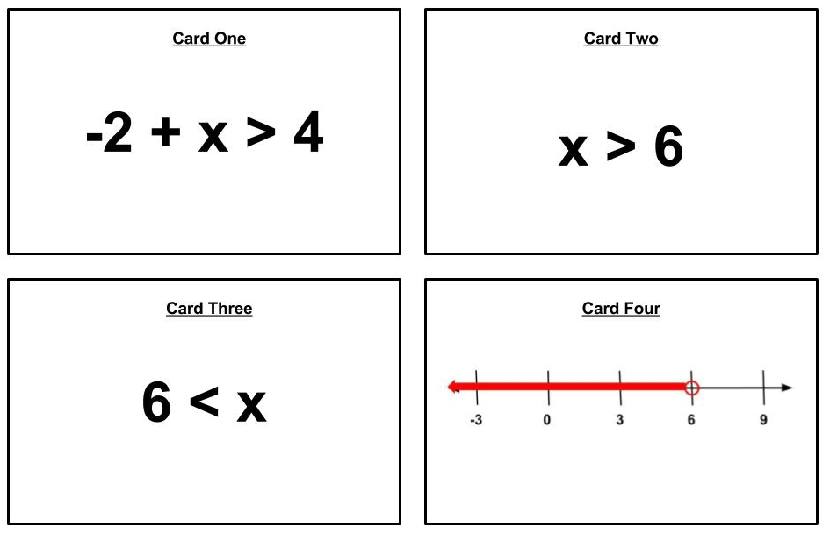
- Have students show their cards to a partner to check for accuracy, if they think they are correct, then you should check them. Once students have correctly completed the cards, collect them. If students finish theirs early and have extra time, they can make more than one set.
- Once all of the students have correctly completed their four cards, put students into groups of three to four. Give each group a set of cards for each number in the group but do not give them their own (e.g., if there are three people in the group, they get three sets of cards). Before giving them the sets of cards, mix up the three sets. You do not want to do this ahead of time because all four cards in the set need to be in that group’s pile.
- Have the students work together to match the inequality, solutions, and graphs together. Once the group has done this successfully, give them the Solving Inequalities activity sheet to do individually.

Assessment

Questions
  - How can you determine whether a solution is true for an inequality?
  - What is the additive inverse property?
  - What are the subtraction and addition properties of inequality?
  - What is the substitution property?
  - How could you solve a one-step addition or subtraction inequality?

Journal/writing prompts
  - Explain why a solution to an inequality can be written as x < 6 and 6 > x.
  - Explain to a new student how they would solve the problem -6 + x > -10 using the additive inverse or addition property of inequality.
  - Students need to ensure that their solution satisfies the given inequality; therefore, explain how they can check their answer with the substitution property.

Other Assessments
  - Present students with one-step addition and subtraction inequality problems and have them solve the problems using whiteboards.
  - Create a game of War out of the cards the students make.
    - In order to play, students need to distribute the cards evenly among two people and place their stack in front of them facedown. Each player flips the top card over. The player with the greatest value wins that round and collects the cards. Once all cards are played, the student with the most cards wins.
    - Because the cards are inequalities, the smallest possible integer solution would be the number that they use for War (e.g., 6 > x would have the smallest possible integer solution of 5, and 6 > x would have the smallest possible integer solution of 6. This means that 6 > x would win.)
  - Make a quizlike game on an online platform (e.g., Kahoot!, Quizizz) from example problems.

Extensions and Connections
- Give students inequalities, such as x < 6, and have them create one-step addition and subtraction inequality problems for them.
- Have students create a maze using one-step addition and subtraction inequality problems where their answers guide them through it correctly.
- Have students create a video or slide show teaching another student how to solve one-step addition and subtraction inequalities.
- Have students create and solve a one-step inequality using addition or subtraction to represent a practical situation.

Strategies for Differentiation
- Provide templates on all four index cards.
- Provide an inequality for students to solve and have the students make the other three cards based on that solution.
- Have students create a dictionary using a graphic organizer of the properties and the symbols to use.
- Only give one card at a time labeled for students to use when making the matching activity.
- Have students work only in pairs.
- Provide a number line for students to use.
- Use mathematics blocks to demonstrate the balance.
- Have students use one card and divide it into four parts and put all four requirements on one card. Or, divide the card into two sections on back and front and put the four requirements. Have students quiz each other to determine the two different requirements that are not seen.

Note: The following pages are intended for classroom use for students as a visual aid to learning.

Virginia Department of Education © 2018

Solving Inequalities
Name: _____________________________
Directions: Find the solution to the given inequality and answer the questions that follow.
- $x-\left(-2\right)>-1$
  - Write the solution using the following format (x, inequality symbol, number):
  - Write the solution using the following format (number, inequality symbol, x):
  - Graph the solution on the number line:
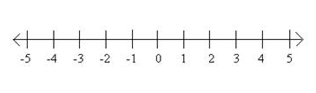
  - Provide one numerical value that would be a part of the solution set.

- $-2+x ≤3$
  - Write the solution using the following format (x, inequality symbol, number):
  - Write the solution using the following format (number, inequality symbol, x):
  - Graph the solution on the number line:
  - Provide one numerical value that would be a part of the solution set.

- Why do you shade the number line when solving an inequality problem but you do not when solving an equation?

