Mathematics Instructional Plan – Grade 6

Side to Side
Strand: Geometry
Topic: Determining congruence of geometric figures
Primary SOL: 6.9 The student will determine congruence of segments, angles, and polygons.

Materials
- Hexagon Cut-out (attached)
- Congruent/Noncongruent Organizer (attached)
- Congruent and Noncongruent Geometric Figures (line segments, angles, and polygons) for display (attached)
- Congruence activity sheet (attached)
- Rulers
- Protractors
- Glue
- Dot paper
- Scissors

Vocabulary
angles, line segment, polygon (earlier grades)
congruent, lines of symmetry, regular polygons (6.9)

Student/Teacher Actions: What should students be doing? What should teachers be doing?
- Begin class with a discussion of regular polygons and their properties. Distribute the Hexagon cut-out. Have students cut the figure out and lead a discussion regarding lines of symmetry. Have students fold the figure various ways, ensuring that each fold creates a figure of the same shape and size. Lines of symmetry are not limited to horizontal and vertical lines.
- Display a chart with two columns, one labeled “Congruent” and the other labeled “Noncongruent,” like the Congruent/Noncongruent Organizer. Begin a discussion about congruent geometric figures, showing students various pairs of line segments, angles, and polygons. Have students cut out and glue pairs of Congruent/Noncongruent geometric figures in the correct columns on the chart. Ask students to look closely at the pairs of figures placed in each category and think about what they notice. In the discussion, ensure that students are familiar with geometric markings that indicate congruency and properties of polygons or angles that will indicate congruency.
- Ask students to create a class definition of the term congruent, based on the examples shown. Ensure that all students understand the concept of congruence and that the concept includes the understanding that a line of symmetry creates two figures of the same shape and size. Then, ask students to explain what noncongruent means. List student responses on the board and discuss.
- Explain to students that they will compare geometric figures and determine whether they are congruent. Group students into pairs, and have pairs create and write down a procedure for determining whether pairs of segments, angles, and polygons are congruent. Encourage them to be creative and specific with their methods. They do not need to test their theories at this time but only put them in writing. Allow students to share the methods they created.
- Distribute the Congruence handout, and instruct students to experiment with their chosen method to determine whether it is effective. (Note: At this point, do not discourage any methods.) Provide students with any materials they may need to test their methods (e.g., rulers, protractors, tracing paper, dot paper).
- Have students state in writing whether their methods worked and explain why they think they worked or did not work.
- Allow pairs of students who found effective methods to explain and demonstrate the methods to the class. At this point, share how to determine the congruence of two polygons by comparing the measures of their sides and angles, if this method has not yet been presented. Make this one of the required methods to use when revising work.
- Have students revise their handouts, if necessary, using one or more of the methods determined to be effective. Have them also complete any problems on the handout that have not yet been completed.

Assessment

Questions
- What method did you decide to use to determine congruence? How did you decide to use that method? Did it work? Why, or why not?
- Can you tell just by looking at two figures whether they are congruent? Why, or why not?
- How do you know when two figures are congruent?
- How do you know when two figures are noncongruent?

Journal/Writing Prompts
- Explain congruence and how you can determine the congruence of any two geometric figures. Include examples.
- Are all regular pentagons congruent? Explain how you know.

Other
- Alphabet Activity: Using all of the letters of the alphabet, name which letters have two lines of symmetry. Prove it.
- Give students various shapes, angles, and lines, and have students cut and paste into a chart labeled congruent and noncongruent.
- Have students find real-world examples in picture form of things that are congruent.

Extensions and Connections (for all students)
- Have students locate congruent geometric figures throughout the classroom.
- Create index cards with different pairs of geometric figures. Have students sort the pairs into “Congruent” and “Noncongruent” categories.
- Have students identify congruent shapes found throughout their homes.
- Invite a landscaper or a contractor to the class to speak about the importance of congruence in his/her job.

Strategies for Differentiation
- Allow students to use patty paper to trace polygons, angles, and segments to determine congruence.
- Review earlier vocabulary and preteach essential vocabulary as needed before instruction.
- Allow students to respond to step 6 orally rather than in writing.
- Provide additional similarly completed examples for each activity on the attached sheets as necessary for some students.

Note: The following pages are intended for classroom use for students as a visual aid to learning.

Virginia Department of Education © 2018

Hexagon Cut-out
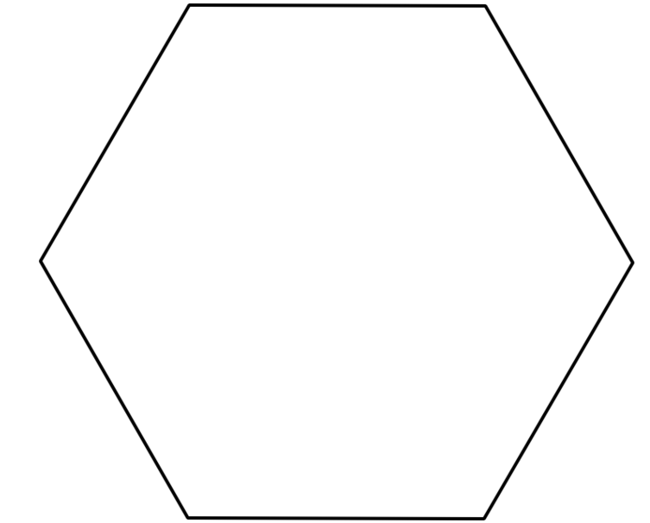

Congruent/Noncongruent Organizer
Congruent Noncongruent

Congruent and Noncongruent Geometric Figures
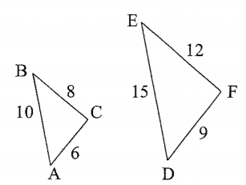 | 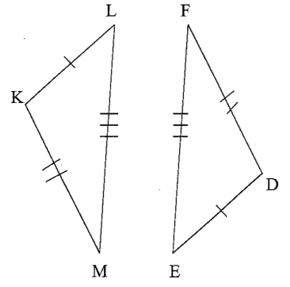
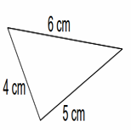 | 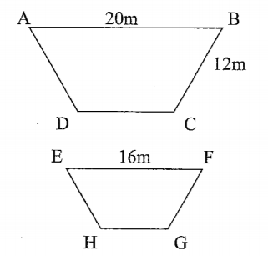
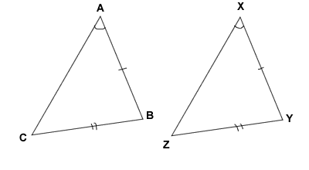 | 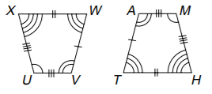

Congruence
Name Date
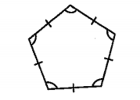
- Decide whether each set of figures are regular polygons. Answer yes for regular polygons and no if they are not regular polygons. Also, name the polygon.
1. _________________

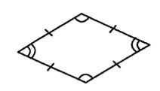

2. _________________

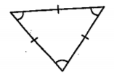

3. ________________

- Draw lines of symmetry to divide the following two figures into two congruent parts. Lines of symmetry are not limited to horizontal and vertical lines.
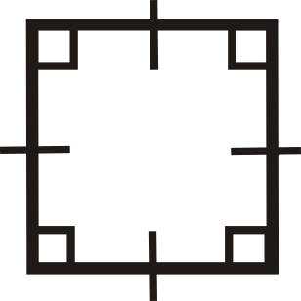
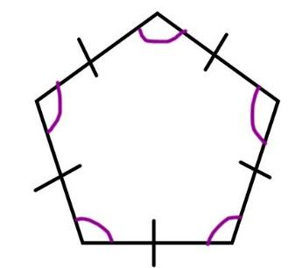

- 2.

- Determine whether each pair of line segments is congruent or noncongruent. Write your answer in the space provided, and explain the method you used to determine congruence.

1. __________________

2. __________________

3. __________________

4. __________________

5. __________________
- Determine whether each pair of angles is congruent or noncongruent. Write your answer in the space provided, and explain the method you used to determine congruence.

1. __________________

2. __________________

3. __________________

- Determine whether each pair of polygons is congruent or noncongruent. Write your answer in the space provided, and explain the method you used to determine congruence.

1. __________________

2. __________________

3. __________________

4. __________________

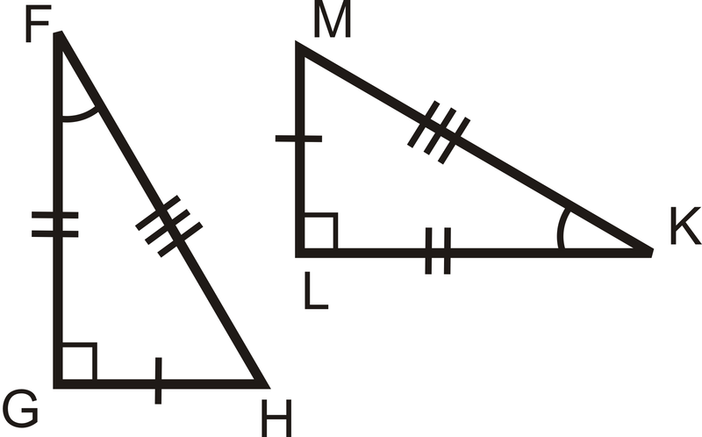
5. _________________

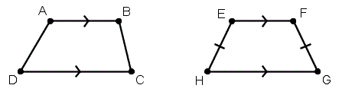
6. _________________

