Mathematics Instructional Plan – Grade 6

Practical Problems Involving
Area and Perimeter
Strand: Measurement
Topic: Solving practical problems involving the area and perimeter of rectangles and triangles
Primary SOL: 6.7 The student will
- solve problems, including practical problems, involving area and perimeter of triangles and rectangles.
Related SOL: 5.8a, 5.8b

Materials:
- Dot paper
- Bob the Builder Activity Sheet

Vocabulary:
area, length, perimeter, square feet, square units, unit, width (earlier grades)

Student/Teacher Actions: What should students be doing? What should teachers be doing?
- Distribute dot paper. As a review, facilitate a discussion regarding how the formulas for area and perimeter are derived.
- Have the students draw both figures on their dot paper.
Figure 1 Figure 2
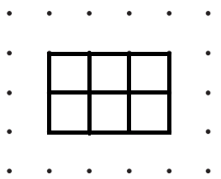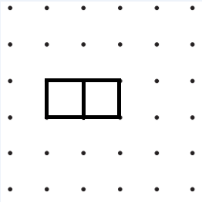
- Ask: “What do you notice about the units in each figure?” “What do you notice about the dimensions?” “What is the area of each figure?” “Can you justify the area by using the pictures?” “Can you justify your thinking using the formula?” Ensure that students are including square units in their discussion and that students can summarize $A=lw$.
- Ask students to determine the perimeter of each figure. Ask, “How does the perimeter relate to the dimensions of the rectangle?” Ensure that students can summarize
$P=2l + 2w$ or $P= 2(l + w).$
- Ask students to draw a diagonal across both figures. What is the resulting figure? How can a person find the area of the triangle? How is this different from the area of a rectangle? What is the relationship between the area of a triangle and the area of a rectangle? Continue the discussion until students see that the area of a triangle is half the product of base and the height, or $=\frac{1}{2}bh$ . Have students draw an additional triangle (without a right angle), and have them calculate the area after identifying the base and height.
- Review how to find the perimeter of the triangle $(P=a + b +c).$
- Read the following to the students:
Bob is a general contractor and needs help deciding on various measurements to complete his latest home improvement project for a client. With your partner, perform the necessary calculations to help him finish his job.
- Distribute the Bob the Builder Activity Sheet. Have students work through each problem with a partner and record their findings in their notebooks.

Assessment

Questions
  - What is the difference between the area of a figure and its perimeter?
  - What is the relationship between the area of a triangle and the area of a rectangle?

Journal/writing prompts
  - Describe in your own words how you can find the area and perimeter of a rectangle and triangle.
  - Describe the similarities between area and perimeter.
  - How are the areas of a triangle and rectangle related?

Other Assessments
  - Write a problem with a practical application for finding area or perimeter and trade with another student to solve.
  - Give students rulers and have them find the perimeter and area of figures around the room.
  - Create an exit ticket that includes one perimeter and one area question for a rectangle and triangle.

Extensions and Connections
- Have students create more Bob the Builder scenarios.
- Create a budget for Bob, and have students determine whether his project is within budget.

Strategies for Differentiation
- Use grid paper to allow students to see the units in the area and perimeter of the figures.
- Give the area of a rectangle and ask students to determine the possible perimeters.
- Give the perimeter of a rectangle and ask students to determine the possible areas.
- Preteach important vocabulary for certain students before the lesson.
- Provide worked examples for certain students to use during the lesson.
- Give fewer problems as necessary for certain students to solve.
- Have students work with a partner before step 8 for all learning activities.

Note: The following pages are intended for classroom use for students as a visual aid to learning.

Virginia Department of Education © 2018

Bob the Builder Activity Sheet
- The kitchen is 20 feet long and 10 feet wide. How many square feet of flooring does Bob need to buy?

- The client wants the four kitchen windows to be framed with a special molding. If the windows are 22 inches by 24 inches, how many total inches of molding are needed for the kitchen windows?

- The homeowner is replacing the laminate countertops with granite. Bob purchased a slab of granite that is 18 square feet. If the slab is 6 feet long, how wide is it?

- Bob wants to place a triangular flower garden in the front of the house to increase curb appeal. What could be the dimensions of the garden if he has a space of 12 square feet to work with?

- The longest side of the triangular flower garden discussed in question 4 will be against the house. Bob wants to place decorative bricks around the other two sides of the garden. How many feet of brick does he need to purchase?

