Mathematics Instructional Plan – Grade 6

Identifying and Representing
Proportional Relationships
Strand: Patterns, Functions, and Algebra
Topic: Determining whether a proportional relationship exists between two quantities and making connections between and among representations of a proportional relationship
Representing proportional relationships, including practical situations, determining unit rates, and determining missing values in a ratio table
Primary SOL: 6.12 The student will
- Determine whether a proportional relationship exists between two quantities; and,
- make connections between and among representations of proportional relationships between two quantities using verbal descriptions, ratio tables, and graphs.
Related SOL: 6.1

Materials
- Linking cubes
- Graph paper
- Comparing Proportional vs. Nonproportional Relationships activity sheet (attached)

Vocabulary
additive relationship, multiplicative relationship, proportion, proportional relationship, ratio, ratio table, unit rate (6.12)

Student/Teacher Actions: What should students be doing? What should teachers be doing?
- Use the Comparing Proportional vs. Nonproportional Relationships activity sheet to compare proportional relationships (multiplicative vs. additive). This activity is used as a means to:
- Discuss the differences between multiplicative relationships and additive relationships.
- Determine the characteristics of multiplicative relationships and additive relationships.
- Determine connections between and among representations of proportional relationships.
- Explore linear graphs and proportional relationships, both of which are tools to have students further their understanding of what proportionality is (and is not), as well as increasing their ability to make predictions and comparisons using proportional reasoning.
- While facilitating and modeling the discussion, take the time for partners or small groups to engage in student-student talk regarding each question. Discuss how the linking cubes can be used to represent the additive nature of the ratios within a nonproportional relationship, and that additive relationships are a concept discussed in grade 7. Here are some examples of linking cube models:

Jerome’s Earnings Tori’s Earnings
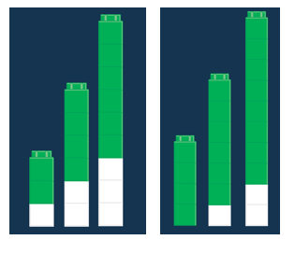

Assessment

Questions
  - What is a multiplicative relationship? Explain your reasoning and provide an example.
  - What is an additive relationship? Explain your reasoning and provide an example.

Journal/writing prompts
  - What is the difference between a multiplicative and an additive relationship? Explain your reasoning.
  - Explain how a graph representing a proportional relationship differs from one representing a nonproportional relationship.

Other Assessments (include informal assessment ideas)
  - Allow students to create at least two of their own examples of multiplicative and additive relationships. Then, share their examples with the class.
  - Ask students to create a graph illustrating one of their relationships.

Extensions and Connections (for all students)
- After completing the Comparing Proportional vs. Nonproportional Relationships activity sheet, allow students to create two graphs: one that displays a proportional relationship and another that displays a nonproportional relationship.
- Using their created graphs of the proportional relationship, have students create connections by developing a double-number line to demonstrate the same values.

Strategies for Differentiation
- Create a Venn diagram to compare and contrast proportional and nonproportional relationships.
- Use color differentiation to denote changes in graphical representations.
- Ensure that each small group is comprised of students with varying ability, and that each student has a meaningful role within the group.
- Preteach essential vocabulary to certain students, as needed, before the lesson is introduced.
- Allow pairs of students to collaboratively complete the Comparing Proportional vs. Nonproportional Relationships activity sheet.

Note: The following pages are intended for classroom use for students as a visual aid to learning.

Virginia Department of Education © 2018

Comparing Proportional vs. Nonproportional Relationships
Jerome wants to start saving money. He has no money in his bank account. He will save $2 per week. Tori has saved $4 in her bank account. She will also save $2 per week. The graphs below represent the amount of money each will save per week.
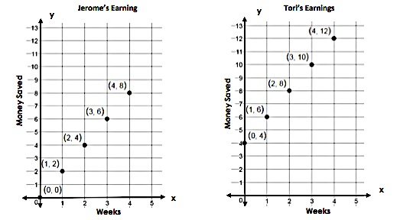

- Use the points on the graph to fill in the ratio tables.
Jerome Tori
Week | Money Saved
Week | Money Saved

- Use linking cubes and draw a picture to show the ratio pairs (money saved per week) for both Jerome and Tori.

- Explain the relationship between money saved and number of weeks on week zero for Jerome and Tori.

- Select two of the non-zero $\frac{Money Saved}{Week}$ ratios within Jerome’s table and within Tori’s table to determine which situation is proportional.

- What makes a ratio table or graph appear to be proportional or nonproportional? Explain your reasoning.

Which graph shows a proportional relationship? Explain your thinking.

What is the unit rate of the proportion? How does your linking cubes model show this?
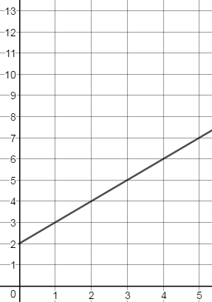
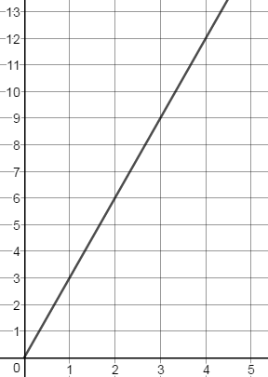
Graph A Graph B

Y
Y

X
X

- Create a ratio table for Graph A and Graph B.

- Which graph/ratio table above represents a proportional relationship? How is it similar to Jerome’s or Tori’s graph/ratio table?

- Which graph/ratio table above represents a nonproportional relationship? How is it similar to either Jerome’s or Tori’s graph/ratio table?

- Explain how you would determine whether a graph/ratio table represents a proportional or nonproportional relationship.

- Create a scenario for Graph A that describes the relationship occurring in the graph.

- Create a scenario for Graph B that describes the relationship occurring in the graph.

