Mathematics Instructional Plan - Grade 6
May I Have Fries with That?
Strand: Probability and Statistics
Topic: Constructing and using circle graphs
Primary SOL: 6.10 The student, given a practical situation, will
- represent data in a circle graph;
- make observations and inferences about data represented in a circle graph; and
- compare circle graphs with the same data represented in bar graphs, pictographs, and line plots.

Materials
- May I Have Fries With That graphic organizer (attached)
- Straight edge
- Colored pencils or markers

Vocabulary
bar graphs, line plots, stem-and-leaf plots (earlier grades)
ratio, percentage, percent, circle graphs (6.10)
Student/Teacher Actions: What should students be doing? What should teachers be doing?
- Ask students to name their five favorite fast-food chains, and write their responses on the board. Have the students write their top choice on a scrap sheet of paper. Collect the papers.
- Review what students learned about graphs in previous grades, as follows:
- Grade 2 and 3 (SOL 2.15 and 3.15):
  - Pictograph: pictures or symbols are used to represent one or more data points; used to collect, organize, and represent data; and to read and interpret data. Example included:
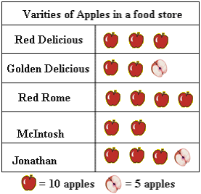
  - Bar graph: used to collect, organize, and represent data; and to read and interpret data
- Grade 4 (SOL 4.14):
  - Bar Graphs: used to collect, organize, and represent data; and interpret data
  - Line Graphs: used to collect, organize, and represent data; and interpret data
  - Comparing graphs with same data (charts to bar graphs, charts to line graphs, or pictographs to bar graphs)
- Grade 5 (SOL 5.16):
- Line plots: used to represent and interpret data; focuses on frequency of data on a number line; can show the spread of data to quickly identify range and mode (SOL 5.16)
- Stem-and-leaf plot: used to represent and interpret data; uses columns to display a summary of the numerical data points but maintaining individual data point integrity; shows the shape and distribution of data
- Understanding that data can be categorical or numerical
- Understanding that different situations call for different types of graphs
- Comparing graphs with same data to show that different representations display different aspects of same data
- During a discussion of the definitions and multiple uses of these four types of graphs (circle graph, bar graph, pictograph, and line plot graph), have students describe different types of data sets, and ask them which of the four types of graphs would be best to represent each type of data set. Provide several types of data sets (e.g., the numerical spread of data across a data set, temperature over time, amount of snow accumulated in specific months, the middle number of a data set, the number that appears the most), and have students individually determine the type of graph that would be best to represent each data set.
- While students are working, tally the number of students selecting each category of fast-food chain. Create a chart to display the top five categories of the fast-food chains selected by the students and the number of students who chose each category. Make sure the data follows the parameters of the standard (a denominator of 12 or less or factors of 100). If the class does not meet this criteria, the teacher might consider adding themselves in as a data point if it is 19 and the teacher adds one more, or have them partner up to make a guess for a pair to make the number smaller. For example, if it is a class of 24, then add the teacher’s vote to make it 25; or, if it is a class of 23, put them in partners to have an even 11 or 12 (teachers can partner with a student).
- Discuss with students how they can take the number of students in each category that chose a specific fast-food category and create the percent using the total count in order to make sure students are converting from the total count to the percents. As a class, convert the numbers of student choices to percents.
- Here is an example of a class of 20 students. Nine might choose a popular hamburger place, two might choose a popular sub shop, one might choose another hamburger place, three might choose a popular taco place, and five might choose a popular pizza place, as shown below.
Fast-food Category | Number of  Students Choosing | Percent of  Students Choosing
Popular Hamburger Place | 9 | 45%
Popular Sub Shop | 2 | 10%
Another Hamburger Place | 1 | 5%
Popular Taco Place | 3 | 15%
Popular Pizza Place | 5 | 25%
- Introduce the circle graph as the type of graph used to display data showing the relationship of parts to a whole. Draw circles on the board, and show different examples of percents of the circles. Make sure to include one that will be a good example for their students to use (e.g., if there are going to be 20 students in the class, include a circle broken into tenths). Here are some examples below:
25%
50%
12.5%
$\frac{1}{8}$
33.3%
16.6%
$\frac{1}{6}$
33.3%

This will assist students in developing skills in drawing conclusions and making predictions based on data presented in circle graphs. In addition, students will be able to determine the amount of data necessary to cover specific areas of the circle. When presenting the values in each section of the circles, use fraction, decimal, and percent notations. Make sure that students know that the total of the various percents in each circle must be 100 percent, and why.
- Have students compare the data from the circle graphs to the following other graphs:
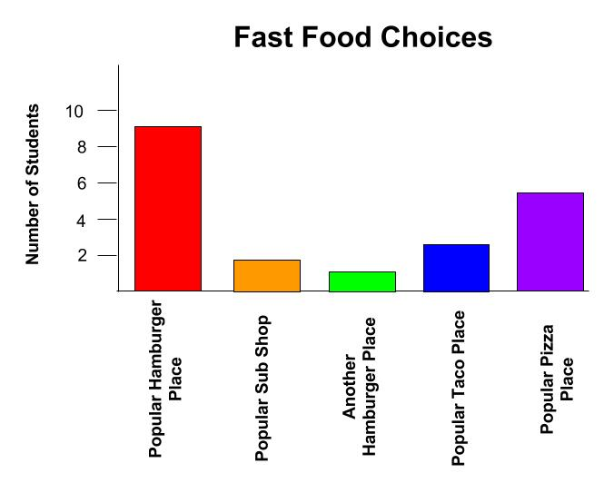
- Distribute Circle Graph Templates for the common denominators and factors of 100, colored pencils or markers, and the May I Have Fries With That graphic organizer. Display the chart created in step 4, and have students fill in the class data collected about fast-food categories. (The teacher should not give them the percents or total counts. Students need to be able to do this conversion).
- Next, have students construct the circle graph by choosing the circle template that matches their data. Then, have them show the various percents by color-coding the appropriate number of sections for each category and filling in the corresponding percent. Finally, have them list the names of the fast-food categories in the spaces provided and use the boxes to create a color key for each category.
- Ask students what components a graph needs to accurately describe the graph (e.g., title, scale, key).
- Ask students to make inferences and observations from their class circle graph. They might infer about reasons for a fast-food place being the most common/least common place to eat, where a student from the class would most likely eat when they went out to eat, class’ favorite type of food, etc.
- Give students examples of the same data in a bar graph, pictograph, and line plot graph. Have them compare the class data to the displayed data on the other three graphs. The data should be the same as theirs, so the teacher will want to create these with the students or while the students are working.
- Discuss with students how they can take the percents for each category and the total number of surveyed to find the number for each category (e.g., 25 percent of students chose fast-food pizza, 15 percent chose fast-food burgers, 50 percent chose fast-food chicken, and 10 percent chose the sub shop. If 40 students were surveyed, how many chose fast-food pizza, fast-food burgers, fast-food chicken, and sub shop?) Do an example with the students.
- Have students check the numbers per category for the class’s circle graph by using the total number of students surveyed and the percents placed for each category.

Assessment
  - Questions
- Why must the percents in a circle graph total 100?
- What types of data would be best represented in a circle graph?
- How can you find the value for each category if you are given the percents and the total number of values for a circle graph?
- How does a circle graph compare to other graphs?
  - Journal/Writing Prompts
- Explain why there is a need for different types of graphs to represent different data sets.
- Describe whether there are different types of graphs that provide similar types of information.
  - Other Assessments
- Post a data set, and have students construct a circle graph of it individually.
- Give students a circle graph with percents and total values and have them figure out the value for each category.
- Give students two different types of graphs with the same data and have students compare the information in the graphs and determine which graph was the better display.

Extensions and Connections
- Provide students with data represented in a selected type of graph, and have them construct a circle graph to present the information from the same data set.
- Present data sets represented by all the types of graphs. Have students develop questions that could be answered about the data by using each graphical representation.

Strategies for Differentiation
- Starting with a circle divided into four quadrants, show students how to move the lines dividing the quadrants to accommodate different data sets.
- Use all fractions, decimals, or percents in circle graphs to further student understanding of the data.
- Have students work with a partner or in small groups of two or three for all learning activities, beginning with step 3.
- Permit students to respond orally to one of the journal/writing prompts.

May I Have Fries With That?
Name Date

Fast-food Category | Number of Students Choosing | Percent of Students Choosing

Fast-food Category Circle Graph Key

Which fast-food category is the most popular with our class?

Which fast-food category is the least favorite with our class?

How did you use the number of students choosing each category and the total number of students in the class to determine the percent for each category? If you were only given the percents, how could you have determined the total count for each section?

Explain how the sizes of the sections of the circle depict the data.

Circle Graph Templates

