Mathematics Instructional Plan – Grade 6

# Modeling Multiplication of Fractions

**Strand:** Computation and Estimation

**Topic:** Modeling multiplication of fractions

**Primary SOL:** 6.5 The student will

1. multiply and divide fractions and mixed numbers*

## Materials

* Fraction Manipulatives
* Paper
* Writing utensils

## Vocabulary

division, equivalent (earlier grades), fraction, multiplication, rectangle

## Student/Teacher Actions: What should students be doing? What should teachers be doing?

*“Models can help students clarify ideas that are often confusing in a purely symbolic mode.”*

— Van de Walle, Lovin

Modeling is an imperative first step in building a long-term retention of the concepts and the connected procedures associated with the multiplication and division of fractions. Teachers are encouraged to scaffold instruction on the multiplication and division of fractions by reviewing the concept of multiplication and division with students. For multiplication, remind students that when developing the concept of 3 x 4 in earlier grades, the words “3 groups of 4” were used to describe the symbolic relationship. For division, $\frac{12}{3}$ symbolically represents the question, “How many groups of 3 are in 12?” The review of these key concepts will assist students in making connections to prior knowledge when developing an understanding of multiplication and division of fractions.

1. Present the following scenario to the class: “I have a rectangular garden, $\frac{2}{3}$ of which is planted with tomatoes. I want to take $\frac{1}{2}$ of the area used for tomatoes and plant it with cucumbers. If I do this, what fraction of my garden will be planted with cucumbers?” Allow students a minute or two to talk with partners about the question and then share their thoughts.
2. Ask students to model $\frac{2}{3}$ of a rectangular garden planted with tomatoes.
3. Ask students how they might modify the model to show half of the planted area. Have students talk with partners about the question and share their thoughts. Ask students to share their ideas. Highlight one that divides the model in half, as shown.

OR

Dark line added to show half of the garden. Planted area is shaded.

1. Ask students what fraction of the garden will be planted with cucumbers. Have students talk with partners about the question and share their thoughts. Point to the cucumber area and ask, “In order to determine how much of my garden is planted with cucumbers, I have to look at the total area of the garden. What fraction of the garden will be planted with cucumbers?”

Dark line added to show half of the planted area.

cucumbers (or )

cucumbers ()

OR

1. Advise the students that a local farmer has donated an additional rectangular garden. Therefore, “I now have $1\frac{2}{3}$ of the garden planted with tomatoes. I want to take $\frac{1}{2}$ of the area used for tomatoes and plant it with cucumbers. If I do this, what fraction of my garden will be planted with cucumbers?” Have the students discuss this with their partners. Model for the students if needed or allow students to share their models.

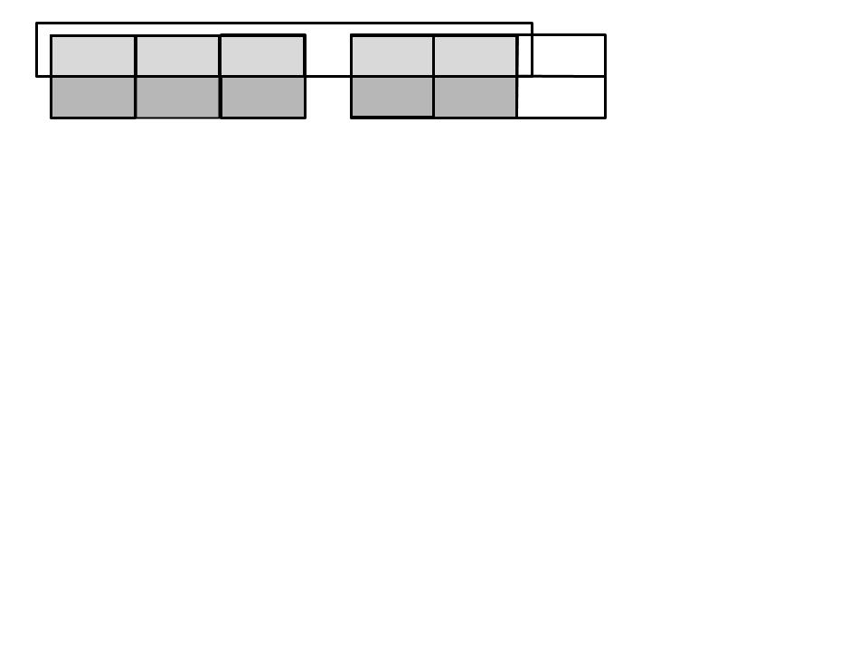

1. We can also use the distributive property of multiplication over addition to compute the multiplication without changing the mixed numbers to improper fractions.

For example:

$$2\frac{1}{3} · 1\frac{1}{4}$$

$$= \left(2 + \frac{1}{3}\right) · \left(1 + \frac{1}{4}\right)$$

$$=\left(2 · 1\right)+ \left(2 · \frac{1}{4}\right) + \left(\frac{1}{3} · 1\right) + \left(\frac{1}{3} · \frac{1}{4}\right)$$

$$= \left(2\right) + \left(\frac{1}{2}\right) + \left(\frac{1}{3}\right) + \left(\frac{1}{12}\right)$$

$$=2\frac{11}{12}$$

1. Have students work in groups to model multiplication of fractions shown in the following examples using the strategy of their choice:

$\frac{1}{3} · \frac{3}{4}$ $\frac{1}{2} · \frac{1}{4}$ $2\frac{1}{4} · \frac{3}{5}$ $1\frac{1}{2} · \frac{5}{6}$

1. Ask groups to share their models with the class (choose groups that represent different models). Have students discuss the shared models, solutions, and patterns that they noticed. These student observations can lead to a discussion of the procedure (algorithm) for multiplying fractions.

## Assessment

### Questions

* How are multiplication of fractions and multiplication of whole numbers alike?
* What other representations might you use to solve a multiplication-of-fractions problem? (arrays, paper folding, repeated addition, repeated subtraction, fraction strips, pattern blocks)

### Journal/Writing Prompts

* Describe how you would use an area model to solve $\frac{1}{4} · \frac{2}{3}$.
* Discuss how repeated addition will help you solve fraction and mixed-number multiplication problems.

### Other Assessments

* Have students complete additional multiplication-of-fractions problems, using other representations, such as arrays, paper folding, repeated addition, repeated subtraction, fraction strips, or pattern blocks. Have them compare the models.
* Use index cards with a multiplication-of-fractions problem written on one card (e.g., $\frac{1}{3} × \frac{3}{4}$) and a pictorial representation of that problem (e.g., a rectangle divided and shaded appropriately) on another card. Make several of these pairs, mix the cards, and lay them facedown on a table. Pair students to play a “memory game,” in which they must select two cards and match pairs.

## Extensions and Connections

* Discuss real-life situations in which multiplication of fractions is used.
* Have students create a multiplication-of-fraction or mixed-number model and explain the steps used to create it.

## Strategies for Differentiation

* Use grid paper with premade rectangles for students to use when solving the problems in their groups.
* Have students use fraction manipulatives in the activities to help them relate to the pictorial models.
* When pairing students or dividing them into small groups, ensure that students with different abilities are put together.
* For any additional problems students are assigned individually, provide two to three worked examples for reference, if needed.