Mathematics Instructional Plan – Grade 6

Compare and Order Positive Rational Numbers
Strand: Number and Number Sense
Topic: Comparing two percents using representations and symbols and ordering positive rational numbers expressed as fractions (proper and improper), mixed numbers, decimals, and percents.
Primary SOL: 6.2 The student will
- compare and order positive rational numbers*
Related SOL: 6.1, 6.2a

Materials:
- Rational Number Cards Team Recording Sheet (one per team; attached)
- Rational Number Cards (attached)
- Markers
- Chart paper
- Envelopes
- Scissors

Vocabulary
ascending order, descending order, improper fraction, mixed number, percent (earlier grades), proper fraction, rational numbers, repeating decimal, terminating decimal

Student/Teacher Actions: What should students be doing? What should teachers be doing?
- Before beginning the lesson, discuss positive rational numbers with students. Refer to the Grade 6 Standards of Learning Curriculum Framework and look at the important information found in “Understanding the Standard” for SOL 6.2. Teachers should note that square roots (e.g., ) can be introduced as a positive rational number; however, they are not tested in Grade 6, and students are not taught the solution to a square root until Grade 7.
- Before the lesson, place each problem from the Rational Number Cards handout in a blank envelope, such that one card is in each envelope. The teacher will number the envelopes 1–10 and set them in the front of the classroom.
- Group students in teams of three or four. Ask students to discuss, within their teams, strategies to compare and order rational numbers. Then, allow a few teams to share their ideas with the class.
- Distribute the Rational Number Cards Team Recording Sheet to each team (one sheet per team).
- Have one student per team retrieve an envelope. The teams will work together to compare and order the presented rational numbers on the number card they picked. The teams will record their results on the recording sheet. One team member will replace their envelope and choose a new one that their team has not completed. The team should continue doing this until all 10 have been completed. Be sure to decide what happens if one team finishes and there are no other cards available.
- Once all teams have completed all 10 problems, discuss the results as a whole group and address any challenges or misconceptions.

Assessment

Questions
  - What strategies are used to compare fractions and mixed numbers?
  - How are rational numbers alike or different?
  - How can we represent rational numbers in various ways?
  - Why is it necessary to have multiple forms of rational numbers?

Journal/writing prompts
  - When ordering rational numbers, detail a strategy used and discuss how you can justify your solution.
  - Discuss what you have learned about ordering and comparing rational numbers.

Other Assessments
  - Describe how rational numbers can be compared and ordered using a number line.
  - Give students four rational numbers and have them place the numbers on a given number line.

Extensions and Connections (for all students)
- As an extension, have teams record their results on chart paper and post them around the classroom. The teams could either report out regarding their team results, or the class can participate in a gallery walk where the teams decide whether they agree with the results from other teams.

Strategies for Differentiation
- Use a preprinted handout for students with a visual impairment.
- Allow kinesthetic learners to use colored tiles or other manipulatives.
- Allow advanced learners to create sample problems along with an answer key and justification of how the answers were selected.
- Preteach or review essential vocabulary for some students as needed.
- Allow students to orally respond to one of the journal/writing prompts with a peer, instead of writing.

Note: The following pages are intended for classroom use for students as a visual aid to learning.

Virginia Department of Education ©2018
Rational Number Cards

Write the percentage represented below. Compare the percentages using the following symbols: <, ≤, ≥, >, =.  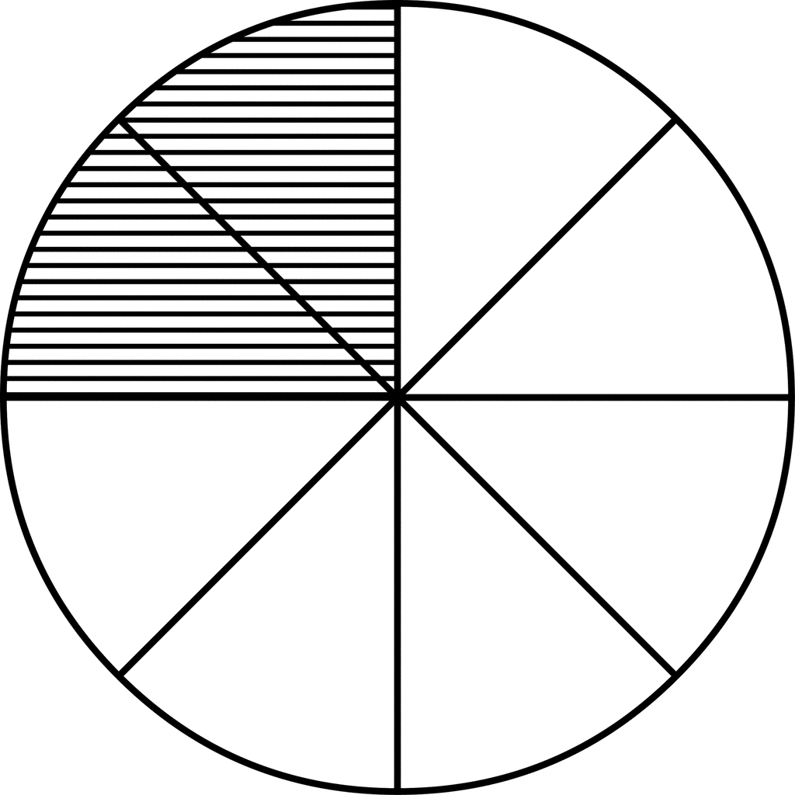 __________ 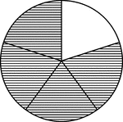 | Place the following rational numbers in ascending order:  3 $\frac{1}{2}$, 0.192, $\frac{12}{5}$, 19 %
Place the following rational numbers in descending order:  $\frac{4}{7}$, $\frac{3}{7}$, 1 $\frac{3}{5}$, $\frac{10}{9}$ | Write the percentage represented below. Compare the percentages using the following symbols: <, ≤, ≥, >, =.  ______
Place the following rational numbers in ascending order:  $\frac{16}{3}$, $\frac{12}{4}$, $\frac{7}{2}$, $\frac{6}{5}$ | Place the following rational numbers in descending order:  0.1 %, 1.25, 225 %, 1 $\frac{3}{4}$
Place the following rational numbers in descending order:  16 %, $\frac{1}{5}$,$0.1\overline{6}$, $\frac{16}{10}$ | Place the following rational numbers in ascending order:  $\frac{15}{4}$, 175 %, $\frac{3}{4}$, 0.175
Write the percentage represented below. Compare the percentages using the following symbols: <, ≤, ≥, >, =.  ______ 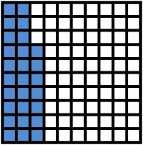 | Write the percentage represented below. Compare the percentages using the following symbols: <, ≤, ≥, >, =.  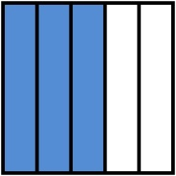 ______
Rational Number Cards Team Recording Sheet
1. | 2.
3. | 4.
5. | 6.
7. | 8.
9. | 10.

