Mathematics Instructional Plan – Grade 6

# Rational Speed Matching

**Strand** Number and Number Sense

**Topic** Investigating rational numbers in percent, decimal, and fractional forms

**Primary SOL** 6.2 The student will

1. Represent and determine equivalences among fractions, mixed numbers, decimals and percents*

**Related SOL** 6.1; 6.2b

## Materials

* Rational Number Cards (attached)
* Large number line
* Timer
* Bell
* Rational Numbers Number Line (attached)
* Multiple Representations Graphic Organizer (attached)
* Converting Rational Numbers activity sheet (attached)
* Representing Rational Numbers activity sheet (attached)

## Vocabulary

decimals, fractions, improper fraction (earlier grades), mixed number, percent, percentage, proper fraction, ratio (6.1, 6.2)

## Student/Teacher Actions: What should students be doing? What should teachers be doing?

***Note:*** *Before the lesson, print the attached Rational Number Cards on cardstock and cut them out. Notice that all of the rational numbers given are expressed as fractions (proper and improper), mixed numbers, decimals, and percents (decimals through thousandths, fractions with denominators of 12 or less, or factors of 100). All cards must be the same size and color.*

Draw a number line on the board, or post a large number line on a wall. Above and to the left of the number line, post three signs, labeled “Fraction,” “Decimal,” and “Percent,” as shown.

Organize the classroom furniture by lining up the desks in a straight line along the length of the room and placing chairs on both sides of the line of desks. This will allow students to be seated in two rows facing each other across the line of desks.

FRACTION

DECIMAL

PERCENT

50%

0.5



For this activity to work, the total number of student participants must be an even number divisible by 3 (e.g., 12, 18, 24, 30, 36). If the number of students in the class does not match one of these numbers, assign the largest possible number of students to be participants, and have the remaining students serve as volunteer timekeepers, number line organizers, and/or recorders for filling in the attached Representing Rational Numbers activity sheet.

If the total number of students matches one of these numbers, the teacher should keep time and direct all students to tape their numbers in order along the number line and complete their individual chart as numbers appear along the number line.

1. Begin the activity by reviewing how to convert between different forms of rational numbers (i.e., between fractions, decimals, mixed numbers, improper fractions, and percents).
2. Give each student one rational number card, making sure that for each number distributed, all three forms of that number are handed out. Distribute the Representing Rational Numbers activity sheet and the Rational Numbers Number Line.
3. Divide the class into two groups by having students count off by twos. Seat one group (Group A) in random order on one side of the desks/tables, and the other group (Group B) on the other side.
4. Explain the following game directions to all students:

* The object of the game is to match all three forms of each rational number.
* Students in Group B will remain seated throughout the game.
* When the bell rings, students have 30 seconds to talk to the person opposite of them to determine whether the two numbers match. If they do match, the student in Group A goes and stands behind the student with the match in Group B. The student will stand there until a third match has been made.
* The bell will ring every 30 seconds, signaling all students in Group A who are still seated to move one chair to their right. The student seated in the last chair at the end of the row will cycle to the first chair in the row. Once this happens, there will be empty seats on Group A’s row.
* The first group of three students to match all three forms of a number will go and tape their numbers in the correct position on the number line. They will also record their numbers on their Representing Rational Numbers activity sheets and Rational Numbers Number Lines. When students have finished placing their number on the number line, they should continue to add the numbers from the other groups on their Representing Rational Numbers activity sheet and to their number line.
* The remaining students will continue to play until all numbers are matched, placed, and recorded. If necessary, numbers previously placed on the number line may be moved slightly to make room for additional numbers.

## Assessment

### Questions

* Looking at the fractions on the number line, what are some relationships between the numerators and denominators that help students place fractions in numerical order before converting them to decimals?
* Why is it necessary to have multiple forms of rational numbers?

### Journal/Writing Prompts

* Explain how this activity helped you understand the relationship between fractions, decimals, and percents.
* Write the procedures for converting rational numbers from one form to another.

### Other Assessments

* Create a class set of rational numbers in the four forms (fraction, decimal, percent, and pictorial representation), pass them out to the class, and have the students find their matches.
* Give students a rational number and have students complete the Multiple Representation Graphic Organizer.

## Extensions and Connections (for all students)

* Have students complete the attached Converting Rational Numbers activity sheet.

## Strategies for Differentiation

* Post the rules for converting rational numbers from one form to another along a “circuit” around the room:
* Converting a fraction to a decimal
* Converting a decimal to a fraction
* Converting a fraction to a percent
* Converting a percent to a fraction
* Converting a percent to a decimal
* Converting a decimal to a percent
* Allow pairs of students to travel around the “converting circuit” with a printed sheet of numbers to convert, stopping at each station to do the conversion. Have each pair present their numbers and explain the connection among the forms.
* Allow students to orally share their response to one of the journal/writing prompts with a peer buddy instead of writing.
* Provide worked examples of converting rational numbers from one form to another for certain students.

**Note: The following pages are intended for classroom use for students as a visual aid to learning.**

Virginia Department of Education ©2018

**Representing Rational Numbers**

**Name Date**

|  |  |  |
| --- | --- | --- |
| **Fraction** | **Decimal** | **Percent** |
|  |  |  |
|  |  |  |
|  |  |  |
|  |  |  |
|  |  |  |
|  |  |  |
|  |  |  |
|  |  |  |
|  |  |  |
|  |  |  |
|  |  |  |
|  |  |  |
|  |  |  |
|  |  |  |
|  |  |  |
|  |  |  |
|  |  |  |
|  |  |  |
|  |  |  |
|  |  |  |
|  |  |  |

**Rational Numbers Number Line**

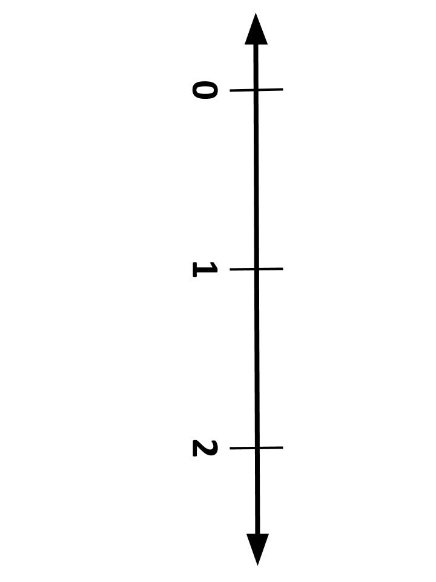

**Converting Rational Numbers**

**Name Date**

|  |  |  |
| --- | --- | --- |
| fraction attraction.jpg | **DECIMAL**  decimal.jpeg | PERCENT percent.jpg |
| |  | | --- | | 8 | | 5 | |  |  |
|  | 2.06 |  |
|  |  |  |
|  | 0.125 |  |
|  |  | 37.5 % |
| |  |  | | --- | --- | | 1 | 17 | | 20 | |  |  |
|  | 0.112 |  |
|  |  | 150 % |
|  |  |  |
|  | 0.098 |  |

**Multiple Representations Graphic Organizer**

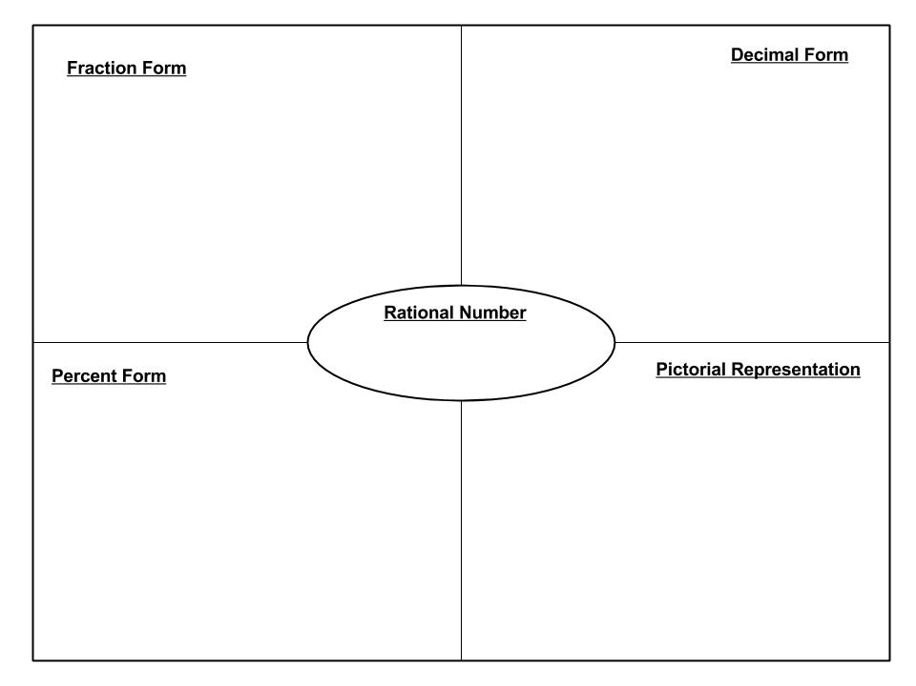

**Rational Number Cards**

Print on card stock and cut out.

|  |  |  |
| --- | --- | --- |
| **75 %** |  | **0.75** |
|  |  | **0.6** |
| **38 %** |  | **0.38** |
| **39 %** | **10 by 10 grid** | **0.39** |
|  |  |  |
| **12.5 %** | |  | | --- | | **1** | | **8** | | **0.125** |
| **110 %** | |  |  | | --- | --- | | **1** | **1** | | **10** | | **1.1** |
| **320 %** | |  | | --- | | **16** | | **5** | | **3.2** |
| **100 %** | |  | | --- | | **25** | | **25** | | **1** |
| **60 %** | **10 by 10 grid  (1)** | **0.6** |
|  |  | **0.3** |
| **137 %** | |  | | --- | | **137** | | **100** | | **1.37** |
| **72 %** |  | **0.72** |
| **50 %** |  | **0.50** |
| **14.3 %** |  | **0.143** |
| **37.5 %** |  | **0.375** |
| **216 %** | |  |  | | --- | --- | | **2** | **8** | | **50** | | **2.16** |
| **250 %** | |  | | --- | | **20** | | **8** | | **2.5** |
| **225 %** | |  | | --- | | **27** | | **12** | | **2.25** |
| **10 by 10 grid  (2)** | |  | | --- | | **7** | | **25** | | **0.28** |
| **106 %** | |  |  | | --- | --- | | **1** | **3** | | **50** | | **1.06** |