Mathematics Instructional Plan – Grade 5

Combining and Subdividing Shapes
Strand: Geometry and Measurement
Topic: Combining and Subdividing Polygons
Primary SOL: 5.14 The students will be able to
- investigate and describe the results of combining and subdividing plane figures.
Related SOL: 5.12, 5.13a, 5.14a

Materials
- 10 cm x 10 cm squares of paper (copy paper, construction paper, or square pieces of origami paper)
- Scissors
- Pencil and paper
- Steps for Folding a Square to Make a Tangram Set activity sheet (attached)
- Tangram Template for Differentiation (attached)
- Combining and Subdividing with Tangrams activity sheets (attached)
- A baggie or envelope for each student to hold tangrams for future projects

Vocabulary
attributes, combine, congruent, diagonal, isosceles, isosceles triangle, parallel, parallelogram, polygon, rectangle, rhombus, right triangle, square, subdivide, trapezoid, vertex/vertices

Student/Teacher Actions: What should students be doing? What should teachers be doing?
Note: You will be leading the students through the steps for making a tangram set starting with a square, by folding and cutting.
Activity 1—Creating and Describing Tangram Pieces
- Give each student a 10 cm-by-10 cm square piece of paper. Ask, “What is this shape, and what attributes make it that shape?” Allow students a minute to discuss this with elbow partners. Then, call on volunteers to share with the class. Guide students to review the formal definition of square: a polygon with four congruent sides and four right angles.
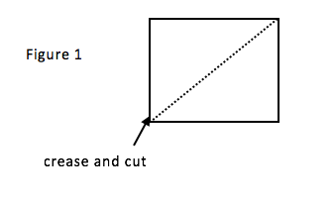
- Demonstrate folding the square along its diagonal, saying, “I am folding this square along its diagonal. What does diagonal mean?” Guide students to the formal definition: a diagonal of a polygon is a segment that joins two vertices that are not next to each other. Have students fold the square along a diagonal, and then cut along the creased diagonal. Model this with a square of your own (Figure 1).
- Ask, “Who can describe these two shapes, using the geometry vocabulary that you have learned?” As students suggest attributes (such as right or congruent), ask them to explain how they knew (for example, “I know they are right triangles because they both have right angles,” or “I know they are congruent because when I lay one on top of the other, they are the exact same size and shape”). Students should eventually be able to state that these are two congruent isosceles right triangles.
- Ask, “What was our original polygon before we cut along the diagonal?” (square) Then ask, “What did we create after we cut along the diagonal?” (two congruent isosceles right triangles) Write the following statement on the board and highlight or underline the important words:
A square can be subdivided into two congruent isosceles right triangles.
Two congruent isosceles right triangles can be combined to form a square.
Have students discuss the meanings of “subdivide” and “combine” with elbow partners. Next, share their ideas with the class. If students have experience with decomposing and composing numbers by place value, you may want to make the connection to subdividing and combining polygons.
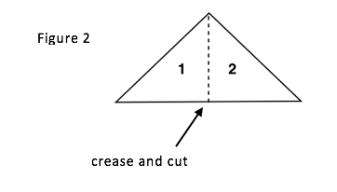
- Have the students place one triangle aside and place the other in front of them with the long side toward them, parallel to the edge of their desk. Ask, “Do you see a way we can fold this triangle into two congruent triangles?” Have students discuss and demonstrate how to fold into two congruent triangles. Model this with your own triangle (Figure 2).
- Next, ask students to write statements using “subdivide” and “combine” to describe the relationship between the large triangle and two small triangles.
A large triangle can be subdivided into two smaller triangles.
Two small triangles can be combined to form one large triangle.
- Ask the following questions to discuss these two new polygons: “Who can describe these new polygons? How are they similar to the one we put to the side? How are they different from the one we put aside?” Students should notice that they created two congruent isosceles right triangles once again, and that they are not congruent, or non-congruent, to the one they put aside. Have the students label the smaller triangles 1 and 2.
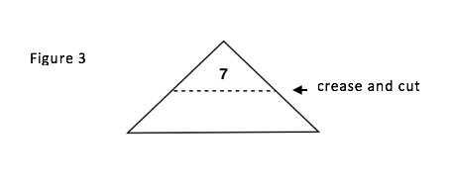
- Have students place the remaining large right triangle in front of them with the long side facing them. Have them fold the vertex of the right angle (angle at the top) down to the midpoint of the opposite side (side closest to you—see Figure 3). Model this with your own triangle, and show the class how it should look. Ask, “What shapes am I creating with this fold?” Students should recognize a small isosceles right triangle folded over a quadrilateral. Ask, “Who remembers what type of quadrilateral this is, and what special attribute makes it that shape?” Guide students to recall that a trapezoid as a quadrilateral with exactly one pair of parallel sides. Have students cut along the crease. Label the new triangle 7 (Figure 3).
- Have students again write statements using “subdivide” and “combine” to describe the relationship between the large triangle, small triangle, and trapezoid.
A large triangle can be subdivided into a triangle and a trapezoid.
A trapezoid and a triangle can be combined to form a large triangle.
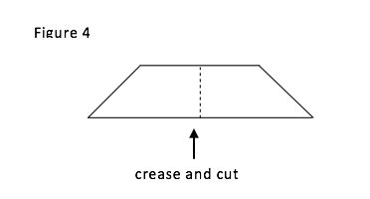
- Have students place the trapezoid in front of them with the longer side toward them. Have them fold the trapezoid to create two congruent polygons (asking, “How can we fold this trapezoid to make two new congruent polygons? What polygons will we create from this fold?”). Students should notice that a fold down the center would create two congruent trapezoids. Model this fold with your own trapezoid. Cut along the crease. (Figure 4).
- Have students write statements using “subdivide” and “combine” for these new shapes.
A trapezoid can be subdivided into smaller trapezoids.
Two small trapezoids can be combined to create a large trapezoid.
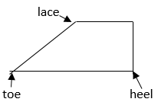
- To assist students in following the next steps, place the following diagram of a “shoe” trapezoid on the board or overhead.

Say: “These are what we are now going to call shoes. You have two of them. Place one in front of you and put the other aside.” Have students take the heel and fold it to the lace. Model this with your shoe. Ask, “What two shapes will this fold create? Describe them with as many geometric vocabulary words as you can.” With questions and discussion with elbow partners, students should recognize an isosceles right triangle and a parallelogram (a quadrilateral with two sets of parallel sides). Label the small triangle 4 and the parallelogram 3. (Figure 5)
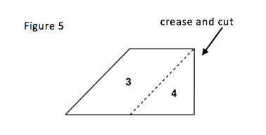
- Have the students take the second shoe and place it in front of them, oriented the same as the model on the board. Take the toe and fold it back to the heel. Model with your own shoe. When the fold is complete, ask, “What two polygons have we created with this fold?” Students should recognize a triangle (“What kind of triangle?”) and a square (“How can you prove it is a square?”) Cut along the crease. Label the triangle 6 and the square 5. (Figure 6).
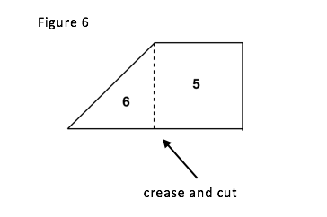
- Have students write statements using “subdivide” and “combine” for these new shapes.
A trapezoid can be subdivided into a triangle and a square.
A square and a triangle can be combined to form a trapezoid.
- Have the students make sure that they each have seven labeled pieces. Allow a few minutes for students to try to put pieces back into the original square.
- At the end of this activity, give each student an envelope with holes punched in it for a three-ring binder, and have them store their pieces for future work.
Activity 2—Combining and Subdividing with Tangrams
- Distribute the Combining and Subdividing with Tangrams activity sheet to each student. Explain that they will be using the tangram pieces they just created and numbered to build shapes from smaller shapes; in other words, they will be combining small shapes to create larger shapes. They will then describe how they would subdivide the larger shape into small shapes.
Explain to students that they should trace the shapes once they have created a larger shape, and then they should write statements to describe how the shapes were combined to create larger shapes and how they can be subdivided to create several smaller shapes. (See previous examples of the combining and subdividing statements.)
They may be creative and may combine more than two shapes. However, they should be able to define the shape they created, such as a hexagon or octagon.
- Allow volunteers to draw examples of their combined shapes on the board and to share the combining and subdividing statements they wrote to describe their drawings.

Assessment

Questions
  - Create a square, triangle, and parallelogram using two isosceles, right triangles. Write combining and subdividing statements to describe the polygons you created.
  - Draw a rectangle using two isosceles, right triangles and a parallelogram. Write combining and subdividing statements to describe the polygons you created.
  - How many different shapes can you make by combing right isosceles triangles. Create your shape, state what the new shape is, and then draw it and label it on your paper. See how many different shapes you can make.

Journal/writing prompts
  - How many ways can you combine two congruent right triangles to create different polygons? Trace and describe those polygons you create.
  - Create a polygon by combining two or more smaller polygons. Write a description for a friend on how you created that shape. Then give your friend your written description and see whether he or she can re-create your polygon.

Other Assessments
  - Have students make a triangle, square, rectangle, and parallelogram using two, three, four, five, six, and seven parts of the tangram. Describe the shapes that are subdivided and combined.
  - Explain what the words combine and subdivide mean, using drawings of polygons to help you.

Extensions and Connections (for all students)
- Using a Geoboard, have students create a square, rectangle, triangle, parallelogram, rhombus, and trapezoid. Have students subdivide these shapes with bands and describe the shapes that are combined to create the original shapes.

Strategies for Differentiation
- Provide prepared tangram pieces.
- Provide instructions for reference at students’ desks.
- Provide the Tangram Template for Differentiation from the activity.
- Use foam to create tangrams for kinesthetic learners.
- Find as many possible ways to make a large right triangle using tangrams.

- Create polygons using at least three tangrams. Share with a partner. Can they find the three tangrams?
- Create your own version of tangrams using a large rectangle instead of a square.

Note: The following pages are intended for classroom use for students as a visual aid to learning.

Virginia Department of Education ©2018

Tangram Template for Differentiation
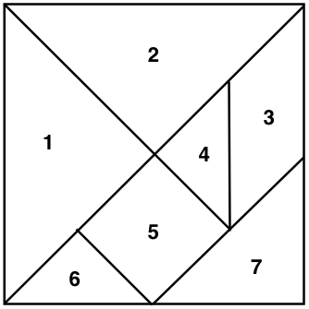

Combining and Subdividing with Tangrams
Name Date
Use your tangram pieces, or cut out the pieces in the diagram above, to help you create four different pairs of statements, using the vocabulary words subdivide and combine. You may use more than two pieces in your statement, and you may refer to each piece as “triangle 1” or “triangle 7.” Trace your pieces on the page provided to show how you combined and subdivided the shapes.
Example:
a) Triangle 1 and triangle 2 can be combined to form a large triangle.
b) A large triangle can be subdivided into triangle 1 and triangle 2.
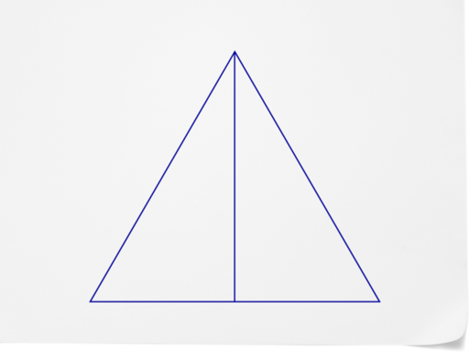
1 2

Name _____________________________ Date ________________________
Trace the shapes you are combining and subdividing below:

Name _____________________________ Date ________________________
Subdividing and Combining Statements
1. a) _________________________________________________________________________
b) _________________________________________________________________________
2. a) _________________________________________________________________________
b) _________________________________________________________________________
3. a) _________________________________________________________________________
b) _________________________________________________________________________
4. a) _________________________________________________________________________
b) _________________________________________________________________________

