Mathematics Instructional Plan – Grade 5

Slides, Flips, and Turns
Strand: Measurement and Geometry
Topic: Identifying and applying transformations: translation, reflection, and rotation
Primary SOL: 5.14 The students will
- recognize and apply transformations, such as translation, reflection, and rotation.
Related SOL: 5.8ab

Materials
- Template with or several rectangles of various sizes
- Template with or several triangles, rhombi, and hexagons
- Circles cut from card stock
- Paper
- Scissors
- Slides, Flips and Turns activity sheet (attached)
- Slides, Flips and Turns Answer Sheet (attached)
- Scraps of card stock

Vocabulary
congruent (congruency), geometric transformation, image, plane figures, polygons, preimage, reflection, rotation, transformation, translation

Student/Teacher Actions: What should students be doing? What should teachers be doing?
- Have students turn a sheet of paper horizontally and fold the paper in thirds horizontally to create three rows. Draw a line across the top of the paper about one-half inch from the top and have students write the term Transformation. Then, under the line, label each row with one the three kinds of mathematical transformations: translation, reflection, or rotation. The teacher should be creating an anchor chart along with the students creating their Transformation graphic organizer.
  - On the board, write slide, flip, and turn. In pairs, students will match words with each label: translation, reflection, and rotation. On the board, students will come to a consensus on the matches. Record these on the anchor chart.
  - Next, facilitate students taking notes on each transformation. Demonstrate with visuals and discuss, with specific details, the meaning of each. Use a sticky note with one corner folded in as the shape being translated. Record notes on the anchor chart and have students record notes on their sheets.
    - Translation is when an image is formed by moving every point on the preimage (discuss the meaning of preimage) the same distance in the same direction.
    - Reflection is formed by reflecting the preimage over a line called the line of reflection (All corresponding points in the image and preimage are equidistant from the line of reflection.).
    - Rotation is formed by rotating the preimage around a point called the center of rotation. Demonstrate the center of rotation.
Discuss when preimages of a shape, such as the sticky note, are translated, rotated, or reflected, the new orientation of the image is congruent to the preimage.
- In groups of three, have students take out a clean sheet of paper while keeping their notes on their desks. Each student chooses one rectangle from the template to draw in each box of their graphic organizer.
- Tell students the rectangle they select will be the preimage (the first image). Next, ask them to move the template to another location on the sheet and trace another rectangle demonstrating the assigned transformation.
- Assign student A the translation, B the reflection, and C the rotation.
- When the group is finished, trade papers with one another to check one another’s work while the person who drew the transformation explains why they think they are correct.
- Circulate around the room and facilitate as needed. Note common misconceptions to address with the entire class.
- To bring closure to this activity, ask students to take a few minutes and turn their notetaking sheet to the back and try to describe a rotation, a translation, and a reflection as best they can. Tell students to turn their papers over and compare what they just wrote with their notes, then underline in their notes what they need to continue to work on remembering.
- Distribute to each student a set of triangular, rhombic, or hexagonal templates and share that any polygon can be translated, reflected, or rotated. Give students a chance to engage in drawing a translation, a reflection, and a rotation these polygons. Then, give students a circle. Ask them to discuss with a partner how to tell whether a circle has been translated, reflected or rotated. Students should understand that a shape needs some type of reference or identification (example: point of rotation) to help identify whether a shape has been transformed.
- Distribute scissors and scraps of card stock. Have each student cut a roughly 2” x 3” rectangle (only a rough approximation—no need to measure) out of the scrap card stock. Then, have them cut a small notch or triangle out of the rectangle, as shown at right. Give students another piece of paper. Direct students to use their notched rectangle as a template, as follows:

- Trace the template, including the notch, on a sheet of paper. Label this rectangle “original.”

- Place the template back in its first position on top of the tracing, slide it slowly in any direction without turning it from its original orientation, and trace it in a second location on the sheet. Label this rectangle “translation (slide).”
- Turn the template on one point, and trace it in a third location. Label this rectangle “rotation (turn).”
- Flip the template over, and trace it in a fourth location. Label this rectangle “reflection (flip).”
original (preimage) translation rotation reflection
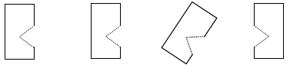
- Discuss how some shapes are easier to tell which transformation has occurred.
- After the class revisits the terms, have students go back to the Congruent Figures activity sheet. Have students label whether it is a translation, rotation, or reflection.

Assessment

Questions
  - What does it mean to have a figure that is translated, rotated, or reflected?
  - If a figure is a square, what can help decide whether it has been translated, rotated, or reflected?
  - What types of figures are best to translate, rotate, or reflect?
  - Why do you think the term transformation is used for translation, rotation, and reflection?

Journal/writing prompts
  - Identify two figures in your classroom that are translated, reflected, or rotated. Describe how you can tell.
  - Some figures are easier to identify their transformation, while others are more difficult. Discuss why.
  - Look at a picture that shows shapes that are congruent and that have been geometrically transformed. Identify the polygons, and sort them as translations, reflections, or rotations. Discuss how you can tell.

Other Assessments
  - Provide students with various figures and have them generate geometric transformations of each figure.
  - Have students draw/trace the figures onto cards and create a game out of the transformed figures. Students have a partner play their game.

Extensions and Connections (for all students)
- Invite a guest speaker or the art teacher to speak about geometric shapes and patterns and how they are used in his or her specialty area. Speakers could include an interior designer, a landscape architect, a quilter, graphic designer, and an artist.
- Ask students to create tessellations, using translation, rotation, and reflection.
- Ask students to bring in pictures or material that demonstrates the use of tessellations to share with the class.

Strategies for Differentiation
- Have students search virtual manipulatives online that offer them the opportunity to create and then translate, rotate, and reflect two-dimensional geometric figures.
- Have students create and then display a color-coded poster related to the vocabulary and concepts presented in this lesson.
- Enlarge the Slides, Flips, or Turns activity sheet as needed.
- Cut the Slides, Flips, or Turns activity sheet into strips to isolate each set of shapes. Provide a student with one set of shapes at a time.
- Use blocks that are different polygons to demonstrate transformations. Then, have students trace the blocks and label each transformation.

Note: The following pages are intended for classroom use for students as a visual aid to learning.

Virginia Department of Education ©2018

Slides, Flips, or Turns
Name Date
Directions: Look carefully at each figure in each row. Which figures on the right have a translation, rotation, or reflection from the original figure on the left? Circle and label them.
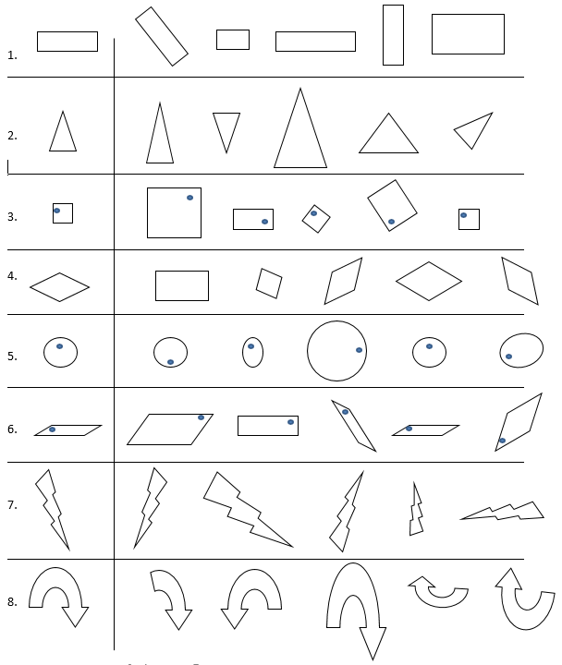

Slides, Flips, or Turns Answer Sheet
Name Date
Directions: Look carefully at each figure in each row. Which figures on the right have a translation, rotation, or reflection from the original figure on the left? Circle and label them.
