*Mathematics Instructional Plan – Grade 5*

# Exploring the Sum of a Triangle’s Angles

Strand:Measurement and Geometry

Topic:Exploring the interior angles of a triangle

Primary SOL:5.13 The student will

1. investigate the sum of the interior angles in a triangle and determine an unknown angle measure.

Related SOL:5.12,5.13a

## Materials

* Pencil and paper
* Ruler or straightedge
* Scissors
* Highlighter, marker, or crayon
* Calculators

## Vocabulary

*angle measure, degrees, interior angle*

## Student/Teacher Actions: What should students be doing? What should teachers be doing?

**Investigating the Sum of the Interior Angles**

1. Using a straightedge, pencil, and paper, instruct students to draw a triangle. Have students highlight or color over the sides of the triangle, making sure that some of the coloring appears just inside the triangle. Students should then cut out the triangle.

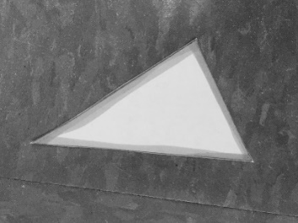

Example of a cut-out triangle with highlighted sides.

1. Say, *“Describe for your neighbor what type of triangle you created. Be sure you name it based on its sides and its angles.”* Remind students they can refer to the Triangle Sort Recording Sheet from Triangle Sort lesson. Say, *“Explain how you know these are the correct names for your triangle.”* Allow students a few minutes to share their triangles with neighbors. Circulate around the room, listening to students’ descriptions of their triangles, informally assessing student understanding. Listen for words like *isosceles, scalene, equilateral, right, obtuse,* and *acute*. The triangle above can be described as a scalene acute triangle.
2. Next, have students tear off each angle of the triangle, making sure the angles are large enough to handle.

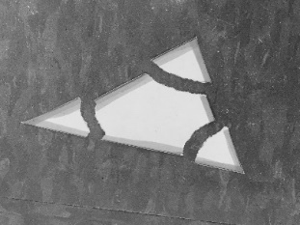

Example of a triangle with torn off angles.

1. Have each student draw a straight angle using their straightedges and pencils. Say, *“Who remembers what a straight angle is? Discuss with a partner.”* Students should be able to describe a straight angle as an angle that measures 180 degrees.
2. Next, have students line up the three angles they have torn off the triangle along the straight angle they have drawn, making sure the angles’ vertices are lined up with the straight angle’s vertex. (The highlighted sides of each angle should be touching.)

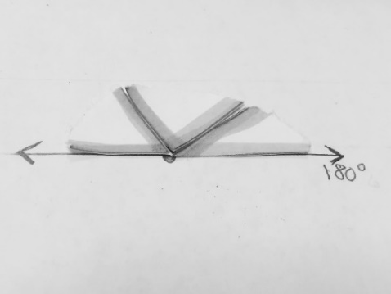

1. Ask, *“What do you notice about the angles from your triangle?”* Students should be able to see that the angles of their triangles form a straight angle when lined up. Ask, *“Did each of you create the same exact triangle?”* Students would respond, “No!” Say, *“Even though you didn’t draw the same triangles, do all of you have angles that form a straight angle?”* Students would respond, “Yes!” Ask volunteers to explain how they know the angles form a straight angle.
2. Then say: *“What statement can we make about the sum of the interior angles of a triangle? Discuss with your elbow partner.”* As you walk around the room, students should be heard discussing how a straight angle measures 180 degrees and the three angles of a triangle form a straight angle.
3. As a class, create a formal statement about the sum of the angles of a triangle, while you write it on the board:

“The sum of the interior angles of a triangle equals 180 degrees.”

**Determining an Unknown Angle Measure**

1. Show the class a triangle like the one below.

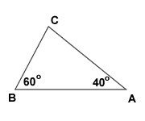

Say: *“What is the measure of the unknown angle, Angle C? How would you figure it out? Talk with an elbow partner.”* Tell students that they may use calculators if they wish as they try to answer this question. As students work collaboratively, circulate around the room, listening to the discussions and assisting, if needed.

1. Allow volunteers to share how their groups solved the problem. The teacher should ask whether others agree and whether other students have other ways to share.

Students should agree that, in order to figure out the measure of Angle C, they would first add the measures of the known angles (60° + 40° = 100°). Next, they would subtract 100° from 180°(180° – 100° = 80°). Thus, Angle C measures 80 degrees. Ask students to explain how they knew they had to subtract the sum of the measures of the two given angles from 180degrees. Throughout the lesson, refer to the anchor activity where they showed that the sum of the three interior angles in a triangle is 180degrees.

To verify their answers, students can find the sum of the three angles to ensure their sum is 180 degrees.

60° + 40° + 80° = 180°

1. Allow students to work independently to figure out the measure of Angle A below, then have them compare their solutions with an elbow partner.

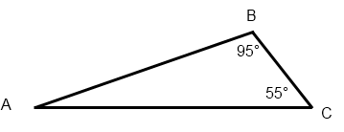

Solution: 95° + 55° = 150°

180° – 150° = 30° Thus, Angle A measures 30°

Check: 95° + 55° + 30° = 180°

Once complete, allow volunteers to share how they figured out the angle measure with the rest of the class.

## Assessment

### Questions

* + How can you prove that the sum of the interior angles of a triangle equals 180 degrees?
  + One angle of a right triangle measures 35 degrees. What are the measures of the other angles?
  + Can a triangle have angles that measure 90 degrees, 50 degrees, and 60 degrees? Why, or why not?

### Journal/writing prompts

* + Your friend does not know what the sum of the interior angles of a triangle equal. Explain how you would show your friend.
  + Can a triangle have two right angles? Why, or why not? Explain with pictures, numbers, and words.

### Other Assessments

* A triangle has one angle which measures 100 degrees and another which measures 25°. Find the measure of the third angle.
  + Have students draw triangles using straightedges, then trade triangles. Then have students measure the angles of the triangles that their friends drew. Check their answers by adding up the angle measures. Does the sum equal 180 degrees?

## Extensions and Connections (for all students)

* Using a similar angle-tearing technique as in this lesson, have students draw quadrilaterals with their straightedges, tear off the angles, and line them up together. Challenge students to figure out what the sum of the angles of a quadrilateral equals.
* Find triangles in the real world and measure their angles. Take pictures, if possible. Is the sum of the angles of all of the triangles you find equal to 180 degrees?
* Use a protractor or angle legs to determine the sum of the measures of the interior angles of a quadrilateral.

## Strategies for Differentiation

* Some students may need larger-sized triangles.
* Challenge students to find as many combinations of angles as they can, within a triangle, that total 180 degrees.

**The following pages are intended for classroom use for students as a visual aid to learning.**

Virginia Department of Education ©2018