Mathematics Instructional Plan – Grade 5

Triangle Sort
Strand: Geometry and Measurement
Topic: Classifying, sorting, and describing triangles
Primary SOL: 5.13 The student will
- classify triangles as right, acute, obtuse, and equilateral, scalene, or isosceles
Related SOL: 5.12

Materials
- Triangles activity sheet (attached)
- Triangle Sort Recording Sheet (attached)
- Comparing Triangles activity sheet (attached)
- Scissors
- Glue sticks
- Protractors or angle rulers
- Inch/centimeter rulers
Vocabulary
acute triangle, angle, congruent angles, congruent sides, degree, equilateral triangle, hash/hatch mark, isosceles triangle, obtuse triangle, polygon, right triangle, scalene triangle, triangle

Student/Teacher Actions: What should students be doing? What should teachers be doing?
- Pair students. Provide two copies of the Triangles activity sheet. Have students cut out one set of the triangles, while the other partner’s sheet remains intact.
  - Have one student select at least two triangles that are alike and explain to their partner why they chose those triangles. Then, have partners switch roles. Encourage students to use vocabulary they have learned about special types of angles. Similarly, each student should select two triangles that are different, and explain to their elbow partner why they chose them. Allow teams some time to go through several rounds. Walk around and note the vocabulary students are using, students with misconceptions.
  - Debrief with the whole class by allowing volunteers to share the triangles they chose and their observations. The teacher writes their responses on the board. Possible answers might be, “I chose triangles A and F because both are long and skinny,” or “Triangle C and Triangle F are different, because one is tall and skinny and the other is short and fat.” For this type of answer, the teacher might encourage the student to use vocabulary that they learned related to angles; these statements could be rephrased, “I chose triangles A and F because both have large obtuse angles,” or “Triangle C has all acute angles, and Triangle F has an obtuse angle.”
Students may also put triangles together based on side lengths—“I put triangles D and G together because the sides are all the same,” or “Triangles D and I are both tall triangles”. For these, encourage students to measure the lengths of the sides with rulers in order to justify their answers.
- Have partners sort the triangles into groups that have similar characteristics and describe each group in writing. As students are sorting the triangles, circulate around the room looking for students who have grouped the triangles by sides (equilateral, isosceles, scalene) and/or angles (right, acute, obtuse).
When students have finished grouping, ask specific groups of students to share how they grouped the triangles, and give those triangles a name. For example, if a group of students put triangles D and G together because they have all equal sides, the teacher can define these as equilateral triangles, triangles with three equal sides. The teacher should indicate sides that are the same length with hash/hatch marks, as shown below.
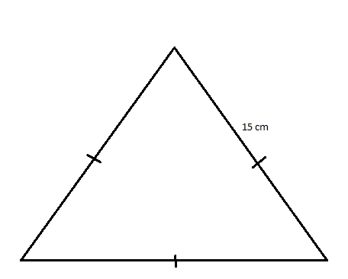
Similarly, for isosceles triangles, the hash/hatch marks would be shown below, with marks on just the two congruent sides.
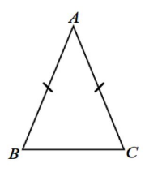
- Continue discussing the groupings of each type of triangle until all three types of triangles are named by angle (acute triangle, obtuse triangle, and right triangle) and all three types of triangles are named by side (equilateral triangle, isosceles triangle, and scalene triangle). For triangles defined by lengths of their sides, encourage students to prove each type by measuring each side with a ruler.
- Distribute the Triangle Sort Recording Sheet to each pair of students. Have partners:
  - sort the triangles based on their angles
  - agree on which column (acute, obtuse, or right)
  - glue the triangles under the correct columns; and
  - describe the characteristics of each triangle in writing under each column.
- The second set of triangles will need to be cut out and sorted by lengths of sides (scalene, isosceles, and or equilateral). Once partners agree on the sorting, have them glue the triangles onto the Triangle Sort Recording Sheet and describe in writing the characteristics of each triangle. Ensure that students use hash marks to indicate any congruent sides of triangles.
- Have the class discuss which triangles they glued under each column, and ask students to explain their decisions. Allow others to agree or disagree with each grouping of triangles.
- Distribute the Comparing Triangles activity sheet to each pair of students. Using the Sorting Triangles Recording Sheet as a guide, have pairs discuss each question, respond in writing, and draw examples to help explain their answers. Encourage vocabulary that includes types of angles and measures of angles and sides. Allow students to share their responses with the rest of the class.

Assessment

Questions
- What are some ways to sort or classify triangles? Give examples for each type of triangle you describe.
- Triangles can be named by the lengths of their sides and by the measures of their angles. If a triangle is acute, can it also be scalene? If a triangle is right, can it also be equilateral? What types can a triangle be simultaneously? Which types can a triangle not be at the same time?

Journal/writing prompts
- Identify places we find triangles in nature and the built environment, and tell what kinds of triangles they are. List as many ideas as you can.
- Describe the six types of triangles. Explain how particular triangles are similar and different.
- Explain why a right triangle cannot have two right angles.
- Explain why an acute triangle cannot be a right triangle.

Other Assessments
- Present students with several precut paper triangles. Have them name each triangle based on its sides and on its angles.
- Ask students to draw a triangle with two right angles. Have them explain their results.
- Ask students to draw an equilateral triangle with an obtuse angle. Have them explain their results.
- Have students find or take pictures of real-world examples of each of the six special triangles and describe under each picture why the object meets the criteria for that kind of triangle.

Extensions and Connections (for all students)
- Have students go on a triangle hunt. Have students use digital cameras to take pictures of triangles they find inside and outside the school. Download them to a computer and embed them into an electronic presentation. Have students identify the types of triangles they found. Give students incentives for finding at least one of each type of triangle.
- Have students use Geoboards to make and classify angles and triangles and to describe and analyze their properties.
- Have students bend straws to make each type of triangle. Tape them to poster board, and label them based on sides and angles.
- Have students identify someone who needs to know about and/or works with triangles in their job and interview them about how triangles are important to their work.
- Have students identify triangles by sides and angles (an acute, isosceles triangle). Ask them to make all possible combinations.

Strategies for Differentiation
- Some students may need a reference to help with identifying and sorting.
- Students can use a graphic organizer to show examples and nonexamples.
- Use picture and vocabulary cards for students to match.
- Challenge students to change the measurement of one angle and find out what happens to the triangle.

The following pages are intended for classroom use for students as a visual aid to learning.

Virginia Department of Education ©2018

Triangles

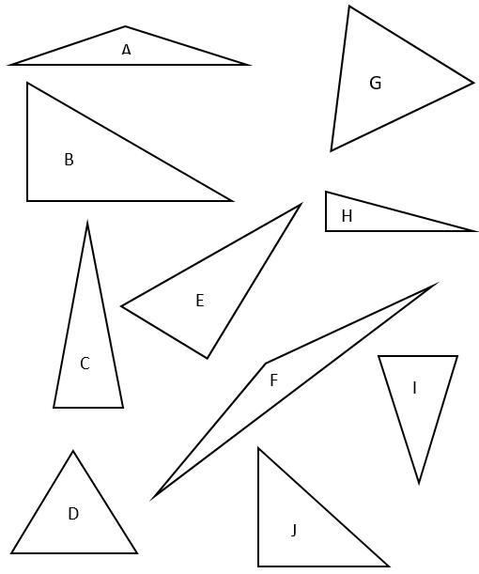

Triangle Sort Recording Sheet
Name Date
Acute | Obtuse | Right
Scalene | Isosceles | Equilateral

Comparing Triangles

Name Date
Directions: Discuss the following questions with your partner, using your Triangle Sort Recording Sheet to help you. Explain your answer in words, and draw examples with a straight edge to help with your explanation.
- Explain the difference between an acute triangle and an obtuse triangle.
- How is a right triangle different from an acute triangle? How is a right triangle different from an obtuse angle?
- How are equilateral and isosceles triangles alike? How are they different?
- How can you prove that a triangle is scalene?

