Mathematics Instructional Plan – Grade 5

Order of Operations
Strand: Computation and Estimation
Topic: Applying the order of operations.
Primary SOL: 5.7 The student will simplify whole number numerical expressions using the order of operations.*
* On the state assessment, items measuring this objective are assessed without the use of a calculator.
Related SOL: 5.4

Materials
- Tiling Puzzle activity sheet (attached)
- Digit Tiles activity sheet (attached)
- Four 4s activity sheet (attached)
- Paper or plastic tiles

Vocabulary
expression, operation, order of operations, parentheses

Student/Teacher Actions: What should students be doing? What should teachers be doing?
Note: The order of operations is a convention agreed upon by mathematicians and defines the computation order to follow in simplifying an expression. An expression, like a phrase, has no equal sign. Expressions are simplified by using the order of operations.
The order of operations is as follows:
- First, complete all operations in parentheses (grouping symbols).
- Second, multiply and/or divide, whichever comes first, in order from left to right.
- Third, add and/or subtract whichever comes first, in order from left to right.
- Have students find the answer to 5 + 3 × 7. Ask students to share their answers and record their ideas on the board. Likely answers are 26 or 56. Ask students to explain how someone might have gotten 56; then ask how someone might have gotten 26. Next, ask, “Do you think it is OK to have two different answers to this problem?” Allow students to discuss.
Next, say, “Mathematicians many years ago realized the confusion it would cause to have more than one answer. Therefore, they developed a rule, known as a convention, that has been accepted by everyone in the world which says exactly how to find the answer in situations like this.” Review how to solve 5 + 3 x 7. Write the rules on the board and have students record them in their notebooks.
- First, complete all operations in parentheses (grouping symbols). There are no parentheses in this problem, so we move to the second step.
- Second, multiply and/or divide, whichever comes first, in order from left to right. In 5 + 3 x 7, we are to multiply first, so 3 x 7 = 21.
- Third, add and/or subtract whichever comes first, in order from left to right. We now have 5 + 21, so the correct solution is 26.
- Write the expression 8 + 4 x 2 + 3 on the board, and tell students the answer is 19. Ask them to explain how to set up the expression so the answer is 19. Call on a volunteer to explain how to set up the expression, and call on another volunteer to talk through the steps to get 19.
- Students can work individually or in pairs to practice using the order of operations with the Tiling Puzzle activity sheet and the Digit Tiles activity sheet. Students must replace the missing numbers in each number sentence so that the statement is true. Students may begin using trial and error. Next, they should begin to find some strategies to make the trial and error efficient. The number sentences are created so that the student uses each of the digit tiles 0–9 once to make true statements. When students finish, ask them to turn their papers over and make up two sentences similar to the ones they just finished to share with another pair of students. When everyone has completed the four tiling problems, call on volunteers to share their answers and their thinking. Ask the class whether they found any strategies to make the trial-and-error approach more efficient.

Assessment

Questions
- Why is it important for everyone to follow the order of operations?
- Given the problem, 15 − 4 + 3, which operation should you complete first, second? Why? What is the correct answer?
- If Sasha were to incorporate parentheses within the problem 6 + 2 x 4, where would she place them, and why?

Journal/writing prompts
  - Describe a situation that shows the importance of following order of operations.
  - Given the problem, 4 + 3 x (9 – 2), explain the order in which each operation should be completed, and give the correct answer.

Other Assessments
- Have students create some problems that require order of operations and trade them with a partner. Students solve each other’s problems.
- Given 6 + 4 ÷ 2 x (5 – 3 + 7), complete the following directions for a student who was absent today.
First, I _____________ because____________________. Then, I ____________________ because _____________. Next, I __________________ because_______________. Last I ___________ because _________________.

Extensions and Connections
- Using the Four 4s activity sheet, have students use order of operations to reach solutions of 0–9.
- Why does addition and subtraction to have the same importance, in terms of what comes first?
- Give students a number and ask them to create complex expressions equivalent to the number. Encourage students to continually expand the expression as shown in the example below:
17
10 + 7
(2 x 5) + 7
[2 x (30 ÷ 6)] + 7
[2 x (15 x 2 ÷ 6)] + 7
- Find the value for 2 x 15 – $\frac{1}{2}$x 10 x 3.

Strategies for Differentiation
- Teach students to group operations using the parentheses, even when they are not included in the original problem. For example, if they see this problem: 6 + 5 x 10 – 4 ÷ 2 they can rewrite it like this: 6 + (5 x 10) – (4 ÷ 2) In this way, the parentheses guide their work.
- Students can use color tiles to solve the problem.
Example: 3 + 4 x 6
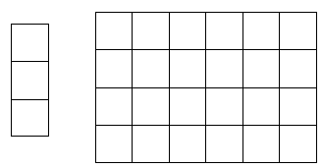
- Students can use colored pencils and graph paper to represent the problem.

Note: The following pages are intended for classroom use for students as a visual aid to learning.

Virginia Department of Education ©2018

Four 4s
Name Date
Use addition, subtraction, multiplication, division, and parentheses so that each set four 4s is part of a true number sentence.

4 4 4 4 = 0
4 4 4 4 = 1
4 4 4 4 = 2
4 4 4 4 = 3
4 4 4 4 = 4
4 4 4 4 = 5
4 4 4 4 = 6
4 4 4 4 = 7
4 4 4 4 = 8
4 4 4 4 = 9

Tiling Puzzle
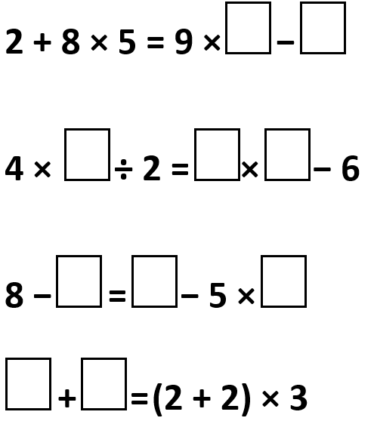

Digit Tiles

0 | 1 | 2 | 3 | 4 | 5 | 6 | 7 | 8 | 9
0 | 1 | 2 | 3 | 4 | 5 | 6 | 7 | 8 | 9
0 | 1 | 2 | 3 | 4 | 5 | 6 | 7 | 8 | 9
0 | 1 | 2 | 3 | 4 | 5 | 6 | 7 | 8 | 9
0 | 1 | 2 | 3 | 4 | 5 | 6 | 7 | 8 | 9
0 | 1 | 2 | 3 | 4 | 5 | 6 | 7 | 8 | 9

