Mathematics Instructional Plan – Grade 5

Multiplying Fractions and Whole Numbers
Strand: Number and Number Sense
Topic: Multiplying fractions and whole numbers.
Primary SOL: 5.6 The student will
- solve single-step practical problems involving multiplication of a whole number, limited to 12 or less, and a proper fraction, with models.
Related SOL: 5.6a

Materials
- Centimeter grid paper
- Unlined or lined paper
- Fraction circles
- Fraction strips
- Color tiles
- Pattern blocks or other area models for fractions
- Large paper and markers for each small group to document their solutions
- Multiplication Problems with Proper Fractions and Whole Numbers with Sample Solutions activity sheet (attached)
Vocabulary
improper fraction, multiplicative inverse, proper fraction, simplest form, unit fraction

Student/Teacher Actions: What should students be doing? What should teachers be doing?
Information to consider before teaching the lesson:
Modeling is a crucial first step in building understanding of concepts and procedures involving multiplication of fractions and whole numbers. Teachers are encouraged to scaffold instruction of multiplication of fractions and whole numbers by reviewing the concept of multiplication with students. Specifically, remind students that when developing the concept of 3 x 4 in Grade 3, the words 3 groups of 4 were used to describe the symbolic relationship. The review of this key concept will assist students in making connections to prior knowledge when developing an understanding of multiplication with fractions and whole numbers.
When students use manipulatives to model problem situations, it is important that they transfer or represent their solutions on paper with drawings in order to record their thought processes. Large pieces of paper and markers are helpful materials for small groups to document their ideas.
- Before introducing the symbolic form of multiplying fractions and whole numbers, have students use their understanding of multiplication to explore the following scenarios involving multiplying a whole number by a unit fraction. This will help students to develop an understanding about multiplying by a fraction and why the product may be less than the whole number. Before starting to work on the problems, ask students, “What does it mean to multiply?” Pose questions for discussion until students recall that multiplication is about finding a total when you know how many groups you have and how many are in each group.
- Write the Leftover Pizza Problem on the board (found in the Multiplication of Proper Fractions and Whole Number Problems with Sample Solutions activity sheet):
“After the class party, 6 medium pizza boxes were left. Each pizza box held $\frac{1}{3 }$ of a pizza. How many whole pizzas were left over?”
Allow students to discuss this problem with groups or partners, encouraging them to demonstrate with fraction circles and drawings. As groups are working, walk around the room and note how students approach the problem. Ask, “What do the 6 and the $\frac{1}{3 }$ represent in this problem?” “Which manipulative pieces are you using?” “How many pieces do you need, and how do you know?” (See attached sample solution.) The teacher may select a few groups to share their solutions.
Ask the class, “Do you agree with their answer?” “Did any group solve it the same way?” “Did anyone solve it differently, and how did you solve it?” “Did anyone write a number sentence to represent the problem?” “How can we think about this as a multiplication problem?”
- Next, write the Relay Problem on the board:
“During a relay race, 12 runners will each run $\frac{1}{4}$ of a mile. How many miles will the runners run altogether?”
Allow students to discuss this problem with groups or partners, encouraging them to demonstrate with fraction strips and drawings. As groups are working, ask them questions like, “What do the 12 and the $\frac{1}{4}$represent in this problem?” “How are you using the fraction strips to help you solve the problem?” “Which pieces are you using?” “How many pieces do you need, and how do you know?” (See attached sample solution.) The teacher may select a few groups to share their solutions.
Ask the class, “Do you agree with their answer?” “Did any group solve it the same way?” “Did anyone solve it differently, and how did you solve it?” “Did anyone write a number sentence to represent the problem?” “How can we think about this as a multiplication problem?”
- If the discussion has not already addressed writing a number sentence, have students look back at two problems and ask, “How might each of these problems be represented using numbers and symbols?”
After allowing students to discuss this in their groups, ask volunteers to share their ideas. Through discussion (“Do you agree? Why, or Why not? Does anyone have different ideas?”), lead students to the equations 6 × $\frac{1}{3}$ = 2 and 12 × $\frac{1}{4}$ = 3 and discuss what the factors and the product in each sentence represent.
- Present the TV Problem to the class, and ask students to model, solve, and create the symbolic equation to represent the situation.
“Karen's mother limits her TV watching to half an hour each weekday. What is the maximum number of hours that can be watched over two weeks (10 weekdays) if she sticks to the limit?”
Allow students to share their solutions and pose questions similar to the previous problem discussions. (See sample solution.)
- Investigate problems involving non-unit fractions (fractions with a numerator greater than 1). Continue to work with partners or small groups. Have students use manipulatives and drawings to model and solve the following problems, then share solutions with the class and pose questions similar to the previous problem discussions. (See sample solutions).
- The Farm Problem: A farmer planted 10 fields of vegetables. Of the fields he planted, $\frac{3}{5}$ were planted with cabbage. How many fields of cabbage did the farmer plant?
- The Basketball Problem: Terrence’s basketball coach said that he would play only the first three quarters of every game. If there are 8 games during the season, how many full games will Terrence play?
4. Looking back at the Farm Problem:
- Write the expressions 10 × $\frac{1}{5}$ and 10 × $\frac{3}{5}$ on the board. Ask, “How are these 2 expressions alike?” “How are they different?” “How would you model each one?” Students should notice that the first equation is 10 sets of$\frac{1}{5}$, and the other is 10 sets of$\frac{3}{5}$. In addition, students should realize that $\frac{3}{5}$ is three sets of$\frac{1}{5}$.
- Instruct partners or small groups to make up two story problems where the solution can be found in one by multiplying a whole number and unit fraction and the other can be solved by multiplying a whole number and a non-unit fraction together. Write the problem on a sheet of paper to share with a different group. Solve the problem on a different paper. Collect the problems and redistribute them to groups to solve.

Assessment

Questions
  - Describe how you modeled the problem. Which model did you choose? Why?
  - Did anyone model this problem in a different way? How did you do model it?
  - How is multiplying fractions and whole numbers similar to multiplying just whole numbers? How is it different?
  - What real-life situations can you think of that would require multiplying fractions and whole numbers?

Journal/writing prompts
  - Create a problem situation for 9 $×$ $\frac{2}{3}$. Explain with pictures, words, and symbols how this problem could be solved.
  - Carlos does not understand how to solve the following problem: “One-fourth of each pie at a family reunion has been eaten. There are 12 pies. How many whole pies have been eaten?” Explain to Carlos how you would solve this problem. Use pictures, words, and symbols.

Other Assessments
  - Present students with symbolic fraction and whole-number multiplication equations, and have them create problem situations for the equations. Have students switch problems with one another and solve the problems using models.
  - Observe small groups as they model problems. Are they using appropriate models? Are they demonstrating an understanding of the problem situations?

Extensions and Connections
- Before introducing multiplication of fractions and whole numbers, review the meaning of multiplication of whole numbers. Ask students to explain what they remember in Grade 3 when they were first learning the meaning of multiplication. (See introductory notes under Student/Teacher Actions).
- Find a simple recipe for a dish that can be made in class, and together, double the recipe. Before preparing the dish, have students figure out how much of each ingredient will be needed if the recipe is doubled (x 2).

Strategies for Differentiation
- Some students may need to continue to use manipulatives or fraction strips to solve.
- Some students may need to use unit fractions and graduate to more complex fractions.
- If the product is 4, what could the equation be? Create a word problem for the equation(s).
- Use a UPSC problem-solving graphic organizer for each word problem.

Note: The following pages are intended for classroom use for students as a visual aid to learning.

Virginia Department of Education ©2018

Multiplication Problems with Proper Fractions
and Whole Numbers with Sample Solutions
Problems with Unit Fractions and Whole Numbers:
- The Leftover Pizza Problem (Area/Region Models)
“After the class party, 6 pizza boxes were left. Each pizza box held $\frac{1}{3 }$ of a pizza. How many whole pizzas were leftover?”
Using fraction circles, select 6 fraction pieces to show $\frac{1}{3}$ of a pizza for each box.
To figure out how many whole pizzas, or circles, are represented, the pieces can be grouped to create whole circles.
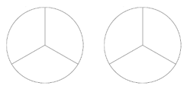
Thus, 6 thirds is equivalent to 2 whole circles.
In other words, 6 boxes each holding$\frac{1}{3}$ of a pizza equals 2 whole pizzas when combined. There are 2 whole pizzas left over.
- The Relay Problem (Length/Measurement Models)
“During a relay race, 12 runners will each run $\frac{1}{4}$ of a mile. How many miles will the runners run altogether?”
Using fractions strips, select 12 strips that show $\frac{1}{4}$.
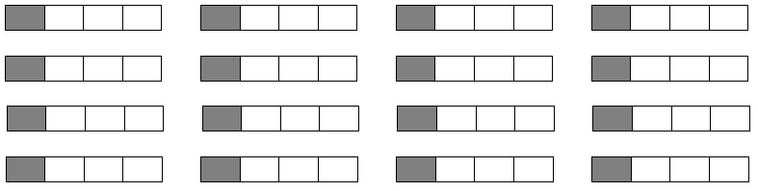

We can rearrange the twelve shaded fourths and completely fill in 3 of the fraction strips. Each strip is $\frac{4}{4}$, or 1 mile, so we have 3 miles.
We can also arrange the strips that are completely shaded in a line, like a ruler or number line, and mark off every 4 fourths for each whole mile.
Thus, if 12 runners each run $\frac{1}{4}$of a mile, they will run a total of 3 miles.
- The TV Problem
“Karen's mother limits her TV watching to half an hour each weekday. What is the maximum number of hours that can be watched over two weeks (10 weekdays) if she sticks to the limit?”

We can use fraction circles to model this problem. If Karen watches $\frac{1}{2}$ an hour of TV for 10 days, we need 10 half circles represent each day of TV watching. Each piece represents half an hour.
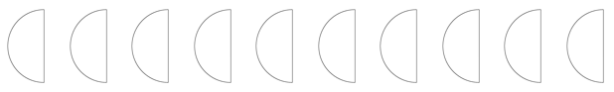
We know that 2 halves make 1 whole, so we can group 2 half circles together to represent whole hours.
These pieces form 5 whole circles, representing 5 hours.
Thus, $\frac{1}{2}$ × 10 = 5. Karen is allowed to watch 5 hours of TV over 10 weekdays.

Problems with Non-Unit Fractions and Whole Numbers:
- The Farm Problem
“A farmer planted 10 fields of vegetables. Of the fields he planted, $\frac{3}{5}$ were planted with cabbage. How many fields of cabbage did the farmer plant?”

On centimeter grid paper, draw 10 rectangles with an area of 5 squares each to represent 10 vegetable fields. To show $\frac{3}{5}$ of each, shade in 3 squares in each rectangle.
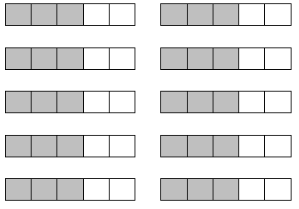
We know that $\frac{5}{5}$ = 1 whole, and we have 30 fifths (squares) shaded. To determine how many whole fields this is, organize and rearrange the 30 squares in groups of 5.
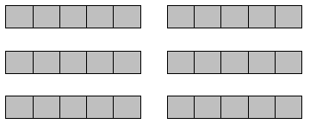
We can now see that 10 fields with $\frac{3}{5}$ planted with cabbage is equivalent to 6 full fields of cabbage. 10 $×\frac{3}{5}$ = 6
- The Basketball Problem
“Terrence’s basketball coach said that he will play only the first three quarters of every game. If there are 8 games during the season, how many full games will Terrence play?”
Any fraction manipulative could be used to model $\frac{3}{4}$ of 8 games. The models should show $\frac{3}{4}$ of one whole, repeated 8 times.

The fourths (24 of them) should then be reorganized and grouped to form wholes ($\frac{4}{4}$). There should be 6 wholes once the grouping is done.

Symbolically, $\frac{3}{4}$ $×$ 8 = 6. Terrence will play 6 full games.

