Mathematics Instructional Plan – Grade 5

Exploring Angles
Strand: Measurement and Geometry
Topic: Classifying and measuring angles
Primary SOL: 5.12 The student will classify and measure right, acute, obtuse, and straight angles.

Materials

Pattern Blocks Shapes Template (attached)

Exploring Angles Recording Sheet (attached)
- Combining Angles activity sheet (attached)
- Large straightedge, such as a meter stick
- Protractors or angle rulers
- Rulers
- Pattern blocks, or copies of the pattern block template (attached)

Vocabulary
acute, angle, degree, hexagon, intersect, measuring tool, obtuse, ray, rhombus, right, square, straight, straightedge, trapezoid, vertex

Student/Teacher Actions: What should students be doing? What should teachers be doing?
- Begin by asking, “What is an angle?” Allow students to share their ideas. Have students form angles with their arms. Discussion should lead to a formal definition of an angle they may recall from Grade 4: two rays that share a common endpoint called the vertex form an angle. Angles are also found wherever lines or line segments intersect.
- Identify right angles around the classroom. Ask, “What do you know about right angles?” Students should be able to share that right angles look like the corner of a square or a piece of paper. They may recall from Grade 4 that perpendicular lines cross to form four right angles.
- Have students coach you to draw a pair of perpendicular lines on the board using a straightedge. Identify the right angles formed by the lines. Ask, “Does anyone know the measure of a right angle?” Some students may know the answer is 90 degrees.
- Introduce protractors or angle rulers to the students. Demonstrate how to measure one of the angles formed by the perpendicular lines.
  - Place the center of the protractor or angle ruler at the vertex.
  - Line up the bottom edge of the protractor or bottom angle ruler along one of the angle’s rays.
  - Note where the second ray crosses the protractor, or where the second ray meets the center of the second ruler of the angle ruler. Notice that the angle is at the 90 ark.
- Have students draw a 90-degree angle on their papers using straightedges. Allow elbow partners to take turns measuring the angles their partners have drawn. Students can make adjustments when necessary in order to create an accurate 90$°$angle. The teacher should circulate around the room, observing and assisting if needed.
- Direct students to notice the degree markings on their protractors or angle rulers. Ask, “What is the smallest degree you see on your protractor/angle ruler?” “What is the largest degree you see on your protractor/angle ruler?” (Note: Some protractors and angle rulers may not have zero or 180 written on them; however, it can be implied by the other markings that zero is the smallest degree and 180 is the largest degree on each measurement tool.) Explain to the class that some angles may measure between zero and 90 degrees, and these are called acute angles. Other angles may measure between 90 and 180 degrees, and these are called obtuse angles.
- Draw two angles on the board using a straightedge, deliberately drawing one acute and one obtuse angle. Ask, “What type of angle did I draw here? How do you know?” Allow students to share their ideas, guiding them to compare each angle to a right angle. “Does this angle appear to be larger or smaller than a right angle?” Use a protractor/angle ruler to verify each angle measure in order to categorize each as acute or obtuse.
- Draw a straight angle on the board, and ask, “What do you think the measure of this angle is? How do you know?” Students should recognize on their protractors/angle rulers that this angle measures 180 degrees, which the teacher can define as a straight angle.
- Have students draw an acute angle, an obtuse angle, and a straight angle on their papers using straightedges. Have students switch papers with an elbow partner, and have them measure and record the degrees of each angle and identify each angle as obtuse, acute, or right. As students are working, the teacher should circulate around the room to observe and assist when needed.
- Activity: Pass out piles of pattern blocks to each group, and the attached Exploring Angles Recording Sheet to each student. Briefly have students identify the shapes of each block. Have students work with elbow partners to trace each shape and use a protractor or angle ruler to measure the angles of each shape. It may be helpful for the teacher to demonstrate how to use the straightedge to extend the rays of each angle so that the rays cross the measurement tool markings; this will help students get a more accurate measure for each angle. After groups have finished measuring the angles of each shape, allow students to share the angle measures they found for each shape. For example, the red trapezoid has two acute angles measuring 60 degrees and two obtuse angles measuring 120 degrees.
- Combining angles: Ask, “What would be the measure of an angle when two right angles are combined?” Challenge students to use pattern blocks to explore this. Students should notice that the orange squares have 90-degree angles. Allow elbow partners to discuss the combined angles, then discuss as a class. Students should recognize that two right angles together form a straight angle and should be able to show this with the orange squares. Guide students to the equation 90$°+$90$°=$180$°$.
- Ask, “Can you use the pattern blocks to form another straight angle?” Have students put blocks together, trace them, write down the measure of each angle, and show the sum of the angles. For example, they might discover that a blue trapezoid and a yellow hexagon have angles that form a straight angle (60$°+$120$°$= 180$°).$ Challenge students to find as many combinations of blocks that form straight angles as they can. Students may discover that they can form straight angles with more than two blocks, such as two white rhombi and one yellow hexagon, or three blue rhombi.
- Allow students to share the shapes they combined and the measures of the angles of the shapes they combined.
- Optional: Combining Angles activity sheet.

Assessment

Questions
- What is an angle?
- What are the characteristics of the different types of angles (acute, right, obtuse, and straight)? Draw an example of each.
- Two angles form a straight angle. One angle measures 45 degrees. What will the other angle measure? Explain how you know.

Journal/writing prompts
- Draw one of each of the four different special types of angles, label them, and include the measure of each angle.
- A friend does not know how to draw the different special types of angles. Describe how each one should be drawn.

Other Assessments
  - Challenge students to combine pattern blocks to form obtuse angles.
  - Challenge students to combine pattern blocks to form acute angles.
  - Ask students to find objects or things in the classroom that have right, acute, obtuse, or straight angles.
  - Complete the following by filling the term that makes the statement true: _____angles have a measure greater than 90 degrees, ______angles have a measure of 90 degrees, and _______ angles have a measure of less than 90 degrees.

Extensions and Connections (for all students)
- Find letters in the alphabet that have the different types of angles (acute, obtuse, right, and straight). Draw the letters and measure the angles.
- Using pipe cleaners, make each of the angles (acute, obtuse, right, and straight), and glue them to a piece of paper. Label each of the angles and include the measure of each angle.
- Using the hands of a clock and a protractor, have students find the angle of the following times: 1:00, 2:00, 3:00, 4:00, 5:00, and 6:00. Is there a pattern?
- Create a picture by using the various special types of angles.

Strategies for Differentiation
- Students need to be engaged in measuring, discussing, and exploring angles in various shapes and real-world objects. Use a graphic organizer for students to organize the many terms they must know. As new terms and symbols are introduced, the students can add the information.
- Other helpful tools to use in your classroom for creating a word wall are the VDOE Mathematics Vocabulary Word Wall Cards created by the Office of Science, Technology, Engineering & Mathematics.

Term | Picture or Representation | Definition | Symbol | Real-world Examples

Note: The following pages are intended for classroom use for students as a visual aid to learning.

Virginia Department of Education ©2018

Pattern Blocks Shapes Template
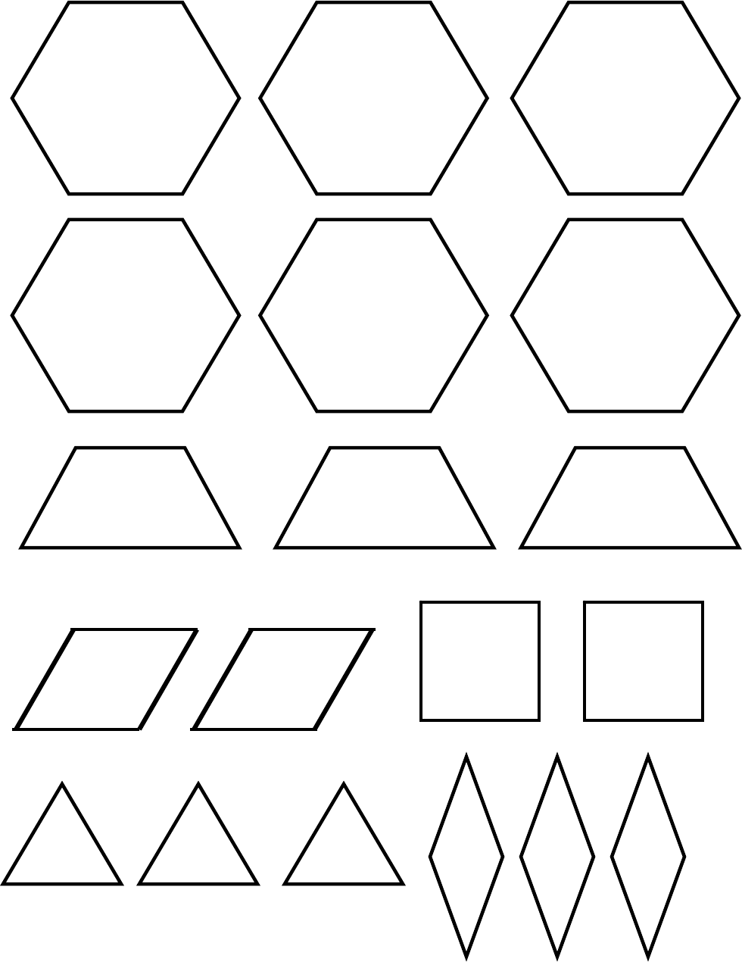

Exploring Angles Recording Sheet
Name __________________________________ Date___________________
Shape | Tracing | Measure of each angle | Classification of each angle
Yellow hexagon
White rhombus
Red trapezoid
Blue rhombus
Orange square
Green triangle
On a separate sheet of paper, show the different pattern block combinations you can find that form straight angles. Trace the shapes, label the angle measures, and write out the addition equation for the angle measures.

Combining Angles
- Use the figures below to answer the following questions. Show your work when finding the measure of the unknown angle.
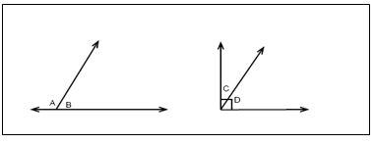
Observe:
  - Angle A looks like an _________ angle.
  - Angle B looks like an __________angle.
  - The two angles joined together make a __________ angle.
  - If the measure of angle B is 85°, what is the measure of angle A? Explain your thinking.

  - Angle C looks like an _________ angle.
  - Angle D looks like an __________angle.
  - The two angles joined together make a __________ angle.
  - If the measure of angle C is 30°, what is the measure of angle D? Explain your thinking.

- Think about different kinds of tasks and careers that may use angles. Write down the task or career and how angles are used, how many can you think of?

