Mathematics Instructional Plan – Grade 5

What Time Is It?
Strand: Geometry and Measurement
Topic: Determining amount of elapsed time and beginning and end time
Primary SOL: 5.11 The student will solve practical problems related to elapsed time in hours and minutes within a 24-hour period.

Materials
- Classroom demonstration clocks
- Classroom schedule

Vocabulary
beginning time, elapsed time, ending time, hours, minutes

Student/Teacher Actions: What should students be doing? What should teachers be doing?
- Begin by asking students the current time. Then, ask what time lunch begins (or another transition or subject change in your class schedule). Ask, “How much longer will it be until then?” Allow students to discuss this with an elbow partner, allowing them to use demonstration clocks if they choose. Ask volunteers to share their answers and explain them. Come to a class consensus on the amount of time that has passed, or elapsed, since lunch or will pass, or elapse, until lunch.
- Ask, “In this situation, what was the beginning time?” “What was the ending time?” “And what was the elapsed time?” Demonstrate using a simple timeline what this situation might look like. (Example times are included here; the teacher should insert times used in the situation the class discussed.)
Elapsed time: 3 hours, 15 minutes
- Create a simple scenario involving minutes only, such as how much time has passed since the school day started. A sample situation might be,
“The bell rang to start school at 7:40 a.m. It is now 8:22 a.m. How much time has elapsed? “
Ask students, “In this situation, do we know the beginning time, ending time, or elapsed time? What will we need to find?” Students should recognize that we know the beginning and ending times, and we will need to find the elapsed time.
Ask students to try to find the elapsed time using a timeline. Ask, “Which of the three times can we include on our timeline?” Because we know the beginning and ending times, we will need to find the elapsed time.
Elapsed time: ?
- Allow pairs of students to discuss how to use a timeline to determine the elapsed time. As they are working, the teacher should visit small groups, providing hints, such as breaking the timeline into chunks and using whole hours as landmarks. For example, adding 20 minutes will get us to the “on-the-hour” landmark of 8:00 a.m. (This can be shown on the demonstration clock.) Thus, mark “8:00 a.m.” near the middle of the timeline.
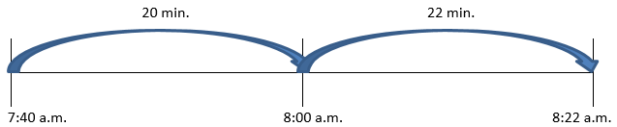
Solution: From 7:40 to 8:00, there is an elapsed time of 20 minutes. Getting from 8:00 a.m. to 8:22 a.m. would require an elapsed time of 22 minutes. By adding 22 minutes to the previous 20 minutes, the total is 42 minutes. Thus, the amount of elapsed time between 7:40 a.m. and 8:22 a.m. is 42 minutes.
- Next, create a scenario that involves computing hours and minutes, such as the amount of time you are at school each day. For example, “You arrive at school at 7:35 a.m. each day. You leave school at 2:13 p.m. How long are you at school each day?” Use the timeline strategy for this problem.
- Have students identify which of the three times are given, and what must be found (beginning and ending times are given, and elapsed time must be found). Encourage students to use the timeline strategy for this situation.
Beginning time: 7:35am Ending time: 2:13pm
Elapsed time: ?
Solution: Begin marking the timeline, counting by hours, marking the new time and how many hours have elapsed. (It will be helpful to emphasize counting the “jumps” rather than the marks.) On the timeline, students can count the six hours that have elapsed. It is important that students note that from 11:35 to 12:35, the time changes from a.m. to p.m. Ask students, “Who can explain what happens when time crosses over 12:00?” Allow students to explain.
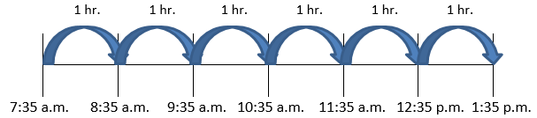
Next, continue the timeline to count minutes. Below is one possible way minutes can be counted. Students can add up the total number of minutes on the timeline (38 minutes).
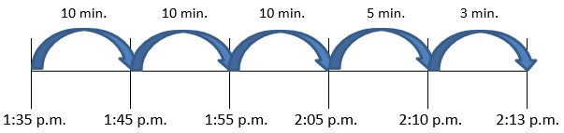
Thus, the amount of elapsed time between 7:35 a.m. and 2:13 p.m. is 6 hours, 38 minutes. Allow students to share different ways they computed the time between 7:35 and 2:13 on their timelines.
- Present other situations that involve finding the beginning time or ending time. As part of planning their solutions, have students list the times that are given and identify the time that is being found. Allow students to work in partners to solve these problems using a timeline. Allow students to share their solutions with the class.
- Unknown Ending Time: The Jones family left for vacation at 7:35 a.m. Their car ride lasted 6 hours and 38 minutes. What time did their car ride end?
SOLUTION:
Beginning time: 7:35 a.m.
Ending time: ?
Elapsed time: 6 hours and 38 minutes
On the timeline, students can mark the starting time. Next, mark off six hours.
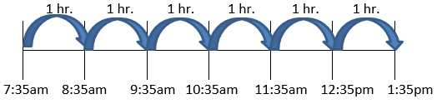

Next, students will need to show 38 minutes elapse. A sample timeline for minutes could be:
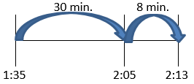
Thus, if the car ride began at 7:35 a.m. and lasted 6 hours and 38 minutes, then the car ride ended at 2:13 p.m.
- Unknown Beginning Time: A movie marathon ended at 7:48 p.m. It lasted 10 hours and 35 minutes. What time did the movie marathon begin?
SOLUTION:
Beginning time: ?
Ending time: 7:48 p.m.
Elapsed time: 10 hours and 35 minutes
To solve this problem, we can work backward on a timeline. Draw a timeline, and mark the ending time as 7:48 p.m.
Elapsed time: 10 hrs. 35 min.
Next, start counting backward for 10 hours.

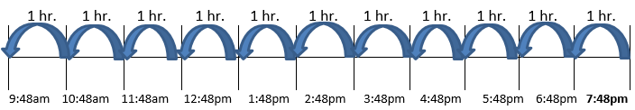
From 9:48 a.m., we can work backward for 35 minutes.
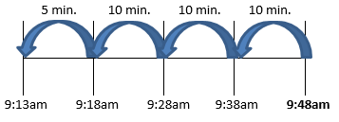
Thus, the movie marathon began at 9:13 a.m.

Assessment

Questions
- If you get on a train at 9:11 a.m. and your train ride lasts 11 hours and 57 minutes, at what time will you reach your destination? Show how you found your answer.
- A concert lasted 4 hours and 46 minutes, and it ended at 9:15 p.m. What time did the concert start? Show how you found your answer.
- Mario’s plane left San Francisco at 11:32 a.m. and arrived in Washington, D.C., at 4:15 p.m. How long was Mario’s flight? Show how you found your answer.
- Journal/writing prompts
  - Create an elapsed-time situation where the elapsed time is unknown. Trade problems with a classmate, and challenge each other to solve them.
  - Create an elapsed-time situation where the ending time is unknown. Trade problems with a classmate, and challenge each other to solve them.
  - Create an elapsed-time situation where the start time is unknown. Trade problems with a classmate, and challenge each other to solve them.

Other Assessments (include informal assessment ideas)
  - Have students document the time they wake up and go to sleep on a particular day. Students can then compute how much time they were awake on that day.
  - Have students document the time when they go to bed and when they wake up. How long did they sleep last night?
  - Students make a schedule of their school day and figure out the elapsed time of each subject or activity. Display in the classroom.

Extensions and Connections (for all students)
- Have students create elapsed-time situations using television guides from newspapers and magazines. Have students trade problems to solve.
- Randomly, throughout the school day, announce, “Start time!” and have students record the time. Later, announce, “End time!” and have students compute the amount of time elapsed. Do this activity daily for several weeks, and periodically throughout the weeks following elapsed-time instruction.
- Have students represent start and end times using demonstration analog clocks and compute elapsed time using these clocks.
- Have students create a story problem with multiple elapsed times and find the beginning or ending times.

Strategies for Differentiation
- Distribute model analog clock manipulatives to students. Ask students to show different times to show on their clocks, starting with hour, half-hour/30-minute, and quarter-hour/15-minute times. When students can do this successfully, ask questions such as hour, half-hour/30-minute, and quarter-hour/15-minute increments earlier and later.
- Have students count on by one hour to find the elapsed time between 1:00 p.m. and 6:00 p.m. Then have students count by fives to find the elapsed time between 1:00 p.m. and 1:35 p.m. Make sure students understand that there are 7 groups of 5 between 1:00 and 1:35, so 7 x 5 = 35 minutes have passed. Students can use the model of an analog clock.
- Review minute and hour abbreviations along with a.m. and p.m. meanings.
- When using the time line strategy, provide specific steps for students to follow.

The following pages are intended for classroom use for students as a visual aid to learning.

Virginia Department of Education ©2018

