*Mathematics Instructional Plan – Grade 4*

# Statistics: Sandwich Data

Strand:Probability and Statistics

Topic:Analyzing, interpreting, and comparing data presented in charts and bar graphs.

Primary SOL:4.14 The student will

* + - 1. collect, organize, and represent data in bar graphs and line graphs;
      2. interpret data represented in bar graphs and line graphs; and
      3. compare two different representations of the same data (e.g., a set of data displayed on a chart and bar graph, a chart and a line graph, or a pictograph and a bar graph).

## Materials

* Sandwich Data 1 activity sheet (attached)
* Sandwich Data 2 activity sheet (attached)
* Variety of five snack-size chip bags per group (for comparison purposes)
* Grid template (attached)
* Scaffold Bar Graph Template (attached)
* Chart paper or large sheet of paper per group
* Tape or glue per group
* Sticky notes

## Vocabulary

*analyze, bar, bar graph, category, chart, compare, data, horizontal axis, inference, survey, tally mark, tally table, vertical axis*

## Student/Teacher Actions: What should students be doing? What should teachers be doing?

1. The purpose of the first activity is to help students understand the value of using charts and graphs to display data in order to more quickly analyze and make comparisons and inferences. *Note:* *Throughout the lesson, emphasize that data is collected, displayed, and analyzed in order to answer questions*. The activity also highlights that charts are better for answering some questions and bar graphs are better for others.
   1. Divide the class into two groups, placing one at the front of the classroom and the other at the back. Distribute the Sandwich Data 1 activity sheet to each student at the front and the Sandwich Data 2 activity sheet to each student at the back. When distributing, place the sheets face down on the desks, and instruct students not to turn the papers over.
   2. Tell students that you are going to ask some questions about sandwiches and that the answers are contained in the information on the handout. Give a signal for students to turn their papers over; begin asking questions one at the time (see below). Keep a record of which group has more hands up first, anticipating that those who have the data in chart and graphical form will respond first. Call on the first student who raises his/her hand to answer the question.

* What kind of sandwich was preferred by the most people?
* Who likes Jelly and Fluff sandwiches the best?
* What kinds of sandwich(es) were preferred by only two people?
* What kind of sandwich did Oliver prefer?
  1. After establishing that students in one group did better than those in the other, reveal that the handouts were not the same. Ask the students to pair up so that there is a person from each group working together. Distribute the alternate handouts so that each student has a copy of both. Also, post the four questions posed to the two groups. Ask the partners to discuss the following.
     + Why was the Sandwich Data 2 handout group able to answer the questions more quickly?
     + Think about the four questions asked to the groups and decide whether it matters that information is in a chart or in a bar graph, and if it does matter, when does it matter?
  2. Lead the students in a discussion about the reasons one handout is quicker to read and easier to understand than the other. They should conclude that the data in the bar graph is quicker to read and easier to understand than the data in the narrative because the bar graph groups and categorizes the important information simply and clearly. And they should conclude that the chart was more valuable for questions about particular people, but the bar graph was more helpful when the question was about how many, because in the bar graph the particular person who voted for each sandwich is not named. Bar graphs show the categories and the number of votes. Share with the students that bar graphs are a way to summarize the data displayed in a chart.
  3. Remind students that when they construct their own charts and bar graphs they need to include a title. The bar graphs show the categories on the horizontal axes and the scale on the vertical axis.
  4. Instruct students to summarize this activity in their mathematics journals and discuss the value of charts and bar graphs.

1. In the second activity, students will have a chance to collect their own data and display the data in charts and bar graphs to represent their findings. Remind students that the reason we collect data is to answer a question. Let students know that they will be doing an investigation and collecting data, but first, we need a question to investigate. Students will need access to five different types but similar snack-size chip bags.
2. Have students examine the bags and determine what kind of data could be collected on the chips. Use the information on the bags in order to learn more about how the different kinds of chips compare to each other. After a few minutes, ask the groups to share and record their suggestions on the board. The class may suggest some the following examples of investigation possibilities for comparing the bag contents.

* grams of fat, sodium, protein, calories, etc., per bag
* number of whole chips per bag
* number of ingredients per bag
* number of calories per bag

1. Each group will select one of the suggestions to investigate. The group will use a sheet of notebook paper to prepare a chart to collect, categorize, and organize the data and then use the grid paper to construct a bar graph.

* Instruct students to tape or glue their chart and their bar graph to the chart paper.
* Then the group is to analyze and interpret their bar graph and discuss what the data in their graph communicates. On the chart paper they are to record a few sentences to describe their analysis and interpretation of the data.
* Then they are to write at least three questions that can be answered based on their graphs.

1. Assign each group a different number to display on their chart, and have the groups will display their charts in numerical order around the class room for a gallery walk. Each group will receive four sticky notes and a pencil to carry on the gallery walk. Organize the gallery walk so that each group starts at a poster that is to the right of their own. Circulate among students during this time, noting any comments in the conversations that need to be highlighted or addressed during the whole-class closure.
   * The groups have 3–5 minutes to review the other groups’ work and answer only oneof the questions using their sticky note. After the allotted time, the groups will shift so they move to the next group’s poster and have 3–5 minutes to review the work and use one of their sticky notes to answer one of the questions that has not been answered or post an alternative to an answer that has already been posted. There will be two more shifts, so each group will visit four other groups’ poster.
   * Student groups should now move back to their own poster to read and discuss the sticky note answers that were left on their poster.
2. Teachers will use the posters and students’ work to develop questions that will help facilitate a class discussion to address ideas and misconceptions heard during the gallery walk, as well as key points about data collection and analysis and graphing that students need to understand.
3. Exit card prompt: What are two ideas that have become clearer for you today, and how have they become clearer? What is one question you still have about the mathematics ideas in this lesson? Review the responses to help determine next instructional steps.

## Assessment

### Questions

* In the sandwich data bar graph, what are the important parts?
* Could the sandwich data be displayed on other types of graphs, such as a line plot or a picture graph? Why, or why not?
* What inferences can you make from the data displayed in the different snack-size chip bag graphs?
* What questions do your group’s chip bag comparison chart and graph answer?

### Journal/writing prompts

* Create your own bar graph to display the same information on the sandwich handout, and include your own sandwich choice. You may choose to turn the graph horizontally and give the graph a different but still appropriate name. The information must be appropriately displayed with all graph requirements included. Then, write two questions that can be answered by reading your graph.
* Identify some places where we typically find graphs. Make a list of the places, and explain some purposes of these graphs.

### Other Assessments

* Create and title your own chart and bar graph to display the data for a chip bag investigation different from the one you did with your group. You may choose to turn the graph horizontally. The information must be appropriately displayed with all graph requirements included. Write two sentences recording your analysis of the graph’s information and two questions that can be answered by reading your graph.

## Extensions and Connections (for all students)

1. Challenge students to find different types of graphs (e.g., bar, line, circle, or pie) in magazines, newspapers, and various other publications. Have them create a poster or display of the graphs they find and write an explanation of the use of each one under it.
2. Have students work individually or in groups of two or three to collect data on topics of their choice (e.g., favorite sandwich choice, favorite fast food restaurant, favorite ice cream flavor, favorite after school activity). Have them first categorize the data they collect by using a chart. Then, have them create appropriate bar graphs to display the organized data. Instruct them to write two or more questions that can be answered by reading the graphs.

* Students can go to the interactive [Create A Graph](https://nces.ed.gov/nceskids/createagraph/)from the National Center for Education Statistics, and select the "Bar Graph" option to construct bar graphs.

## Strategies for Differentiation

* Ensure that groups of students include fluent readers in addition to the slower readers.
* Strategically place students in groups to create their own graphs.
* Redirect and give corrective feedback throughout lesson.
* Use the Scaffold Bar Graph template.

**Note: The following pages are intended for classroom use for students as a visual aid to learning.**

Virginia Department of Education ©2018

**Scaffold Bar Graph**

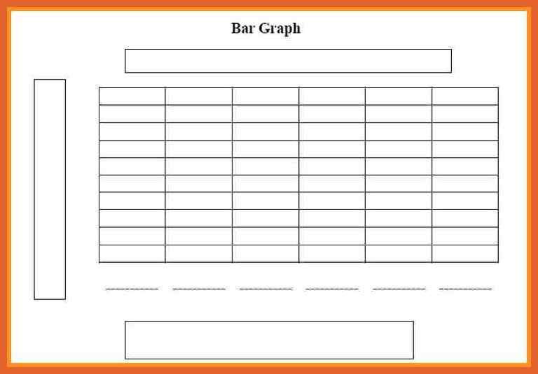

Decorative **Sandwich Data 1**

**The Lunch Bunch’s Favorites**

Laura liked peanut butter and jelly. Kenny liked plain jelly. Oliver also liked plain jelly. Kate and David liked plain peanut butter. Oh, I forgot to mention that Steve, Isabel, and Sam also preferred peanut butter and jelly. Kristen liked peanut butter and fluff. Mariko liked plain fluff, while Sally and Ty liked jelly and fluff.

MC900334424[1] **Sandwich Data 2**

**The Lunch Bunch’s Favorites Chart**

| **Sandwich Types** | **Voting Students** |
| --- | --- |
| Plain Peanut Butter | David, Kate |
| Plain Jelly | Oliver, Kenny |
| Plain Fluff | Mariko |
| Peanut Butter and Jelly | Isabel, Steve, Sam, Laura |
| Peanut Butter and Fluff | Kristin |
| Jelly and Fluff | Ty, Sally |

