Probability: Sweet as Candy
Strand: Probability and Statistics
Topic: Create models to represent a given probability.
Primary SOL: 4.13 The student will
- determine the likelihood of an outcome of a simple event;
- represent probability as a number between 0 and 1, inclusive; and
- create a model or practical problems to represent a given probability.

Materials
- Square tiles or pieces of square construction paper
- Dry erase boards
- Crayons (optional)
- Gumball Machine activity (attached)
- Gumball Machine activity alternative (attached)

Vocabulary
certain, equally likely, event, fraction, impossible, least likely, likelihood, likely, most likely, outcomes, probability,

Student/Teacher Actions – What should students be doing? What should teachers be doing?
- Create enough bags of square tiles for partners to share prior to the lesson. Use square pieces of construction paper if square tiles are not available. Each bag should have 10 red square tiles, 10 blue square tiles, 10 yellow square tiles, and 10 green square tiles. These square tiles will be used to create “bags of candy” to model a given probability. Answers may vary and should be discussed as a class.
- Group the students into teams of two, and give each group a bag of squares tiles to use during the activity. Tell the students that together they are to use the tiles to create several different bags of candy based on the given probability. For each activity either write the problem on the board or share on the document camera.
- Have students pile the tiles in the middle of their desks and then instruct the students to create a bag of candy where the probability of selecting a blue piece of candy is $\frac{7}{8}$. They should create this bag of candy with their partner and display it on their desk. Have the students share their model with the class. All students should have a model where the chances of selecting a blue piece of candy is $\frac{7}{8}$. The remaining piece of candy in the bag may be different for each group. Possible models shown below.
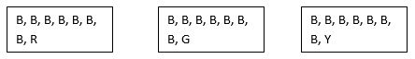
Using the dry erase board have the students answer the following questions. What term can be used to describe the likelihood of selecting a blue piece of candy? What fraction can be used to describe the probability of selecting a piece of candy that is not blue?
- After creating each bag of candy and discussing the probability as a class, have the student remove the tiles from the bag and put them back in the pile in order to get ready to create another model based on the given probability.
- Write directions on the board, create another bag candy where the probability of selecting a red or yellow piece of candy is equally likely and the probability of selecting each piece is $\frac{2}{8}$. Ask students if they have questions about the instructions. Once the students have created the bag. Ask the students how they determined the number of red and yellow pieces of candy in the bag. What is the probability of selecting a blue or green piece a candy in your bag? Do you think everyone will have the same answer? Why or why not? Sample responses are shown below.

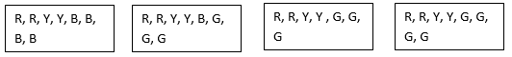
- The third activity asks the students to create another bag of candy where the probability of selecting a red piece of candy is $\frac{7}{10}$ and the probability of selecting a yellow, green or blue piece of candy is equally likely. What is the likelihood of selecting a green piece of candy? How many blue pieces of candy are in the bag? Sample response is shown below.
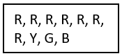
- The fourth activity asks the students to create a bag of candy where it is equally likely to select a green, blue, red, or yellow piece of candy. Some sample responses are shown below.
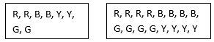
How many pieces of candy are in your bag? Did everyone in the class have the same total amount of candy on their bag? Why or why not? What strategies can we use to determine that the different colors of candy are equally likely to be chosen? What if I had 20 pieces of candy in the bag and each of the 4 colors were equally likely, how many of each color are in the bag?
- Have the students create one more bag of candy. Tell the students that this bag has 12 pieces of candy. It is likely to select a blue piece of candy, but it is impossible to select a red piece of candy. It is also equally likely to select a green or yellow piece of candy. Create a model to represent the candy in the bag. Once the students have created a model, ask the students the following questions. What is the probability of selecting each color of candy as a fraction? How many pieces of red candy is in the bag? Do you think there is more than one way to model this problem? Explain your answer. Next have the student share the bags of candy that they modeled based on the given probability. If the students didn’t discover more than one way, have the students revisit the problem to see if they can create another model. Some sample responses are shown below.
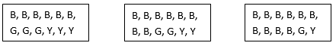
- Next tell the students that they are going to work together with a partner to create a gumball machine. Give each student or partner the Gumball Machine handout (attached) to solve. Tell the students that they can use crayons or write the initial of the color in each gumball. Once they have the completed the gumball machine, have the students write the probability of each color as a fraction in the table provided. Encourage students to use the tiles to decide how many gumballs of each color they need to show on their paper.
- Once the students have completed the gumball activity, ask the students to share the different strategies they used to solve the problem. Was there a particular gumball color you were able to figure out first? Why? Which color was the hardest to determine? Is there more than one way to solve this problem? Looking at the given probability how many gumballs in the machine could be yellow or blue? Could there be 3 blue and 3 yellow pieces of gum in the machine? Since the white color gumball is the least likely to select, then there can only be 4 or 5 yellow and blue gumballs in the machine.
- Have the students create a problem, similar to the gumball machine. Tell the student to list several different probability statements and create a model that would represent the given probability.

Assessment

Questions
  - When the probability of two events is written as the same fraction, what term can we use to describe the likelihood of those events occurring?
  - Can there be more than one way to create a model to represent a given probability? Why or why not?

Journal/writing prompts
  - Explain how a bag of M&M’s is an example of probability. If your bag of M&M’s has 24 pieces of candy, draw your bag and list the total number of colors in each bag. Write the probability of selecting each color as a fraction.
  - Draw a bag of candy where the probability of selecting one color is $\frac{3}{9}$ and the other color is $\frac{6}{9}$.

Other Assessments
  - If I have a bag of candy and the probability of selecting a red is impossible, what could the bag of candy look like?
  - I have 4 pink jellybeans, 3 yellow jellybeans, 5 green jellybeans, and 4 blue jellybeans. What is the probability of selecting a yellow jellybean? Write two probability statements about the jellybeans.

Extensions and Connections (for all students)
- Have students use the bag of square tiles to create their own probability statements that other could use to create a model to represent the given probability.

Strategies for Differentiation
- Use the Gumball Activity alternative handout.
- Provide experience with pulling tiles out of a bag to try to figure out what part of the tiles are each color. For example, put two red tiles and 6 blues tiles in a bag and tell the students that there are 8 tiles in the bag. Ask them to make 15 pulls out of the bag where they will pull out one tile at the time and write the color down, then replace the tile. After the 15 pulls they should write a fraction for what part of the tiles in the bag are red and what part of the tiles are blue. Teachers make up various combinations so that students have multiple experiences.

Note: The following pages are intended for classroom use for students as a visual aid to learning.

Virginia Department of Education ©2018

Gumball Machine
Directions: Use the clues below to color the gumballs in the gumball machine that is shown below. Use crayons to color each gumball or write the initial of each color inside the circle, for an example “r” for red. You may want to use color tiles to determine how to color the gumballs.
- There are 24 pieces of gum inside the machine.
- The probability of getting a red piece of gum is $\frac{6}{24}$.
- There are only 5 different colors of gum in the gumball machine.
- The probability of getting a yellow piece of gum is equally likely to getting a blue piece of gum.
- The probability of getting a green piece of gum is $\frac{7}{24}$.
- The white gumball is an odd amount and is the least likely to get.

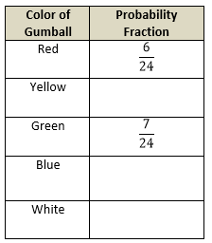
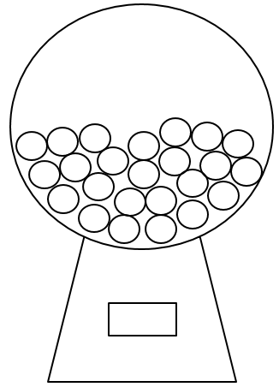

Gumball Machine Alternative
Directions: Use the clues below to color the gumballs in the gumball machine that is shown below. Use crayons to color each gumball or write the initial of each color inside the circle, for an example “r” for red. You may want to use color tiles to determine how to color the gumballs.
- There are 12 pieces of gum inside the machine.
- The probability of getting a red piece of gum is $\frac{4}{12}$.
- There are only 4 different colors of gum in the gumball machine.
- The probability of getting a yellow piece of gum is equally likely to getting a blue piece of gum.
- The probability of getting a green piece of gum is $\frac{2}{12}$.

Color of Gumball | Probability Fraction
Red | $$\frac{4}{12}$$
Yellow
Green | $$\frac{2}{12}$$
Blue

