Mathematics Instructional Plan – Grade 4

How Much Longer? (Elapsed Time)

Strand: Measurement and Geometry

Topic: Determining elapsed time in hours and minutes

Primary SOL: 4.9 The student will solve practical problems related to elapsed time in hours and minutes within a 12-hour period.

Materials
- Elapsed Time Tools activity sheet (attached)
- How Much Longer? Game Recording Sheet (attached)
- How Much Longer? Time Cards (attached, will need to be cut apart)
- How Much Longer? Context Problems (attached)
- Demonstration Analog clock
- Small analog clocks with movable hands for students (Students may also make clocks using paper plates)
- Tag board
- Sheet protectors
- Dry-erase markers, board, wipes
- Index cards
- Thumb tacks
- Stopwatch

Vocabulary
a.m., beginning time, elapsed time, ending time, hour, minute, p.m., o’clock, 12-hour period

Student/Teacher Actions: What should students be doing? What should teachers be doing?
- Present the following word problem to the class: “You are at the movies. The movie started at 3:45 p.m. You look at your watch when it ends, the time is now 5:27 p.m. How long was the movie?” Have students work in pairs to solve this problem. Make timelines and clocks available for students to use. Also, copy the Elapsed Time Tools activity sheet on tag board and put copies in sheet protectors to use with dry-erase markers, if students wish to use them.
- Have pairs of students compare their answers and share their strategies for finding the elapsed time. Discuss with students the tools that would be helpful in completing this task. Ask whether any students used the Elapsed Time Tools activity sheet to solve the problem, and if they did, have them demonstrate how they used it. If none used it, model how to use it to find elapsed time.
- Present another problem for students to solve: “Your mother says you are not getting enough sleep at night. She has demanded a new bedtime of 9:30 p.m. She says you must sleep for eight hours. You go to bed at 9:18 p.m. What time can you get up so that you will get all the sleep your mom wants you to get?” Again, have students solve. This time ask students whether they will use another strategy that was shared to solve the problem, such as a number line, T-chart, or clock. Have students share their answers. If no one used a T-chart, demonstrate how to use it. Also, review how to use the number line method.
Distribute the How Much Longer? Context Problems activity sheet and have students work with a partner to solve the elapsed-time problems. Each group must model how to find the elapsed time, using a timeline and clocks. Students should feel free to use the Elapsed Time Tools and the dry-erase boards to show other methods they would like to share. Circulate around the room and take note of misconceptions or confusion that you want to bring out in the whole-class discussion. Also, identify teams you want to call on to share one of their solutions.
- Address one problem at the time, and invite the students you identified to share one of their solutions about how elapsed time was determined. Ask students whether one method of solving was easier for them than another. Do not encourage addition or subtraction of times because it will often involve regrouping hours and minutes. During the discussion, address misconceptions and confusion you noted while students were working.
- Once groups have shared their methods of solving the problem, have student pairs play the How Much Longer? game using the using the How Much Longer? Time Cards.

Assessment

Questions
  - What are two strategies you can use for determining elapsed time?
  - How is elapsed time relevant to everyday life, and how will it be helpful to you? Give an example.
  - What does a “12-hour period” mean, and what are some examples of a 12-hour period?
  - Can a 12-hour period include a.m. and p.m. times? Why, or why not?
  - Is there more than one way to determine elapsed time? Is there more than one way to solve this problem?

Journal/writing prompts
  - Show your solution to the following problem: “Your mom called at 2:20 p.m. and said she would be home in an hour and 45 minutes. What time will she get home?”
  - Show your solution to the following problem: “It takes you 2 hours and 25 minutes to get to your cousin’s house. If you need to be there for a birthday party that starts at 2:30 p.m., what time should you leave to get there on time?”

Other Assessments
  - Have students show how they used more than one method to determine elapsed time.
  - Have students write their own elapsed-time problems and exchange problems with other students to solve. Have them check for accuracy.

Extensions and Connections
- Pass out index cards showing the times of various events that occur during the day. Use your daily schedule to start with, and expand it with other happenings, if necessary. Post the daily schedule on a bulletin board. When the time of a listed event arrives, the student with the card showing that time will go to the board and tack the card below the event. Then, the students must determine how much time will elapse until the next scheduled event that is listed. Keep dry-erase boards close by for students to determine how much time will elapse.
- Have students look up the starting times for movies at local theaters and determine what time various movies will end, given the starting times and the lengths of the films.
- Incorporate real-world examples of elapsed time into the students’ daily routines on a regular basis. Example: It is now 9:00. How much longer until lunch, mathematics, gym, etc.?

Strategies for Differentiation
- Add additional time cards, as needed.
- Enlarge attached time cards, as needed.
- Have students label each number on a clock with appropriate five-minute intervals.
- If students are not able to use a timeline to solve elapsed-time problems, then model some simple elapse-time problems using a number line. Begin only with hours. Next, move to five-minute intervals. Next combine hours and minutes. Then watch and provide feedback to them as they solve some problems.
- Create and post a vertical or horizontal timeline, using register tape.
- Work on elapsed time in hours and then half hours before beginning elapsed time in hours and minutes.
- Suggestion: Set two clocks to 4:00. The first clock shows the “start” time. Ask a student to move the second clock slowly from 4:00 to 4:30. The second clock will move to show the end time. Using the second clock, ask students to count by fives as you move the minute hand from 4:00 to 4:30. Explain that the elapsed time is 30 minutes, or a half-hour. (Focus on the idea of elapsed time as passing by or goes by).
- Students can view a sample teacher guided lesson on using the timeline method, Elapsed Time-Christine Munafo's Flipped Classroom-4th grade STEM. URL: https://www.youtube.com/watch?v=h6uSv5bw-Lw.

Note: The following pages are intended for classroom use for students as a visual aid to learning.

Virginia Department of Education ©2018

Elapsed Time Tools

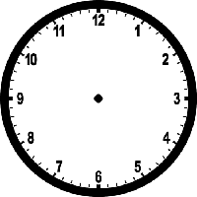

How Much Longer? Game Recording Sheet

Each partner has a recording game sheet. Work with your partner. Place the time cards facedown. One person chooses a card from the deck of time cards. Each player records the starting time and ending time in the chart below. Individually, determine how many hours pass between the two times. Now, record the extra minutes that remain and that will get you to the ending time. Finally, record the elapsed time on the chart. Remember to use a clock, timeline, or your own strategy to determine the elapsed time. When both people are finished, compare answers. If you both have the same answer, you each get 1 point. If you have different answers you must work together to figure out who is correct and why. The person who originally got the correct answer gets 2 points.

Starting  Time | Ending  Time | Hours Passed | Extra Minutes  Passed | Elapsed  Time

How Much Longer? Time Cards

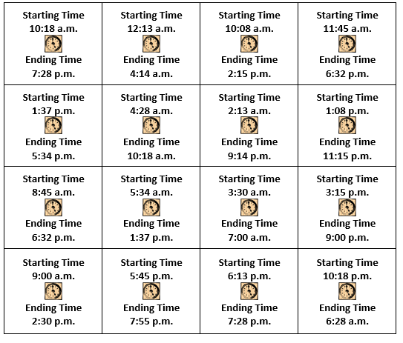

How Much Longer? Context Problems
Name__________________________ Date______________
- Baseball practice begins at 5:30 p.m. The coach says it will last for 2 hours and 45 minutes. It takes 32 minutes to get from the field to home. What time will you arrive at home from practice?

- Your class has a field trip to the science museum. It is a 2-hour and 15-minute bus ride from the school to the museum. The first tour starts at 9:30 p.m. What time should we leave the school to arrive for the first tour?

- Your dad promised that he would take you to the trampoline park if you got all A’s and B’s on your report card. He says he can take you Saturday, but he has to be home by 4:00 p.m. You want to leave at 12:30 p.m. It will take 24 minutes to get there. You want to jump for 3 hours. Will your dad be home in time?

