*Mathematics Instructional Plan – Grade 4*

# Will the Tablecloth Fit?

Strand:Measurement and Geometry

Topic:Solving practical problems involving perimeter and area

Primary SOL:4.7 The student will solve practical problems that involve determining perimeter and area in U.S. Customary and metric units.

Related SOL**:** 4.4a, b, d

## Materials

* Table Measurements activity sheet (attached)
* Manipulative materials (to include, but not be limited to: scissors, centimeter cubes, centimeter grid paper, color tiles, glue, scratch paper, colored pencils/crayons)
* Problem-solving Questions I Need to Ask Myself (Attached)
* Everyday Perimeter and Area Problem-solving Task Cards (attached)

## Vocabulary

*addends, area, area model, array, diagram, factor, formula, length, measure, measurement, perimeter, polygon, product, rectangle, sides, square, sum, unit, width*

**Student/Teacher Actions: What should students be doing? What should teachers be doing?**

*Note: In advance, set up a station or table with materials that can be used by students for problem solving.*

1. Arrange students in pairs. Present the following scenario to students, also described on the Table Measurements activity sheet, which can be projected using a demonstration tool (e.g., document camera, digital display). Allow students to read the scenario independently, then have a volunteer read it to the class. Clarify for the class what a catering company does. It may be helpful to have a tablecloth and demonstrate how it can be placed on a table, in case some students are not familiar with tablecloths.

*Mr. Hill runs a catering company. He has an event today and must set up three tables covered with black tablecloths for the guests. The only rectangular tablecloths that are clean will cover a table measuring 42 square feet, because they are 6 feet wide and 7 feet long. Using a diagram of the available tables, are there at least three tables that can be used for the event that can be covered by the tablecloths? Show your work and justify your solution.*

Distribute the Problem Solving Questions I Need to Ask Myself handout, and ask student pairs to think about the questions. Then ask volunteers to share the team’s thoughts about each question. After clarifying the situation and the question, ask students to help generate vocabulary that could be used to communicate their problem solving clearly on their written artifacts. Create a list of viable words suggested by students. Ask, *“Without giving away a solution strategy or solution to the problem, what mathematics language could be used as part of your solution?”* Allow a few minutes for brainstorming. If the words *length, width, area*, and *perimeter* are not generated by students, suggest these words as potential words to be considered in student work.

1. Have partners work together to determine the solution to the problem. Monitor student conversations to ensure that students do not have misconceptions regarding the meaning of perimeter and area and how each is determined.
   1. As you walk around, identify the solutions to use as the basis for the whole-class discussion. Then, let the partnerships know which solution you want them to draw and label with the dimensions and the area on the board.
   2. Make note as student pairs make connections to determine the sum of the sides of a rectangle to find perimeter efficiently, (2 × the length of the longer side + 2 × the length of the shorter side) and which partners you want to call on during the whole-class debrief about finding area and perimeter.
   3. Also take note as student pairs make connections to multiplication arrays and how area can be found more efficiently by multiplying the length and width of the rectangle together and which partners to call on during the whole-class debrief about finding area and perimeter.
2. Gather students in a whole-group setting to first debrief the solutions to the problem and then follow that conversation with a discussion about what the students uncovered about the processes for finding area and perimeter.
   1. To launch the discussion about the solutions to the problem, invite the partners you selected to record the solution they were assigned on the board. Then facilitate a conversation to have students share how they approached the problem and how they arrived at their solutions.
   2. Next, spark a conversation regarding the connections students made between perimeter and area of rectangular shapes, the various processes students used to find the area, which processes where most efficient, and how the processes are connected to the formula to determine the measurements of perimeter and area.
   3. The formula for finding the perimeter of any rectangle is (l + l + w + w) or (2 × length) + (2 × width), which leads to p = 2l + 2w.
   4. The formula for finding the perimeter of the special rectangle—the square—can be found by (s + s + s + s) or (4 × length of any side), which leads to p = 4s.
   5. The formula for finding the area of any rectangle is length x width, which leads to A = l x w. The formula for finding the area of the special rectangle—the square—is s × s, which leads to A = s x s. The formulas can be connected to the factors in a rectangular array.
3. Prepare students to use the formulas for finding the area and the perimeter of rectangular shapes to solve real-world/contextual problems. Ask students to share situations in real life where someone would need to find the area or the perimeter. Have students share the similarities and differences between the area and the perimeter of rectangular shapes. Then ask student pairs to each make up and write on notebook paper two problems, one that requires finding area and one that requires finding perimeter for a rectangular shape. Student pairs will exchange papers and solve each other’s problems. When the class is finished, have the two pairs come together to discuss the problems and solutions.

## Assessment

### Questions

* + How does using a rectangular open-area model for multiplication help with efficiently determining the area of a rectangular shape?
  + How would you explain how the formulas to determine area and perimeter were developed?
  + Marcus says he has a sheet of plywood that has an area of 72 square inches and it is 8 inches wide and 9 inches long. Paul says he does not think that can be correct because he has a sheet of plywood that is 72 square inches but his piece is 4 inches by 18 inches. What do you think about this situation, and what would you suggest the two friends consider regarding their disagreement?

### Journal/writing prompts

* Describe a situation in which you would need to find the area of a rectangular space or shape.
* You mom wants to carpet the living room. She says she needs to measure the perimeter. Is she correct, why or why not?
* A new student joins the class, and the teacher asks you to explain how the measurements of area and perimeter similar and different.

### Other Assessments

* + Monitor students closely as they work on the problem to discover and correct misconceptions regarding the measurements of perimeter and area.
  + Analyze student recording sheets for clear and accurate communication of mathematical language associated with perimeter and area.
  + Ask students to talk with several adults and ask them when they use area and perimeter measurements in their work or home life and make of list about what they learn.

## Extensions and Connections

* Write a formula for finding the perimeter of any figure with three or more sides.
* Provide students with a set of Perimeter and Area Problem-solving Task Cards. Students can work with a partner or independently to determine perimeter or area of real-world problems.
* Use tiles to construct five different multiplication arrays that have a total area of 72 square units. What is the perimeter of each array? Which array has the greatest perimeter?
* You are getting a new chicken and you want to build a rectangular pen. You have 18 feet of fencing. What are the possible dimensions of the pen? Which dimensions would you recommend? Why?

**Strategies for Differentiation**

* Encourage students to use tiles or centimeter cubes during the tablecloth activity as needed.
* Encourage students to act out the scenario and to draw out the scenario for enhanced engagement and entry points for problem solving.
* Some of the Everyday Perimeter and Area Problem-solving Task Cards encourage application of the concept of area and perimeter for providing depth of these concepts for high-ability students. Allow these students to work on the “Challenge” cards.

**Note: The following pages are intended for classroom use for students as a visual aid to learning.**

Virginia Department of Education ©2018

**Table Measurements**

Mr. Hill runs a catering company. He has an event today and must set up three tables covered with black tablecloths for the guests. The only rectangular tablecloths that are clean will cover a table measuring 42 square feet, because they are 6 feet wide and 7 feet long. Using a diagram of the available tables, are there at least three tables that can be used for the event that can be covered by the tablecloths? Show your work and justify your solution.

**graphic with rectangles for problem solving**

**Problem-solving Questions I Need to Ask Myself**

* What do I know?
* What do I want to know?
* What information given is important to what I want to know?
* What can I do to find the answer?
* Does the answer make sense for the situation and why?

**Everyday Perimeter and Area Problem-solving Task Cards**

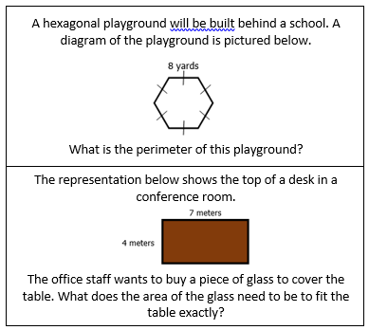

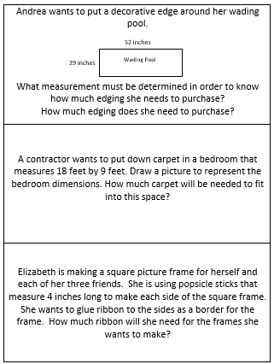

|  |
| --- |
| Sharon is putting down tile in her kitchen. The kitchen is 12 feet by 26 feet. How tile will she need to buy to cover the kitchen floor? |

**Everyday Perimeter and Area Problem-solving Task Cards**

