Mathematics Instructional Plan – Grade 4

Classifying Quadrilaterals
Strand: Measurement and Geometry
Topic: Classifying a variety of quadrilaterals based on properties
Primary SOL: 4.12 The student will classify quadrilaterals as parallelograms, rectangles, squares, rhombi, and/or trapezoids.
Related SOL: 4.10

Materials
- Shapes activity sheet (attached)
- Shapes activity sheet teacher answer key (attached)
- Quadrilateral Property Summary (attached)
- Venn diagram graphic organizer or a pair of hula hoops for comparing and contrasting shapes
- Index cards
- Ruler (optional)

Vocabulary
angles, congruent, equal, exactly, parallel sides, opposite sides, pair, parallelograms, polygon, properties, quadrilaterals, rectangles, rhombi, right angles, squares, trapezoid

Student/Teacher Actions: What should students be doing? What should teachers be doing?
Note: This lesson should be taught after the students have some familiarity with the characteristics and properties that define each of the quadrilaterals.
- Tell the students that you have a mystery quadrilateral, which is the only clue, and that you want the students to try to figure it out. (Have this shape drawn on an index card before the lesson.) The mystery quadrilateral should allow for a class discussion on properties used to classify quadrilaterals, such as angles, parallel sides, and congruency.
- Have students draw what the mystery quadrilateral might look like. Because their only clue is that it is a quadrilateral, students may draw a variety of polygons with exactly four sides. Some of these quadrilaterals may classify as a square, rectangle, trapezoid, rhombus, or parallelogram. Have students share the quadrilateral they drew. Have a class discussion on why there are several different types of quadrilaterals created by the students. Ask the students if they need additional information in order to determine the mystery quadrilateral.
- Before the students ask for additional information, as a class, make a list of properties that you could use to classify or identify the quadrilateral. Next, have the students ask yes or no questions to determine the mystery quadrilateral. Record the following questions on the board for the students to view. Students should be encouraged to alter their original shape drawn at the beginning of the lesson. Sample questions may include: “Are all sides equal?” “Does it have right angles?” “Are opposite sides parallel?” Students should use these descriptions to change their quadrilateral to see if they can create the mystery quadrilateral.
- Once the students have explored all the different properties used to classify quadrilaterals, have the students share their quadrilateral to see if it matches the mystery quadrilateral. Have a class discussion on the importance of using properties of shapes to classify polygons.
- Distribute the Shapes activity sheet. Facilitate a class discussion about each figure and discuss the properties of each. When discussing the properties have the students use the appropriate geometric marking, such as the square in the corner to show a right angle, an equal number of arrows to indicate parallel sides, and an equal number of hash marks to label congruent sides. In addition, encourage students to use terms such as exactly, both, and pair to identify parallel and congruent sides. When looking at each figure individually, discuss and share all of the properties of that particular figure. Make a list of the characteristics and properties for each figure.
- Once the students have finished the geometric marking for that figure, review the definitions of a square, parallelogram, rectangle, rhombus, and trapezoid, and prepare for classifying the figure. Explain to the students that each figure may match more than one definition. Included are some questions you can ask the students to assist in classifying the shape. First, have the students determine whether the shape is a polygon. If the shape is a polygon, then we can identify the number of sides. Ask, “Does this polygon have exactly four sides?” If the answer is yes, then the polygon is a quadrilateral. Once we have determined whether it is a quadrilateral, then we can ask additional questions to classify the quadrilateral. “Does this quadrilateral have both pairs of opposite sides parallel and congruent?” If yes, then the quadrilateral is also a parallelogram. If the answer is no, then ask whether the quadrilateral has exactly one set of parallel sides? If yes, then the quadrilateral is a trapezoid.
- If students classified the quadrilateral as a parallelogram, then ask students whether the parallelogram has exactly four right angles. If yes, then the parallelogram is also a rectangle. If the answer is no, then we can ask the students whether the parallelogram has all sides congruent. If the answer is yes, then the parallelogram is also a rhombus.
- If the parallelogram is a rectangle, then we can ask students, “Does the rectangle have all sides congruent?” If yes, then the rectangle is also a square.
- Continue to work through each figure, identifying the properties and classifying the quadrilaterals.
- Note: Below are the properties of each figure and the classification of each shape.
  - Figure A: both pairs of opposite sides are parallel and congruent. (polygon, quadrilateral, and parallelogram)
  - Figure B: four right angles, both pairs of opposite sides are parallel and congruent. (polygon, quadrilateral, parallelogram, and rectangle)
  - Figure C: four right angles, all sides congruent, both pairs of opposite sides are parallel and congruent. (polygon, quadrilateral, parallelogram, rectangle, rhombus, and square)
- Figure D: exactly one set of parallel sides, two right angles (polygon, quadrilateral, and trapezoid)
- Figure E: exactly one set of parallel sides, exactly one set of congruent sides. (polygon, quadrilateral, and trapezoid)
- Figure F: four congruent sides, both pairs of opposite sides are parallel and congruent. (polygon, quadrilateral, parallelogram, and rhombus)
- Figure G: exactly four sides (polygon, quadrilateral)
- Figure H: curved sides (non-polygon)
- Once all of the figures have been reviewed, ask students, “When classifying quadrilaterals, what are the properties we use to determine the classification of the shape?” “Why are these properties important when classifying these shapes?”
- Have students complete the Quadrilateral Property Summary graphic organizer. Students should work in pairs, but each student needs to use their notes and complete an organizer for their notebooks. You may want to collect this as a quick formative assessment on where each student is in their learning, to make decisions about further instruction.

Assessment

Questions
  - Can all squares also be classified as rectangles? Are all rectangles also classified as squares? Use pictures or words to explain your answer.
  - Explain why figures G and H on the activity sheet do not have any geometric markings? How can we use geometric markings to help use determine the classification of a quadrilateral?
  - How are squares and rhombi similar? How are they different?
  - Can you draw a trapezoid that has two right angles?

Journal/writing prompts
  - Can you draw a quadrilateral where all sides are not equal but has both opposite sides parallel and congruent? Name your quadrilateral. Is there another quadrilateral you can draw to match this description?
  - Using the definition of a trapezoid, draw two different quadrilaterals that are also classified as a trapezoid. Use pictures, words, and geometric markings to support the definition of a trapezoid.
  - Explain why a square is also a rectangle, a parallelogram, and a rhombus.

Other Assessments
  - Provide the student with a group of quadrilaterals and have the quadrilaterals different ways. They should draw the results of the sort and state the attribute(s) they used for the sort. For example, shapes that have four congruent sides and shapes that do not, or shapes with opposite sides both parallel and congruent and shapes that do not have opposite sides both parallel and congruent.
- Have the students use a Venn diagram graphic organizer to compare and contrast different quadrilaterals. Some sample comparisons could include looking at parallelograms and rhombi, rectangles and squares, squares and rhombi, and parallelograms and rectangles.

Extensions and Connections (for all students)
- Have students explore the relationships between the diagonals of each shape.
- Cut strips of tag board about one inch wide in varying lengths. There should be four strips of each length, such as three inches, five inches, six inches, and eight inches. Use a hole punch to make a hole at the end of each strip. Each student will need 4–8 metal paper fasteners to join strips. Students can explore making each of the quadrilaterals. They can also explore which ones you can start with and without unfastening clips but only shifting to change the angles change to a different quadrilateral. This activity can also be completed with straws and pipe cleaners.
- Create an art project or construction using all of the quadrilaterals at least once.
- Walk around the school or your home and neighborhood and take pictures of objects that look like each of the quadrilaterals. Create a poster or picture book using the pictures, and label the picture with the actual object and which quadrilateral(s) you see in the object. Students who do not have access to a way to take pictures can go through magazines and newspapers to find pictures.

Strategies for Differentiation
- Provide students who need extra help with a cutout, large enough to write on, of each type of quadrilateral and a ruler. Write the name of the shape on the cutout and then support students to discover the properties of each shape and write those properties on the shape. When all the cutouts have been described, provide a handout with the definitions of each shape and use the definitions to help students record on the shape other names the shape could be called by. For example, a rectangle is also a quadrilateral and a parallelogram. Students may connect this to having a family (last) name but each person has a special name that identifies who in the family is being referred to.

Note: The following pages are intended for classroom use for students as a visual aid to learning.

Virginia Department of Education ©2018

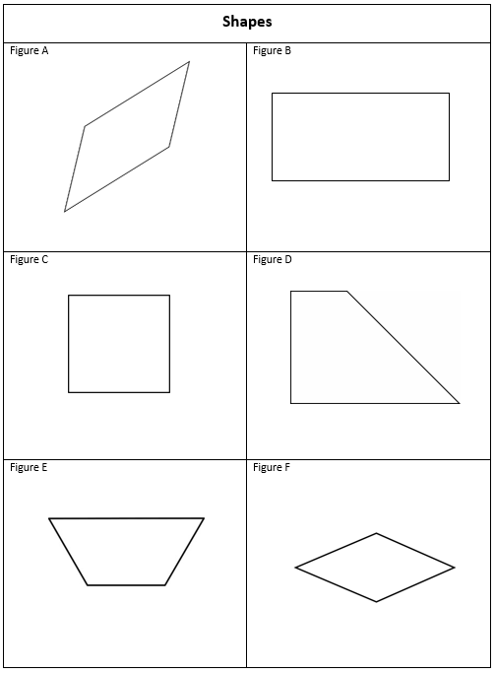

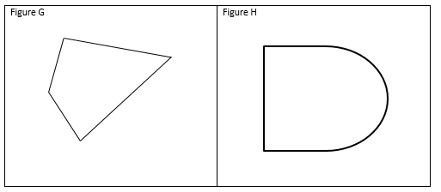

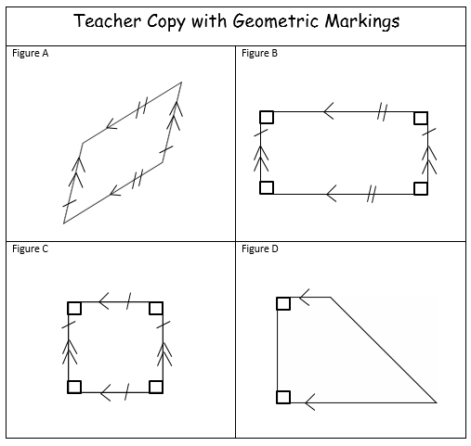

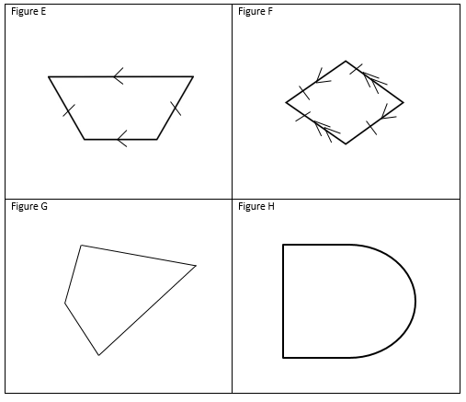

Quadrilateral Property Summary
Read each statement and then put a check mark in the column for each quadrilateral for which the statement is true. Some columns will have more than one check mark.
 | Parallelogram | Rectangle | Square | Rhombus | Trapezoid
Is a quadrilateral

Both pairs of opposite sides are congruent
All four sides are congruent

Both pairs of opposite sides are parallel
Has exactly one pair of opposite sides parallel
Has four right angles

Opposite angles are congruent

