*Mathematics Instructional Plan – Grade 4*

# Characteristics of Solids

Strand:Measurement and Geometry

Topic:Geometric characteristics of solid figures

Primary SOL:4.11 The student will identify, describe, compare, and contrast plane and solid figures according to their characteristics (number of angles, vertices, edges, and the number and shape of faces) using concrete and pictorial representations.

Related SOL:4.10a, b

## Materials

* Set of geometric solid models for students (cube, rectangular prism, square pyramid, sphere, cone, and cylinder)
* Demonstration set of geometric solids models
* Nets for Geometric Solids (attached)
* Real-world objects in the shape of a cube, rectangular prism, square pyramid, sphere, cone, and cylinder.
* Why Am I Special? activity sheet (attached)
* Spaghetti
* Sticky notes or squares of paper
* What Am I? Matching Cards Shapes (attached)
* What Am I? Matching Cards Descriptions (attached)
* Real World Look-a-Like 3-D Shapes handout (attached)

## Vocabulary

angle, attributes, cone, congruent, cube, cylinder, edge, face, parallel, plane figure, rectangular prism, solid figure, sphere, square pyramid, three dimensional, two dimensional, vertex/vertices

## Student/Teacher Actions: What should students be doing? What should teachers be doing?

*Note: To support students as they develop an awareness and an understanding of the vocabulary associated with two- and three-dimensional geometric shapes/figures, consider creating a word wall using the geometry related* [*vocabulary cards*](http://www.doe.virginia.gov/instruction/mathematics/resources/vocab_cards/index.shtml) *developed by the Virginia Department of Education.*

1. Students will be working in groups of 2–3. To introduce the lesson, provide each student with a set of geometric solids: *cube, rectangular prism, square pyramid, sphere, cone,* and *cylinder.* This is a chance to observe and explore the figures, so allow students to work without providing any explanation of the figures, these ideas will be made clear in the remainder of the lesson.
2. Allow about 5 minutes and ask students to sort the shapes into no more than three groups using a characteristic of their choice. The groups should be laid out on the table/desk for others to see. Each person in the group should be able to describe the characteristics of each group. Circulate around the room and note groups who have sorted by different attributes.
3. Call on groups with different ways of sorting to share their sort and the characteristics they used for the sort. At this point, there should be little discussion, but the student sharing is chance for you to formatively assess the vocabulary the students are using and to determine what students may already know about any of the shapes.
4. To prepare for the next activity, hold up the classroom model of each and write the name on the board: *cube, rectangular prism, square pyramid, sphere, cone,* and *cylinder*. Let students know the figures belong to a set of shapes called solids.
5. Ask students how these solids differ from the plane shapes, such as a triangle, square, or circle they have studied. Listen to their responses and bring out the idea that plane shapes are two-dimensions, or 2-D, because they only have length and width. However solid figures are three-dimensional, or 3-D, because they have length, width, and depth.
6. Let students know that they are now going to examine the solid figures more closely to determine what geometric characteristics determine each shape.
7. Review the following terms with the students to prepare them to identify the shapes that make up each of the solids. Following the description is a way to test the figure for that geometric characteristic.

* *Face*: Any flat surface of a solid figure. Will the face of the figure sit on your desk without rolling?
* *Edge*: A line segment where two faces of a solid figure come together. Can you lay a piece of spaghetti on the edge so that completely covers the edge without bending?
* *Vertex/Vertices*: The point at which three or more faces meet. To address the cone, the vertex can also be thought of as the highest point of a cone or pyramid. Can I use three sticky notes to cover the faces so they come together at a point? Or can I sit the figure on a face so there is a point that is the farthest away from that face? (Note: Grade 4 students will only need to identify the cone not describe its characteristics.)

1. Distribute the Why Am I Special? activity sheet. Allow students to handle, examine, and discuss the geometric components of the six solid figures in order to complete the chart. Remind students to discuss the characteristics of the shapes within their groups and then each student will complete their own handout. Also, let students know that can write other descriptive comments about the shape in the name column.
2. Circulate around the room support students by asking questions or redirecting them when they have recorded incorrect information. Note students who have misconceptions.
3. Facilitate a discussion of the shapes and their characteristics. Use the information provided by the students to create an anchor chart about the characteristics of the six solid figures. In addition, capture other additional descriptive information students recorded.
4. Once the chart is completed, continue the discussion by asking students to describe the comparison between some of the figures, such as the cube and the rectangular prism.
5. Print one set of the What Am I? Matching Card Shapes and What Am I? Matching Card Descriptions for each pair of students on card stock. Provide scissors and a baggy to each pair so they can cut apart the cards and store them after the game. There are two ways to use the cards.
6. Lay the shape cards face up between the two students. Deal out the description cards so each student has three cards. The winner is the first person who can lay the description card on the matching shape card. Allow the second player to finish laying down his/her description cards. Then discuss the placements and reach consensus that the cards are matched correctly. Play a second time, but this time lay out the description cards face up and deal out the shape cards so each person gets three of them. The rest of the steps are the same.
7. A second way to use the cards is to play concentration. Shuffle all 12 cards and lay them face down in a three-by-four array. The person with the birthdate closest to today will go first and turn over any two cards. If the cards match shape and definition, the cards belong to that person. If they do not match, turn them facedown and the second persons turns up a card and then tries to turn up a matching card. The game continues until all cards have been matched. The winner is the person with the most cards.
8. Use the Real World Look-a-Like 3-D Shapes activity sheet for a homework project that can span several nights. Ask students to identify things in the real world that look like one of the six solids. They should include a sketch or picture of the item and its name. They can ask their parents to help them look around the house or brainstorm ideas.

## Assessment

### Questions

* What combinations of shapes would you need to create a cube? A rectangular prism? A square pyramid?
* Which solid cannot have two parallel faces?
* How are a cube and rectangular prism similar? How are they different?
* The shape has no edges. What can it be?
* The shape has eight vertices and all faces are congruent. What can it be?
* Is there a solid figure that has zero faces? What is the meaning of *face* when applied to a solid figure?
* Jose cut three shapes out of paper. He has two circles that are the same size and one rectangle with two sides equal in length to the circumference of the circles. Which shape can Joe most likely form? Justify your response?

### Journal/writing prompts

* Ms. Pitt taught her class to make paper models of geometric figures. Each student created a three-dimensional figure with a square base, five vertices, and four triangular faces. Which geometric figure did Ms. Pitt's class create? Justify your response with a picture and words.
* You are making up a game that involves guessing the mystery geometric solid with the least number of clues. You need to write several clues about each shape (cube, rectangular prism, square pyramid, sphere, cone, and cylinder) to share with a classmate so he/she can guess what figure you have.
  + Jaime held up a shape and said, “This is a rectangular prism,” and Carli held up the same shape and said, “This is a cube.” Both students are sure they are correct and the other person is incorrect. What would you ask them to think about to work through the situation?

### Other Assessments

* Provide students with the Real World Look-a-Like 3-D Shapes activity sheet and ask them to name real-world objects that look like each shape.
  + Ask students to look at the nets handouts and state which shape they think the net will make and why.

## Extensions and Connections (for all students)

* Guide students in constructing models of the solid geometric figures, using different options for materials. One idea is to use toothpicks as the edges and gumdrops or balls of clay as the vertices; another possibility is drinking straws and marshmallows. Students could also create a chart that would help them calculate how many toothpicks or straws and gum drops or marshmallows they would need for each figure.
* Ms. Crow glued four white cubes together as shown at the left. Then she painted the entire figure red. How many faces of the four cubes were painted red? Explain why your answer is correct.

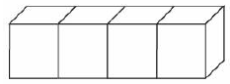

* Read Phillip Murphy’s *Captain Invincible and Space Shapes*. The story incorporates the three-dimensional shapes. Access a [six-minute reading](https://www.youtube.com/watch?v=r6x4VLjYyBk) of the book.
* Students can then create their own *illustrated story* set in the context of their choice. The story must include each of the following at least once: cube, rectangular prism, square pyramid, sphere, cone, and cylinder. And, the story should use the characteristics of the shapes to develop the story.
* Students can design and build a model and write the description for building a playground, neighborhood, and skate park, etc., that must include each of the shapes at least once. The description of the model must include information about the characteristics of the shapes.

## Strategies for Differentiation

* The [Geometric Solids 3-Dimensional Figures](https://www.mathatube.com/geometry-geometry-solids) 15-minute instructional video reviews the characteristics of the geometric solids and uses pictorial representations to support the teacher’s mini-lecture.
* Work with the cube, rectangular prism, and square pyramid first. Provide cardboard models that students can write on. Write the name on each shape. Use the spaghetti-and-sticker test to identify edges and faces, then use black markers to show the edges and put stickers on the faces. Use a red marker to show the vertices. After discussing these, help the student fill in the chart for Why Am I Special?
* Bring in paper or cardboard real-world objects for each solid. Have students decompose the shapes and discuss the shapes that make up each.
* Use the What Am I Matching? shapes and description to allow students to match up the cards.

**Note: The following pages are intended for classroom use for students as a visual aid to learning.**

Virginia Department of Education ©2018

## Why I Am Special

**Name: Date: ___________________**

|  |  |  |  |  |  |
| --- | --- | --- | --- | --- | --- |
| **Geometric solid** | **Name** | **Number**  **of faces** | **Shape(s) of faces** | **Number**  **of edges** | **Number**  **of vertices** |
| MC900048285[1] |  |  |  |  |  |
|  |  |  |  |  |  |
|  |  |  |  |  |  |
|  |  |  |  |  |  |

**Why Am I Special? (Answer Key)**

|  |  |  |  |  |  |
| --- | --- | --- | --- | --- | --- |
| **Geometric solid** | **Name** | **Number**  **of faces** | **Shape(s) of faces** | **Number**  **of edges** | **Number**  **of vertices** |
| MC900048285[1] | Sphere | 0 | None | 0 | 0 |
|  | Rectangular Prism | 6 | Rectangles | 12 | 8 |
|  | Square Pyramid | 5 | 1 square  4 triangles | 8 | 5 |
|  | Cube (Is also a rectangular prism with square faces) | 6 | Squares | 12 | 8 |

## What Am I? Matching Cards Shapes

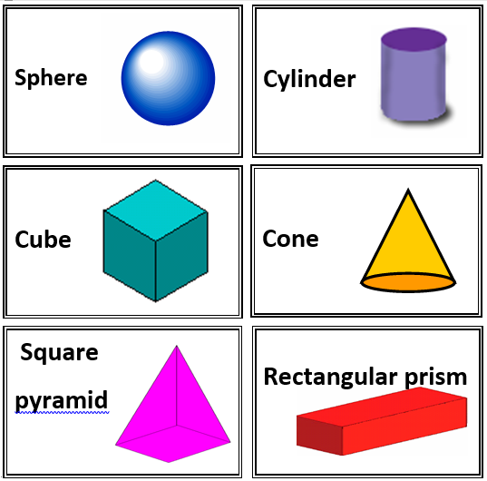

## What Am I? Matching Cards Descriptions

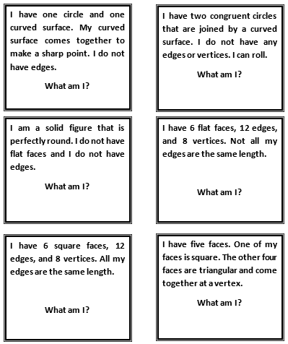

**Real World Look-a-Like 3-D Shapes**

| **Shape Name** | **Picture** | **Looks Like This Real-world Object.**  **Include a picture or sketch.** |
| --- | --- | --- |
| **Cube** |  |  |
| **Rectangular Prism** |  |  |
| **Square Pyramid** | Image result for square pyramid |  |
| **Sphere** | Image result for sphere |  |
| **Cone** | Image result for cone |  |
| **Cylinder** |  |  |

**Net for a Cylinder**

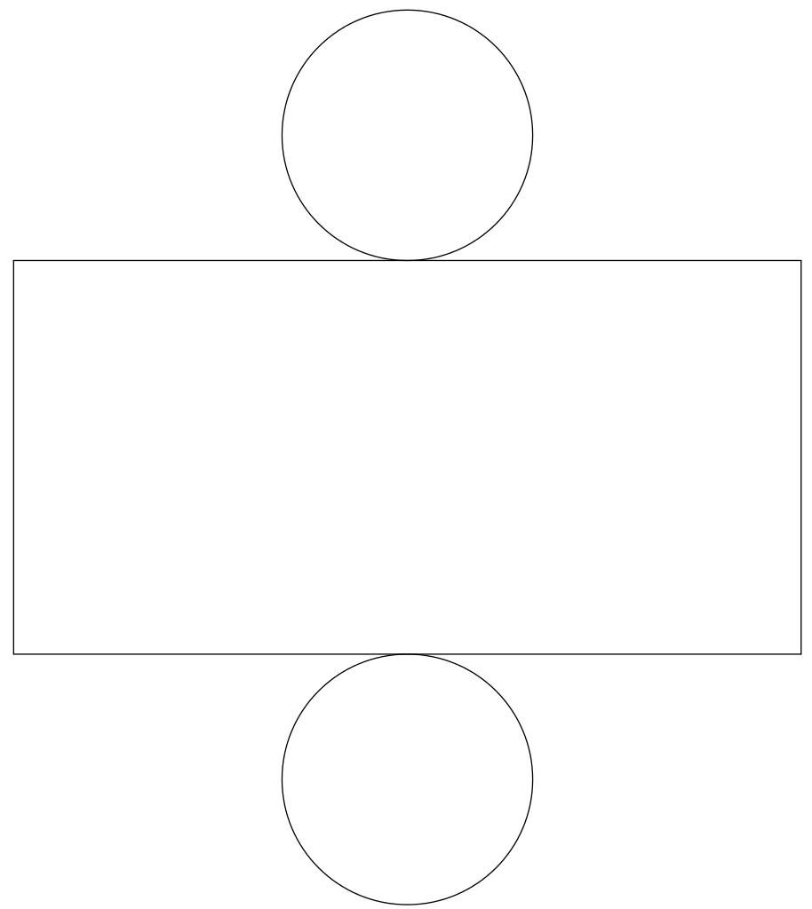

**Net for a Cone**

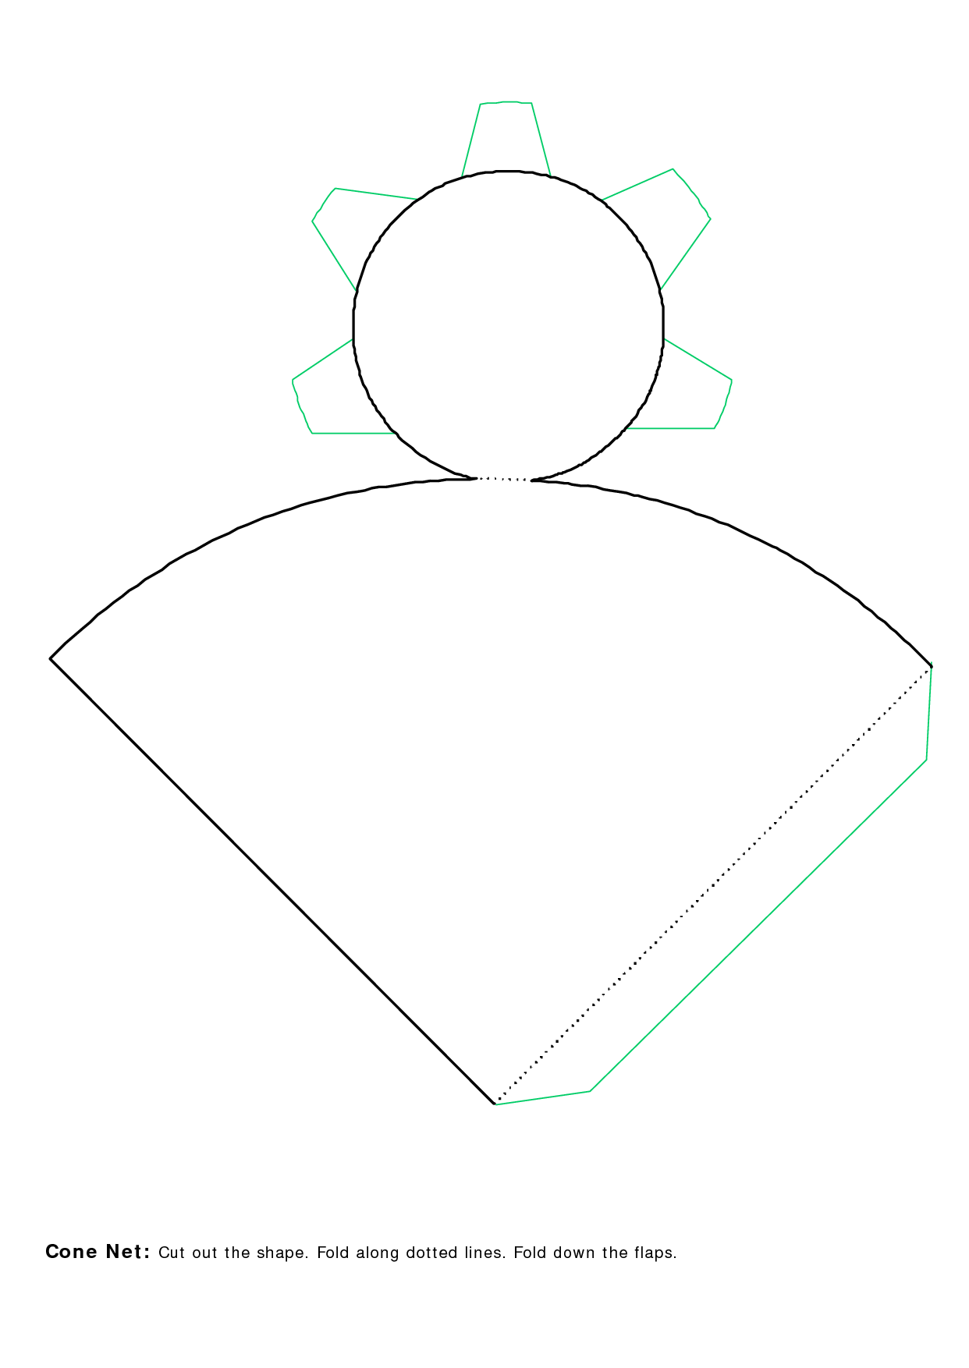

**Net for a Rectangular Prism**

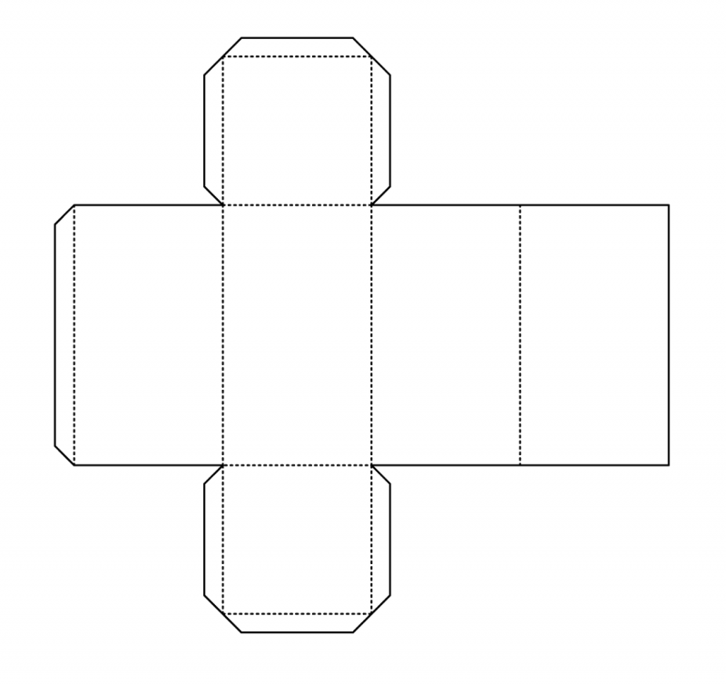

**Net for a Cube**

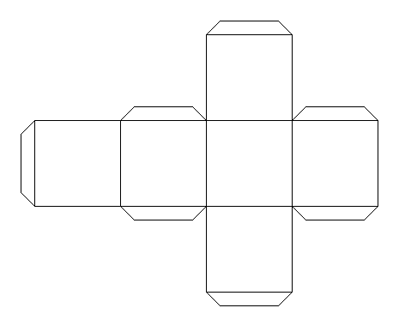

**Net for a Square Pyramid**

