Mathematics Instructional Plan – Grade 4

Geometry in Real-world Situations
Strand: Measurement and Geometry
Topic: Identify, describe, and represent points, lines, line segments, rays, angles, and intersecting, parallel, and perpendicular lines.
Primary SOL: 4.10 The student will
- identify and describe points, lines, line segments, rays, and angles, including endpoints and vertices; and
- identify and describe intersecting, parallel, and perpendicular lines.
Related SOL: 4.11

Materials
- Modeling clay
- Colored pencils or crayons
- Spaghetti or thin linguine pasta
- Dry-erase boards, markers, and erasers
- Chart paper
- Simple House Drawing (attached)
- Simple House Drawing (attached, with points labeled)
- Geometric Figures Picture Cards (attached)
- Geometric Figures in Real Life Objects Picture Cards (attached)
- True or False? How Do You Know? Representation (attached)

Vocabulary
angle, component, element, endpoint, intersecting lines, intersection, line, line segment, noncircular, parallel lines, parallelism, perpendicular lines, perpendicularity, plane figure, point, ray, right angle, symbols, vertex

Student/Teacher Actions: What should students be doing? What should teachers be doing?
- Access prior knowledge of geometric figures from previous grade levels. Arrange students in groups of four. Ask students to use their dry-erase boards and markers to generate a list of geometric figures that are used to construct other plane figures or help name plane figures. Tell students that we call these the fundamental components of shapes that are not circular. Circulate and make note of student conversations and recordings to identify students you want to share and to note misconceptions or confusion to clarify during whole-class discussion.
- Label the top of a piece of chart paper, “Fundamental Components of Geometric Figures That are Noncircular.” Draw three columns on the paper, one labeled Geometric Component, one labeled Representation, and one labeled Description in Words. Briefly share with students the meaning of the term component in this activity. Students will likely have written down the following terms during small-group brainstorming: point, line, line segment, ray, angle, endpoint, and vertex. Call on student groups who have named these terms and add the terms to the chart paper.
- Provide student groups with modeling clay and pasta pieces. Ask students to work together to construct a model for each of the components written on the chart paper. Ask students to recall definitions of these components as they build them. After construction, have groups share their constructions.
  - Consider having groups travel together to each group’s work station to review the work of other groups.
  - Have students use a clean sheet of notebook paper to make a chart like the one you have started on the board so that they can take notes during the discussion.
  - During the whole-class discussion, take one component at the time and call on various students to have a discussion to clarify the defining features of each of the figures and a representation for each. Direct students in filling in the information on their chart. Highlight how to name points on each figure as a way to identify and discuss a particular figure.
- Display the Simple House Drawing activity sheet. Displaying drawing versus giving a copy to each student will promote clear communication of ideas using specific and accurate vocabulary terms. Ask groups to work together to identify as many representations of plane geometric figures they can. As students are working, encourage the use of geometric vocabulary by asking, “Where is a line segment? How can you prove that the figure is a line segment?” “Do you see points that connect line segments? What are these points called?” “Are there any angles in the drawing? Justify where.” With questioning, help students identify and justify locations of points (i.e., doorknob), lines (i.e., road in front of house), line segments (i.e., sides of the house, roof), rays (i.e., sun’s rays), and angles (i.e., corners of house and roof), including endpoints and vertices. Use opportunities when confusion arises about exactly which element students are talking about to prompt discussion of the importance of labeling each point and to describe specifically how to use the letters to name plane geometric components.
- Provide each student with a copy of the Simple House Drawing activity sheet. Guide students in labeling the main points, modeling how to represent the points with small circles and label each with a capital letter or letters. (Use the Simple House Drawing with Points Labeled activity sheet as a guide.)
- Have students again look at the Simple House Drawing, focusing on finding the angles where line segments intersect each other, as follows:
- Have students search for angles that are not right angles. Lines forming such angles (e.g., roof line and chimney line) are called intersecting line segments. This is a good time to highlight that in a pictorial representation the use of arrows on the end(s) is the way to differentiate between lines, rays, and line segments. Model representing intersecting line segments using two pieces of pasta. Show students how to test for line segments that intersect when they cross at one point or when they intersect at one endpoint of both line segments. Lay pasta pieces down on the lines forming the roof, making them touch at the vertex at the top of the roof. Ask students to describe what intersection means in their groups. Allow one group with an appropriate description to share. An intersection is where two lines or line segments meet at a common point, which could be endpoints and/or intersecting lines or line segments having one point in common that is not an endpoint. Have students use pasta to find additional intersecting lines in the Simple House Drawing. Discuss and share solutions. Note: If any students discover a pair of intersecting line segments that are perpendicular, use the example to segue into the perpendicular line segment discussion.
- Have students search for right angles. Lines/line segments/rays forming such angles are called perpendicular (e.g., top right and left interior angles of the chimney and any interior angle of the front door). Model representing perpendicular line segments using two pieces of pasta. Show students how to test for line segments that intersect when they cross at one point or when they intersect at one endpoint of both line segments, forming four or two right angles, respectively. Lay pasta pieces down on any two line segments forming the front door in the drawing. Ask students to talk with their group and discuss whether they think perpendicular line segments can also be called intersecting line segments. Students should understand that because of the definition of intersecting lines—two lines that meet at a common point—perpendicular lines also fit that description. However, the angle that is formed is a right angle. Therefore, perpendicular line segments are a special case of intersecting line segments. Have students use pasta to find additional perpendicular line segments in the Simple House Drawing. Discuss and share solutions.
- Have students search for pairs of lines or line segments that lie in the same plane and never intersect. Such lines or line segments are called parallel (e.g., top and bottom lines representing the road and the roof line segment and line representing the bottom of the house). Model representing parallel line segments using two pieces of pasta. Show students how to test for lines that are parallel, mentioning that sometimes the lines may need to be extended in drawings to ensure they would not touch if they did go on forever in space. Have students use pasta to find additional parallel lines or line segments in the Simple House Drawing. Discuss and share solutions.
- Ask students how they might communicate these examples of perpendicular, intersecting, and parallel lines symbolically by making a connection to how the statements are read orally and then translated in written form. As time permits, have groups consider symbols for each of these cases and draw a quick sketch of the symbol they might use for perpendicular, intersecting, and parallel lines and line segments. Ask a student to share the example discussed for perpendicular lines (door) and record a written statement using a demonstration tool (e.g., document camera, digital display) or on the board. The student may say, line segment ML is perpendicular to line segment L J. Model how a representation of perpendicular lines might be drawn to match the orientation in the picture (similar to an upside-down capital letter T). Discuss and draw other ways perpendicular line segments could be oriented (diagonally, vertically). Show students the symbol mathematicians use to represent “perpendicular lines.” Show students the symbolic translation, $\overline{ML} ꓕ$ $\overline{LJ}$. Tell students that there is not a mathematical symbol for intersecting lines that are not perpendicular. Ask a student to share the example discussed for parallel lines (road) and record a written statement under the document camera or on the board. The student may say, line A’B’ is parallel to line C’D’. ( A’B’ is read as A Prime B Prime.) Model how a representation of parallel lines or line segments might be drawn to match the orientation in the picture (two horizontal parallel lines). Discuss and draw other ways parallel lines or line segments could be oriented (diagonally, vertically). Draw the symbol mathematicians use to represent “parallel lines.” Show students the symbolic translation, $\overset{⃡}{A'B'}$ II $\overset{⃡}{C'D'}$.
- Guide students using the class chart and their individual chart started earlier in class to summarize and record the ideas about parallel lines, parallel line segments, perpendicular lines, and perpendicular line segments on the Fundamental Components of Geometric Figures That are Noncircular chart.
- Working together in groups with their dry-erase boards, have students use symbolic notation to name at least one pair of parallel and one pair of perpendicular lines in the Geometric Figures Picture Cards. Monitor work and ask each group to share at least one statement. During sharing, have the entire group read the statement orally. Ask the rest of the students to practice writing the statement with symbols on a scratch sheet of paper. Model writing the statement with symbols under a demonstration tool or on the board, and have students self-correct their work on paper.

Assessment

Questions
- How many right angles are there in the Simple House Drawing? Name each right angle found.
  - Have students create a drawing, using a straight edge, based on the following instructions: (1) draw two line segments; (2) add one angle to your drawing; (3) add four lines; (4) add three rays; (5) label six points. Then answer the following questions about the drawing. What are the names of the two line segments, at least one angle, all four lines, and the three rays? Can any of these figures be named in more than one way? If so, which ones, and what other ways can they be named?
  - What is the difference between a line, a ray, and a line segment? Draw a few representations of each as part of your discussion.
  - In what ways are points important to the construction of lines, line segments, rays, and angles?
  - Are intersecting lines always considered perpendicular? Are perpendicular lines always considered intersecting?
  - Use symbolic notation to name as many parallel and perpendicular lines in the Geometric Figures Picture Cards as possible. Write a statement in words to translate each of the symbolic notations as if you were reading them orally.

Journal/writing prompts
  - Pretend you are a mathematician. Propose a symbol for representing “intersecting lines that are not perpendicular.” Justify why your symbol is reasonable.
- Using the labeled Geometric Figures Drawing, analyze the statements below over a period of time (i.e., one a day, one a week, etc.). Which statements are true? Which statements are false? Justify each of your responses.
      - Line segment AB is parallel to line segment CD .
      - $\overline{GE}$ II $\vec{FH}$
      - Line segment GA intersects, but is not perpendicular to line segment AB
      - $\overline{NP}$ is not parallel to $\vec{GM}$
      - Ray FH is perpendicular to line segment FD
      - $\overline{GC}$ includes 3 labeled points, point E, point A, and point F
      - $\vec{GC}$ is perpendicular to $\overline{EF}$

Other Assessments
  - Ask students to draw a representation and then write a symbolic statement to match each of the following:
- Line BN is parallel to line KR
- Line segment TZ is perpendicular to line segment RD
- Ray HW is parallel to line JL
- Line segment MN is perpendicular to ray CK

Extensions and Connections (for all students)
- Provide students with a picture of a real-life object (i.e., a building, a train, or a map of a playground). Ask them to draw a representation of the object, label points, and identify the components of noncircular geometric figures including points, lines, line segments, rays, angles, vertices, and endpoints.
- Students can work with a partner or independently to make connections to how parallel, intersecting, and perpendicular lines can be represented in other real-life objects and geometric plane and solid shapes. Provide students with either the Geometric Figures Picture Cards or the Geometric Figures in Real-life Objects Picture Cards. Have students represent the figures in a drawing and label all points with capital letters. Ask students to name as many points, lines, line segments, rays, and angles as possible in each picture. Students may also name as many examples of intersecting, perpendicular, and parallel lines as possible in each picture.
- Students can design a model playground or create an art project using each of the geometric components at least once.

Strategies for Differentiation
- Use grid paper for drawing accurate representations of components of noncircular geometric figures.
  - Have students engage in tactile representations by using craft supplies (i.e., craft sticks, straws, play dough, pasta, modeling clay) to create a model for all three types of lines. Students may glue their work onto paper or cardboard, labeling all points, and identifying the different geometric components of noncircular figures. Students can do the same for point, line, line segment, ray, angle, and right angle.
- ELL students may benefit from having pictorial representations of vocabulary terms for reference.
- Students who are mastering the concept of identifying and using mathematical symbols for parallel and perpendicular may be challenged to complete the True or False. How Do You Know? activity sheet. Give students a copy of the activity. Have them cut out the strips. Students use the representation to determine whether the statement on each strip is true or false and justify their reasoning. Consider having the strips glued down either in a journal or on a piece of paper where students would have space to write about each one.

Note: The following pages are intended for classroom use for students as a visual aid to learning.

Virginia Department of Education ©2018

Simple House Drawing

Simple House Drawing with Points Labeled
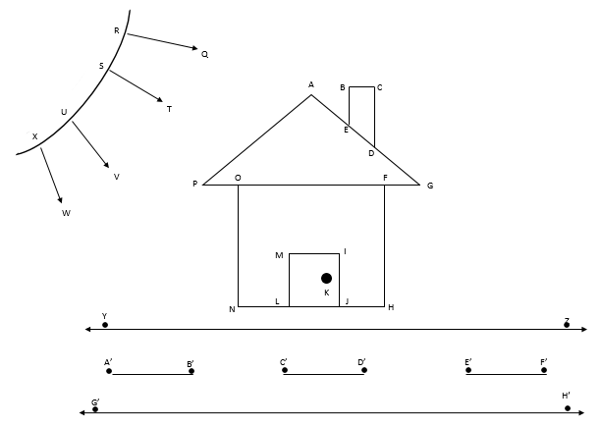

Geometric Figures Picture Cards
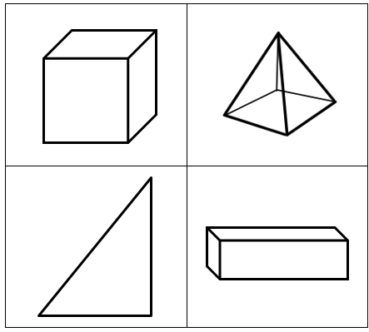

Geometric Figures in Real-life Objects Picture Cards
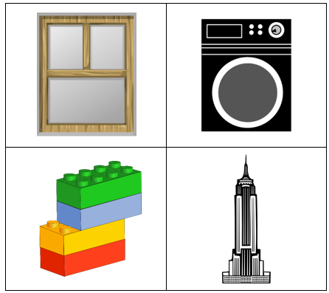

True or False? How Do You Know?
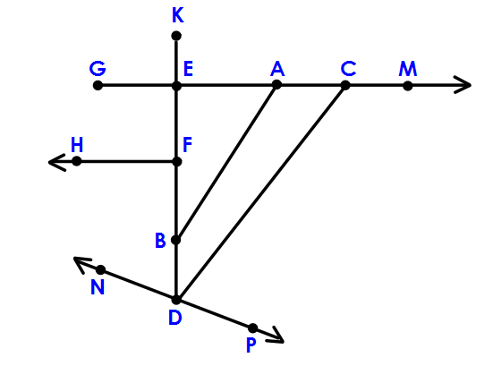
Line segment AB is parallel to line segment CD
$\overline{GE}$ II $\vec{FH}$
$\overline{GA}$ intersects, but is not perpendicular, to $\overline{AB}$
$\overline{NP}$ is not parallel to $\vec{GM}$
∠FBA is a right angle
Ray FH is perpendicular to line segment FD
$\overline{GC}$ includes 3 labeled points: point E, point A, and point F
$\vec{GC}$ is perpendicular to $\overline{EF}$

