Four in a Row: Fraction Addition and Subtraction
Strand: Computation and Estimation
Topic: Adding and subtracting fractions and mixed numbers.
Primary SOL: 4.5 The student will
b) add and subtract fractions and mixed numbers having like and unlike denominators.*
* On the state assessment, items measuring this objective are assessed without the use of a calculator.
Related SOL: 4.5ac

Materials
- Estimation Splash! master activity sheet (attached)
- Fraction Strips (attached)
- Four-in-a-Row Fraction Choice Chart A (attached)
- Four-in-a-Row Sum/Difference Game Board A (attached)
- Four-in-a-Row Fraction Choice Chart B (attached)
- Four-in-a-Row Sum/Difference Game Board B (attached)
- Four-in-a-Row Solution Proof Recording Sheet (attached)
- Game board markers in two different colors (e.g., two-color counters, color tiles)
- Manipulatives for subtracting fractions (e.g., fraction tiles, fraction circles, fraction strips, number lines)

Vocabulary
add, common factors, common multiples, difference, estimation, factor, fraction, greatest common factor (GCF), improper fraction, least common denominator, least common multiple (LCM), like denominators, mixed number, simplest form, simplify, unlike denominators, subtract, sum

Student/Teacher Actions: What should students be doing? What should teachers be doing?
Note: Estimation helps students focus on the meaning of the numbers and operations involved in a computation. It also helps build number sense with fractions. Beginning with an activity to intentionally encourage estimating fraction sums and differences, before determining the exact sum or difference, may promote using estimation as a strategy during play of the Four-in-a-Row game and in continued work with fraction computation.
- Warm up to review using estimation with finding the sum or difference of fractions and mixed numbers. Arrange students in pairs. Students will work together using mental math to play Estimation Splash. Present the Estimation Splash! master activity sheet. Model estimation with a few pairs of fractions/mixed numbers. Include a think-aloud to share the estimation strategy. Then model using a manipulative and a number line to find the exact answer and see whether the conditions were met.
  - Find two fractions and/or mixed numbers that, when added together, have a sum close to 2.
  - Find two fractions and/or mixed numbers with a difference of approximately $\frac{9}{8}$.
- Continue with the Estimation Splash! activity. Read the following prompts and have pairs work together to discuss a possible solution. Have a few pairs share their solutions after each problem is presented and how they came up with their fractions. Then have the students find the exact answer to determine whether the conditions were met. Present as many prompts as possible for a 10- to 15-minute time frame.
  - Find two fractions and/or mixed numbers whose sum is less than 3.
  - Find two fractions and/or mixed numbers whose difference is less than $\frac{1}{2}$.
  - Find two fractions and/or mixed numbers whose sum is between 1 whole and $1\frac{1}{2}$.
  - Find two fractions and/or mixed numbers with a difference between 2$\frac{1}{2}$ and 3.
  - Find two fractions and/or mixed numbers with a sum that is less than 1.
  - Find two fractions and/or mixed numbers which have a difference that is greater than 1 but less than 2.
- Tell students that the same strategies they used for Estimation Splash! will be helpful in playing a new game called Four-in-a-Row. Introduce students to the Four-in-a-Row game. Model one round of the Four-in-a-Row game with students. For modeling play, you will need the following materials (attached): a Four-in-a-Row Fraction Choice Chart (A or B), a Four-in-a-Row Sum/Difference Game Board (A or B), and a Four-in-a-Row Game Solution Proof Recording Sheet. Students will also need a pair of counters in two colors, and fraction manipulatives. Model game play as follows:
- Partners decide in a fair way who will be player 1 and who will be player 2. Player 1 will go first.
- Player 1 chooses two fractions from the fraction chart and an operation (addition or subtraction) to get one of the answers shown on the game board. Player 1 and player 2 simultaneously solve the problem using a fraction manipulative of their choice.
- When both players have a solution, player 1 must demonstrate their problem-solving method and justify their solution. Player 2 must agree with the problem-solving method and solution. After agreement, player 1 may cover the answer on the board with a marker. Once a fraction has been covered, it may not be used again.
- Both players record the problem solving demonstrated by player 1 on their Four-in-a-Row Solution Proof Recording Sheet.
- Player 2 now takes a turn.
- Play continues until someone covers four fractions in a row—horizontally, vertically, or diagonally.
- Students should use the Four-in-a-Row Solution Proof Recording Sheet to document the problem-solving strategies they used for two of their rounds of play. Model how to play the game and how to record their problem solving before play begins.
- Arrange students in pairs. Distribute to each pair a Four-in-a-Row Fraction Chart, a Four-in-a-Row Game Board, two copies of the Four-in-a-Row Solution Proof Recording Sheet, and piles of counters in two colors. Monitor students as they play the game and record their problem solving as an opportunity for formative assessment. Also, make note of particular problems where students are adding or subtracting fractions/mixed numbers with unlike denominators to use in the closing activity.
- Bring the class back together and ask students to share a particular problem they thought was challenging and why. Have a few volunteers share. Use the opportunity to prepare students for thinking about why adding or subtracting with like denominators is easier than with unlike denominators, and why it is necessary to have common denominators when adding and subtracting fractions.
- Select a student’s problem or create one to use as a demonstration and discussion. For example, $\frac{3}{4}$ - $\frac{2}{3}$. First, ask a volunteer to describe the action for this problem or to make up a story problem to represent the action. That is, you have $\frac{3}{4}$ and you need to take away or subtract $\frac{2}{3}$. Write a story problem on the board that provides context for thinking with a particular manipulative. For example, “Following his game Saturday, Stephen has $\frac{3}{4}$ of a foot-long fruit rollup in his backpack. He eats $\frac{2}{3}$ of what he has.” As you work through interpreting the problem with the students, discuss the important information in the word problem. Ask, “How much of the fruit rollup will he have to eat later that day?”
  - Set up a concrete model in stages and represent the model pictorially so the students can use the model to think about common denominators.
First, show the model for $\frac{3}{4}$.

  - Pose questions such as, “What does the following show?” (The three-fourths of the fruit rollup Stephen has and the one-fourth that he does not have.) “Why is the denominator 4?” (The whole or original fruit rollup is divided/partitioned into four equal parts.) “Why do you think I started with the model for three-fourths?” (That is what Stephen started with. Push students to say that the three-fourths is part of the original fruit rollup.)
  - Ask, “How much of the fruit rollup did Stephen eat Saturday after the game?” Have student volunteers to share their answers. Ask someone to come up to the board and with their hands show how much. Then ask, “Do you think what you are showing is exactly how much Stephen ate?” (Listen for responses that indicate they cannot be sure because they had to estimate. Ask how they decided that the distance between their hands was about two-thirds. (Listen for responses for how students are thinking about the two-thirds$.)$ Ask, “Exactly how of the fruit rollup is left?” (Students may guess but likely may be unable give the exact amount.)
  - Ask, “Why was it hard to show exactly how much Stephen ate using the model?” (At this point, students should start realizing that because the denominators are not the same, the size of the parts he started with are fourths and the size he ate are thirds.) Have students think about what they did in the Four-in a-Row game to find the exact answer. This should bring out ideas about finding a fraction strip that can be used to talk about both of the denominators in question. Ask students which fraction strip they would use and how they know it will work to talk about both fourths and thirds. (Someone will say twelfths. Put that strip on the board, then ask for a volunteer to prove that the twelfths strip works. Listen for students’ words that brings out the idea that both 3 and 4 are factors of 12 or that 12 is the least common multiple of 12. Then use their words to clarify the idea that 12 is the least common multiple of 3 and 4.) Then place the thirds and fourths strips in alignment with the twelfths strip for the purpose of students have reference pictorials to think with and talk about.
  - Have students examine the representation for a few minutes and write a number sentence on their paper that shows the answer to how much of the fruit rollup Stephen has left. Walk around the room and identify students who have different number sentences to send to the board to write their responses. Once the students have recorded the various responses, ask whether anyone has a question about any of the number sentences.
  - Use the number sentence $\frac{3}{4} - \frac{2}{3} =\frac{1}{12}$as the discussion starter. Ask: “Can someone explain how they arrived at $\frac{1}{12}$ as an answer?” “Did anyone think about it a different way?” Now say, “When I look at this sentence, I do not see that we are taking twelfths away from twelfths. How do I make sense of that?” Listen for responses that will allow you to begin to talk about how to record the numerical work to show finding the common denominator.
  - Then use students’ ideas to support writing $\frac{9}{12} - \frac{8}{12}=\frac{1}{12}$, and then ask how the numerical fraction $\frac{9}{12}$is related to $\frac{3}{4}$. When you get the response, “They are equivalent fractions,” point out they are equivalent and represent the same amount as shown by the fractions strips. Then write $\frac{3 x 3 }{4 x 3} = \frac{9}{12}$ and use this to show that if you start with $\frac{3}{4}$ and partition the whole into twelfths, you triple the number of pieces in the whole and therefore triple the number of pieces in the numerator. Now give students a chance to draw pictures and write an explanation for how $\frac{8}{12}$ is related to $\frac{2}{3}$. Ask some volunteers to share. Conclude by saying and writing on the board that when adding or subtracting fractions, one needs to have common denominators, and to find the common denominator, one first finds the least common multiple of the denominators and then finds the related numerators so that the new fractions are equivalent to the original fractions.
  - As an exit slip or an entry slip for the next day, ask students to solve the following with pictures, words, and numbers. Two same-sized pans of brownies were made for a birthday party. There is $\frac{5}{6}$ of the brownies left in one pan and $\frac{1}{3}$ of the brownies left in the other pan. How much of the brownies are left over from the party?

Assessment

Questions
  - In what ways are manipulatives helpful for solving these problems?
  - In what ways can estimation help with playing the Four-in-a-Row game?
  - Other than manipulatives, what other strategies can be used to solve problems requiring fraction sums and differences?
  - How is being able to find the least common multiple helpful when adding and subtracting fractions?

Journal/writing prompts
  - From the Estimation Splash! master activity sheet, pick a fraction or mixed number. Name a second fraction or mixed number which is not listed on the Estimation Splash! master activity sheet that would yield a sum that is greater than 1 but less than 2.
  - Choose an addition or subtraction problem you created during the Four-in-a-Row game and write a word problem that corresponds to the problem.
  - Name two fractions that are not on the Four-in-a-Row Fraction Chart that could be added together so that $\frac{5}{4}$ can be covered on the game board. Use pictures, words, and symbols to represent your problem-solving.
  - What are two fractions that when subtracted give a difference between $\frac{1}{2}$ and $\frac{3}{4}$?
  - If you want to add 2$\frac{1}{5}$ and $\frac{3}{4}$ but do not have manipulatives, what steps would you take to find an exact answer?

Other Assessments
  - Collect recording sheets and select one problem to provide formative feedback to each student.
  - Jayden was playing the Four-in-a-Row game with a friend. He selects $\frac{4}{5}$ and $\frac{3}{10}$ from the Four-in-a-Row Fraction Chart. What fraction can he cover on the game board? Is there another pair of fractions Jayden could have selected in order to cover the same solution on the game board?
  - Is the sum of $\frac{4}{3}$ and $\frac{3}{4}$ less than, equal to, or greater than the difference of 2$\frac{1}{2}$ – $\frac{4}{12}$? Discuss your problem-solving method as part of your answer.

Extensions and Connections
- Explain how estimating sums and differences could be helpful as a strategy for selecting numbers on the Four-in-a-Row game board.
- Create a new Four-in-a-Row Fraction Chart and corresponding Four-in-a-Row game board that is different from the original Four-in-a-Row game board.
- Students could examine the relationship between fraction strips and number lines and then use number lines for adding and subtracting.
- Explore around their homes, talk with adults, or look through newspapers and magazines and then write about real-world situations where people need to add and subtract fractions.

Strategies for Differentiation
- Students could use area-model representations such as fraction circles or squares before using fraction strips for fraction computations.
- Create a game board where students have fraction models pictured versus only symbols, or where they could shade or cover sums and differences using models.
- Some students may need to use Game Board and Fraction Chart A until they are proficient with computations with mixed numbers. Others may be able to use either Game Board A/Fraction Chart A or Game Board B/Fraction Chart B.

Note: The following pages are intended for classroom use for students as a visual aid to learning.

Virginia Department of Education ©2018

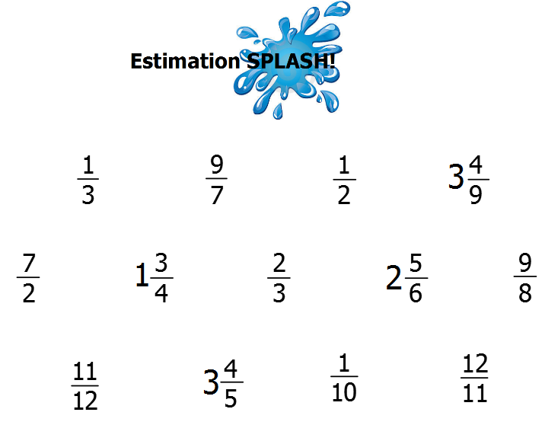

Fraction Strips
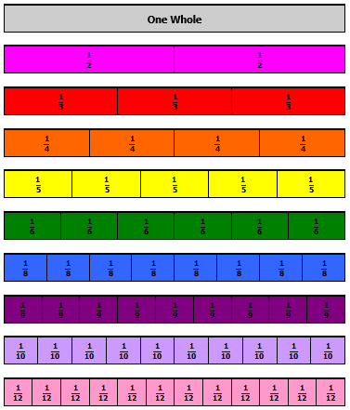

Four-in-a-Row Fraction Choice Chart A
7  8 | 1  2 | 1  4 | 1  3
2  5 | 2  3 | 3  4 | 2  4
1  8 | 5  8 | 3  6 | 6  8
3  5 | 4  5 | 3  8 | 1  5
9  10 | 7  12 | 3  10 | 5  12

Four-in-a-Row Sum/Difference Game Board A
1  4 | 3  8 | 2  3 | 1  2
3  4 | 1  12 | 7  8 | 1  8
5  8 | 1  12 | 11  8 | 3  2
13  10 | 9  8 | 5  4 | 0

Four-in-a-Row Fraction Choice Chart B
$$1\frac{5}{6}$$ | 2 | $$\frac{9}{8}$$ | $$\frac{6}{2}$$
$$\frac{5}{2}$$ | $$\frac{3}{8}$$ | 1 | $$2\frac{3}{4}$$
$$\frac{1}{2}$$ | $$\frac{7}{5}$$ | $$2\frac{1}{3}$$ | $$3\frac{2}{9}$$
$$\frac{5}{6}$$ | $$\frac{11}{12}$$ | 3 | $$\frac{13}{10}$$
$$1\frac{8}{8}$$ | 0 | $$\frac{7}{9}$$ | $$\frac{6}{3}$$

Four-in-a-Row Sum/Difference Game Board B
$$1\frac{1}{2}$$ | Greater than  4 | 1 | $$\frac{11}{12}$$
Less than  2 | $$\frac{7}{8}$$ | $$\frac{20}{9}$$ | $$3\frac{2}{3}$$
0 | $$\frac{7}{5}$$ | Less than  1 | $$\frac{1}{8}$$
$$1\frac{1}{3}$$ | $$\frac{1}{4}$$ | $$2\frac{4}{9}$$ | 2

Four-in-a-Row Game Solution Proof Recording Sheet
Round ______
Fractions and Operation Selected | Pictorial Representation of Solution
 | Equation to Represent the Sum or Difference
Round ______
Fractions and Operation Selected | Pictorial Representation of Solution
 | Equation to Represent the Sum or Difference

