Number Ray Investigators: Factors and Multiples
Strand: Computation and Estimation
Topic: Describing the relationships between common multiples and factors of a given number and finding the least common factor and greatest common multiple of no more than three numbers
Primary SOL: 4.5 The student will
- determine common multiples and factors, including least common multiple and greatest common factor.
Related SOL: 4.2a, 4.2b, 4.5b, 4.5c

Materials:
- Number Ray Investigators Recording Sheet (attached)
- Number Ray Investigators Venn Diagrams Recording Sheet (attached)
- Number Ray Investigators Student Recording Sheet (attached)
- Index cards, cut into eighths
- Markers or crayons
- Dry-erase markers
- Demonstration tool (e.g., document camera, digital display) (optional)

Vocabulary
common factors, common multiples, divisor, factor, greatest common factor (GCF), least common multiple (LCM), multiples, multiplication/division-related facts, product, ray

Student/Teacher Actions: What should students be doing? What should teachers be doing?
Note: In previous grades, students should have been exposed to factors and multiples. This lesson is a discovery or concept-attainment lesson. The goal for this lesson is for students to make connections and understand the relationships between factors and multiples of a given number. The students will not be given any clues. They can play the game as a whole class, in a small group, or individually.
Before undertaking this activity, prepare index cards with the factors and multiples of the number ray you will model for students. It is a good idea to color code the factors and multiples in contrasting colors.
- Distribute the Number Ray Investigators handout (attached) and the Number Ray Investigators Student Recording Sheet (attached). Have students play Number Ray Investigators as follows:
- Display a Number Ray Investigators Recording Sheet with a demonstration tool or on a poster.
- Write the “target number” 6 in the circle on the number ray.
- Explain to students that they are “investigators,” and their task is to investigate specific relationships of the target number to other numbers. Do not give any clues or hints that will cause students to realize they are working with factors and multiples. The intent of this activity is for students to make the connection and discover on their own how the target number relates to the other numbers. You may want to limit the students to guessing numbers up to 60.
- Allow students, as individuals or as teams, to start guessing numbers that relate in some way to the target number. The number ray could be set up in advance to include an index card for each of the numbers that will ultimately need to be guessed. When students guess a factor or multiple of the target number, write the number on one of the index cards and place it in its corresponding location on the number ray. Factors should be placed in numerical order on the left of the target number, and multiples should be placed in numerical order on the right of the target number. When students guess numbers that are not factors or multiples of the target number, also write those numbers on blank index cards, but display them away from the number ray in a “Misfits” area.
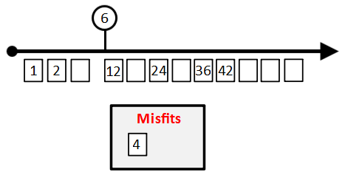
- After a couple of factors and multiples are on the number ray, have students, again either as individuals or as teams, discuss what they think the relationships of the numbers on the left and right of the target number are. (i.e., when the target number is 6, discuss the relationships that could exist between 1, 2, and 6, then discuss the relationships that could exist between 12, 24, 36, 42, and 6). At this time, do not indicate whether student suggestions regarding the relationships are correct or incorrect. Write student suggestions on chart paper or list them on the board so they can refer to them as play continues.
- Allow students to continue guessing numbers, stopping periodically to have students investigate the relationships of the numbers to the target number as more and more are added to the number ray.
- Once all of the factors and at least five multiples have been added to the number ray, ask individuals or teams to brainstorm additional guesses on the relationship each of these numbers could have to the target number. Have students share out additional relationship suggestions, and add them to the suggestions chart or list them on the board.
- Have students come back together to determine the best suggestion for the relationships of the guessed numbers to the target number. Students should have some appropriate ideas generated by now but may have not named the groups of numbers “factors” and “multiples.” If students struggle with naming the relationships as factors and multiples, consider asking one or more of the guiding questions below to lead students to naming these relationships:
  - “Do the numbers on the left and right of the target number have the same relationship to the target number? Why or why not?”
  - “Is there any way to describe the numbers on the left of the target numbers in terms of multiplication? What about the numbers on the right of the target number?”
  - “Are there any number patterns that exist with the numbers on the left of the target number? On the right of the target number?”
  - “Describe the order of the numbers, including the target number, moving left to right along the number ray. Does this order give any clue to the relationship between the numbers and the target number?”
- Make connections to vocabulary and the relationships of the index card numbers to the target number. Label the diagram and have students generate mathematical descriptions of the terms factors and multiples, given the conversations had during the lesson. A completed diagram is shown below. (Note: Misfit numbers may vary depending on student guesses.)
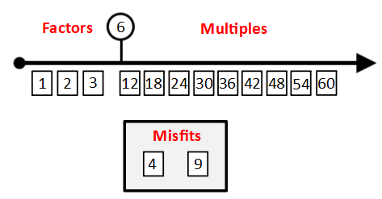
- In partnerships or teams, have students repeat the activity with a different target number, 8. The Number Ray Investigators Recording Sheet may be laminated, and a dry-erase marker may be used to record guessed numbers. As an alternative, students may record guesses on the Number Ray Investigators Student Recording Sheet. Monitor play for misconceptions and errors. A completed artifact for factors and multiples of 8 is shown below. (Note: Misfit numbers may vary depending on student guesses.)
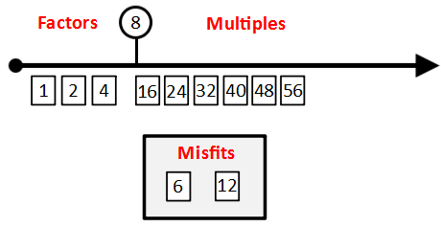
- Once the two number rays have been completed and discussed, distribute the Number Ray Investigators Venn Diagrams Recording Sheet. Label the left heading with the first number (6) and the right side of the diagram with the second number (8). Tell students that by comparing the factors of both numbers, they can determine the greatest common factor. Model labeling “Greatest Common Factor” on the line at the top of a Number Ray Investigators Venn Diagrams Recording Sheet. Using the factors generated in each number ray, have student partnerships or teams help fill out the Venn Diagram as you model writing in the factors into the correct locations of the diagram. After all factors have been included in the diagram, ask students to determine the greatest common factor. Ask, “Which of the factors represents the greatest common factor of 6 and 8?” “How do you know?” Have students turn and talk to their partners or teams to discuss, then share out answers. The greatest common factor is the largest number represented in the common center area of the Venn Diagram; in this case, it is 2.
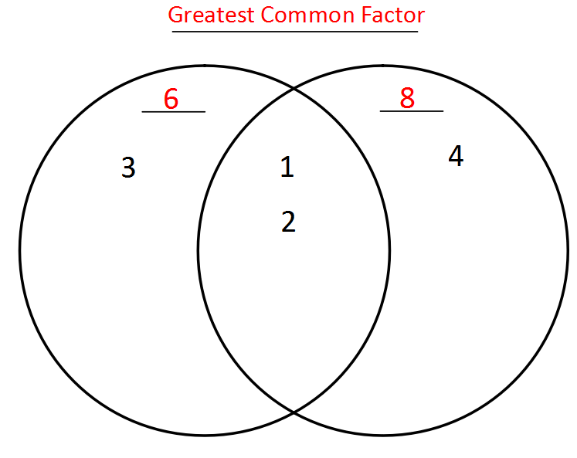
- Distribute a second Number Ray Investigators Venn Diagrams Recording Sheet. Again, label the left heading with the first number (6) and the right heading with the second number (8). Tell students that, by comparing the multiples of both numbers, they can determine the least common multiple. Model labeling “Least Common Multiple” on the line at the top of a Number Ray Investigators Venn Diagrams Recording Sheet. Using the factors generated in each number ray, have student partnerships or teams help fill out the Venn diagram as you model writing in the multiples into the correct locations of the diagram. After all multiples have been included in the diagram, ask students to determine the least common multiple. Ask: “Which of the multiples represents the least common multiple of 6 and 8?” “How do you know?” Have students turn and talk to their partners or teams to discuss, then share out answers. The least common multiple is the smallest number represented in the common center area of the Venn diagram; in this case, it is 24.

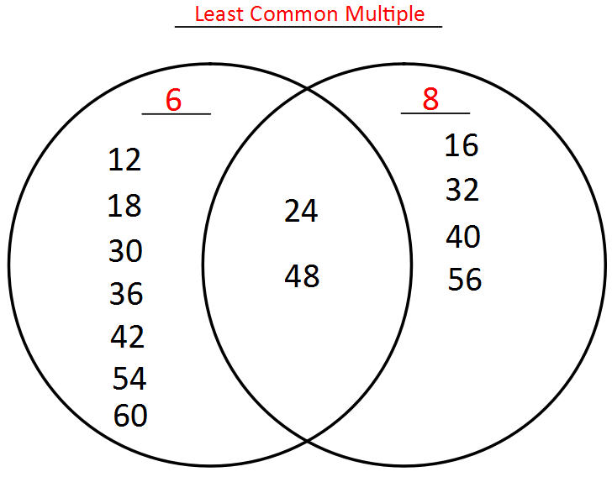
- Close the activity by asking students to talk with a partner to identify a connection between the number ray to any other concept in mathematics.

Assessment

Questions
  - Do the numbers on the left and right of the target number have the same relationship to the target number? Why or why not?
  - Is there any way to describe the numbers on the left of the target numbers in terms of multiplication? What about the numbers on the right of the target number?
  - Are there any number patterns that exist with the numbers on the left of the target number? On the right of the target number?
  - Describe the order of the numbers, including the target number, moving left to right along the number ray. Does this order give any clue to the relationship between the numbers and the target number?

Journal/writing prompts
  - Pick an even number between 12 and 40. Create a number ray and use the selected number as the target number. Ask a classmate to check your work and discuss the solution.
  - A new a student has come to our class, and the teacher has asked you to explain with words, numbers, and visuals the difference between factors and a multiple.

Other Assessments
  - Create a set of index cards with target numbers written on them. Provide students with a Number Ray Investigators Student Recording Sheet. Monitor student work as they select a target number and complete a number ray on the recording sheet.
  - Present students with two target numbers, 15 and 30. Have them draw number rays and determine the factors and multiples for both target numbers. Then have them determine the least common multiple and greatest common factor for these numbers.
  - Marco determined that the LCM of 21 and 7 is 3. Is he correct or incorrect? Prove your answer. Prove your answer.
  - Which numbers have more common factors: 5 and 25, or 18 and 20? Show your problem-solving.

Extensions and Connections
  - Are there always fewer factors than multiples for any given number? Pick three numbers, determine the factors and multiples for the three numbers, then discuss the findings.
  - Why is it important to know how to determine the least common multiple and the greatest common factor?

Strategies for Differentiation
- Some students may benefit from guided practice with determining factors and multiples of target numbers before this lesson.
- Factor and multiple cards could be created for students who may need scaffolding or are tactile learners. Students can select from these cards in lieu of writing factors and multiples on their recording sheets.
- Some students with memory or processing skills may benefit from the use of a calculator or a hundreds chart to determine the factors and multiples of target numbers.

Note: The following pages are intended for classroom use for students as a visual aid to learning.

Virginia Department of Education ©2018

Number Ray Investigators Recording Sheet

MISFITS

Number Ray Investigators Venn Diagrams Recording Sheet
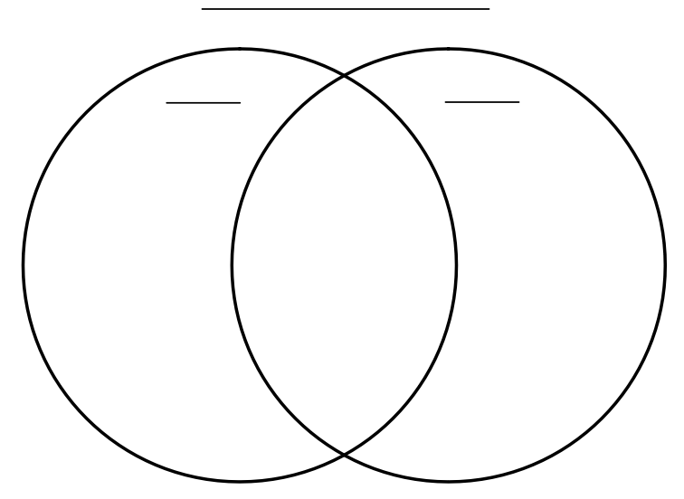

Number Ray Investigators Student Recording Sheet

