Mathematics Instructional Plan – Grade 4

Fraction-Decimal Relationships with Grids
Strand: Number and Number Sense
Topic: Identifying and representing fraction and decimal equivalents using grids
Primary SOL: 4.3 The student will,
- given a model, write the decimal and fraction equivalents.*
* On the state assessment, items measuring this objective are assessed without the use of a calculator.
Related SOL: 4.3a

Materials
- Fraction-Decimal Relationships Discovery activity sheet (attached)
- Fraction-Decimal Equivalence Recording Sheet (attached)
- Fraction-Decimal Equivalence Concentration Cards (attached)
- Class-display-sized 10-by-10 grid for teacher demonstration
- Coffee stirrers or flat straws (ones that do not roll)
- Base-10 materials (flats)
- “What’s my Number?” decimal game board (attached)
- Fraction/Decimal Combo cards (Set A and B) attached

Vocabulary
compare, decimal, decimal equivalent, decimal point, denominator, digit, equivalent, fifth, fourth, fraction equivalent, half, hundredth, leading zero, numerator, order, place value, tenth, value, whole

Student/Teacher Actions: What should students be doing? What should teachers be doing?
- Group students in pairs, and have them explore different ways they might be able to represent fractions, using base-10 materials. Give each pair some coffee stirrers, the flat from the base-10 materials, and the Fraction-Decimal Relationships Discovery activity sheet. Allow students only five minutes to explore what fractions they can find and the decimal equivalent for the fraction. Have several volunteers share out a fraction-decimal relationship they found. Record this on the board by modeling it on the 10-by-10 grid and then writing the numerals to represent the fraction and the decimal. Remind students about using the leading zero in decimals less than 1.
- Distribute the Fraction-Decimal Equivalence Recording Sheet. Allow students to keep the base-10 flats and stirrers for use in this activity if they need to use them. Then, ask each student to use a pencil to shade the first grid on the recording sheet to show fractions that are halves, fourths, fifths, or tenths and then find the decimal equivalent. Observe students as they figure out the first grid, then facilitate a discussion among several students to discuss what they shaded in on their grid and what relationship they found. Use a demonstration tool to show students’ work or enter it on the class 10-by-10 grid. Students should be guided to using precise vocabulary, such as one-fourth is equivalent to twenty-five hundredths, which is written as 0.25. Ask, “Is there more than one way to model $\frac{1}{4}$ or 0.25 with the grid?” Model this on the demonstration tool or on the class 10-by-10 grid. Have students explain how they arrived at their results. Ask, “How did you figure that out?”
  - Ask, “How many small squares are in the grid?” (100) “How many of the small squares are shaded in?” (50) “How would you write this in fraction form?” (0.50) Review with students that the second place after the decimal is called the hundredths place. “How would you write that in fraction form?” Call on a student who has shaded in one-half of the grid. Use this example to help students see that $\frac{1}{2}$ written as a decimal is 0.50 because 50 out of the 100 small squares are shaded.
  - Review the grid as columns and rows and ask, “How many columns?” (10) “How many rows?” (10) Shade in five columns on the class 10-by-10 grid and ask, “What fraction is shaded?” ($\frac{1}{2}$ ). “What decimal is shaded if five of the 10 columns are shaded?” (0.5) Ask students to think about why $\frac{1}{2}$ can be written as 0.5 or as 0.50 and how they would pronounce each decimal number. Ask for several volunteers to share. Use the students’ words to highlight the equivalences, $\frac{1}{2}$ = 0.50 = 0.5. Also, review that the first place after the decimal point is called the “tenths” place and the second place is the “hundredths.”
- Ask students to complete the Fraction Decimal Recording Sheet, recording the fraction relationships using different fractions than those that have been discussed so far. Tell students to use what they learned while working on the first grid to shade in the fraction and then writing the equivalent decimal for the second grid. Circulate around the room and note students that are confused or have misconceptions. Ask questions to help them work through their challenges. When everyone is finished, form groups of four for students to share their work, prove their thinking, or identify their missteps if challenged by a group member.
- The fractions with a denominator of 5 are a little more challenging, and if no one has demonstrated a relationship with fifths, then facilitate a discussion about fifths. Ask the class to shade in $\frac{1}{5}$ of the 10-by-10 grid. Circulate and determine which student’s grids you want to use for the class discussion. Some students will be able to reason that one row, or column, is equivalent to $\frac{1}{10}$, so two rows are equivalent to $\frac{2}{10},$ which is equivalent to $\frac{1}{5}$. Another technique is to make five equal groups out of the 100 squares. Then use the grids you identify and ask students for the fraction and decimal equivalents written as numerals ($\frac{1}{5}$ = 0.20 = 0.2) Have students explain how they can justify the numbers.
- Copy and cut apart the attached Decimal Fraction Equivalence Concentration Cards for students to use in playing Concentration. Students play the game in pairs. Players place the cards face down and take turns drawing two cards at a time to see whether they are a fraction-decimal match. There are four cards for a full match. If a player draws matching cards, he/she keeps them. If another player chooses the other two cards that would complete a full match of four cards, the player with the first two cards can choose to not draw two new cards on his/her next turn but take the two cards that make a full match instead. At the end of the game, students total their scores. A full match of four cards is 5 points; a half match of two cards is 2 points. The student with the highest score wins the game.

Assessment

Questions
- What are some similarities between using fractions and decimals as numbers? What are some differences?
- If you know that $\frac{1}{5}$ = 0.20, how can use that information to find the decimal equivalence for $\frac{3}{5}$ ?
- Describe to me everything you know about the decimal that must be equivalent to 1$\frac{3}{4}$.
- Describe the relationship between money, fractions, and decimal equivalents?
- If you are asked to find the decimal equivalent for $2\frac{3}{4}$, what can you tell me about the decimal that will represent the mixed fraction even without knowing what $\frac{3}{4}$ is equivalent to as a decimal?

Journal/Writing Prompts
- Explain how fraction and decimal equivalents can be used in the real world and how this concept is relevant to your life.
- Explain to a student who was absent for the lesson how to use the 10-by-10 grid to find fraction and decimal equivalences.
- Explain why decimal equivalents for halves, fourths, fifths, and tenths can each be represented with decimals in the hundredths.

Other Assessments
- Have student pairs use the blank grids and work together to find decimal equivalents, given fractions and mixed numbers with denominators of 2, 4, 5, and 10.

Extensions and Connections
- Students can play the game “What’s my Number” as a whole group or with a partner. To play this game, students would write a “secret” decimal on an index card or piece of paper. The decimal should be less than 1 and should not be written past the decimal place value hundredth. Students take turns asking “yes” or “no” questions in order to discover the mystery number. Students can use a decimal hundred board chart (attached) or create a number line to identify the mystery decimal. Below is an example of how to play the game. The mystery decimal is seventy-five hundredths.
  - Is your decimal more than half? Yes
  - Is the decimal between six tenths and seven tenths? No
  - Is the decimal less than four-fifths? Yes
  - Is the decimal between seven tenths and eight tenths? Yes
  - Is your decimal equal to three-fourths? Yes
  - Is your decimal seventy-five hundredths? Yes
Encourage your students to ask yes or no questions that focuses on benchmarks, decimal number sense, and fraction-decimal equivalences. Students will continue to ask “yes” or “no” questions until they have correctly guessed the secret decimal.
- Two different sets of fraction/decimal combo cards have been created to have students identify the fraction and decimal equivalences with a given model. Each set has additional decimals cards as distractors to help identify those students who have misconceptions with fraction/decimal equivalences. Students can work together with a partner or individually to match the equivalent fraction and decimal. With the additional decimal cards students could identify the equivalent fraction.
- Arrange for students to visit a local bank to meet with a bank employee to discuss the relationship between fraction and decimals in relation to money.
- Give each group of students a meter stick and ask them how they might be able to relate a meter stick to fraction-decimal equivalents.
- Have students use long pieces of bulletin board paper to draw a number line and place zero at one end point and 1 at the other end point. Have them determine equivalent fractions and decimals between zero and 1 on the line by using measuring devices or by folding the paper.
- Have students research various sports and determine the sports for which someone needs to understand decimal and fraction equivalents.

Strategies for Differentiation
- Provide models for students to explore the relationships among fractions and decimals (i.e., base-ten models or 100-grid representations).
- Engage students in shading grids to represent benchmark fractions in different ways on 100-grid paper. For example, have the students shade one-half in multiple ways on different grids. Ask what they notice?
Note: The following pages are intended for classroom use for students as a visual aid to learning.

Virginia Department of Education ©2018

Fraction-Decimal Equivalence Recording Sheet

Name Date
Shade in each grid to represent the fraction shown below it. Use the grid to help you figure out the equivalent decimal for each fraction. Write the equivalent decimal name for each fraction.
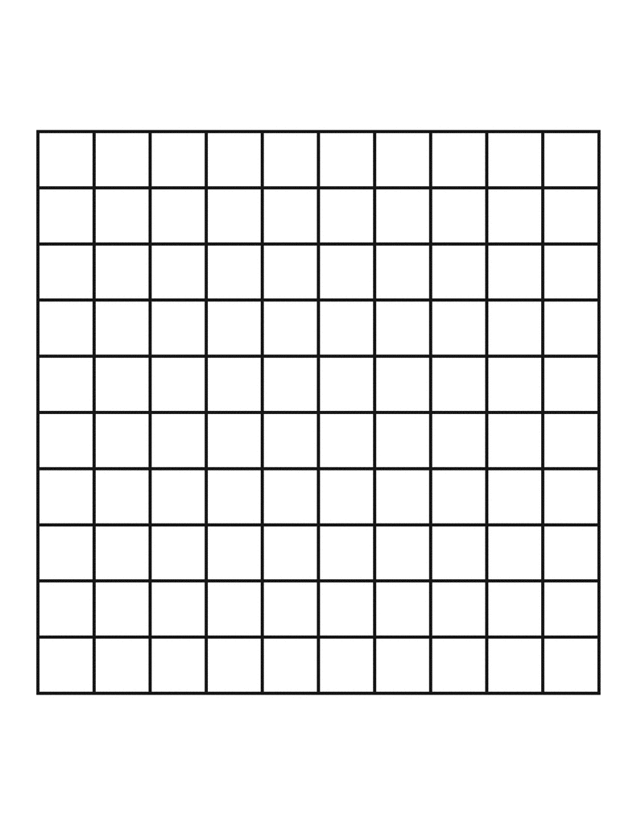
$\frac{1}{2}$ = | $\frac{1}{4}$ = | $\frac{3}{4}$ =
$\frac{1}{5}$ = | $\frac{2}{5}$ = | $\frac{3}{5}$ =
$\frac{4}{5}$ = | $\frac{1}{10}$ = | $\frac{7}{10}$ =

Fraction-Decimal Relationships Discovery

Use the 10-by-10 grid to model and state what fraction and decimal equivalents you find.
MODEL FRACTION DECIMAL

Fraction-Decimal Equivalence Concentration Cards
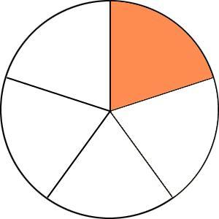 | $$\frac{1}{5}$$ | 0.2
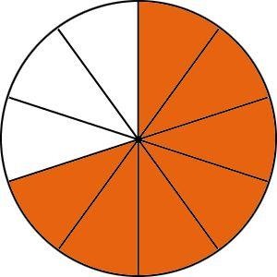 | $$\frac{7}{10}$$ | 0.7
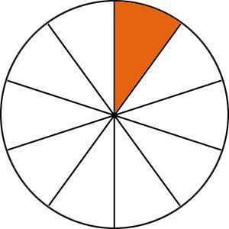 | $$\frac{1}{10}$$ | 0.1
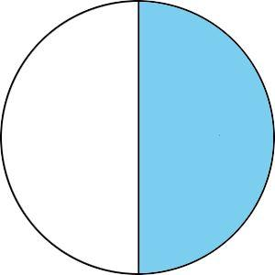 | $$\frac{1}{2}$$ | 0.5 | 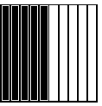
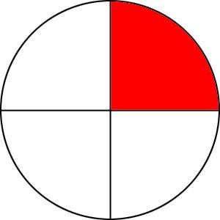 | $$\frac{1}{4}$$ | 0.25 | 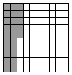
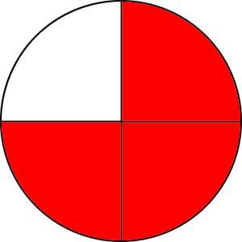 | $$\frac{3}{4}$$ | 0.75 | 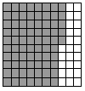
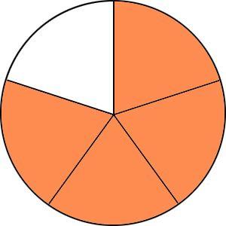 | $$\frac{4}{5}$$ | 0.8
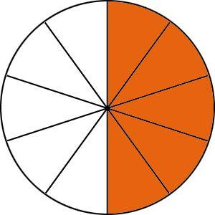 | $$\frac{5}{10}$$ | 0.5
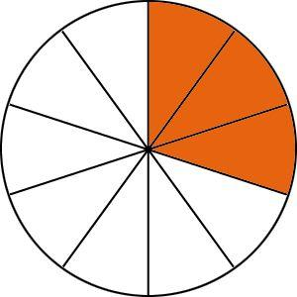 | $$\frac{3}{10}$$ | 0.3
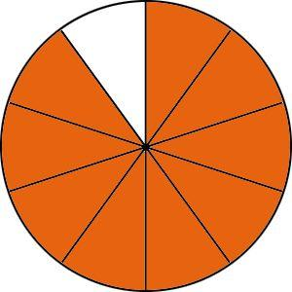 | $$\frac{9}{10}$$ | 0.9

What’s My Number?

0.01 | 0.02 | 0.03 | 0.04 | 0.05 | 0.06 | 0.07 | 0.08 | 0.09 | 0.1
0.11 | 0.12 | 0.13 | 0.14 | 0.15 | 0.16 | 0.17 | 0.18 | 0.19 | 0.2
0.21 | 0.22 | 0.23 | 0.24 | 0.25 | 0.26 | 0.27 | 0.28 | 0.29 | 0.3
0.31 | 0.32 | 0.33 | 0.34 | 0.35 | 0.36 | 0.37 | 0.38 | 0.39 | 0.4
0.41 | 0.42 | 0.43 | 0.44 | 0.45 | 0.46 | 0.47 | 0.48 | 0.49 | 0.5
0.51 | 0.52 | 0.53 | 0.54 | 0.55 | 0.56 | 0.57 | 0.58 | 0.59 | 0.6
0.61 | 0.62 | 0.63 | 0.64 | 0.65 | 0.66 | 0.67 | 0.68 | 0.69 | 0.7
0.71 | 0.72 | 0.73 | 0.74 | 0.75 | 0.76 | 0.77 | 0.78 | 0.79 | 0.8
0.81 | 0.82 | 0.83 | 0.84 | 0.85 | 0.86 | 0.87 | 0.88 | 0.89 | 0.9
0.91 | 0.92 | 0.93 | 0.94 | 0.95 | 0.96 | 0.97 | 0.98 | 0.99 | 1.0

Set A - Fraction and Decimal Combo Match Cards
This set includes 8 model cards and their fraction and decimal equivalences. There are additional decimals cards that are distractors.

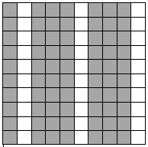 | 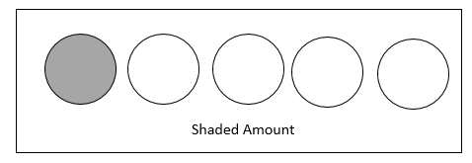
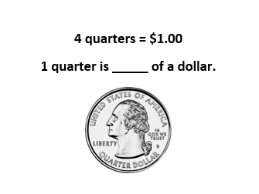 | 1  2  ?
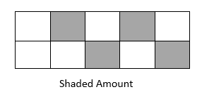 | 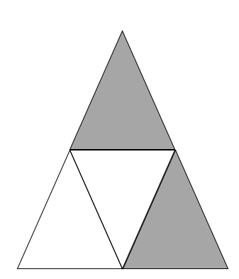
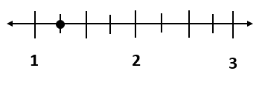
$$\frac{1}{5}$$ | $$\frac{1}{4}$$
$$\frac{4}{10}$$ | $$\frac{4}{5}$$
$$\frac{7}{10}$$ | $$\frac{2}{4}$$
$$\frac{5}{4}$$ | $$1\frac{1}{2}$$
0.15 | 0.2
0.14 | 0.25
0.4 | 4.10
0.45 | 0.8
0.7 | 0.17
0.24 | 0.5
5.4 | 1.25
1.12 | 1.5

Set B - Fraction and Decimal Combo Match Cards
This set includes 8 model cards and their fraction and decimal equivalences. There are additional decimals cards that are distractors.

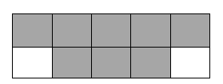
 | 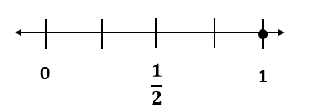
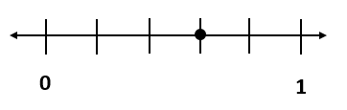 | 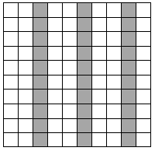
$$\frac{3}{5}$$ | $$\frac{3}{4}$$
$$\frac{3}{10}$$ | $$\frac{9}{10}$$
$$\frac{2}{5}$$ | $$\frac{8}{10}$$
$$\frac{1}{2}$$ | $$\frac{4}{4}$$
0.34 | 0.75
0.3 | 0.31
0.9 | 9.1
0.6 | 0.35
0.5 | 0.12
0.45 | 0.8
0.4 | 0.25
1.0 | 4.4

