Mathematics Instructional Plan – Grade 4

Comparing Decimals
Strand: Number and Number Sense
Topic: Comparing decimals and ordering up to four decimal numbers expressed through thousandths
Primary SOL: 4.3 The student will
- compare and order decimals.
Related SOL: 4.3a

Materials
- Base-10 blocks
- Decimal War Number Cards (attached)
- Decimal War Recording Sheet (attached)
- Base-10 Blocks Template (attached)
- Digit Cards (attached)
- Dry-erase boards (one per student; optional)
- Decimal Showdown activity (attached)
- Scissors
- Small baggies
- 6-sided Number Cube

Vocabulary
compare, decimal, decimal point, digit, equal to (=), greater than (>), greatest, hundredth, leading zero, least, less than (<), not equal to (≠), order, place value, tenth, thousandth, value, whole

Student/Teacher Actions: What should students be doing? What should teachers be doing?
- Remind students of the terms greater than (>), less than (<), and equal to (=), and write the symbol and what it represents on the board. Students should have access to base-10 materials, and there should be a place-value chart posted in the classroom. Remind students of the name of the places and let them know that you are expecting them to use appropriate mathematics language when they share their work.
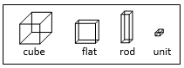
- Record the following on board and ask students to copy the sentence on their dry-erase boards or in their notebooks and fill in the symbol (<, >, or ≠) that makes the sentence true. They should be able to explain how their arrived at their answer.
- 235 ___ 255
- 2.35 ___ 2.55
- 0.3 ___ 0.30
- 9.46 ___ 9.52
- 47.216 ___ 47.206
- 5.060 ___ 5.06
- 8.37 ___ 8.369
- Circulate around the room as students are working to support students who are having trouble and to make note of any misunderstandings students have.
- When students have had sufficient time to work on the task, ask them to compare their answers with a shoulder partner. If partners have a different answer for any of the problems, the student pair must reach a consensus on the correct answer and have a way to justify the answer.
- Facilitate a class discussion by selecting some of the problems for identified students to show on the board and justify the correct answers. If students do not refer to the base-10 material, follow up by saying, “Now let us look at what ____ just said by looking at our models as additional support.”
- End the activity by asking students to write in their notebooks what is important to remember when comparing decimals.
- Students will work in pairs to play Decimal War, to practice comparing decimals. Provide each pair with the Decimal War handout, two pairs of scissors, and a baggie. Students should cut apart the numbers along the lines and store them in their baggies when not in use. Base-10 blocks should be available for students who want or need to use them. Review the rules of the game:
- Each play will randomly take 12 of the numbers.
- Students should place the cards facedown. Each student turns over the top card at the same time. Whoever has the greatest number gets to keep both cards. The person who has the most cards at the end of the game wins!
- Tell students that in a case where two cards are equal to each other, each player keeps their own card.
- Students must reach consensus on which symbol to use. Make base-10 blocks available for students who want to use them.
- Encourage students to use their place-value charts, if needed.
- Circulate around the room to support students and to note any misconceptions students may have. Use the misconceptions to facilitate a discussion at the end of the game.
- Write the following prices on the board: $1.79, $1.96, $1.61, and $1.72. Then share the following scenario with the students. “You and your Mom stopped to buy gas for the car. The station has four gas pumps, each marked with one of these prices. Put the gas prices in order from least to greatest, and write your response on your dry-erase board.”
- Ask students to compare their responses with a shoulder partner and, if their responses differ, discuss the difference and try to reach an agreement on the correct order and record that order on their dry-erase boards.
- Ask students to share strategies they used to order the numbers. Ask one student in each pair to hold up the pair’s answer and record all the different orders you see on the board.
- If some of the orders differ, open it up to the class to decide which is the correct order and why. Also, ask whether anyone has an idea about what misconception may have led to an incorrect order.
- End the discussion by comparing the representation for $1.61 in money to the representation of 1.61 in base-10 blocks. Students who are struggling with decimal place value need to continue to explore with the proportional manipulative, base-10 blocks, so they can see the 10-to-1 relationship.
- Write the following on the board: 8.36, 8.434, 8.379, and 8.52. Inform students that the numbers represent meters for the four top distances for the college championship long jump. Ask students to order the distances from least to greatest and record the numbers on their dry-erase boards. Use the directions in 3a–c to debrief the activity. Again, the base-10 blocks can help students who need additional support. The following graphic organizer will provide support for interpreting decimals when there are a different number of decimal places.
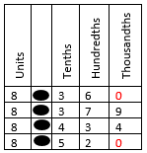
- Group students in pairs. Provide each pair with a set of Digit Cards, scissors, and a baggie. Students will cut the cards apart and use the baggie to store their digit cards after the activity. Each student will need a sheet of notebook paper. Review the directions with the students.
- Shuffle the Digit Cards and place them face down in the middle of the table.
- One player chooses three or four cards and turns then face up in no particular order. Working together, create the largest decimal number you can and the smallest decimal number you can. Each player records the two numbers on their notebook paper. Use the appropriate symbol (>, <, =) and words to compare the decimals. Put the digit cards in a discard stack.
- The partners take turns pulling out three to four cards and then following the steps in 5a. Remind the students to vary pulling out three or four cards on the rounds. Stop when they have four comparison sentences.
- First, take the four decimal numbers that were the greatest and order them from least to greatest. Each student will record the order numbers on their notebook paper. Then take the four decimal numbers that were the smallest and order them and record the ordered numbers.
- Circulate around the room to support students and to make note of who understands the concepts involved in comparing and ordering and who still needs more help.
- Each team should trade papers with another team so that they can review one another’s comparisons and ordered numbers. When the review is complete, the pairs will meet to discuss their recommendations for revisions as necessary.
- Provide teams time to revise their work and then collect the work to review as a formative assessment in preparation for the next lesson.

Assessment
- Questions
- Why is 0.348 less than 0.36?
- Compare the value of 0.820 and 0.82. Which decimal is larger? How do you know?
- Why did your group choose to put 0.67 after 0.5?

Journal/Writing Prompts
- Look through retail advertisements and find the costs of five items. Order the costs from greatest to least.
- Amy says that 0.36 is bigger than 0.7 because 36 is bigger than 7. Is she right? Explain why Amy is correct or incorrect in her thinking using words and pictures.

Other
- Have students compare decimals shown on a calculator or written down. Make sure they are using the correct symbol and writing a sentence to explain what the symbol means.

Extensions and Connections (for all students)
- Look through students’ science textbooks for ways that decimal numbers are used and ways that ordering and comparing is helpful in some contexts.
- Review the sports section of the newspaper for ways that decimal numbers are used and ways that ordering and comparing is helpful in some contexts.
- Look around your home and identify where decimals can be found and in what ways ordering or comparing might be helpful.
- Have the students play the game “Decimal Showdown” with a partner. This activity focuses on the concept of comparing decimals. Each student will need a “Decimal Showdown” game mat (attached), one game board (attached), a set of digit cards (attached), game markers, and a 6-sided number cube. Students take turns selecting one digit card from the pile and strategically placing the digit card on his/her game mat trying to create the largest number. Once both players have completed their number, Showdown. The player with the largest number will roll the 6-sided number cube and move their marker on the game board that many spaces. After each round the digits should be shuffled and placed faced down in the pile. The first player to reach the finish line wins.

Strategies for Differentiation
- Have students use place-value pockets to display the numbers represented by the base-10 blocks.
- Provide students with a decimal place-value chart.
- Have students color-code the >, <, = symbols.
- Encourage students to use base-10 blocks.
- Invite the school librarian to discuss the Dewey decimal system.
- Invite the P.E. teacher to discuss how being able to compare and order decimals is important in certain athletic competitions.
- Have students use pipe cleaners or modeling clay to create the symbols <, >, and =.
- Have students use a graphic organizer (see activity 3), so they can compare the digits in each place value.
- Have students work in small groups to compare numbers with decimals. Two students hold cards with decimal numbers written on them. Another student stands between the card-holding students and creates with his/her body the correct comparison symbol to make a true sentence. Another student reads the sentence aloud.

Note: The following pages are intended for classroom use for students as a visual aid to learning.

Virginia Department of Education ©2018

Decimal War Number Cards
10.0 | 10.02 | 9.15 | 0.915
12.432 | 1.2 | 9.8 | 9.08
90.0 | 90.01 | 25.0 | 2.55
16.087 | 16.87 | 80.9 | 89.0
23.4 | 12.345 | 5.5 | 5.05
3.2 | 3.200 | 14.1 | 4.023

Decimal War Recording Sheet

Player 1 Name _____________________ Player 2 Name__________________________
Each player writes their decimal number below, and then players reach consensus on which symbol (>, <, or =) to fill in to show the correct comparison of the decimal numbers generated.
Player 1’s Decimal Number | >, <, or = | Player 2’s Decimal Number

Discuss the following and write the partner response. If you need more room to write, use the back of the paper.

- What did you find tricky or challenging about comparing some of the numbers?

- You overheard some say, “Of course 4.79 is greater than 4.8, because 79 is way more than 8.” What misconception or confusion does this student probably have, and how would you help understand their confusion?

Digit Cards
0 | 1 | 2 | 3
4 | 5 | 6 | 7
8 | 9 | 1 | 2
3 | 4 | 5 | 6
7 | 8 | 9 | 0
1 | 2 | 3 | 4

Base-10 Blocks Template

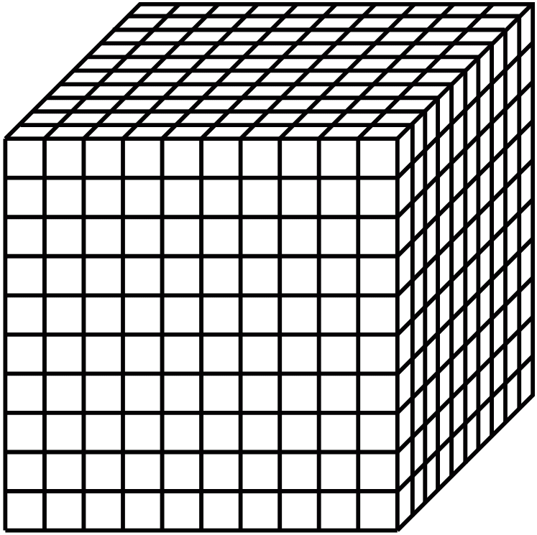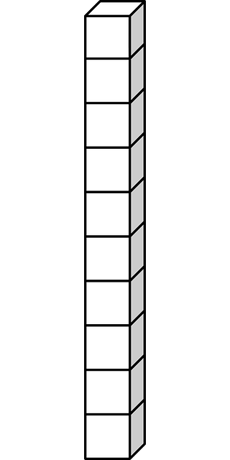

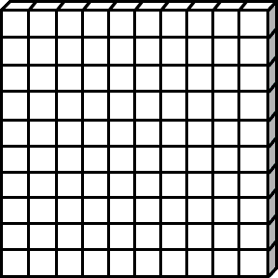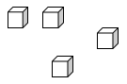

Decimal Showdown

Directions: Take turns placing a digit card in each place value shown below. Do not let your partner see the placement. Once your number is created, SHOWDOWN! The partner with the largest number wins the round. Roll the number cube to see how many space you advance on the game board. First one to the finish line wins.

Player 1

Decimal Showdown

Directions: Take turns placing a digit card in each place value shown below. Do not let your partner see the placement. Once your number is created, SHOWDOWN! The partner with the largest number wins the round. Roll the number cube to see how many space you advance on the game board. First one to the finish line wins.

Player 2

Digit Cards
0 | 1 | 0 | 1
2 | 3 | 2 | 3
4 | 5 | 4 | 5
6 | 7 | 6 | 7
8 | 9 | 8 | 9

Go Back

1 Space

Start

Decimal
Showdown
Decimal
Showdown

Forward2 Spaces

Move Forward 2 Spaces

Lose a Turn

Go Back 3

Spaces

FINISH

