Mathematics Instructional Plan – Grade 4

Reading and Writing Decimals
Strand: Number and Number Sense
Topic: Modeling, writing, and reading decimals through thousandths
Primary SOL: 4.3 The student will
- read, write, represent, and identify decimals expressed through thousandths.
Related SOL: 4.3bd

Materials
- Base-10 blocks
- Base-10 Templates (attached)
- Decimal Place-value Chart (attached)
- A Number by Many Names activity sheet (attached)
- Dueling Decimals Game activity sheet (attached)
- Model Match decimal activity (attached)
- Decimal Memory game (attached)
- Dry-erase boards
- Calculator
- Scissors
- Glue
- Clear tape
- Snack-size baggie

Vocabulary
base-10 number system, decimal number, decimal point, digit, expanded notation, hundredth, leading zero, model, place value, standard notation tenth, thousandth, unit, value, whole

Student/Teacher Actions: What should students be doing? What should teachers be doing?
Note: It is important for students to understand the 10-to-1 relationship between whole, tenths, hundredths, and thousandths. When using base-10 blocks to model decimals, you must first identify the base-10 block that will represent the whole, or 1. Repeatedly changing the type of block representing the whole helps students build an understanding of decimals and how they are used to represent part of the whole or part of 1. Students understand and identify the relationships among the large cube, flat, rod, and unit.
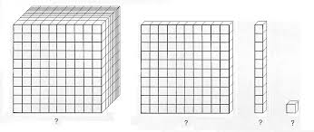
Before undertaking this activity, create a set of 11 cards for each student: 10 cards with the digits 0–9 written on them and one card with a decimal point on it.
- This is a guided note-taking activity. Review the base-10 blocks as a tool to represent decimal numbers and to highlight the 10-to-1 relationship of the base-10 number system. As part of the review, develop an anchor place-value chart. Use pictures of the base-10 pieces, but do not glue them to the chart so that you will be able to assign the whole to various pieces throughout the lesson. The anchor place-value chart should have five columns and four rows.
When complete, it will look like the following.
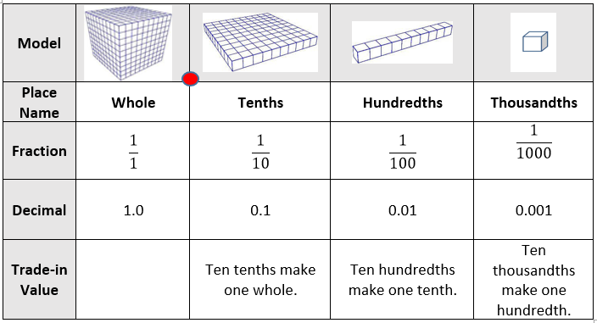

- Distribute the Decimal Place-value Chart to each student, along with a pair of scissors and a snack-size baggie. Students will cut out the chart and glue it in their notebooks. They should cut out the pictures of base-10 pieces (1,000-cube, flat, rod, and unit cube). The teacher should begin with a large 4-by-4 empty chart on chart paper and have large pictures of the base-10 materials.
- Show each of the four types of base-10 blocks to the class and remind them that they used these when they were learning about whole numbers, and in third grade they used them to learn about decimals. Today, they will continue using them to learn more about decimals.
- Hold up the large cube and tell students that for this activity the large cube will represent 1 whole. Write in the place-value name on the anchor chart and attach a picture of the large cube as the model. Instruct students to write the word whole and to tape their picture of the large cube in the Model row. In the Fraction row, write$\frac{1}{1}$; if students have not seen this notation before, help them understand that the fraction $\frac{1}{1}$ is the same as 1 because one divided into 1 is 1. Then remind them that we write the decimal in standard notation as 1.0. Highlight the purpose of the decimal point and the use of the trailing zero.
- Hold up the flat and ask students to figure how many flats it would take to make the whole, or one cube. Ask students to hold up the number of fingers to show how many it would take. When everyone agrees that it takes 10 flats to make a whole cube, let them know that one of the pieces is called a tenth and the place value is tenths, then guide them through filling in the table with the remaining information in the Tenths column. Highlight the use of the leading zero.
- Work through figuring out how many rods make a flat and how many small cubes make a rod and completing each column in turn.
- Remind students that the anchor chart illustrates how to write the place values in preparation for expanded notation: that is, 1.0 + 0.1 + 0.01 + 0.001. Record this on the board using different colors for each addend. Ask what the number would be written in standard form, and record it on the board to make a number sentence: 1.0 + 0.1 + 0.01 + 0.001 = 1.111. Use the relevant color for each of the ones. Ask students the following questions:
- What is the place value of each of the ones?
- What is to the right of the ones place? The tenths place? The hundredths place?
- What is to the left of the thousandths place? The hundredths place? The tenths place?
- Direct students to look at the tenths place column on the anchor chart and then look at the row for Trade-in Value, then ask what they notice and wonder about trade in value.
- When is it important to know the trade-in value of a place value?
- How would you read the compact number?
- How would we write the number in words?
- Distribute base-10 blocks to each pair of students and the A Number by Many Names activity sheet. Leave the Decimal Place-value Anchor Chart and the base-10 blocks model on display as students create their own decimal numbers with their blocks.
- Review with students how to sketch pictures of the concrete place-value pieces quickly, using a dot for the units, a line segment for the rod, a square for the flat, and a cube for the large cube. Students may be challenged to draw a cube, but it does not have to be perfect. You can also provide small pictures of each, and the students can glue them to their handout.
- Model completing one row with the class and then let them work in pairs to complete the activity.
- Circulate around the room, supporting students and posing questions to gain knowledge of student understanding and misconceptions.
- Post an answer key in the room, along with several crayons, to create a checking station. Students who finish can take their handout to the checking station, no pencils, and use the crayons to indicate what they need to continue working on.
- As a closing activity or a number talk for the following day, challenge students to write some decimal numbers on dry-erase boards (if available) as you describe them, focus on the value of the number so students know where each digit belongs. Students can hold up their white boards so that you can quickly determine which students need additional support. Note that in some situations there may be more than one number that meets the criteria. Some sample statements follow:
- I am thinking of a number greater than 5 that has a 6 in the tenths place. (More than one response possible)
- I am thinking of a number that when read is 4 and three hundred twenty-eight thousandths.
- I am thinking of a number that can be modeled with three large cubes, 5 rods, and 8 units.
- I am thinking of a number between 6 and 7 that has a 4 in the hundredths place. (More than one response possible.)

Assessment

Questions
- How are decimal numbers and whole numbers alike? How are they different?
- How can zeros affect the value of a decimal number?
- Which is larger, 0.065 or 0.65? How do you know?
- How do you know that 0.23 is smaller than 0.237

Journal/Writing Prompts
- Describe a situation in which the number 1.53 might be used.
- One friend said the cafeteria made 234 cookies for the fourth-grade lunch, and another friend said he heard the cafeteria made 0.234 cookies. Explain how you would help the two friends understand why one answer makes more sense than the other.
- If the flat in the base-10 blocks represents the whole, explain and draw pictures to show how you would represent 5.34.

Other
- Give students a base-10 blocks model and a key, and have them write the modeled decimal number in standard form as well as word form.
- Have students look through magazines, newspapers, and labels on meats at the grocery store to identify ways decimals are used. They should record the name of the item, the decimal number, and then write the decimal number in words.

Extensions and Connections (for all students)
- Provide each student with a set of 11 cards: 10 cards with the digits 0–9 on them and a decimal-point card. Repeat the earlier activity about reading and describing numbers, but this time, have students model the number both with blocks and with their digit and decimal cards. Having students read aloud the numbers they model will also give them practice in reading decimal numbers.
- Have students explore the relationships between decimal numbers and money. Students can create a poster to display pictures of coins and a $1 bill. Write the value of the money and then explain how understanding decimal place value helps understand the relationships among the pieces of money.
- Have students collect sales receipts from shopping in the community, and have them practice reading the decimal numbers on them.
- Ask students to create a comparison chart to illustrate the common uses for fractions and the common uses for decimals. They should look through magazines and newspapers, science and history textbooks as well as talking with other adults such as the P.E. teacher, music teacher, banker, grocery store worker, etc.

Fractions are Commonly Used for- | Decimals are Commonly Used for-
$\frac{1}{2}$ gallon of milk | 18.5 gallons of gas pumped
- Students play the Dueling Decimals Game with partners. Provide a copy of the activity, which includes the rules of the game and a recording chart, to each student. The game asks students to use their digit cards to make a number close to a target number. The also game encourages students to think about the magnitude of decimal numbers.
- Students can complete the activity “Model Match” (attached), which is designed to have students match decimals that are represented in a variety of forms. These forms include identifying the model, standard form, and written form. Students may work individually or in a group to match the standard form of a decimal to the written form and pictorial representation. Each individual or group should receive a “Model Match” recording sheet (attached), set of “Model Match” cards (attached), set of “Standard Form Cards” (attached) and a set of “Written Form Cards” (attached). Once students have matched the three cards for each decimal, they should record their matches on the recording sheet. In the picture column on the recording sheet, students should shade the base-10 block provided to represent the decimal. Prior to completing this activity, the teacher should identify that the whole is one flat and the decimals is represented by the shaded amount.
- Students can play the game “Decimal Memory” to practice reading and representing decimals in variety of forms. Students should place the “Decimal Memory” cards (attached) faced down on a playing surface. Players will take turns selecting two cards in an attempt to find a match. If the player has a match, he/she will record the match on the recording sheet. If the player does not have a match, then the next player has the opportunity to find a match. The game will continue until all of the cards have been matched. The players with the most decimal matches wins the game.

Strategies for Differentiation
- Provide students with grids and place-value charts or charts to help the students keep track of decimal vocabulary, such as tenths, hundredths, and thousandths. Use color-coding for the different places.
- Use individual place-value pockets with corresponding number cards.
- Have students match pictures of base-10 block models of decimals with decimal numbers written in standard form as well as word form.
- Use base-10 stamps or pictures of base-10 models to create pictorial representations of given numbers.
- Continue to use base-10 blocks or other proportional models to solve assignments.
- Student pairs take turns calling out decimal numbers and writing them down. (Also, have students use a word processing program to display the corresponding decimal or use their place-value charts with number cards.)
- Students work in groups of three or four to represent numbers called out to the class. Provide each group with a set of 11 cards with the digits 0–9 and a card with a decimal point. Group members pull the digits based on the number called out and the decimal point and then stand in the correct order, displaying the cards.
- This eight-minute video shows and explains the relationship among the base-10 materials, illustrates how the materials can be used for whole numbers and for decimal numbers, and illustrates how the name of each base-10 piece is determined by which piece is designated as the whole.

Note: The following pages are intended for classroom use for students as a visual aid to learning.

Virginia Department of Education ©2018

Base-10 Templates
Name Date

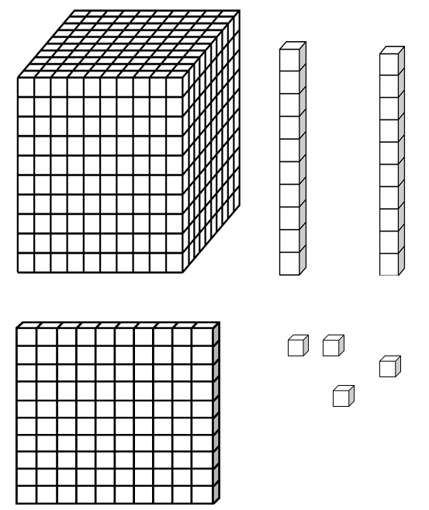

Decimal Place-value Chart
Cut out the table and glue it into your notebook. Cut out the base-10 pieces below the chart and put them in the baggie. Do not glue the pieces onto the chart. Follow the directions from the teacher to fill in the chart.

Model
Place Name
Fraction
Decimal
Trade-in Value

A Number by Many Names
If the large cube represents one whole, fill in the empty cells in the chart for rows 1-4. Make up your own numbers to fill in the last three rows.
Base-10 Model | Expanded Notation | Standard Number | Written Number
 | 2.0 + 0.4 + 0.07 + 0.005
 |  | 0.237
 |  |  | One and thirty-five hundredths
. . . .

Dueling Decimals Game
This is a partner game. You will need both partners’ sets of digit cards to play the game.
- Combine your digit cards, shuffle them and put them facedown between the partners.
- Each partner keeps the decimal point card in front to use on each round.
- Take turns pulling four cards from the digit deck and write the digits on the recording chart below.
- Think about the target number for the round and make a number using a decimal point and the four digits. Write your number in the chart.
- Partners will read their numbers and then compare the numbers each made and decide who is closer. You must reach consensus on the winner. The person closer wins the duel. If numbers are the same, the duel is a draw/tie.
- Return the cards to the bottom of the deck and start the next duel.

Round | The Four Digits  Turned Over | Target Number | Number You Made  (Remember to Include the Decimal Point) | Who is closer?
Round 1 |  | 0
Round 2 |  | 5
Round 3 |  | 10
Round 4 |  | 50
Round 5 |  | 100

Model Match Recording Sheet

WRITTEN FORM | STANDARD FORM | MODEL
WRITTEN FORM | STANDARD FORM | MODEL

Model Match Cards

Standard Form Cards
0.46 | 0.68 | 0.52 | 0.53
0.4 | 0.06 | 0.43 | 0.9
0.38 | 0.64 | 1 | 0.16
0.2 | 0.08 | 0.32 | 0.75
0.24 | 0.55 | 0.67 | 0.25
0.75 | 0.5 | 0.36 | 0.37

Written Form Cards
forty-six  hundredths | sixty-eight  hundredths | fifty-two  hundredths | fifty-three  hundredths
four tenths | six hundredths | forty-three  hundredths | nine tenths
thirty-eight  hundredths | sixty-four  hundredths | one whole | sixteen  hundredths
two tenths | eight hundredths | thirty-two  hundredths | seventy-five  hundredths
twenty-four  hundredths | fifty-five  hundredths | sixty-seven  hundredths | twenty-five  hundredths
seventy-five  hundredths | five tenths | thirty-six  hundredths | thirty-seven  hundredths

Decimal Memory
Standard Form

3.817 | 0.092
4.201 | 0.386
0.374 | 3.306
8.92 | 1.503
0.738 | 2.902
0.064 | 0.433
0.203 | 12.008
0.359 | 0.794
0.14 | 0.85
0.725 | 0.87

Decimal Memory
Written Form

Three and eight hundred seventeen thousandths | Ninety-two thousandths
Four and two hundred one thousandths | Three hundred eighty-six thousandths
Three hundred seventy-four thousandths | Three and three hundred six thousandths
Eight and ninety-two hundredths | One and five hundred three thousandths
Seven hundred thirty-eight thousandths | Two and nine hundred two thousandths
Sixty-four thousandths | Four hundred thirty-three thousandths
Two hundred three thousandths | Twelve and eight thousandths
Three hundred fifty-nine thousandths | Seven hundred ninety-four thousandths
Fourteen hundredths | Eighty-five hundredths
Seven hundred twenty-five thousandths | Eighty-seven hundredths

Name: _______________________________

Decimal Memory Recording Sheet

Standard Form | Word Form
Standard Form | Word Form

