*Mathematics Instructional Plan – Grade 4*

# Comparing Fractions: Developing Strategies

Strand:Number and Number Sense

Topic:Reasoning with benchmarks and other strategies to compare fractions.

Primary SOL:4.2 The students will

1. Compare and order fractions and mixed numbers, with and

without models.*

*\* On the state assessment, items measuring this objective as assessed without the use of a calculator.*

Related SOL:4.2b

## Materials

* Individual Fraction Strips (attached)

## Fraction Circles (To Fourths) activity sheet (attached; one per student)

* Fraction Circles (Fifths to Eighths) activity sheet (attached; one per student)
* Fraction Circles (Ninths to Twelfths) activity sheet (attached; one per student)
* Which is More? activity sheet (attached)
* Dry-erase board or sheet of paper

## Vocabulary

*benchmarks, compare, denominators, equal to, fraction, greater than (>), greatest, least, less than (<), like denominators, mixed number, number line, numerator, order, part, represent, unlike denominators, whole*

## Student/Teacher Actions: What should students be doing? What should teachers be doing?

1. Review the benchmark fractions of 0, $\frac{1}{2}$, and 1, and ask students how these benchmarks can be helpful. Remind students how the benchmarks can be shown on a number line. Ask volunteers to identify fractions that are equivalent to these benchmarks and explain their thinking. Ask volunteers to identify fractions that are less than $\frac{1}{2}$, more than $\frac{1}{2}$, and more than 1 and explain their thinking. Have the students review the characteristics of these fractions that were identified based on the benchmarks of 0, $\frac{1}{2}$, and 1. The characteristics should include relationships such as the numerator is half of the denominator, the numerator is more than or less than half the denominator, or the numerator is more than the denominator. Ask, *“Are there any other strategies that we could use to compare fractions?”*
2. Have the students work with a partner or in a small group to compare the following fractions, circle the larger fraction, and be ready to explain their thinking.
   1. $\frac{3}{4}$ and $\frac{1}{4}$
   2. $\frac{1}{8}$ and $\frac{4}{8}$
   3. $\frac{6}{6}$ and $\frac{1}{6}$
3. Once the students have compared the fractions, have a class discussion on the strategies used. Listen for ideas such as:
   * + When the denominator is the same, then the numerator will tell you which fraction is the larger amount.
     + When one fraction is equivalent to one-half, decide whether the other fraction is more or less than one-half.
     + When one fraction is equal to 1, decide whether the other fraction is more or less than a whole.

If students do not bring out the idea that if the denominators are the same, you just need to examine the numerator, or the idea that $\frac{3}{4}$ can be thought of as three $\frac{1}{4},$ then facilitate a discussion to examine these ideas. Ask, *“Can we look at the numerator when the denominators are the same to compare and order fractions?”* Have the students share their strategies and use models such as a number line or fraction strips to justify their answers if they need help to express their ideas.

Give the students another set of fractions to compare with their partner or in a small group. Encourage the students to spend some time reasoning without any manipulatives and then use their fraction strips to test their answer. This set of fractions focuses on using benchmarks and/or like numerators.

* 1. and
  2. and $\frac{6}{8}$
  3. $\frac{3}{5}$ and $\frac{3}{6}$

The class discussion should allow students to share the kind of reasoning they used, because students need to realize that you can often use more than one strategy to solve a problem. Pose questions to facilitate student sharing and a class discussion on the multiple ways to compare these sets and use models to justify their answer. Bring out the idea that when numerators are the same, it means you have the same number of parts and you can use the denominator to see which parts are larger or smaller.

1. Next, have students work with their partner or small group to compare the following fractions using their strategies. These fractions lend themselves to using benchmarks of 0, $\frac{1}{2}$, and 1, but encourage students to work without manipulatives and use their own reasoning strategies to compare the fractions. When they have completed the set, use the fraction strips to check their answer. Tell students that if they did not get the correct answer, they need to figure out where they went wrong in their reasoning.
   1. $\frac{2}{6}$ and $\frac{5}{8}$
   2. $\frac{4}{6}$ and $\frac{3}{8}$
   3. $\frac{5}{12}$ and $\frac{6}{10}$

Ask students to share the strategies they used and why their strategy worked. If no one used the benchmark of $\frac{1}{2},$ then pose questions for students to recognize that each of these fractions are close to the benchmark $\frac{1}{2}$. Then ask students whether they can use this same strategy of distance from one-half to compare fractions that are more than half. For example: Which fraction is greater, $\frac{5}{8}$ or $\frac{6}{10}$? Using fraction strips would model that these fractions are both one unit fraction more than $\frac{1}{2}$. Comparing the unit fractions, $\frac{1}{10}$ and $\frac{1}{8}$, would be beneficial when determining that $\frac{5}{8}$ is greater because $\frac{1}{8}$ is larger than $\frac{1}{10}$.

1. Last, have the students compare the following fractions using their own reasoning strategies. The strategy of examining the distance from the whole is helpful for this set of fractions. When students have finished, ask them to use their fraction strips to check their answers, and if their answer is incorrect, they need to figure out where they went wrong with their reasoning.
   1. $\frac{3}{4}$ and $\frac{9}{10}$
   2. $\frac{8}{9}$ and $\frac{7}{8}$

Ask for volunteers to share their thinking and why their reasoning worked. If no one discusses looking at the distance from a whole, encourage the students to spend some time thinking about the strategy of distance from the whole. This can be challenging for students to put into words, so you may want to use a number line to show that in set (j.), the fraction $\frac{3}{4}$ is $\frac{1}{4}$ away from the whole, and $\frac{9}{10}$ is $\frac{1}{10}$ away from the whole. The number line model will guide the students to see that $\frac{1}{10}$ is a smaller distance away from the whole than the fraction $\frac{1}{4}$, so the fraction $\frac{9}{10}$ is larger than $\frac{3}{4}$.

Have students create a human number line to visually represent each fraction. Have the student first represent 0, $\frac{1}{2}$, and 1 on the human line in front of the classroom by holding an index card or small dry-erase board with the fraction labeled. Next, have a student identify the location of $\frac{3}{4}$ on the human number line. One way to model this fraction is to have a student take 4 equal steps from 0 to 1, stopping at step 3 to model $\frac{3}{4}$. Use the same strategy to model $\frac{9}{10}$ by having the student take 10 equal steps from 0 to 1, stopping at step 9 to model the fraction $\frac{9}{10}$. Have a class discussion on the size of the steps and recognizing that they both have one more step to reach the whole. Because the fraction $\frac{1}{10}$ is smaller than the fraction $\frac{1}{4}$, the fraction $\frac{9}{10}$ is greater than $\frac{3}{4}$.

1. In groups of three, have each student make their four-column notes page so they make a list of the strategy descriptions and illustrate with a model and with a number sentence. The group is responsible for brainstorming together to come up with as many of the strategies as they can. They can set the page up as shown below. You should model one strategy with the class and review the greater than (>) and less than (<) notation.

| **Strategy for Comparing Two Fractions and When to Use the Strategy** | **Describe how the Strategy Works when Comparing Two Fractions** | **Show with a Model** | **Show the Number Sentence with**  **> or <.** |
| --- | --- | --- | --- |
|  |  |  |  |

When the groups have finished or time is up, pair up the groups to review each other’s work.

1. Have students work in pairs to use the four-column notes to complete the Which is More? activity sheet. Teachers should circulate around the room to identify student partners to share with the whole class. Look for work that illustrates each of strategies for comparing. Facilitate a class discussion to identify how the different strategies compare with each other.
2. Distribute the Comparing and Ordering activity sheet.
   1. Ask students to select any two fractions to compare and write the number sentence on a dry-erase board using the appropriate comparison symbol. Students should hold up their boards when finished. Call on volunteers to share their strategy. These fractions should allow the students to use a variety of strategies identified by the students, such as like numerators, like denominators, distance from one-half,distance from 1, and benchmarks.
   2. Ask students to pick three fractions to order from least to greatest and write the order on their dry-erase boards. Students should hold up their boards when finished. Select volunteers to share their strategy.
   3. Ask students to pick four fractions to order from greatest to least and write the order on their dry erase boards. Students should hold up their dry erase boards and teacher can call on volunteers to share their strategy. Highlight what it means to order from least to greatest or greatest to least.

## Assessment

### Questions

* Are the following fractions closer to $\frac{1}{2}$ or 1: $\frac{5}{8}, \frac{6}{9}, \frac{4}{12},\frac{7}{10}$? How do you know?
  + Is the fraction $\frac{1}{3}$ closer to $\frac{1}{2}$ or 0? Explain your answer.
  + When comparing the fractions $1\frac{2}{3}$ and $1\frac{5}{6}$, what strategies can you use to determine which fraction is greater?

### Journal/writing prompts

* + Jackson and Kaden were comparing $\frac{6}{10}$ and $\frac{2}{3}$. One student said $\frac{6}{10}$ was larger because 6 was more than 2. Another student said $\frac{2}{3}$ was larger because it was closer to a whole. Which student is correct? Use pictures or words to explain your answer.
  + Marta and Haley each bought a Kosmic candy bar. Marta ate $\frac{7}{8}$ of her candy bar, and Haley ate $\frac{3}{4}$ of her candy bar. Who has more of her candy bar left for later? Explain your answer with words and pictures.
* Emerson ran $\frac{5}{8}$ of a mile and Kristen ran $\frac{4}{6}$ of a mile. Who ran more distance? Explain your answer with words and pictures.

### Other Assessments

* + Give the students a pair of fractions to compare. Have the students find as many strategies they could to compare the fractions.
  + Have the students complete the Which is More? activity sheet.

## Extensions and Connections

* Give the students a set of fractions that are already compared, with either the numerator or denominator missing. Have students fill in the blank to make it a true statement. Example:

$\frac{2}{}$ > $\frac{3}{8}$ See if the students could identify a denominator or find all denominators that would make this statement true. Ask the students whether the denominator could be 6. Why or why not?

* Provide students with a set of four mixed numbers to compare and order. For example, 2 $\frac{2}{3}$, 2 $\frac{3}{8}$, 2 $\frac{4}{5}$, 2 $\frac{4}{7}$.

## Strategies for Differentiation

* Use area models such as fraction circles and fraction squares to model each fraction.
* Use fraction strips and/or number lines.
* Provide additional instruction on the strategies to compare fractions.
* Use anchor chart that show the strategies and how to use them.

**Note: The following pages are intended for classroom use for students as a visual aid to learning.**

Virginia Department of Education ©2018

## Which Is More?

**Name Date**

Use the strategies shown below to compare the fractions. Some strategies you can use when comparing fractions include:

* comparing to the benchmarks 0, $\frac{1}{2}$, or 1;
* investigating the distance from a whole or half; and
* reasoning with the denominator or numerator.

Write the correct symbol, > or <, to show the comparison. Then explain which strategy you used to compare the fractions.

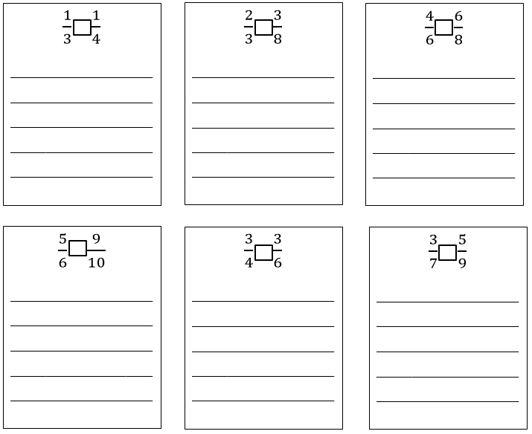

**Individual Fraction Strips**

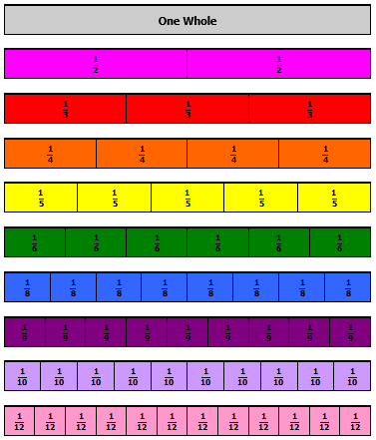

**Fraction Circles (To Fourths)**



1

$$\frac{1}{2}$$

$$\frac{1}{2}$$

$$\frac{1}{3}$$

$$\frac{1}{3}$$

$$\frac{1}{3}$$

$$\frac{1}{4}$$

$$\frac{1}{4}$$

$$\frac{1}{4}$$

$$\frac{1}{4}$$

**Fraction Circles (Fifths to Eighths)**



$$\frac{1}{8}$$

$$\frac{1}{8}$$

$$\frac{1}{8}$$

$$\frac{1}{8}$$

$$\frac{1}{8}$$

$$\frac{1}{8}$$

$$\frac{1}{8}$$

$$\frac{1}{8}$$

$$\frac{1}{7}$$

$$\frac{1}{7}$$

$$\frac{1}{7}$$

$$\frac{1}{7}$$

$$\frac{1}{7}$$

$$\frac{1}{7}$$

$$\frac{1}{7}$$

$$\frac{1}{6}$$

$$\frac{1}{6}$$

$$\frac{1}{6}$$

$$\frac{1}{6}$$

$$\frac{1}{6}$$

$$\frac{1}{6}$$

$$\frac{1}{5}$$

$$\frac{1}{5}$$

$$\frac{1}{5}$$

$$\frac{1}{5}$$

$$\frac{1}{5}$$

**Fraction Circles (Ninths to Twelfths)**

$$\frac{1}{12}$$

$$\frac{1}{12}$$

$$\frac{1}{12}$$

$$\frac{1}{12}$$

$$\frac{1}{12}$$

$$\frac{1}{12}$$

$$\frac{1}{12}$$

$$\frac{1}{12}$$

$$\frac{1}{12}$$

$$\frac{1}{12}$$

$$\frac{1}{12}$$

$$\frac{1}{12}$$

$$\frac{1}{11}$$

$$\frac{1}{11}$$

$$\frac{1}{11}$$

$$\frac{1}{11}$$

$$\frac{1}{11}$$

$$\frac{1}{11}$$

$$\frac{1}{11}$$

$$\frac{1}{11}$$

$$\frac{1}{11}$$

$$\frac{1}{11}$$

$$\frac{1}{11}$$

$$\frac{1}{10}$$

$$\frac{1}{10}$$

$$\frac{1}{10}$$

$$\frac{1}{10}$$

$$\frac{1}{10}$$

$$\frac{1}{10}$$

$$\frac{1}{10}$$

$$\frac{1}{10}$$

$$\frac{1}{10}$$

$$\frac{1}{10}$$

$$\frac{1}{9}$$

$$\frac{1}{9}$$

$$\frac{1}{9}$$

$$\frac{1}{9}$$

$$\frac{1}{9}$$

$$\frac{1}{9}$$

$$\frac{1}{9}$$

$$\frac{1}{9}$$

$$\frac{1}{9}$$

