Mathematics Instructional Plan – Grade Three

Patterns in a Staircase
Strand: Pattern, Function, and Algebra
Topic: Exploring patterns
Primary SOL: 3.16 The student will identify, describe, create, and extend patterns found in objects, pictures, numbers, and tables.

Materials
- Linking cubes
- Pattern Staircase Recording Sheet (attached)
- Pattern Staircase Task Cards (attached)
- Additional Growing Patterns Task Cards (attached)

Vocabulary
extending, geometric pattern, growing, missing term, numeric pattern, pattern, repeating, rule, table

Student/Teacher Actions: What should students be doing? What should teachers be doing?
- Explain to students that they will be exploring patterns by building a staircase out of linking cubes. The staircase will begin with one cube, and each step will be a tower of cubes that is two cubes higher than the previous step. There must be at least eight towers or steps. The towers will be considered steps numbers 1, 2, 3, 4 …. Allow students time to build their staircases.
3
2
1
- Have a discussion with your students about the staircase. Ask, “How are the stairs growing?” Have students discuss with a partner and then share what they discussed. Ask, “If we build the next step, how many linking cubes would we need to build it?” Have students explain how they knew it would take ___cubes to build the next step. Ask, “What is remaining the same in each step?”
- Distribute the Pattern Staircase Recording Sheet. Put students into pairs or small groups to build the staircases on the recording sheet. Ask groups to describe the pattern in their staircases and record this information on their individual recording sheets. Have students work in their groups to complete their recording sheets.
- While the students work with a partner or in small groups, circulate around the room to listen to student conversations and check their work. Are students able to describe the growing pattern? Take note of any misconceptions students have as they work on the task. You may want to ask them questions to help clarify/understand their thinking.
- Please note, some students may say that the color of each step is part of the pattern. For this lesson, we are focusing on how the stairs are growing with each step, not necessarily the color.
- After some work time, bring the students back together to discuss the work they recorded on Pattern Staircase Recording Sheets. Have students share how they saw the pattern growing? Ask, “Where might you see this type of pattern in real life?” or “How long could we continue this pattern?”

Assessment

Questions
- Looking at the grid pattern that you created on the recording sheet, what would you write as the rule for the pattern staircase?
- Would you describe this pattern staircase as a repeating pattern or a growing pattern? Explain your reasoning.
- If we added another step to the staircase, how many cubes would be needed to make the ninth step?
- What patterns do you notice as the steps grow?

Journal/writing prompts (include a minimum of two)
- Draw a staircase that begins with two linking cubes and add two more to each new tower. Identify how many cubes will be in the fifth tower and how many cubes will be in the 10th tower of this staircase. Explain how you know.

Other Assessments (include informal assessment ideas)
  - Observe students while they build models and generalize patterns.

Extensions and Connections (for all students)
- Distribute the Pattern Staircase Task Cards. Have students build staircases out of linking cubes, using the information on the cards. Students could use blank copies of the attached recording sheet to record information for the task cards.
- Distribute the Additional Growing Patterns Task Cards, and have students complete them. Give assistance, as needed.

Strategies for Differentiation
- Give students a similar stair pattern, where each tower or step only grows by one block.
- Have students use a hundreds chart to find and create numerical patterns.
- Have students use a number line to create and extend numerical patterns.
- Have students use linking cubes or wooden blocks for the Additional Growing Pattern Task Cards.

Note: The following pages are intended for classroom use for students as a visual aid to learning.

Pattern Staircase Recording Sheet
Name: Date:
Directions: Shade in the grid below to match the pattern staircase model that you created.
Step 1 | Step 2 | Step 3 | Step 4 | Step 5 | Step 6 | Step 7 | Step 8
Using the pattern in the staircase, fill in the number of linking cubes for steps 9 and 10.
 | Step 1 | Step 2 | Step 3 | Step 4 | Step 5 | Step 6 | Step 7 | Step 8 | Step 9 | Step  10
Number of linking cubes
Using the pattern in the staircase and the numbers recorded in the chart, make a prediction of the number of linking cubes in step 15. _____
Is there a pattern in the chart that helps you explain your answer? ______. If there is, what is it?
_____________________________________________________________________________________
_____________________________________________________________________________________

Pattern Staircase Task Cards
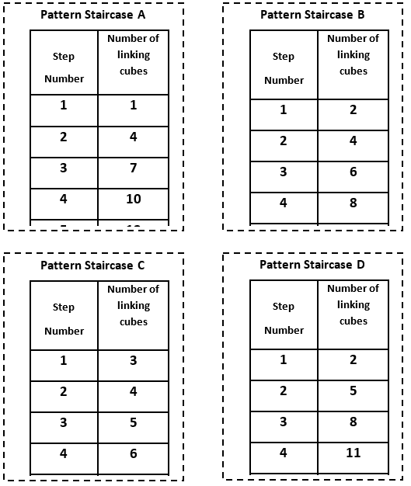

Additional Growing Patterns Task Cards
