Mathematics Instructional Plan – Grade Three

Probability Boxes
Strand: Probability and Statistics
Topic: Exploring the concept of probability
Primary SOL: 3.14 The student will investigate and describe the concept of probability as a measurement of chance and list possible outcomes for a single event.

Materials
- Nine small boxes labeled A through H (e.g., takeout food box, pencil box)
- Small manipulatives (e.g., wrapped pieces of candy, colored paper clips, colored bottle caps, linking cubes, colored tiles, crayons, markers, beads)
- Pencils or markers
- Probability Boxes Recording Sheet (attached)
- Probability Picture (attached)
- Probability Picture Question Cards (attached)

Vocabulary
certain, equally likely, event, impossible, likely, possible outcome, predict, probability, unlikely

Student/Teacher Actions: What should students be doing? What should teachers be doing?
Note: Before undertaking this activity, prepare eight “Probability Boxes” by placing into each small box a different number of manipulatives of the same set but with at least one varied attribute (e.g., nine paper clips—seven blue and two red). Colored cubes, coins, paper clips, color tiles, and pattern pieces are some examples of manipulatives that work well for this lesson. Close the boxes.
- Explain to students that they will be exploring probability by using Probability Boxes. Hold a class discussion of the probability terms certain, impossible, likely, equally likely, and unlikely, and have students give examples of sentences using each term. (e.g., It is likely that I will pull out a blue paper clip. It is impossible for me to pull out a red paper clip.)
- Distribute the Probability Boxes Recording Sheet. Put students into eight small groups. Model how to use one a Probability Box to complete the recording sheet. Dump the contents of the box for all students to see. Discuss what contents are in the box. Ask questions like:
  - Which item am I likely to pull from this box?
  - Which item am I unlikely to pull from this box?
  - Which item is it impossible for me to pull from this box?
  - Am I equally likely to pull anything from this box? Why or why not?
- Next, distribute the eight boxes among the eight teams, and have the teams complete the recording sheets for their boxes. Encourage team members to discuss their findings and to justify their reasoning.
- Rotate the boxes among the teams so that each has an opportunity to discuss the probability of each of the Probability Boxes.
- Ask each team to select a representative to share their probability results with the whole class, explaining why the teams decided on their answers.

Assessment

Questions
- How did you determine whether one kind of item was likely to be drawn?
- How did you determine whether one kind of item was unlikely to be drawn?
- How would you make drawing a particular kind of item from Probability Box A certain?
- How would you make drawing a particular kind of item from Probability Box B impossible?
- How would you make drawing a particular kind of item from Probability Box C equally likely as the other kind of item?

Journal/writing prompts
- Draw a bag that contains seven marbles. Using green and purple crayons, color the marbles so that the green marbles would be likely to be drawn out and the purple marbles would be unlikely to be drawn out. Draw a bag containing seven marbles and color them so that it is certain that you will pull out a blue.
- Draw a bag containing seven marbles and color them so that it is impossible you will pull out an orange.
- Draw a basket with eight apples. Color the apples so that it would be impossible to draw out a yellow apple. Write a statement about the basket that proves it is impossible to draw out a yellow apple.

Extensions and Connections (for all students)
- Distribute the Probability Picture sheet and the Probability Picture Question Cards sheet. Have students carefully examine the picture and answer the questions. When students have finished answering, discuss the answers. Have students explain what strategies they used to make their decisions.
- Have students create their own probability box and write true statements using probability words based on the contents of their boxes.

Strategies for Differentiation
- Instead of giving students boxes with materials in them, give them a probability picture and ask students to make statements about the picture using probability language. Record their statements on a poster or the board. A picture may have four oranges, four potatoes, and five lemons. Students may makes statements such as, “You are equally likely to get an orange or a potato” or “You are more likely to get a lemon than an orange.”
Note: The following pages are intended for classroom use for students as a visual aid to learning.

Probability Boxes Recording Sheet
Name: Date:
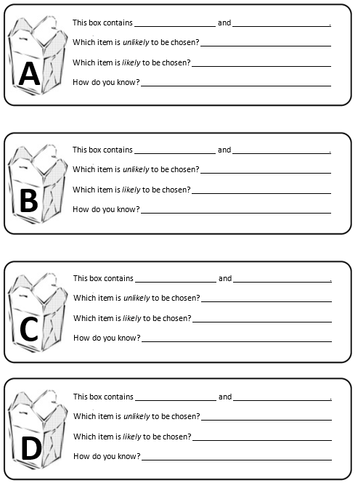

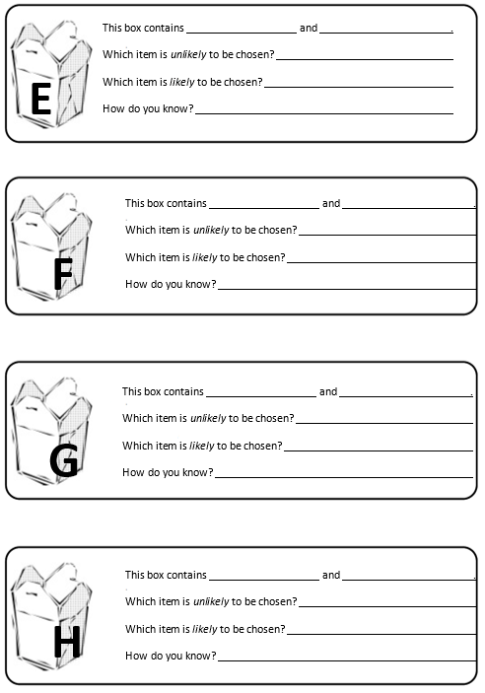

Probability Picture
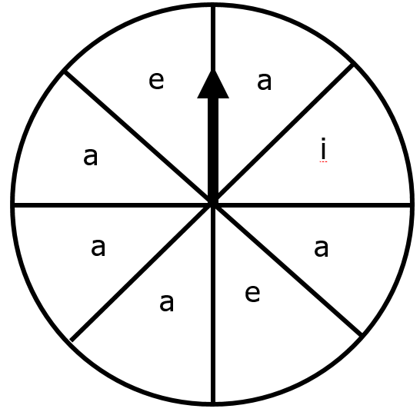

Probability Picture Question Cards
Name: Date:
Look at the Probability Picture very carefully. Use the probability terms certain, impossible, likely, equally likely, as likely as, and unlikely to answer the questions.
