Mathematics Instructional Plan – Grade Three

Hoppin’ on the Elapsed Time Line
Strand: Measurement and Geometry
Topic: Determining elapsed time
Primary SOL: 3.9 The student will
- solve practical problems related to elapsed time in one-hour increments within a 12-hour period
Related SOL: 3.9a, 3.9c

Materials
- Elapsed Timelines Practice activity sheet (attached)
- Elapsed Time Word Problems activity sheet (attached)
- Elapsed Timeline Recording Sheet (attached)

Vocabulary
a.m., analog clock, digital clock, elapsed time, half-hour, hour hand, hours, minute hand, minutes, p.m., quarter hour

Student/Teacher Actions: What should students be doing? What should teachers be doing?
- Ask, “What happens to the time from the moment you get to school until you leave for home?” Describe elapsed time as an amount of time that passes between two given times. Using the Elapsed Timelines and Elapsed Time Word Problems, demonstrate how students will use the timelines to determine elapsed time.
- Explain that in order to determine elapsed time on the timeline, students will write the start time and end time information that they read in the word problems, and then they will count the hours that elapse between the two times.
- Demonstrate to students how this can be recorded on an Elapsed Timeline in “hops,” or one-hour increments, by hopping forward from the start time hour by hour until they come to the end time. Students need to record each hop, and then they will count the hops. Ask, “Why are you counting in hours instead of minutes?” Model by solving the following problem:
The movie starts at 2:00 p.m. and it ends at 5:00 p.m. What is the elapsed time between the start time and the end time of the movie? How long is the movie? 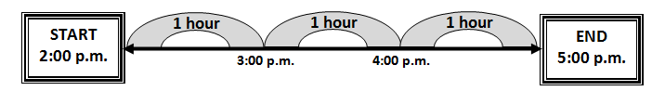
- Explain to students, that we not only have to sometimes find the elapsed time, but we also have to try to solve for the start and end times as well. Demonstrate that when this problem occurs, a student would write down the start or end time given, create the number of hops given, and then find the missing time. Model by solving the following problem:
A bicycle race begins at 8:00 a.m. If the race continues for four hours, what time will the bicycle race end?
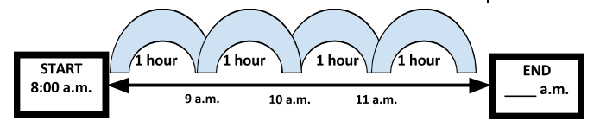

- Once the students have practiced several teacher-provided elapsed-time problems using the Elapsed Timelines Practice sheet, distribute the Elapsed Time Word Problems activity sheet and the Elapsed Timeline Recording Sheet. Using the Elapsed Timeline Recording Sheet, students will solve the word problem cards given to them.
- When the students have completed this activity, discuss how each problem card was solved. Review the questions when the students were solving for the elapsed time, start time, and end time. Ask: “How do we solve these different kinds of problems?” “How are these problems alike?” “How are they different?”

Assessment

Questions
  - If the start time is 8:00 a.m. and the end time is 11:00 a.m., what is the elapsed time?
  - How can you determine elapsed time in hours if the start time is 3:30 p.m. and the end time is 5:30 p.m.? Explain your reasoning by using the Elapsed Timeline.
  - If the start time is 7:00 p.m. and the elapsed time is four hours, what is the end time?
  - If the end time is 9:30 a.m. and the elapsed time is two hours, what is the start time?

Journal/writing prompts
  - You and a friend are going to the movies. The movie starts at 4:00 p.m. and ends at 7:00 p.m. Explain how you can find out how long the movie is.
  - Using an elapsed timeline that you have drawn, create your own elapsed time problem. Have a friend solve your problem.
  - Your teacher leaves the bookstore at 9:00 a.m. If she stayed in the bookstore for two hours, what time did she arrive at the bookstore?
  - Describe an activity that you have done or do every day. List a start time and end time. How long does this activity last?

Strategies for Differentiation
- Allow students to use clock manipulatives to help determine the amount of elapsed time.
- Have premade number lines to help aid students when counting the hours.
- Create a clock on the floor using index cards for the numerals and two different colored pieces of yarn in different lengths for the hands. Allow students to be the hour and minute hands holding the yarn pieces. Students re-create the problem by either walking the clock forward or backward, depending on the problem given. This will allow students to visually see the elapsed time in the problem.

Note: The following pages are intended for classroom use for students as a visual aid to learning.

Virginia Department of Education ©2018

Elapsed Timelines Practice
Name: Date: ____________________

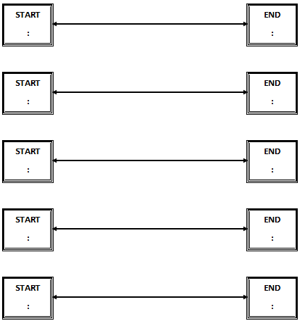

Elapsed Time Word Problems

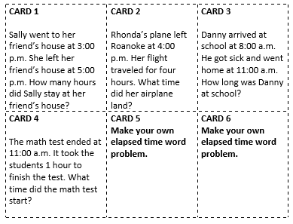

Elapsed Timeline Recording Sheet
Name: Date: __________________

