*Mathematics Instructional Plan – Grade Three*

Measuring Area and Perimeter

Strand:Measurement and Geometry

Topic:Measuring area and perimeter, using U.S. Customary and metric units

Primary SOL:3.8 The student will

1. Measure the distance around a polygon in order to determine its perimeter using U.S. Customary and metric units;
2. Count the number of square units needed to cover a given surface in order to determine its area.

Related SOL:3.7a

## Materials

* Construction paper shapes (perimeter activity)
* Inch and/or centimeter rulers
* Grid paper
* Premade grid paper shapes (area activity)
* Measuring Perimeter activity sheet (attached)
* Measuring Area activity sheet (attached)
* Discovering the Area of Virginia activity sheet (attached)

## Vocabulary

*area, centimeter, inch, measure, perimeter, polygon, square units, surface*

## Student/Teacher Actions: What should students be doing? What should teachers be doing?

1. Ask students to discuss how they would use perimeter to figure out the amount of paint that would be needed to outline a football field. Have student pairs or small groups discuss possible solutions. Then, have group representatives share their suggestions with the class.
2. Using construction-paper shapes, demonstrate how to determine the perimeter of a shape by measuring the length of each side of the shape and adding all of the lengths together. Remind students that they must add the lengths of *all* sides, no matter how small, and label the answer with the unit of measure they used.
3. Thinking back to the football field, if I needed to cover the football field with new grass, I would need to know amount of space or area inside the field. Using shapes drawn on grid paper, demonstrate how to determine the area of a shape by counting the number of squares needed to cover the shape. Remind students that they must add all the squares and label the answer with the square unit of measure they used.
4. Have students draw their own shapes on grid paper and determine the area and perimeter of each one by counting the squares. Have students exchange their work with their partners to check their solutions.
5. Have students create shapes with an area of 12 units. Ask students to look at the shapes they created and the shapes created by classmates. Did everyone that created a shape with an area of 12 units have the same perimeter? Why or Why not?
6. Have students create a shape with a perimeter of 15 centimeters or units. Have them compare their shape with other students sitting by them. Do all students have the same area? Why or why not?

**Assessment**

### Questions

* Why is it important to measure all sides of a shape when measuring perimeter?
* How can you calculate the perimeter of a square?
* To determine how much material you would need to make a cover to fit the top of your bed exactly, would you use area or perimeter? Explain.
* What jobs would require you to know how to find the perimeter?
* What are the differences between perimeter and area?

### Journal/writing prompts

* You are going to build a fence around your backyard, and you need to know the quantities of materials you need to buy. Explain whether you would use area or perimeter, and why.
* Explain how area helps a landscaper with his/her job.
* Jacob is making business magnets for his lawn-mowing business. The magnets have a perimeter of 24 units. On grid paper, draw at least three ways Jacob could design his magnets.

### Other Assessments

* Have students determine the area of your classroom by counting the floor tiles.
* Have students complete the Measuring Perimeter and Measuring Area activity sheets.

## Extensions and Connections (for all students)

* Discuss how area and perimeter are used in sports.
* Have students research the area of Virginia, comparing it with the areas of the bordering states. Distribute copies of the Discovering the Area of Virginia activity sheet, and have students complete it.
* What shapes have the greatest area?

## Strategies for Differentiation

* Use larger grid paper to assist students with fine-motor issues.
* Have high-ability students draw shapes that correspond to given areas or perimeters.
* Create a paper ruler using a 1” x 12” strip of construction paper and two colors of 1” x 1” squares. Each student will need one strip, six squares of one color, and six squares of another color. Create an AB pattern with the color squares on the strip and glue them on. Label each square with the corresponding number to represent the 12 inches on the ruler. Use the measuring tool to find the length of each side of the polygon.

**Note: The following pages are intended for classroom use for students as a visual aid to learning.**

Virginia Department of Education ©2018

**Measuring Perimeter**

**Name: Date:**

For each shape below, estimate the length of each side to the nearest *inch,* and calculate the **estimated perimeter**. Then, measure each side with a ruler, and calculate the **actual perimeter**.

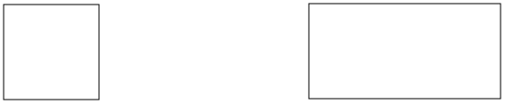

___________ ___________ ____________ ____________

estimate actual estimate actual

___________ ___________ ____________ ____________

estimate actual estimate actual

For each shape below, estimate the length of each side to the nearest *centimeter,* and calculate the **estimated perimeter**. Then, measure each side with a ruler, and **calculate the actual perimeter**.

___________ ___________ ____________ ____________

estímate actual estímate actual

___________ ___________ ____________ ____________

estimate actual estimate actual

## Measuring Area

**Name: Date:**

Estimate and then calculate the **shaded area** of each object below in square units.

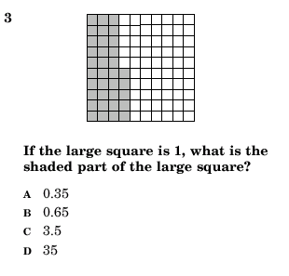 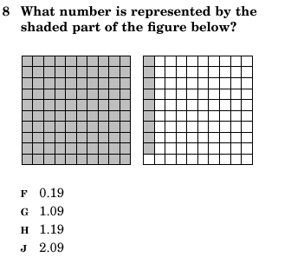

___________ ___________ ____________ ____________

estimate actual estimate actual

Estimate and then calculate the **area** of each object below in square units.

___________ ___________ ____________ ____________

estimate actual estimate actual

___________ ___________ ____________ ____________

estimate actual estimate actual

## Discovering the Area of Virginia

**Name: Date:**



Area of Virginia: square miles

Areas of Virginia’s neighboring states:

North Carolina: sq. mi.

Maryland: sq. mi.

West Virginia: sq. mi.

Kentucky: sq. mi.

Washington, D.C.: sq. mi.

Tennessee: sq. mi.

The state with the largest area: ; area: sq. mi.

The state with the smallest area: ; area: sq. mi.

States with areas similar to Virginia’s:

STATES AREA in square miles