Mathematics Instructional Plan – Grade Three

Fit to Be Congruent
Strand: Measurement and Geometry
Topic: Identifying and describing congruent and noncongruent figures.
Primary SOL: 3.13 The student will identify and describe congruent and noncongruent figures.

Materials
- What’s My Definition? activity sheet (attached) printed in color
- Congruent/Noncongruent Figures sheet (attached)
- Congruent/Noncongruent Figures Recording Sheet (attached)
- Congruency Exit Ticket

Vocabulary
angle, circle, congruency, congruent, noncongruent, plane figure, polygon, rectangle, shape, side, size, square, triangle
Student/Teacher Actions: What should students be doing? What should teachers be doing?
- Have students work with a partner. Give each pair a color copy of the What’s My Definition activity sheet. Explain that all pairs of shapes under each header represent the definition of each word, congruent and noncongruent. Have students examine each pair of shapes and write a definition for each word based on what they know about the shapes.
- Engage the class in a discussion of what they noticed about the shapes under each word. Create a class definition for each word.
- Distribute the Congruent/Noncongruent Figures sheets, the Congruent/Noncongruent Figures Recording Sheet, and tracing paper. Demonstrate how to determine whether a pair of figures is congruent or noncongruent by tracing one of the figures and then placing the tracing over the other figure to check for congruency. Ask, “Why do you need to trace one of the figures?” “How does placing the tracing of one figure on top of the other figure help determine whether the figures are congruent?” Have students work in pairs or small groups to determine whether the pairs of figures are congruent or noncongruent. Have students share their outcomes with the whole class.

Assessment

Questions
  - What do you notice about congruent figures? What attributes of the figures did you need to compare to determine whether they were congruent or noncongruent?
  - Given a picture of a real-life image that contains congruent figures, how would you describe the congruent figures? Does the picture contain any noncongruent figures?

Journal/writing prompts
  - Locate and describe two shapes in the classroom that are congruent. Justify why you think they are congruent.
  - Using advertisements in magazines or other sources, locate images of things that are congruent and noncongruent. Cut out the advertisements, glue them down, and explain in writing below each one why the images in it are congruent or noncongruent. Justify your reasoning.

Other Assessments
- Have students use peg boards to create congruent shapes. Name and discuss the properties of the shapes created.
- Have students use a mirror to create congruent figures.
- Have students complete the Congruency Exit Ticket.

Extensions and Connections (for all students)
- Provide a set of congruent/noncongruent figures on cards and two hula hoops, one for congruent figures and the other for noncongruent figures. Have students form two teams to compete at placing the figure cards into the correct hoops.
- Distribute copies of the Congruent/Noncongruent Figures Seen in a Mirror sheet and mirrors (optical drawing instruments). Have students use the mirrors to verify whether each pair of figures is congruent or noncongruent.
- Distribute pattern blocks, and have each student use them to create a picture or model to trade with a partner. Each student must then create an image that is congruent with the traded picture or model. Allow students to trace the outlines of the pictures or models in order to create their congruent images.

Strategies for Differentiation
- Have students create their own congruent and noncongruent shapes.
- Discuss the attributes of each shape and how the attributes prove congruency.
- Have students measure attributes of shapes to determine congruency.

Note: The following pages are intended for classroom use for students as a visual aid to learning.

Virginia Department of Education ©2018

What’s My Definition?
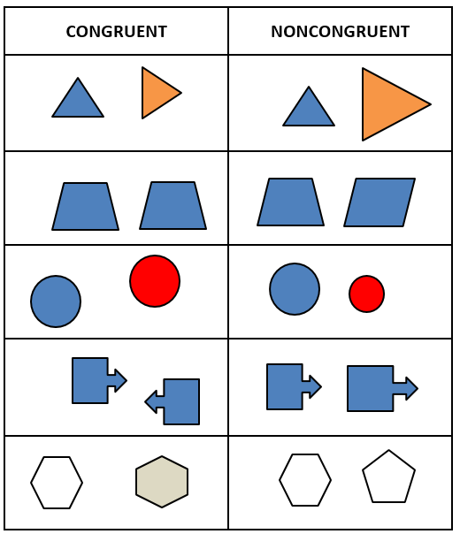

Congruent/Noncongruent Figures

For each pair of figures below, trace one of the figures, and then use the tracing to determine whether the pair of figures is congruent or noncongruent. Record your answer on the recording sheet.
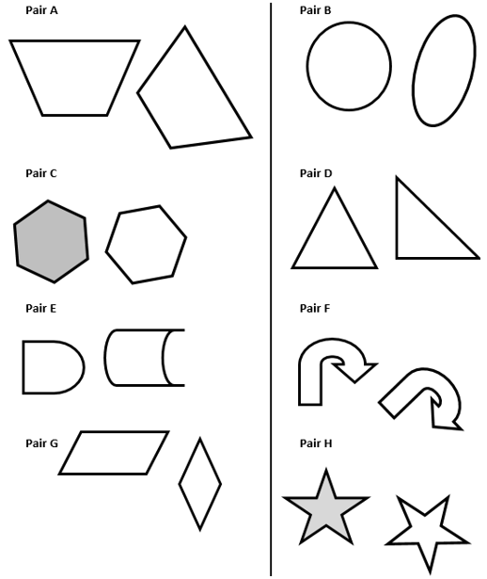

Congruent/Noncongruent Figures Recording Sheet

Name: Date: ____________________
Pair | Congruent or  Noncongruent | Justify your decision
A
B
C
D
E
F
G
H

Congruency Exit Ticket
Circle the figures that are congruent and put an X on the one that is noncongruent in each set.
A.
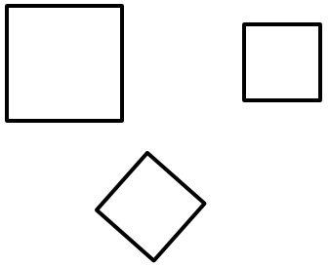

B.
