Mathematics Instructional Plan – Grade Three

What is It Worth?
Strand: Measurement and Geometry
Topic: Combining and subdividing polygons
Primary SOL: 3.12 The student will
- combine and subdivide polygons with three or four sides and name the resulting polygon(s).
Related SOL: 3.11, 3.12a, 3.12b, and 3.13

Materials
- Polygon Shapes sheet (attached)
- The Value of Shapes sheet (attached)
- Scissors
- Crayons
- Construction paper
- Demonstration tool (e.g., document camera, digital display)

Vocabulary
angles, combine, decagon, heptagon, hexagon, nonagon, octagon, parallel, parallelogram, pentagon, plane figure, polygon, quadrilateral, rectangle, rhombus, square, subdivide, trapezoid, triangle, vertices
Student/Teacher Actions: What should students be doing? What should teachers be doing?
- Distribute the Polygon Shapes sheet. Discuss the attributes of each shape and name them. Students will need to color and cut out each individual polygon.
- With their cut shapes, have students practice combining shapes to create new shapes. Have them share with a partner the new shapes they made. Record this on the board. New shapes should be named based on the number of sides.
Shapes Used | New Shape
- Discuss the attributes of the new shapes and how they differ from the attributes of the original shapes. Have students showcase their new shape using a demonstration tool or in a way that all students can see. Be sure they explain the properties of their new shape.
- Discuss subdividing shapes and how subdividing changes the attributes of the original shape. Put examples on the board. Name the original shape. Subdivide (see example) and name the new shapes. How did the attributes of the original shape change with each subdivision? Can we subdivide the shape another way and get different polygons?

- Distribute the Value of Shapes sheet. Explain that each shape has a value. They should combine shapes to create new shapes and find the value of the new shape.
- Challenge them to make a rectangle with the highest possible value. Then create a rectangle with the least possible value.
- Have students create a new polygon worth 50 or more points. Have them draw a representation of their new polygon. Have them create a new polygon with a value of more than 30 points but less than 50.
- Have students create a picture using their polygon shapes. They may subdivide their shape to create a new one but the value is now shared between the new shapes.
- Once students have their shapes in place, they may glue them onto the construction paper and total the value.
- Have students hang their pictures and do a gallery walk so they can share their creations with the rest of the class. Discuss, as a class, the variety of new shapes.
- Have students reclaim their pictures and then, as a class, line up in order from the picture with the least value to the picture with the greatest value. There may be several pictures that have an equal value. Discuss the similarities and differences based on the shapes used.
- Engage the class in a discussion on what they noticed about the pictures and their values. What questions do they have for their classmates about the pictures they created and the total value they came up with?

Assessment

Questions
  - How can subdividing shapes help in creating pictures?
  - What new polygons can be created by combining a rectangle and a right triangle? A square and a rectangle?
  - What polygons can be created when subdividing a rectangle? A trapezoid?

Journal/writing prompts
  - Write a story about your picture.
  - What polygon shapes can be combined to create a rectangle?

Extensions and Connections (for all students)
- Create a rectangle using two or more polygons. Can you find another way to create that same rectangle, using different polygons?
- How many ways can you create a rectangle with two or more polygons?
- What shapes can you combine to make a hexagon? A decagon? Draw pictures of your solutions.

Strategies for Differentiation
- Provide students with a calculator to total their picture.
- Provide students with a template for adding their shape values.
- Challenge students to create a picture with the greatest possible value or the least possible value.

Note: The following pages are intended for classroom use for students as a visual aid to learning.

Virginia Department of Education ©2018

Polygon Shapes
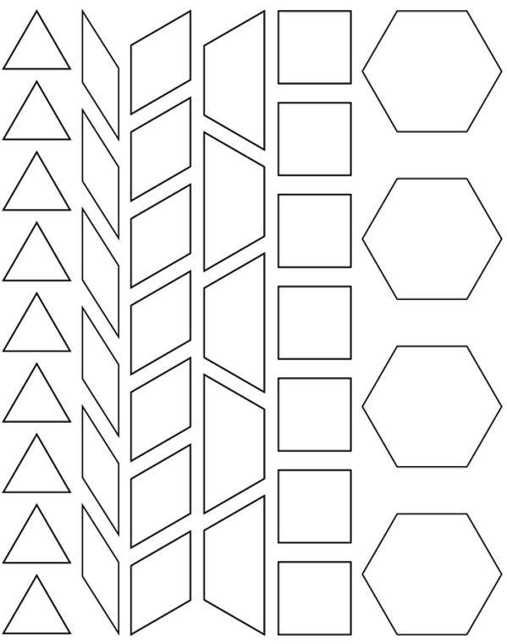
The Value of Shapes
