Mathematics Instructional Plan – Grade Three

Subdividing Polygons
Strand: Measurement and Geometry
Topic: Subdividing polygons
Primary SOL: 3.12 The student will
- combine and subdivide polygons with three or four sides and name the resulting polygon(s).
Related SOL: 3.11, 3.12a, 3.12b, and 3.13

Materials
- Peg boards and bands
- Peg Board Dot Paper (attached)
- Subdividing Polygons sheets (attached)

Vocabulary
angles, combine, divide, line segment, plane figure, polygon, quadrilateral, rectangle, right triangle, square, subdivide, triangle, vertices
Student/Teacher Actions: What should students be doing? What should teachers be doing?
- Using peg boards or dot paper, have students create a rectangle (2 x 4). Discuss the rectangle’s attributes. Ask students what they notice about the rectangle they created.
- Have students divide the rectangle in the middle with another band (or draw a line on the dot paper) as illustrated below. Have students describe what they notice now. What are the attributes of the new shapes?
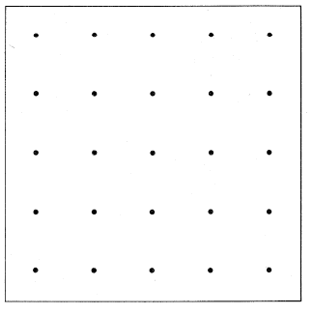
1
- Have them remove the center band (if using dot paper have them create a second rectangle). Have them place the band as illustrated in step 2. Have students describe what they notice now and describe the attributes of the new shapes.
- Ask students what they “wonder” about subdividing the rectangle again using one or more bands. List their ideas on the board.
2
- Give students time to explore subdividing their rectangle to create various shapes with bands (or on dot paper). Have them share their findings with their group or the class.
- Hand out the Subdividing Polygons activity sheets. Name and discuss the attributes of each polygon. For steps 7–10, students may continue to use the peg board to create and subdivide shapes or use the shapes on dot paper.
- Have students subdivide the square to make two rectangles. Ask, “How many bands (or cuts) did you use to make the rectangles?” “Can you subdivide the square a different way to make two rectangles?” “Now subdivide to make triangles.” “What kind of angles do you see in your triangles?” Discuss the various ways students divided the square to make the shapes. Have students record the way they subdivided on the Subdividing Polygons sheet.
- Ask, “What shapes can you make by subdividing the triangle?” Let students explore the various ways to subdivide the triangle. Record the new shapes created on the attached Subdividing Polygons sheet.
- Have students look at the quadrilateral labeled C–and ask, “How can we subdivide this quadrilateral to make three new polygons?” Give them time to explore and record their new polygons.
- Do the same with the quadrilateral labeled D–the parallelogram. Challenge students to find more than one way to subdivide to create three polygons. Have them record their new polygons.
- Ask students to explain what they noticed about subdividing their shape. Did everyone make the same new shapes when they subdivided? Refer back to the “wonder” list and discuss which had been resolved. What do you still wonder and how can we resolve these?

Assessment

Questions
  - What does it mean to subdivide polygons?
  - Name two polygons created when subdividing a square? A rectangle? Are there others?
  - How many ways can you subdivide a square? A rhombus? A trapezoid? A rectangle?

Journal/writing prompts
- Explain how to subdivide a rectangle to make two triangles. Be sure to use appropriate mathematics vocabulary.
- When would you need to subdivide shapes?
- Bill is building a patio in the backyard. He needs to subdivide the brick to fit his pattern. What shapes did he make when he subdivided the brick?

Extensions and Connections (for all students)
- Have students subdivide polygons to create more than three new shapes.
- Have students practice subdividing shapes and recombining to create new polygons.
- Prepare a selection of paper polygons and have students select three or four different shapes. Have students subdivide to create a “person” or a “creature.” Have them name and write a story about their creation.

Strategies for Differentiation
- Pattern blocks can be used to combine and subdivide polygons.
- Have students create each shape from the Subdividing Polygons sheet on their peg boards. Then have them divide each and name the resulting shapes.
- Have students draw the resulting shapes they make.
- Search for an interactive geoboard to allow students to create shapes.
- Create a word bank to help students identify each shape.

Note: The following pages are intended for classroom use for students as a visual aid to learning.

Virginia Department of Education ©2018

Subdividing Polygons

Subdividing Polygons
Name ____________________________ Date ________________
Illustrate how you subdivided each polygon and name the new shapes that were created.
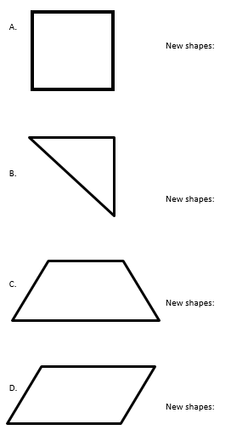

Peg Board Dot Paper

Peg Board Dot Paper

