Mathematics Instructional Plan – Grade Three

Combining Polygons
Strand: Measurement and Geometry
Topic: Combining Polygons
Primary SOL: 3.12 The student will
- combine and subdivide polygons with three or four sides and name the resulting polygon(s).
Related SOL: 3.11, 3.12a, 3.12b, and 3.13

Materials
- Scissors
- Combining Polygons activity sheet (attached)
- Combined Polygons activity sheet (attached)
- Envelope or sandwich baggie to hold polygon pieces for later use (optional)

Vocabulary
angle, line segment plane figure, polygon, quadrilateral, rectangle, square, triangle, vertices

Student/Teacher Actions: What should students be doing? What should teachers be doing?
- Distribute the Combined Polygons activity sheet. The students will need to cut out each individual polygon. Once the pieces have been cut out, allow time for the students to handle, examine, and discuss the various shapes. As the students examine the plane figures, lead a discussion about the attributes and names of each polygon, encouraging students to use appropriate mathematical terms, such as sides and vertices.
- Lead a discussion about three- and four-sided polygons and their attributes. During the discussion, begin to generate a list of these named polygons and their characteristics for students to view (a picture of each polygon may also be included on this list).
- Once these plane figures have been reviewed and discussed, distribute the Combining Polygons activity sheet. Explain to the students that they will now be completing this activity sheet using the previously cut polygons.
- Have the students name polygons a, b, and c, and write their answers on their worksheets. After the students have made their choices on the names of the three listed polygons, have students share their guesses. Discuss the correct names of the polygons.
- Using the individual polygons, have students build the new plane figure described in the first box. Once they have correctly built a shape resembling the quadrilateral below, they will need to draw the newly created figure in the box, exactly as they see it on their desks (see example below). Ask, “What type of lines does a square have?” (all lines or sides that are the same length) “Now that we’ve added the triangles, how does that change the sides?” (only two sides are the same length)
- Allow students to work independently to complete the three remaining boxes. Remind them that, before drawing the described shape on the activity sheet, they need to make the shape using their pieces.
- Once the students have completed all four boxes, have students continue to create new plane figures using their large cut-out polygons. Have students describe what new polygons they were able to create. Ask, “What polygons did you use to create this shape?” A list of these student-created polygons may be written for the students to see. Allow time for class discussion about these polygons and their attributes. Reiterate the fact that polygons can be combined to form new polygons.
- At the end of this activity, give each student an envelope or sandwich baggie, and have them store their pieces for future work.

Assessment

Questions
  - What does it mean to combine polygons?
  - What two polygons can be combined to create a square? A rectangle?
  - How many ways can you make a square? A rectangle? Other quadrilaterals?

Journal/writing prompts
  - Make a list of objects in the classroom that are made of smaller shapes? (Provide an example to get students started, if needed: Legos, the floor, a window.)
  - Draw a rectangle using two or more polygons. Can you draw another way to create that same rectangle, using different polygons?
  - You have a secret plane figure. Write some clues about it to share with a classmate. See whether your classmate can use your clues to create your secret polygon.

Extensions and Connections (for all students)
- Look at pictures of various real-world objects. Discuss with the students the name of each object, as related to what kind of polygon it is. Have students describe ways that they could have created that polygon using smaller polygons.
- Using a pegboard, have students create large polygons using smaller polygons. Allow students to describe how their large plane figures were formed.

Strategies for Differentiation
- Search for an interactive Geoboard to allow students to create shapes.
- Pair students to assist each other with following directions and the physical manipulation of the paper.
- Demonstrate the cutting and also have a sample of the finished tangram pieces for the students to see.
- Create a word bank to help students identify each shape.
- Split the class into groups of seven (or less if needed) and enlarge each tangram piece. Have the students work together to physically create various polygons with their teammates.

Note: The following pages are intended for classroom use for students as a visual aid to learning.

Virginia Department of Education ©2018

Combining Polygons
Name: ____________________________________________ Date: ___________________
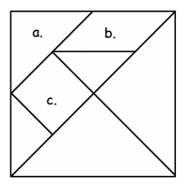
- Identify each labeled polygon piece by the name of its shape below.
c.

- ____________________________
g.
e.
b.
- ____________________________
- ____________________________
d.
f.

- Using your large polygon pieces, create the following shapes described, on your desk. In the space provided, draw the new polygons you have created.
- Using the square and the two smallest triangles (d and e), create a shape that resembles this quadrilateral . | - Using the quadrilateral labelled c and the two smallest triangles, create a large triangle.
- Using three polygons (of your choice), create a rectangle. | - Using four polygons (of your choice), create another rectangle.

- Continue to rearrange your polygon pieces. Identify and describe them as you work.

Combined Polygons
Cut out each polygon labeled below. Once cut, the shapes will then be used to complete the Combining Polygons activity sheet.

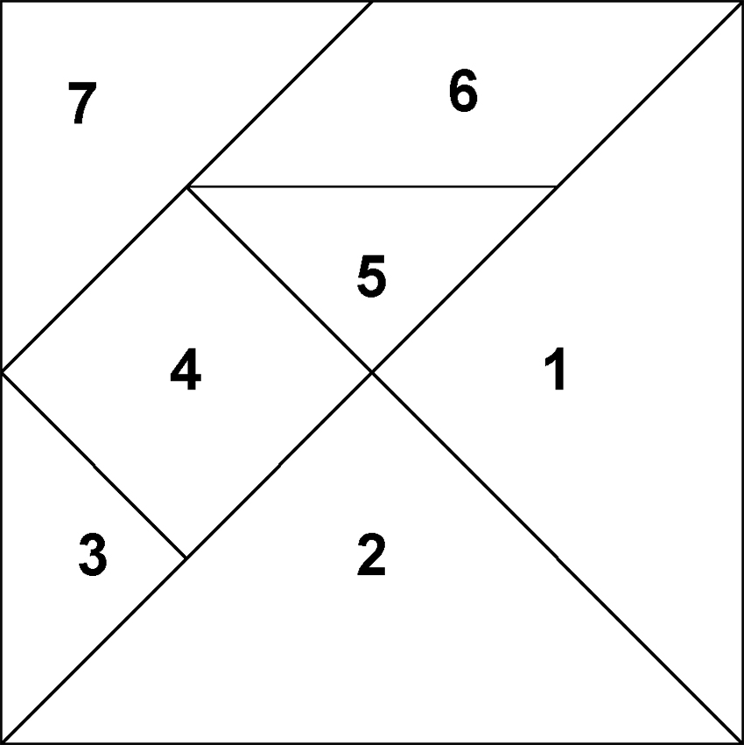
c.
b.
g.
f.
e.
d.
a.

